Project-2 Analytics Engineering

Created a dev workspace

Created a final Lakehouse

Uploading fact orders to snowflake

Get data from snowflake into fabric lakehouse

Data from snowflake to fabric Lakehouse

Landing Lakehouse to get the data here

Land fact orders table to final warehouse into table

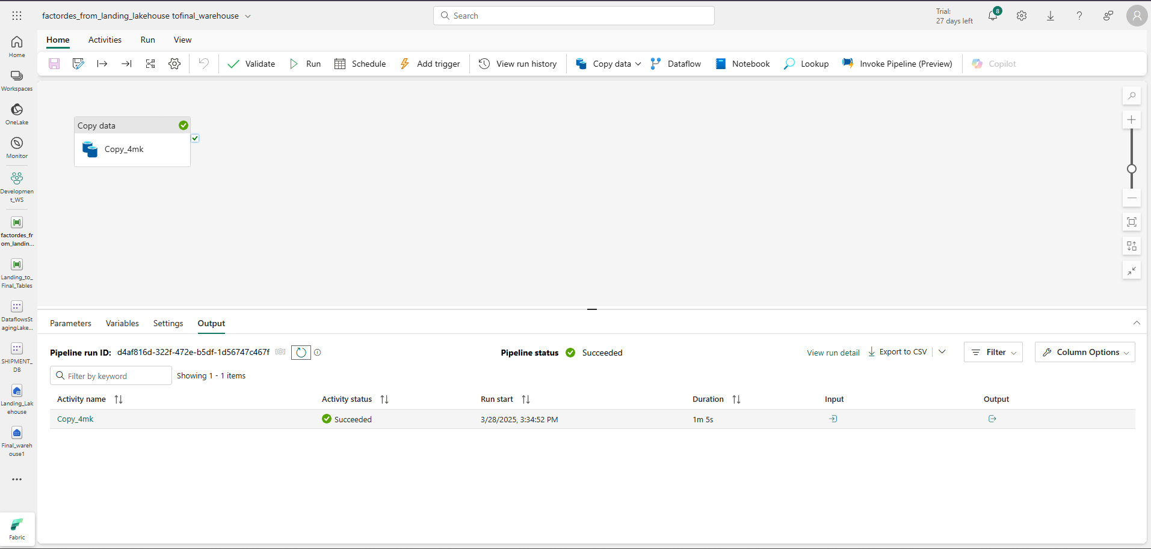

Now FactOrders is present in final warehouse

Now for all the csv’s send from landing Lakehouse to final_warehouse1

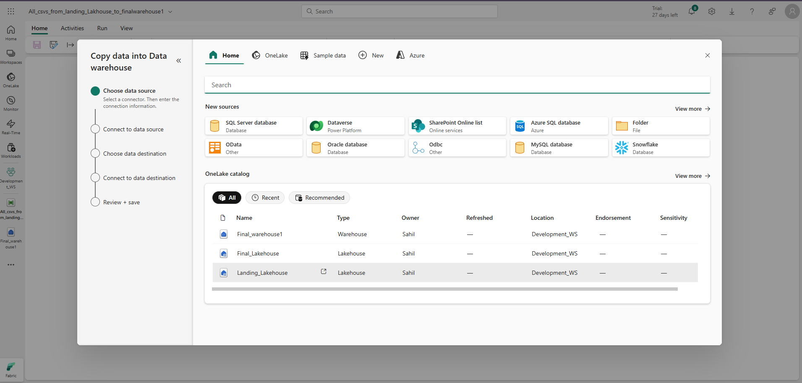

Datasource choose

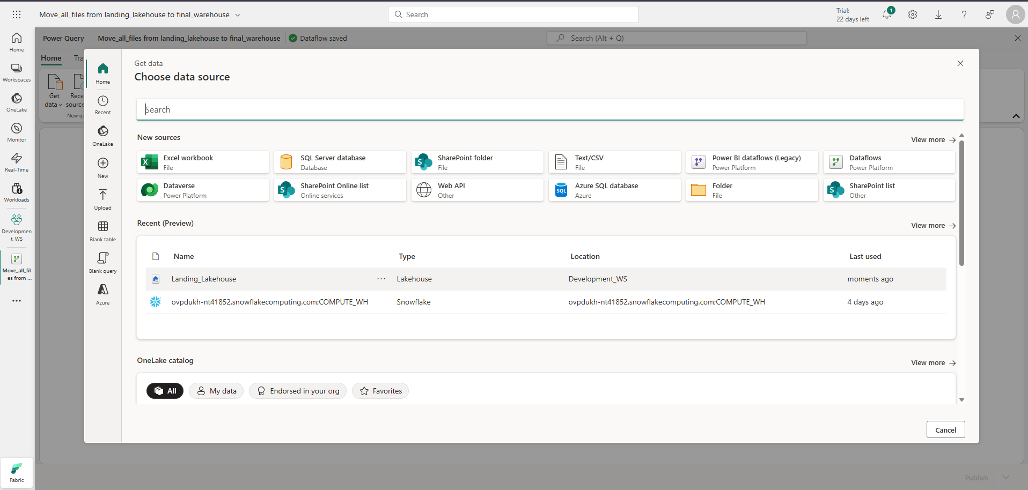

All files are now present into our dataflow

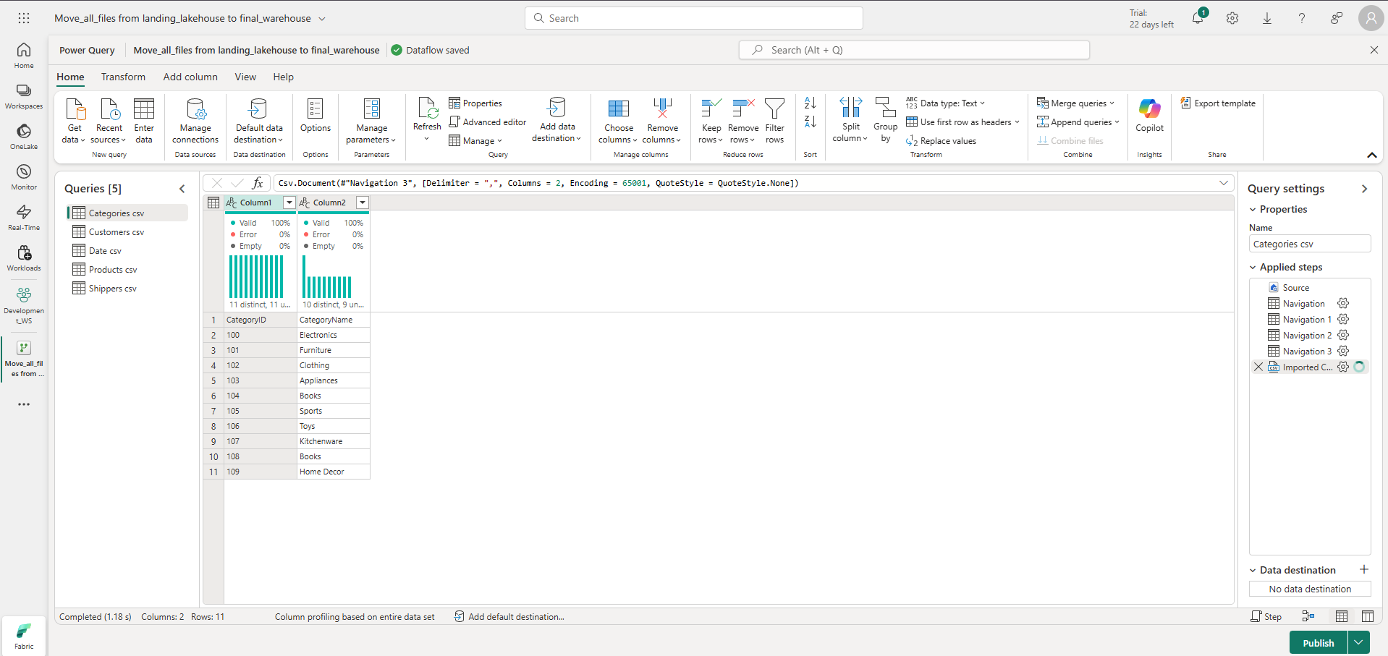

Add destination for final lakehouse

From final warehouse to final Lakehouse

Pipeline completed

Now all files are present in final Lakehouse

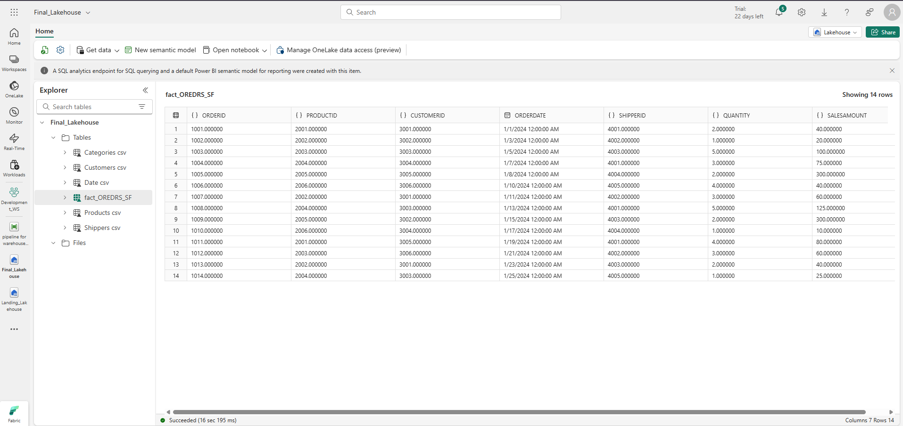

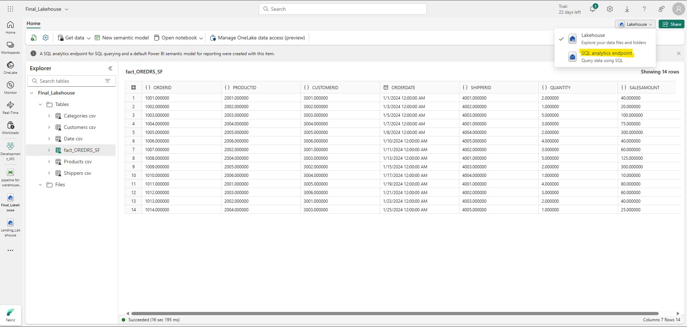

SQL analytics endpoint is for those where end users are exposed and can write queries

DML operations are not supported here its just to read your data you don’t give Lakehouse access just give the SQL analytics endpoint’s access

Now creating the report



