maliciousRecursive.code

recursive2.code



recursivecall.code

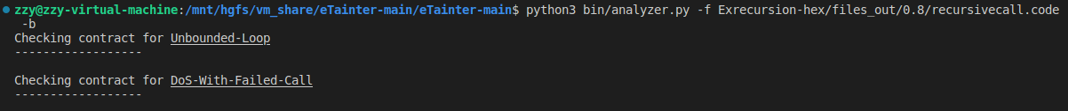

recursivel.code

