files_out/0.4/crowdfunding.code

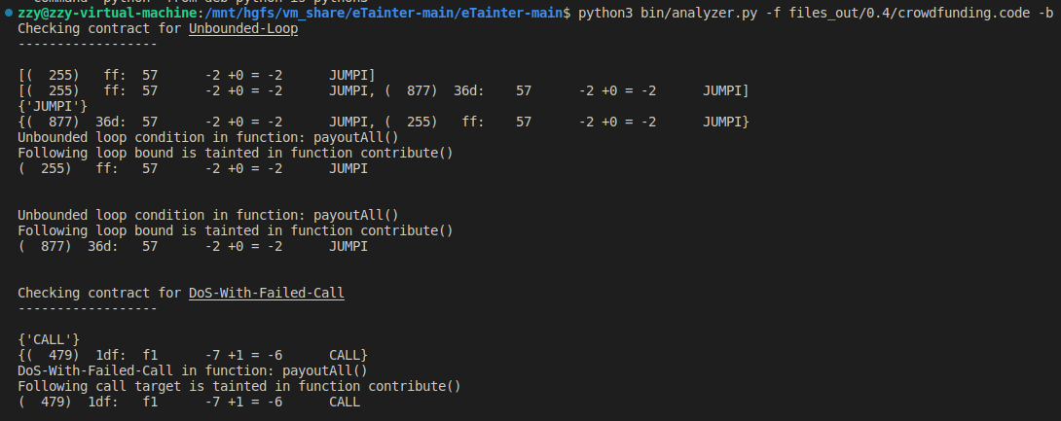

files_out/0.8/CrowdFunding1.code



files_out/0.8/doloop.code

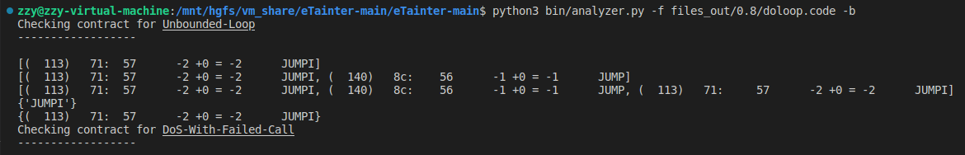

files_out/0.8/ReentancyGuard.code

/

files_out/0.8/value-loop.code

