MA5121 Nextflow Assignment
Mary Liza Gannon & Sanhita Bhowmik

We downloaded the assignment.zip file and the data (reads one and two, and the adaptors.fa file) from canvas. We unzipped the assignment.zip file and placed the contents in a Nexflow_assignment directory. We moved the adaptors.fa file into this directory. We made a data directory and placed the fq.gz reads files into this directory.
We initially ran the nextflow main.nf file:

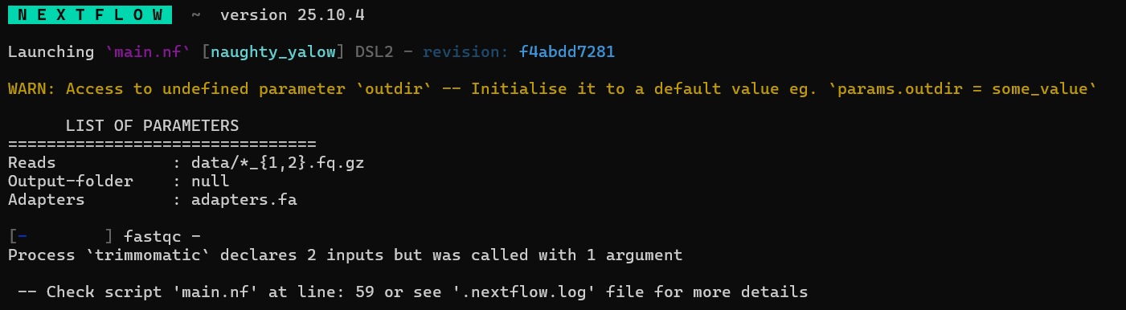

We then observed the main.nf file and noticed that there was indeed a misspelling of the oudir parameter.
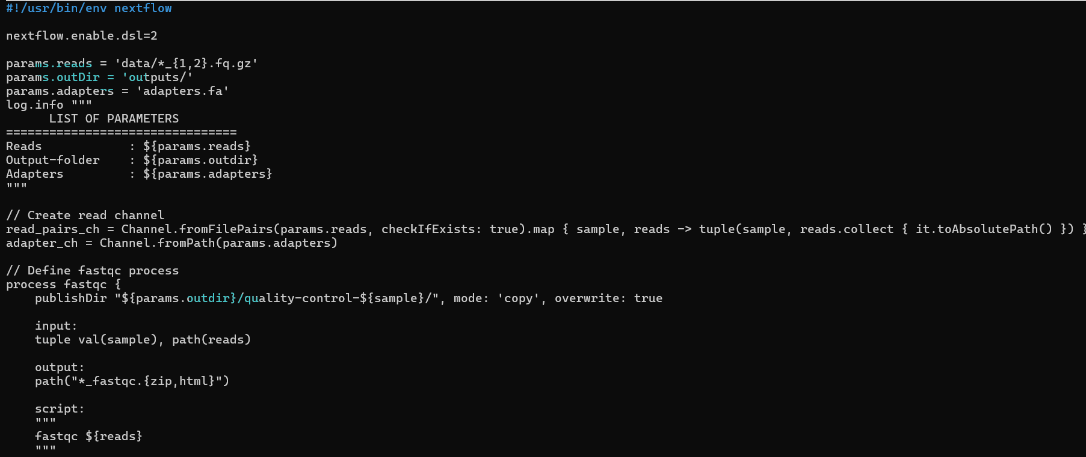
Trimmomatic requires 2 inputs but was only called with one, we also specified and adaptor.fa channel as an argument. This is because trimmomatic uses a predefined list of typical adaptor sequences (byproducts of sequencing) and removes those from the input file.
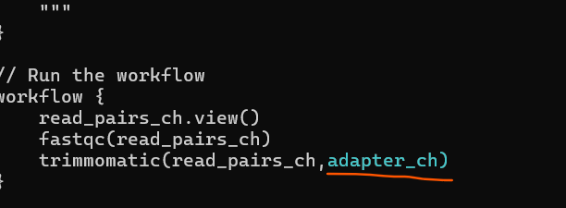
We also fixed an error in the trimmomatic process script
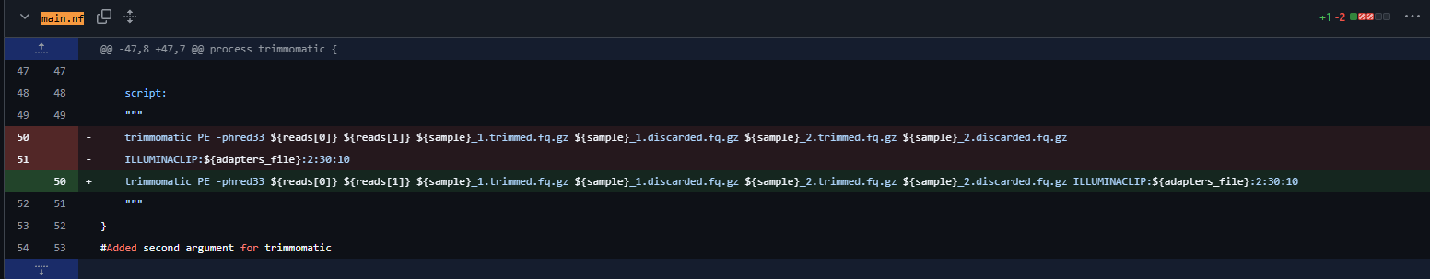
(removed a space)

March 11th:
On observation of the main,nf file, we noticed there were not labels for the processes (fastqc and trimmomatic). We added the labels “fastqc” and “trimmomatic” respectively. We checked the nextflow.config file to ensure labels were the same.
After adding the labels, we ran the main.nf file, and received this error message.
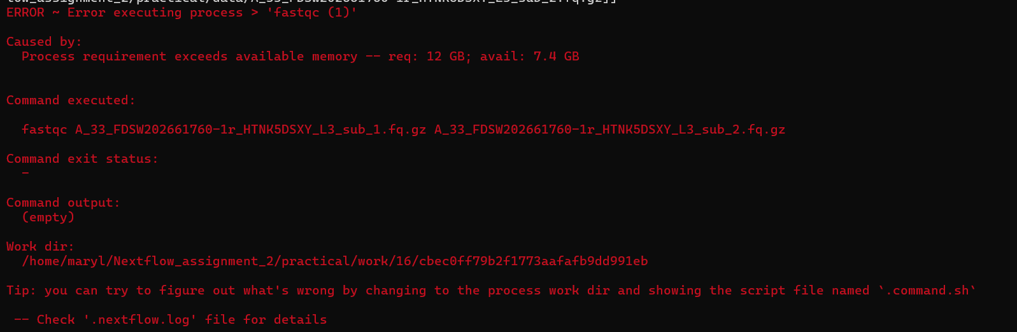
To resolve this, we changed the nextflow.config file to reduce the memory used for each process to 4GB.
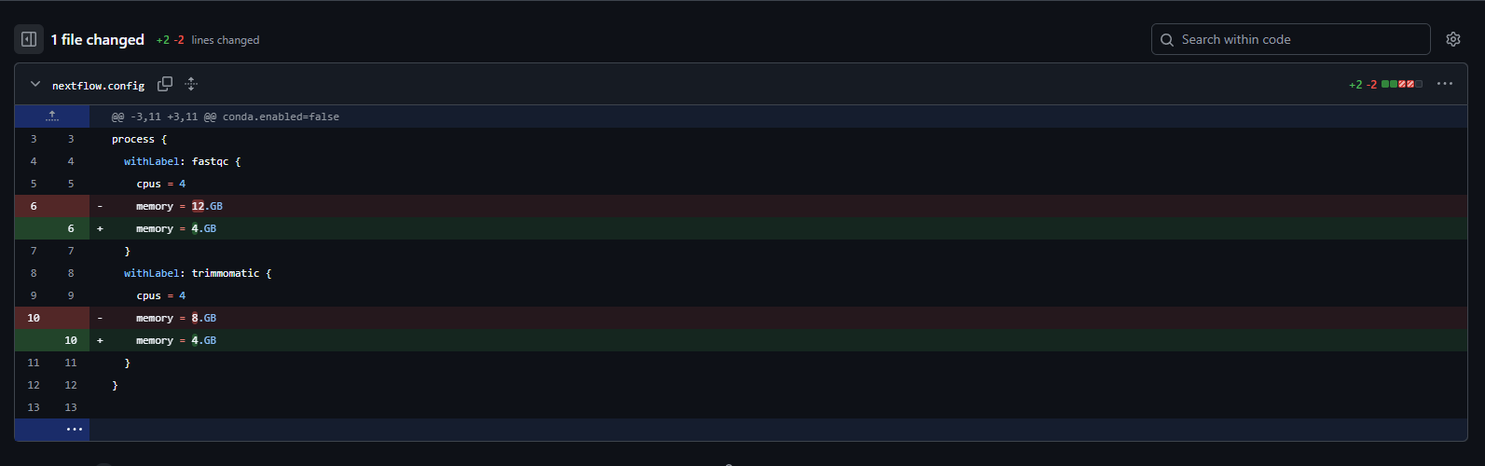

When running the main.nf file, it stalled during the fastqc process. On observation of the command.err file, we discovered it was an issue with java (“no fontmanager in system library path).

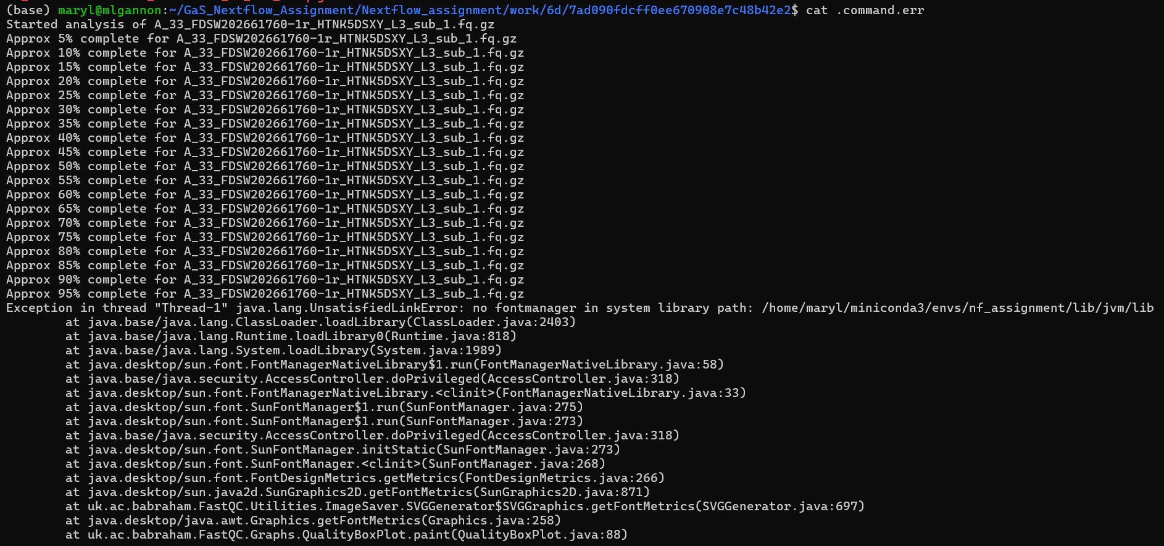
We created a new conda environment specifying openjdk=17 (As well as fastqc, trimmomatic etc). Reran the code and the fastqc and trimmomatic processes/tasks both ran
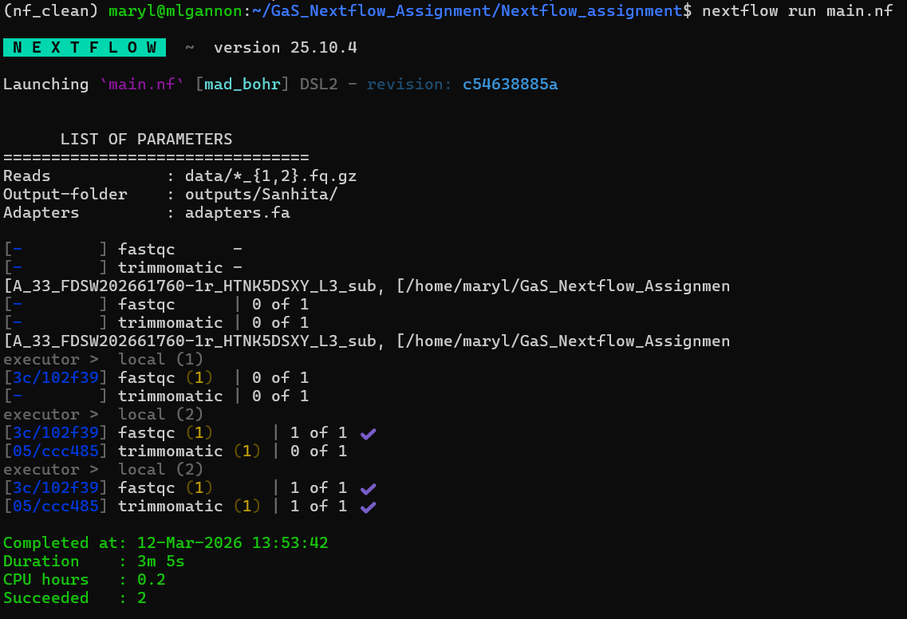
See above completion message ^

STEP2 : “Add an alignment step”
Tool: bwa-mem2
https://github.com/bwa-mem2/bwa-mem2
Installed bwa-mem2 via conda
Command used: conda install bioconda::bwa-mem2

Next we edited the main,nf file to include an alignment process.
We had the reference sequence + corresponding index in the main folder.
We added a reference parameter and make a reference channel in the main.nf file.
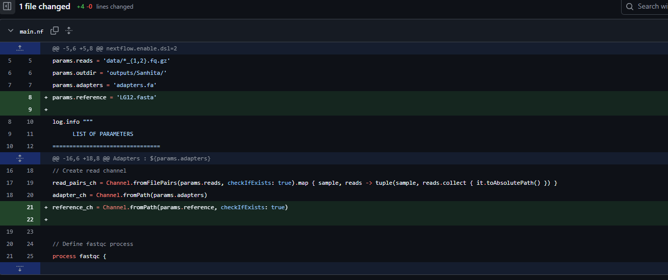

Since the output of the trimmomatic process was to be used for the alignment process, we changed the output of the trimmomatic process, to give the channel a name. (like it was done in the lecture slides).
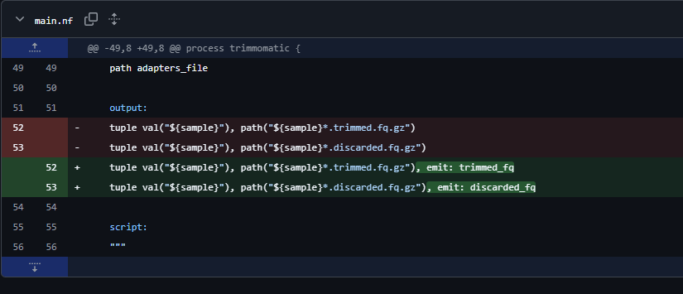

We then defined the alignment process, which we called “bwa-mem2”
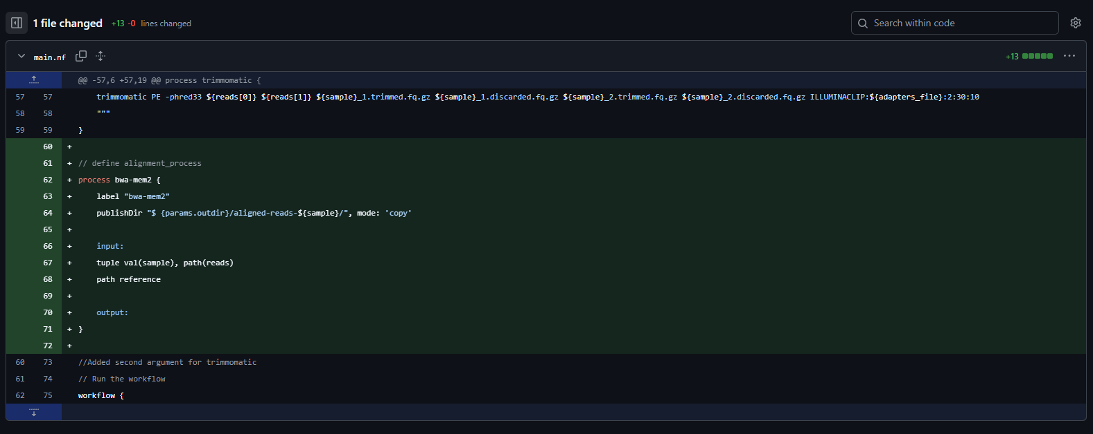
As shown above, we gave it a name “bwa-mem2”, and specified that the outputs appear in our outputs directory with names with the prefix “aligned_reads”.
We gave the process a label, and also specified the inputs.

We then added the ouputs section of the process chunk as well as the script to run the process.
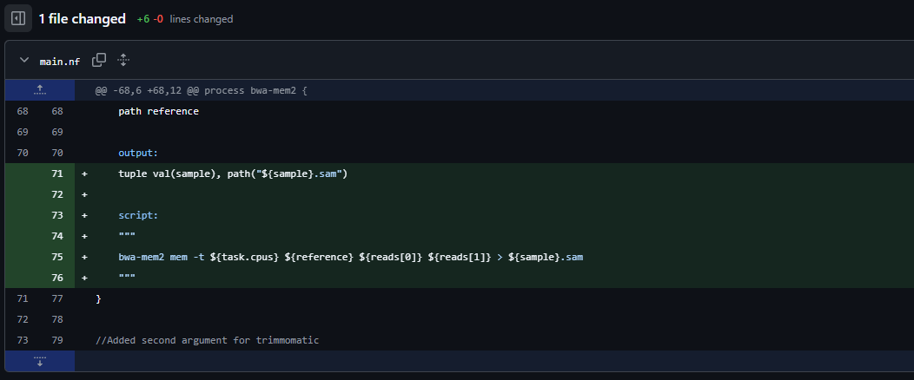
We consulted the bwa-mem2 documentation to create the command for the script.

When we ran the main.nf file after these changes:
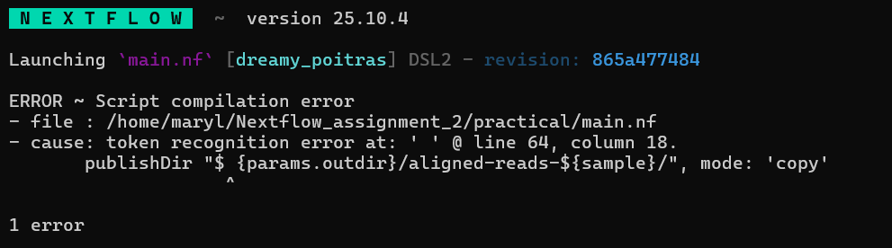
This error told us that we had an extra space where there should not have been (line 64, in our bwa-mem2 process chunk).
We removed it.
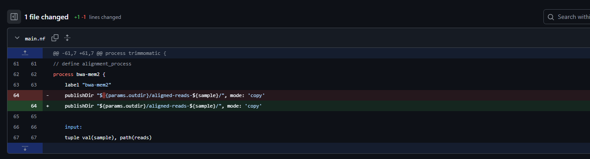
We reran main.nf

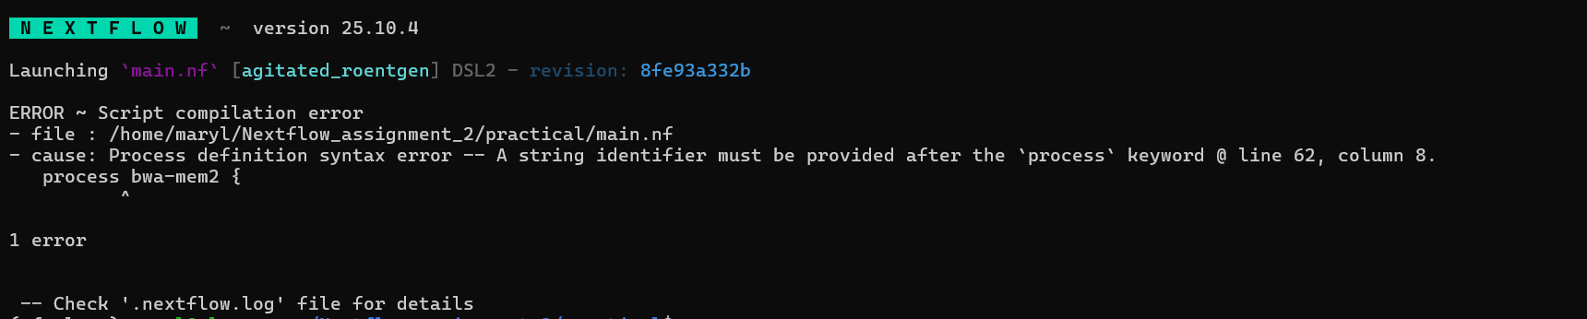
This error message told us there was something wrong with the identifier after the “process” keyword. The name we had chosen “bwa-mem2” was not acceptable as it included a hyphen. We changed it to an underscore.

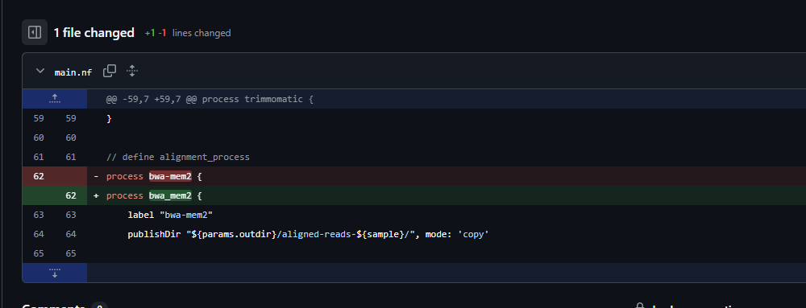
After we ran main.nf again, we received this error. It told us that hyphens are not allowed in labels either.
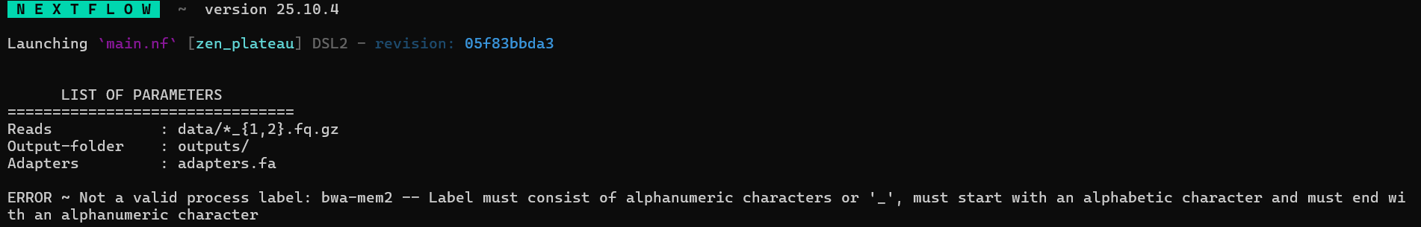
We changed the hyphen to an underscore.
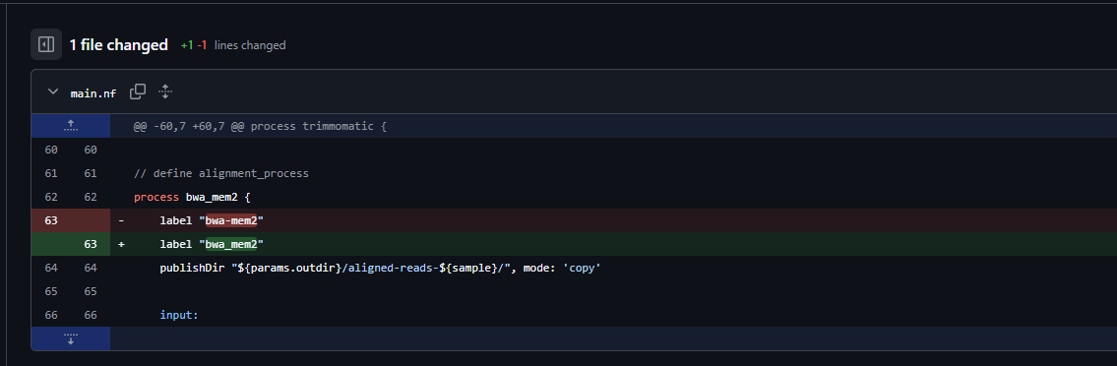

We then added a line in the workflow to run the bwa_mem2 process.
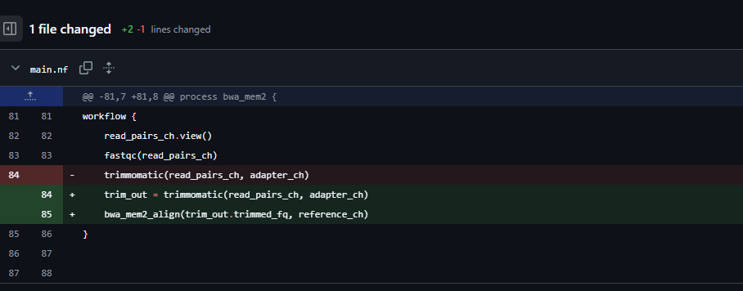

When we ran main.nf, error:
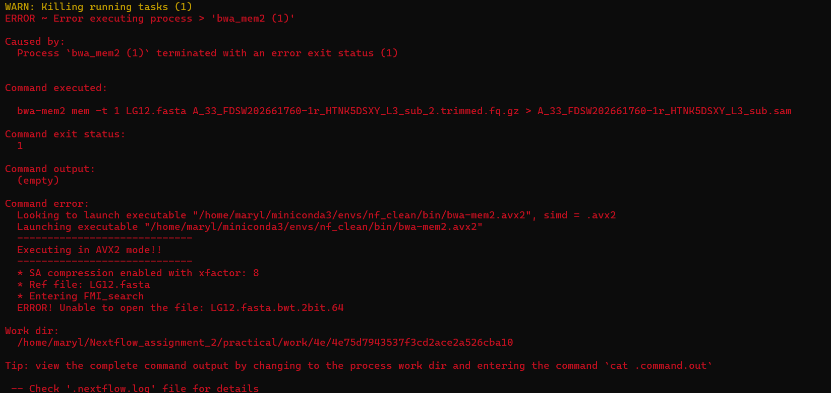

This error message told us that the index file (LG12.fasta.bwt.2bit.64) could not be opened. We think this was because we only specified 1 file as our reference when we specified the reference parameter. In fact, bwa needs to access the index files too. They are in the same directory as our reference fast file.
We tried a few different ways to solve this:
We changed the parameter to LG12.fasta* to include all files that begin with LG12.fasta, with the hope that the indices would be picked up.

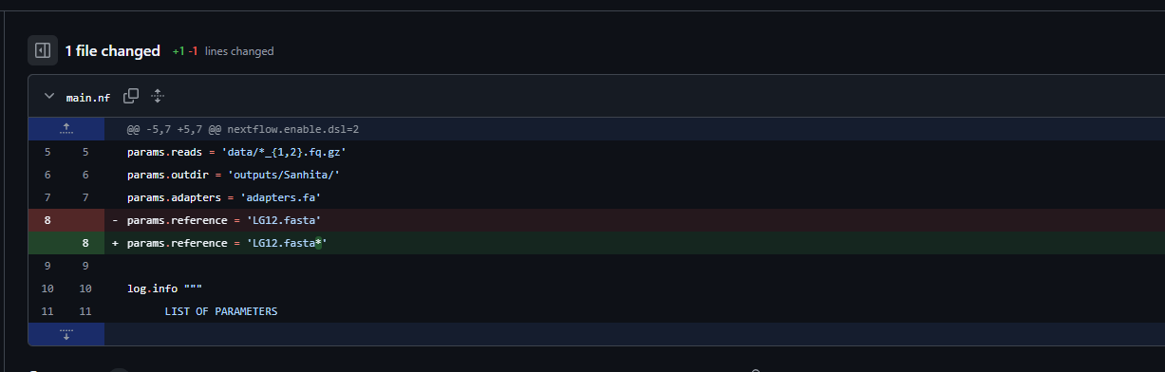

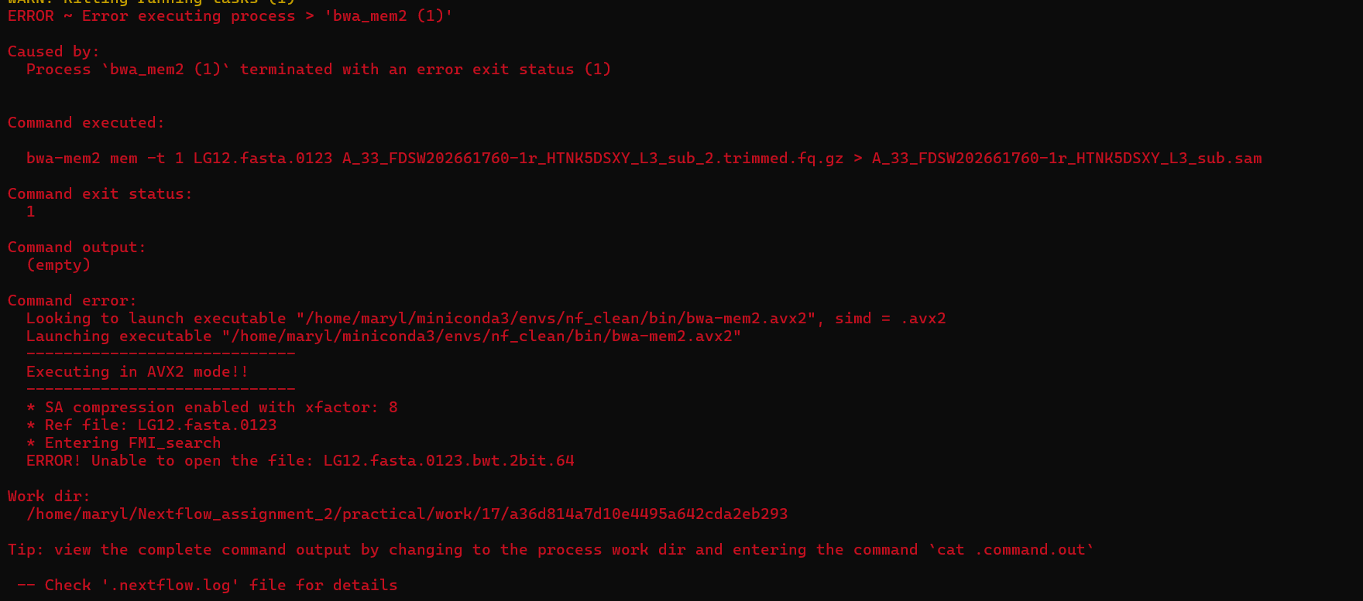
The index file was still not accessible.

We made other changes to the bwa_mem2 process.
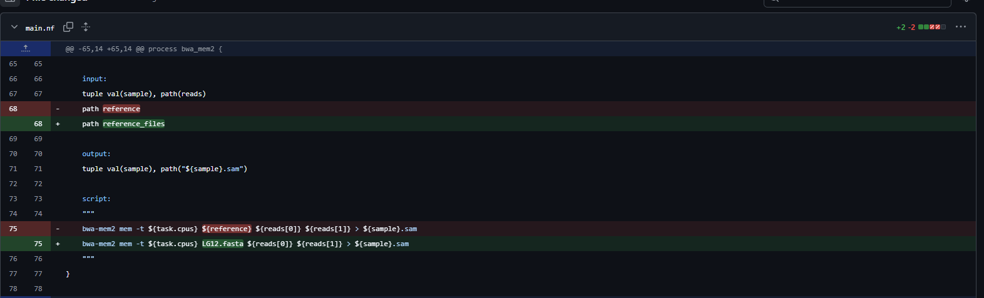

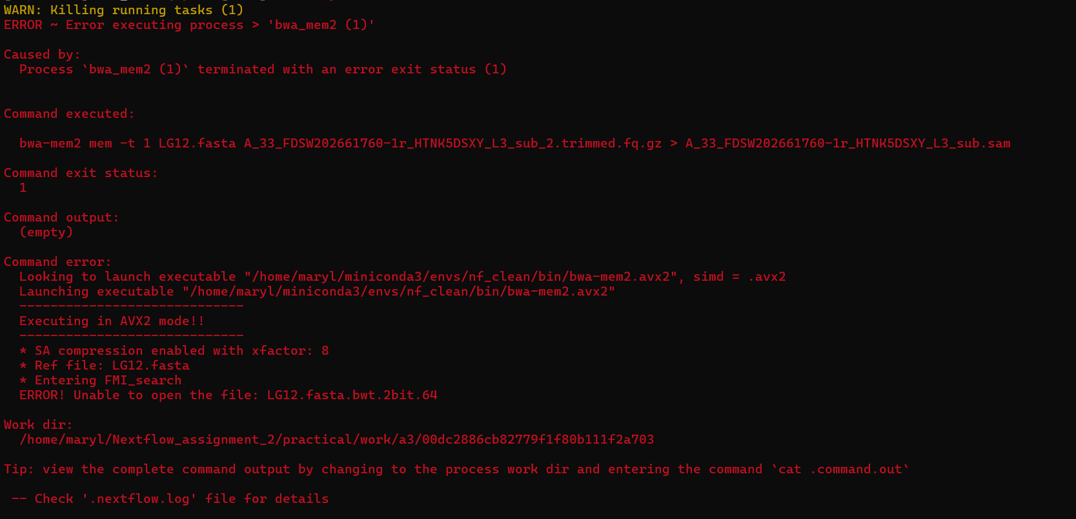

Globbing (*) did not seem to work so instead we added a used the .collect() functionionality.
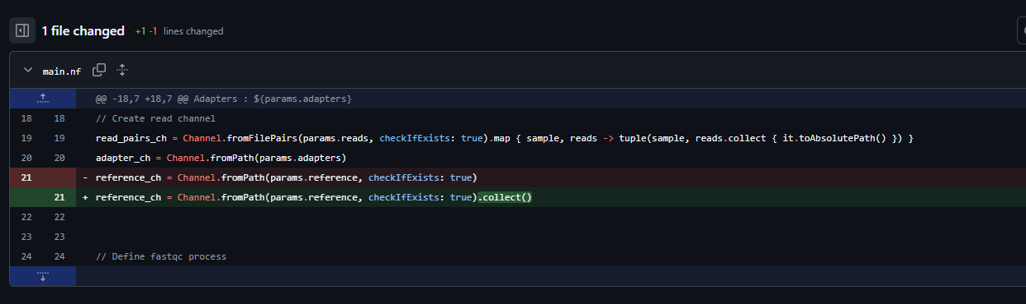

All 3 processes worked.

We then made the process modular, creating a new subdirectory “modules” with nf files within for each process, and created a new .ng file called main_modular.nf.

