Solutions commands for Graph:

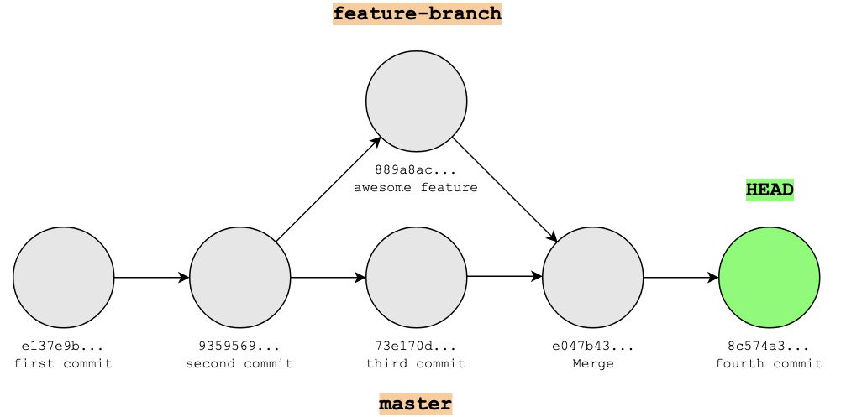

Local Repo --> git init
git status (untrack files)
git add .
git status (no untrack files)
HEAD->master git commit -m "first commit"
git status (git is upto date)
git add file
git commit -m "second commit"
HEAD->master git log --oneline

git checkout -b featureb1
git branch
HEAD->featureb1 git add newfeature.file
git status (all files tracked)
git commit -m "awesome feature"
git log --oneline(HEAD -> featureb1, origin/master, master)

git checkout master
HEAD->master git status(some untacked files to be staged)
git add file
git status(no untrack file)
git commit -m "third commit"
git log --oneline (HEAD -> master, origin/master, featureb1)

HEAD->master git merge featureb1
git log --> (HEAD -> master, feature1)
git add newfile
git commit -m "fourth commit"
git log-->(HEAD -> master)

