Exp No: 1
1. Use Figma to create an interactive diagram illustrating the components of a basic cellular system.
Aim:
To create an interactive diagram illustrating the components of a basic cellular system.
Procedure:
- Open Figma.
- Create a new design file.
- Select the Frame tool and add frames (slides) for each screen.
- Fill in the content required for the presentation.
- Design the visual elements (shapes, icons, colours, images).
- Make it interactive by linking the frames in the Prototype tab.
- Add annotations and explanations.
- Incorporate multimedia.
- Storyboard the animation using Smart Animate or Dissolve.
- Review and edit the prototype using the Present mode.
- Save and share the file.
Output Screenshot:
Design:
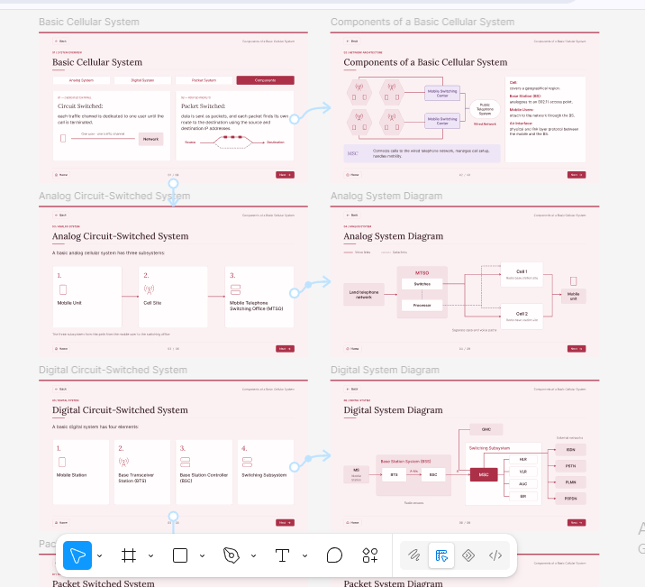
Result:
Hence an interactive diagram illustrating the components of a basic cellular system using Figma is created and executed successfully.

