CSA47 - DEEP LEARNING
CO1 ASSESSMENT 1
Analyse the Mathematical and Machine Learning Foundations of a Crop-Disease Screening System
AgriVision - Experimental Report

Field | Details
Student name | Thikkavarapu Sanhith
Register number | 192311228
Course | CSA4704 - Deep Learning
Assessment | CO1 Assessment 1 - Individual assignment
Total marks | 50
Dataset | PlantVillage color images; tomato subset for Tasks 1-11; 38 classes for Task 12
Environment | Kaggle Notebooks / Python

Report structure
- Executive summary and experimental setup
- Task 1 - Problem structure and data representation
- Task 2 - Linear algebra, PCA and SVD
- Task 3 - Probability and information theory
- Task 4 - Numerical computation issues
- Task 5 - Baseline learning strategies
- Task 6 - Capacity, overfitting and underfitting
- Task 7 - Bias-variance and Bayesian estimation
- Task 8 - Gradient-based optimisation
- Task 9 - Experimental performance
- Task 10 - Theory versus experiments
- Task 11 - Whether deep learning is justified
- Task 12 - Changed requirements design challenge
- Limitations and final conclusion
- Appendix A - Captured Kaggle output records
- Appendix B - Consolidated reproducibility code
Conventions: final calculated values are shown to four decimal places. Image counts and tensor dimensions are shown as integers. Reported timings are measured in the Kaggle environment and can vary on rerun.

Executive summary
This assessment studies whether classical machine learning is adequate for a crop-leaf disease screening task. The experimental setup follows the official brief: public leaf-disease images, a 64 x 64 grayscale representation (4,096 features), training-set scales of 1,000, 5,000, 10,000 and the full available training split, and a final redesign analysis for 38 classes, 20% noisy labels, a 50 ms latency target and a 5 MB memory target.
The selected PlantVillage color folders contain 54,305 images in 38 classes. The tomato subset contains 18,160 images across 10 tomato classes. The original tomato experiment uses 12,712 training images, 2,724 validation images and 2,724 test images. The 38-class challenge uses 38,013 training images, 8,146 validation images and 8,146 test images.
The strongest tested classical baseline is k-nearest neighbours with 100 PCA components: validation accuracy 0.5683 and macro-F1 0.4936. The capacity study finds depth 8 (C3) has the lowest validation error among the five tree depths tried, while depths 16 and 32 show a large train-validation gap. The 38-class experiment gives the selected noisy-label SGD model test accuracy 0.3451 and test macro-F1 0.2266. Its saved pipeline is 1.5522 decimal MB and has a measured Kaggle p95 latency proxy of 0.3858 ms on an already resized 64 x 64 image.
Decision: Redesign before deployment. Resource proxies are under the specified limits for the selected SGD configuration, but predictive performance is too weak and the SGD training run reported a convergence warning. Smartphone latency and peak memory have not been measured on the target device. A CNN was not trained in the recorded experiments, so deep learning is justified for further testing but has not been proven superior by a direct comparison.

Experimental setup and reproducibility
Item | Choice used in this report
Dataset source | PlantVillage public dataset, color representation only
Original experiment | All 10 tomato classes because the three-class example has only 4,500 images and cannot supply a 5,000 or 10,000 image training subset
Image preprocessing | Convert to grayscale; resize to 64 x 64 with Lanczos resampling; flatten to 4,096 values; normalise by dividing by 255 where required
Data splits | Stratified 70% training / 15% validation / 15% test; this was an experimental choice, not a percentage dictated by the assessment
Random seeds | 42 for the principal train/validation/test split and most sampling steps
Feature compression | PCA fitted on the training split only; 100 components used for the primary baseline comparison
Evaluation | Validation data for model selection; held-out test used for the selected 38-class model
Rounding | Final calculations to 4 decimal places

Data-source counts and all measured results in this report are transcribed from the Kaggle outputs supplied during the work. Several runtime measurements vary slightly between cells because the models were evaluated in separate runs. Timing differences are reported rather than averaged together.

Task 1 - Analyse the problem structure and data representation (4 marks)

1.1 Learning-task decomposition
Component | AgriVision specification | Constraint / implication
Learning task | Supervised multi-class image classification | Training data must include images and disease labels
Input | A smartphone crop-leaf photograph; for the experiment, a 64 x 64 grayscale image | Resizing and grayscale conversion simplify inputs but discard fine detail and color cues
Output | One of 10 tomato classes for Tasks 1-11; 38 crop-disease classes in Task 12 | More classes increase the output label space and make some confusions more likely
Performance measures | Accuracy, precision, recall, macro-F1, confusion matrix; runtime and size | Class imbalance means one accuracy score is not sufficient
Deployment objective | For Task 12: <= 50 ms per image and <= 5 MB model/memory limit | Predictive performance must be considered together with speed and storage

1.2 Scalars, vectors, matrices and tensors
Object | Shape | Interpretation
Single pixel intensity | Scalar | One grayscale pixel value from 0 to 255; after normalisation it lies in [0, 1]
One grayscale image | 64 x 64 matrix | Two-dimensional arrangement retains explicit pixel neighbourhood
One flattened image | (4096,) vector | One feature vector; flattening keeps values but removes explicit 2-D structure
Mini-batch of 32 flattened images | (32, 4096) matrix | Rows are images and columns are pixel features
Mini-batch before flattening | (32, 64, 64) tensor | Batch axis plus row and column axes; a color batch would have an extra channel axis
Training inputs | (12712, 4096) matrix | Rows are training images and columns are features
Labels | (12712,) vector | Each integer 0-9 maps to one tomato class; 38-class labels use IDs 0-37

1.3 L1, L2 and L-infinity norms
For the first training image, the code converts the 4,096 uint8 pixels to float64 and divides each value by 255. Let x_i denote the resulting normalised feature value.
L1 norm: ||x||_1 = sum_{i=1}^{4096} |x_i|
Substitution from the computed vector: |x_1| + |x_2| + ... + |x_4096| = 1631.4549. Final answer: ||x||_1 = 1631.4549.
Meaning for AgriVision: L1 is the total absolute pixel intensity. It describes the overall intensity mass but is not, by itself, a disease severity score.
L2 norm: ||x||_2 = sqrt(sum_{i=1}^{4096} x_i^2)
The computed sum of squares is 763.2129. Therefore, ||x||_2 = sqrt(763.2129) = 27.6263.
Meaning for AgriVision: L2 measures the overall magnitude of the image vector and is useful for comparing feature-vector magnitudes.
L-infinity norm: ||x||_infinity = max_i |x_i|
The largest normalised pixel value is 0.6824, so ||x||_infinity = 0.6824.
Meaning for AgriVision: L-infinity records the largest individual pixel intensity, not the full image intensity.
Verification: NumPy independently returned 1631.4549, 27.6263 and 0.6824, respectively. The assertions in the Kaggle cell passed.

1.4 Preprocessing effects and label imbalance
Step | Effect on representation | Risk / reason for use
Resize to 64 x 64 | Each image has the same number of pixels | Smaller files and fixed model input; tiny spots or edges may be lost
Convert to grayscale | 3 color channels become one intensity channel | Reduces features to 4,096, but removes color information useful for some diseases
Normalise /255 | Pixel range changes from 0-255 to 0-1 | Improves scale consistency for gradient-based learning
Flatten | 64 x 64 matrix becomes a 4,096-vector | Classical models can consume a vector, but explicit spatial neighbourhoods are no longer represented
Train/validation/test split | Creates disjoint data partitions | Validation supports model selection; the test set must remain untouched until final evaluation

The training class shares include 29.4997% Tomato Yellow Leaf Curl Virus and 2.0532% Tomato Mosaic Virus. The largest-to-smallest class-share ratio is 29.4997 / 2.0532 = 14.3677. This imbalance can bias overall accuracy toward common classes, so per-class recall and macro-F1 are needed.
Task 1 conclusion: representation choices reduce dimensionality and standardise inputs, but each can discard information. The model comparison must measure whether those changes improve classification, not assume they do.

Task 2 - Examine the feature space using linear algebra (5 marks)

2.1 SVD, eigenvalues and explained variance
X_c = U Sigma V^T; lambda_i = sigma_i^2 / (n - 1)
X_c is the centred training feature matrix; sigma_i is a singular value; lambda_i is the corresponding eigenvalue of the sample covariance matrix; n = 12712 training images. The PCA implementation used a randomized SVD solver with 256 components.
PC | Singular value | Covariance eigenvalue | Variance ratio | Cumulative variance
1 | 469.4708 | 17.3395 | 0.1966 | 0.1966
2 | 348.9064 | 9.5772 | 0.1086 | 0.3051
3 | 332.0560 | 8.6745 | 0.0983 | 0.4035
4 | 320.8000 | 8.0963 | 0.0918 | 0.4952
5 | 170.8500 | 2.2964 | 0.0260 | 0.5213
6 | 153.5338 | 1.8545 | 0.0210 | 0.5423
7 | 135.9263 | 1.4535 | 0.0165 | 0.5588
8 | 134.9085 | 1.4319 | 0.0162 | 0.5750
9 | 131.1254 | 1.3527 | 0.0153 | 0.5903
10 | 106.6960 | 0.8956 | 0.0102 | 0.6005

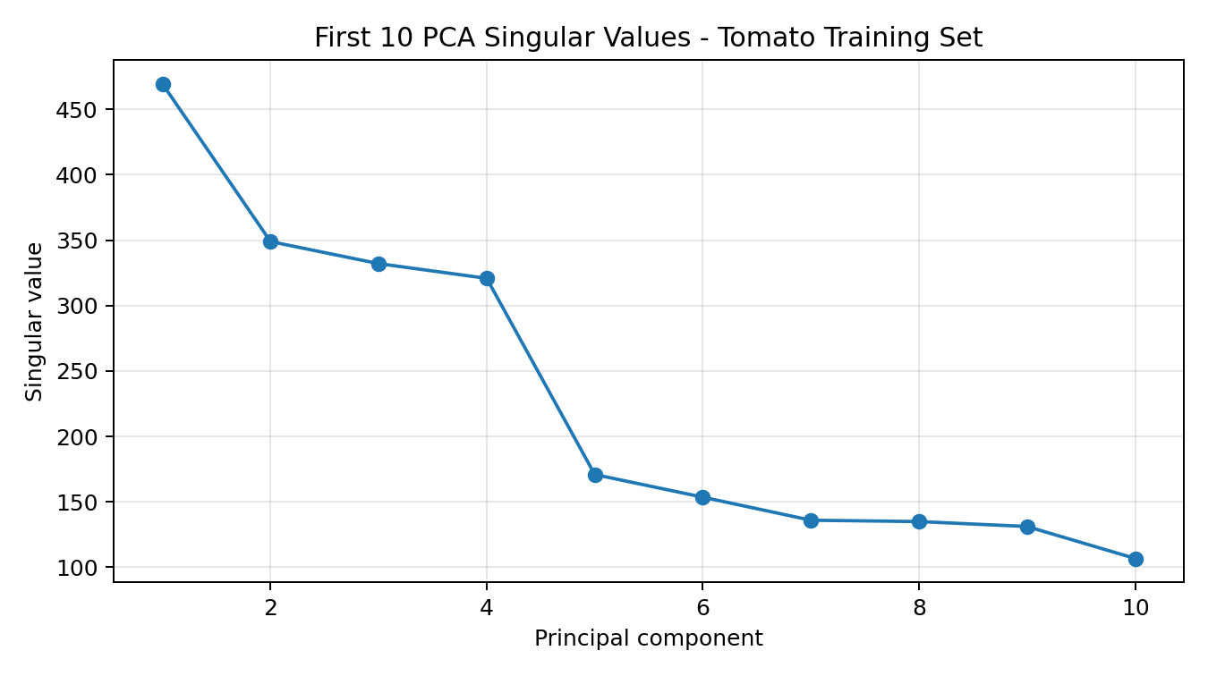
Figure 1. The first ten singular values from the tomato PCA run.
The first principal component accounts for 19.6600% of the variance, and the first ten account for 60.0481%. The first 256 components account for 89.0371%. The sharp fall in the spectrum indicates that variance is not evenly spread across all 4,096 pixel features; some directions contain much more variation than others.
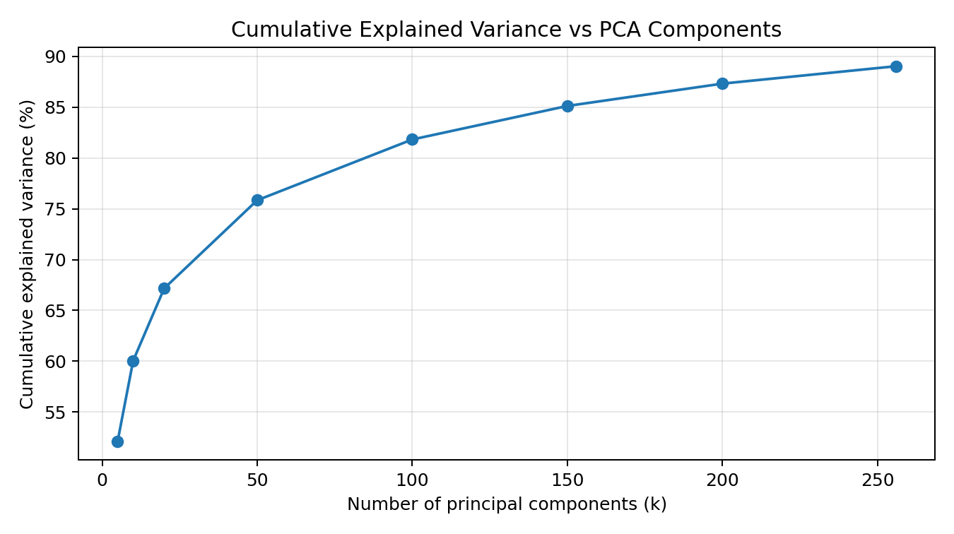
Figure 2. Cumulative explained variance for selected component counts.

2.2 Reconstruction-error trade-off
Relative reconstruction error E_k = ||X_c - Xhat_c^(k)||_F / ||X_c||_F
Components k | Explained variance (%) | Validation relative reconstruction error
5 | 52.1264 | 0.7058
10 | 60.0481 | 0.6483
20 | 67.1677 | 0.5885
50 | 75.8431 | 0.5063
100 | 81.8237 | 0.4433
150 | 85.1243 | 0.4036
200 | 87.3225 | 0.3748
256 | 89.0371 | 0.3510

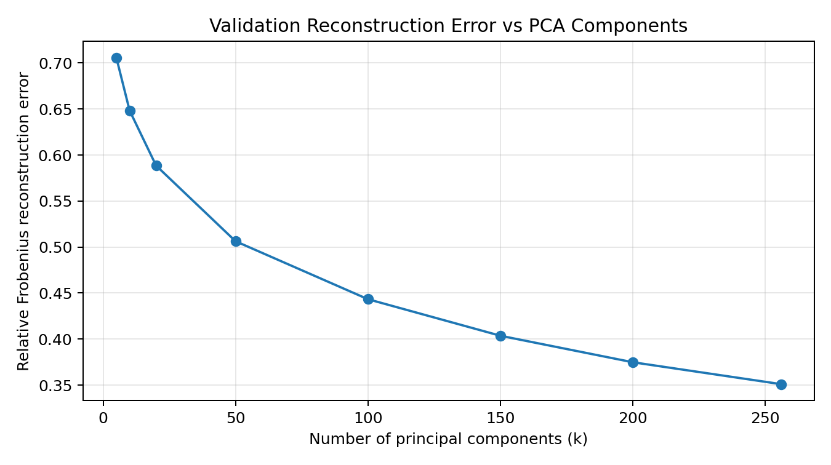
Figure 3. Reconstruction error decreases as more PCA components are retained.
At k = 100, 81.8237% of training variance is retained and the sampled validation reconstruction error is 0.4433. At k = 256, retained variance increases to 89.0371% and the error falls to 0.3510. There is no single best k on reconstruction error alone; Task 9 shows classification accuracy and resource costs also matter.
The 256-component PCA fit on the full 12,712-image tomato training matrix took 18.7822 s. PCA fitting time for 64 components on varying sizes was 2.7361 s (1,000 training images), 4.4388 s (5,000), 4.4004 s (10,000), and 5.7493 s (12,712). The general direction is an increase with dataset size, but timings are not strictly monotone because of runtime variability and algorithm overhead.

2.3 Hand-worked 2 x 2 eigendecomposition
The code extracted a covariance submatrix for pixel indices 2058 and 1994:
C = [[0.02932759, 0.02667736], [0.02667736, 0.02894818]]
For C = [[a,b],[b,d]], the characteristic equation is det(C - lambda I) = 0. Expanding gives lambda^2 - (a+d)lambda + (ad-b^2) = 0. Equivalently, the eigenvalues are:
lambda_(1,2) = ((a+d) +/- sqrt((a-d)^2 + 4b^2)) / 2
Substitution: a+d = 0.05827577; sqrt((a-d)^2 + 4b^2) approximately 0.0533560. Thus lambda_1 = 0.0558 and lambda_2 = 0.0025 to four decimal places. NumPy returned [0.0558, 0.0025].
The eigenvector matrix, with columns ordered by descending eigenvalue, was approximately Q = [[-0.7096, 0.7046], [-0.7046, -0.7096]]. The diagonal eigenvalue matrix was Lambda = [[0.0558, 0], [0, 0.0025]]. The reconstruction Q Lambda Q^T matched C, and the Frobenius reconstruction difference printed as 0.0000000000.
Meaning for AgriVision: this small subproblem demonstrates a dominant direction in the covariance of two selected pixels. It illustrates the mathematics of PCA; it is not enough by itself to justify the compression level for all 4,096 features.
Visual-component limitation: The Kaggle cell generated the leading-component image figure as pca_component_images.png. That rendered figure was not uploaded into this chat, so this report does not assign a specific visual meaning to individual PCs based only on numerical eigenvalues. Inspect the saved figure in Kaggle and add a visual interpretation before final submission.

Task 3 - Analyse uncertainty using probability and information theory (4 marks)

3.1 Class entropy
H(p) = - sum_i p_i log2(p_i)
The validation class distribution across the ten tomato classes has measured entropy H(p) = 3.0298 bits. The maximum entropy for ten classes is log2(10) = 3.3219 bits. Therefore the normalised entropy is 3.0298 / 3.3219 = 0.9120.
Meaning for AgriVision: there is substantial class uncertainty, but the classes are not perfectly balanced. The training distribution has a ratio of 14.3677 between the largest and smallest class shares, so class-specific metrics are important.

3.2 Cross-entropy and KL divergence
H(p,q) = - sum_i p_i log2(q_i)
D_KL(p || q) = sum_i p_i log2(p_i / q_i)
Model | Features | Marginal cross-entropy (bits) | KL(p||q) (bits) | KL(q||p) (bits) | Per-image CE (bits)
SGD log loss | Raw 4096 | 3.2309 | 0.2011 | 0.1989 | 5.2895
k-NN k=5 | Raw 4096 | 3.2528 | 0.2230 | 0.1952 | 13.8795
Decision tree | Raw 4096 | 3.0309 | 0.0010 | 0.0010 | 20.7338
SGD log loss | PCA-100 | 3.0409 | 0.0111 | 0.0110 | 2.3877
k-NN k=5 | PCA-100 | 3.1093 | 0.0795 | 0.0702 | 8.8623
Decision tree | PCA-100 | 3.0319 | 0.0021 | 0.0020 | 20.8248

In this experiment p is the empirical marginal validation class distribution and q is the mean predicted probability distribution across validation images. Thus these marginal quantities are different from per-image cross-entropy, which evaluates probability assigned to each individual true label.

3.3 Verify H(p,q) = H(p) + D_KL(p||q)
H(p,q) = H(p) + D_KL(p || q)
For raw-feature SGD: 3.0298 + 0.2011 = 3.2309 bits. For k-NN with PCA-100: 3.0298 + 0.0795 = 3.1093 bits. The identity-check gap reported by Python was 0.0000 for every configuration.
Meaning for AgriVision: the cross-entropy identity shows that, for a fixed true distribution p, minimising cross-entropy is equivalent to minimising D_KL(p||q), because H(p) does not depend on model predictions q.

3.4 KL asymmetry and interpretation
For k-NN with PCA-100, D_KL(p||q) = 0.0795 bits while D_KL(q||p) = 0.0702 bits. The values differ because each direction weights the logarithmic ratio differently. KL divergence is non-negative and is zero only when the compared distributions match on all classes with positive probability.
The raw decision tree has marginal KL divergence 0.0010 bits but validation accuracy 0.4170, while its per-image cross-entropy is 20.7338 bits. Its average predicted class frequencies look similar to the true marginal distribution, yet its individual predictions can be poorly calibrated or confidently wrong. Marginal distribution agreement must not be mistaken for classification quality.

Task 4 - Diagnose numerical computation issues (3 marks)

4.1 Naive softmax failure
softmax(z_i) = exp(z_i) / sum_j exp(z_j)
For z = [1000, 999, 995], the direct exponentials overflowed: NumPy returned [inf, inf, inf]. Dividing by the infinite sum produced [nan, nan, nan].

4.2 Stable softmax
m = max(z); softmax(z_i) = exp(z_i - m) / sum_j exp(z_j - m)
m = 1000 and z-m = [0, -1, -5]. The exponentials are [1.0000, 0.3679, 0.0067], with denominator 1.3746. The resulting probabilities are [0.7275, 0.2676, 0.0049] and their sum is 1.0000.
Subtracting the same m from every logit leaves the softmax unchanged because the common factor exp(-m) cancels in the numerator and denominator. It prevents overflow for this example.

4.3 Log-sum-exp and covariance conditioning
LSE(z) = m + ln(sum_j exp(z_j - m))
Using the stable exponentials, LSE(z) = 1000 + ln(1.3746) = 1000.3182.
Condition number: kappa_2(C) = lambda_max / lambda_min
For the retained 256-component PCA covariance subspace, lambda_max = 17.33952904 and lambda_min = 0.02197102. Therefore kappa_2(C) = 17.33952904 / 0.02197102 = 789.2001.
Meaning for AgriVision: a large condition number means directions have different scales/curvatures and can slow or destabilise gradient-based optimisation. Task 8 uses standardised PCA coordinates, so the condition number above is not a direct measurement of the standardised feature matrix used in that separate experiment.

Task 5 - Differentiate baseline learning strategies (4 marks)
Three distinct baseline algorithms were implemented: SGDClassifier with log loss (linear parametric model), k-nearest neighbours with k=5 (non-parametric, local-neighbour model), and a decision tree (tree-based partitioning model). Each was evaluated with raw 4,096 features and PCA-100 features.
Model | Representation | Accuracy | Macro-F1 | Fit time (s) | Validation prediction time (s)
SGD log loss | Raw 4096 | 0.3990 | 0.3549 | 213.6941 | 0.0255
k-NN k=5 | Raw 4096 | 0.4486 | 0.3644 | 0.0376 | 12.7039
Decision tree | Raw 4096 | 0.4170 | 0.3327 | 78.7767 | 0.0119
SGD log loss | PCA-100 | 0.4758 | 0.3456 | 3.7198 | 0.0082
k-NN k=5 | PCA-100 | 0.5683 | 0.4936 | 0.0030 | 0.4062
Decision tree | PCA-100 | 0.4244 | 0.3523 | 4.2239 | 0.0036

The raw-feature SGD run reached the maximum number of iterations and emitted a convergence warning. The metrics should therefore be interpreted as results for the specified training settings, not as proof that this implementation reached its best linear-model solution.
The linear model has a fixed coefficient matrix and a relatively small stored model. k-NN stores the training examples and uses distances at inference time; this is expensive in high-dimensional space. The decision tree learns a set of hierarchical feature splits and has a compact inference path, but its accuracy and Macro-F1 are lower than PCA-100 k-NN in this experiment.
PCA-100 improved accuracy for all three models. Macro-F1 improved for k-NN and the tree but fell slightly for SGD from 0.3549 to 0.3456, reinforcing that compression can affect classes differently.

Task 6 - Analyse capacity, overfitting and underfitting (4 marks)
The extra instructions specify a capacity plot for C1-C5, including training and validation error, underfitting, overfitting, optimal capacity and the generalisation gap. This plot is included here under the closest matching official requirement, Task 6.
Error rate E = 1 - accuracy; generalisation gap G = E_validation - E_training

Capacity | Tree depth | Training error | Validation error | Gap
C1 | 2 | 0.6573 | 0.6553 | -0.0020
C2 | 4 | 0.5753 | 0.5815 | 0.0062
C3 | 8 | 0.4541 | 0.5209 | 0.0668
C4 | 16 | 0.1340 | 0.5734 | 0.4394
C5 | 32 | 0.0944 | 0.5712 | 0.4768

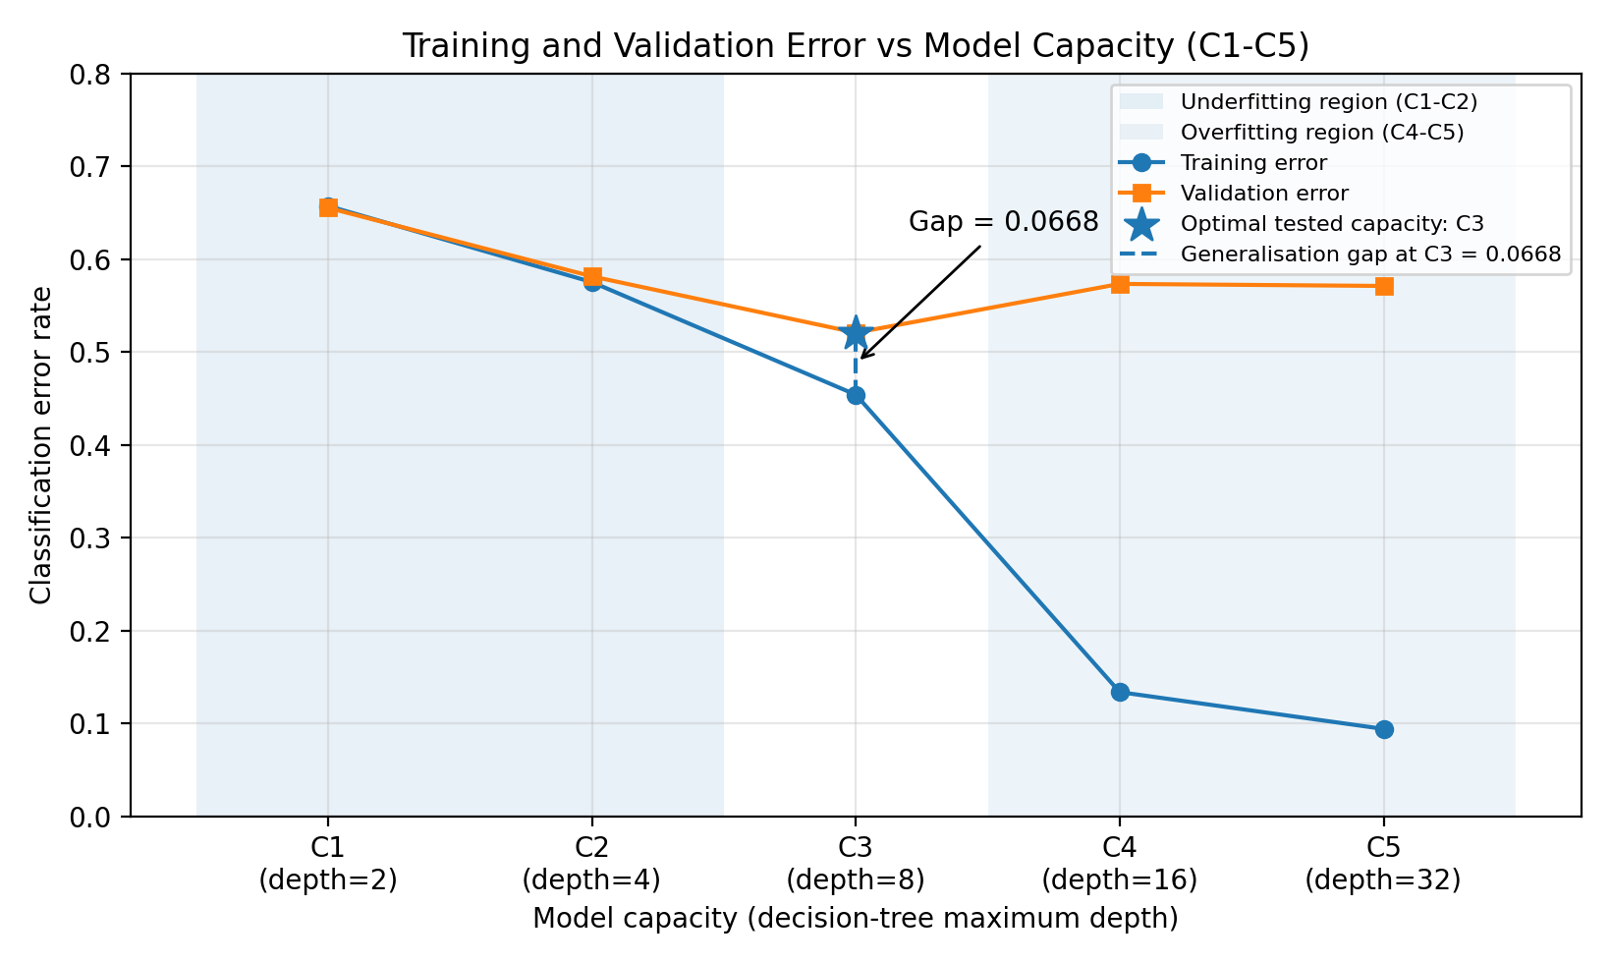
Figure 4. Required capacity curve: C1-C5, underfitting/overfitting regions, optimal tested capacity and generalisation gap.
C1 and C2 have high training and validation errors, which is consistent with underfitting. At C4 and C5, training error drops substantially while validation error remains high; the gaps are 0.4394 and 0.4768. C3 (depth 8) has the lowest validation error of the tested settings, 0.5209, so it is the optimal tested capacity, not a guaranteed global optimum.
Meaning for AgriVision: increasing tree depth can fit the training images more closely without improving unseen-image performance. The large gap at C5 indicates poor generalisation. Model selection should rely on validation data or cross-validation, not the test set, because repeated selection on the test set biases the reported test error.

Task 7 - Decompose error into bias and variance (4 marks)

7.1 Bootstrap experiment
Empirical multiclass Brier loss = mean_i sum_c (p_ic - y_ic)^2
Bias-squared proxy = mean_i sum_c (mean_b[p_bic] - y_ic)^2
Variance = mean_i sum_c Var_b(p_bic)
Model | Replicas | Squared-bias proxy | Variance | Mean Brier loss | Residual
Low capacity, depth 2 | 10 | 0.7851 | 0.0027 | 0.7878 | 0.0000
High capacity, depth 32 | 10 | 0.6166 | 0.5137 | 1.1303 | 0.0000

For depth 2: 0.7851 + 0.0027 = 0.7878. For depth 32: 0.6166 + 0.5137 = 1.1303. The residual reported by Python is approximately zero because the decomposition is defined from the same replicated probabilities and observed one-hot labels.
Interpretation: the deeper tree lowers the squared-bias proxy but has much greater prediction variance across bootstrap samples. The higher-capacity model is more sensitive to the data sample and has the larger mean Brier loss in this experiment.
Limitation: The empirical residual of zero does not mean irreducible label noise is zero. With one observed label per validation image, true conditional label noise cannot be isolated independently. This is stated explicitly because the assessment asks about bias-squared + variance + noise.

7.2 MLE versus MAP using Beta(2,2) prior
MLE: p_hat = s/n; MAP for Beta(alpha,beta): p_hat = (s + alpha - 1)/(n + alpha + beta - 2)
For the selected class Tomato Yellow Leaf Curl Virus, the chosen prior is Beta(2,2), so MAP = (s+1)/(n+2). At n=100, s=28: MLE = 28/100 = 0.2800; MAP = 29/102 = 0.2843.
n | Class count s | MLE | MAP Beta(2,2) | Absolute difference
100 | 28 | 0.2800 | 0.2843 | 0.0043
500 | 155 | 0.3100 | 0.3108 | 0.0008
1000 | 279 | 0.2790 | 0.2794 | 0.0004
5000 | 1451 | 0.2902 | 0.2903 | 0.0001
12712 | 3750 | 0.2950 | 0.2950 | 0.0000

Meaning for AgriVision: the Beta prior has a greater relative effect for small samples. As n grows, the MAP estimate approaches the MLE, and their difference rounds to zero at the full sample size.

Task 8 - Analyse gradient-based optimisation (4 marks)

8.1 Softmax-regression gradient derivation
Z = XW + b; p_ic = exp(z_ic) / sum_j exp(z_ij)
J(W,b) = -(1/N) sum_i sum_c y_ic ln(p_ic) + (lambda/2)||W||_F^2
For softmax with cross-entropy, the derivative of loss with respect to a logit is p_ic - y_ic. Applying the chain rule to Z = XW + b gives:
dJ/dW = X^T(P - Y)/N + lambda W
dJ/db = (1/N) sum_i (p_i - y_i)
The update is W_(t+1) = W_t - eta*dJ/dW and b_(t+1) = b_t - eta*dJ/db. These expressions are used in the from-scratch NumPy softmax-regression implementation. The experiment used standardised PCA-100 coordinates, regularisation lambda = 0.0001 and eight epochs.

8.2 Final losses and runtime
Strategy | Learning rate | Train loss (nats) | Validation loss (nats) | Gap
Batch GD | 0.0010 | 2.3011 | 2.3011 | 0.0000
Batch GD | 0.0100 | 2.2881 | 2.2880 | -0.0001
Batch GD | 0.1000 | 2.1673 | 2.1670 | -0.0003
SGD | 0.0010 | 1.5173 | 1.5219 | 0.0046
SGD | 0.0100 | 1.6821 | 1.6883 | 0.0063
SGD | 0.1000 | 6.3960 | 6.2345 | -0.1614
Mini-batch SGD | 0.0010 | 2.1680 | 2.1676 | -0.0004
Mini-batch SGD | 0.0100 | 1.6797 | 1.6756 | -0.0041
Mini-batch SGD | 0.1000 | 1.5187 | 1.5232 | 0.0045

Strategy | 8-epoch runtime (s) | Runtime per epoch (s)
Batch gradient descent | 7.3056 | 0.9132
Stochastic gradient descent | 18.2309 | 2.2789
Mini-batch SGD | 3.1803 | 0.3975

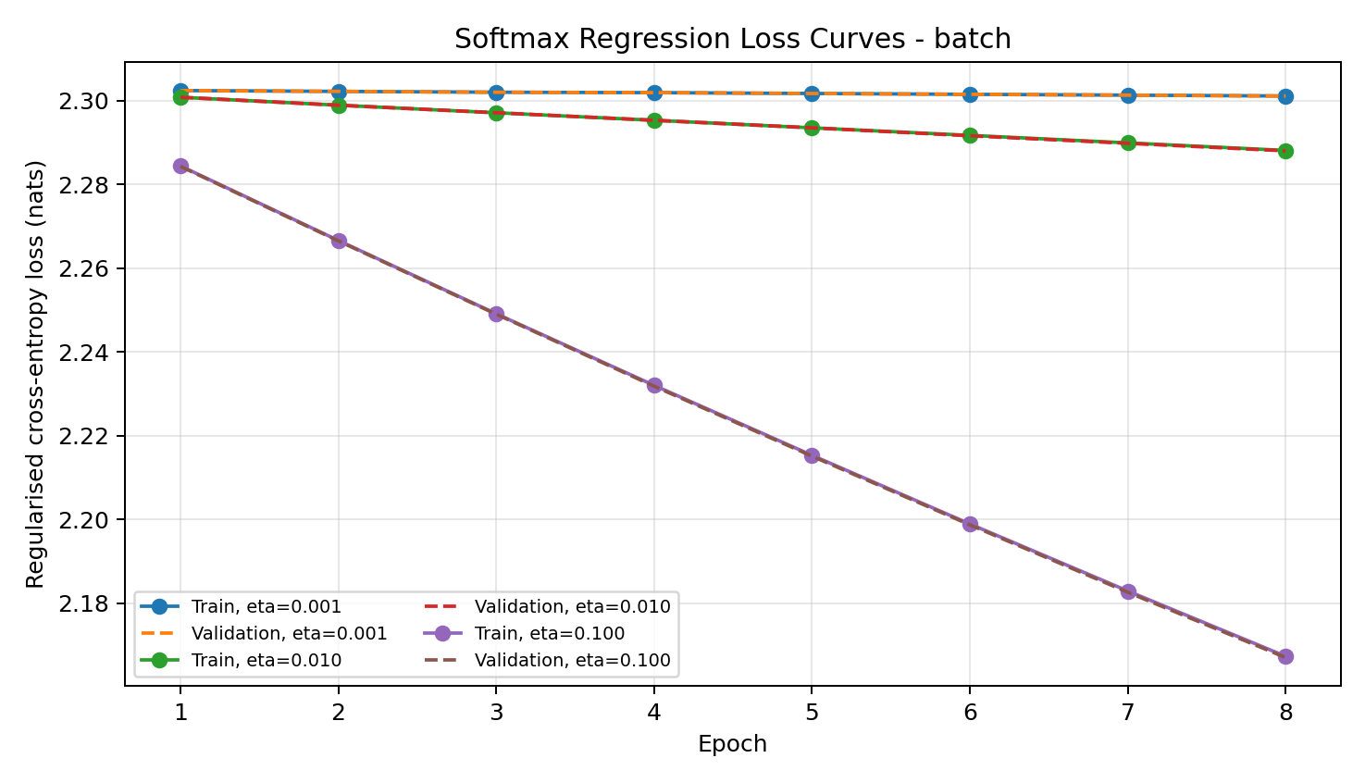
Figure 5. Batch gradient descent loss curves.
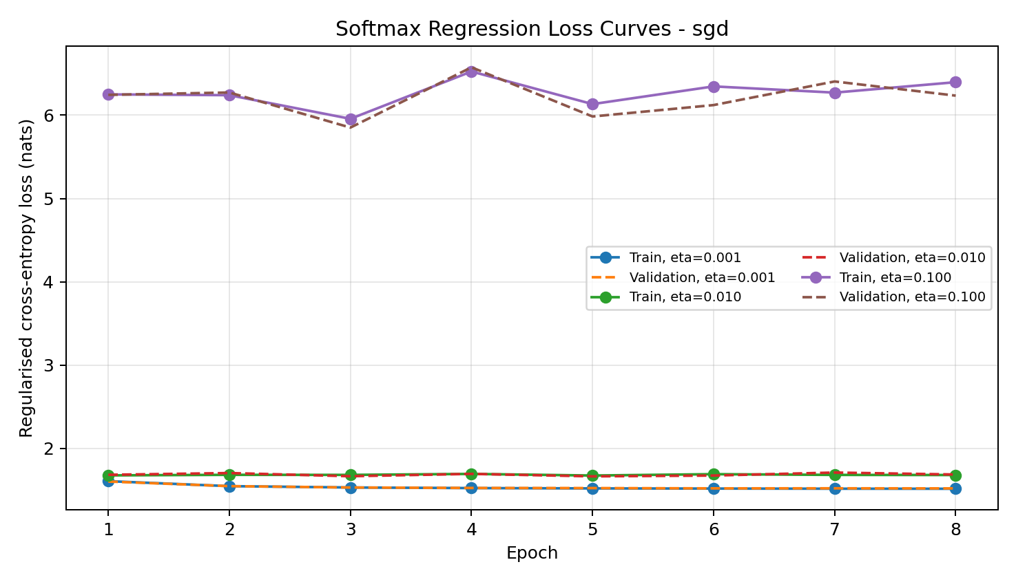
Figure 6. SGD loss curves; eta=0.1000 is visibly unstable in this run.
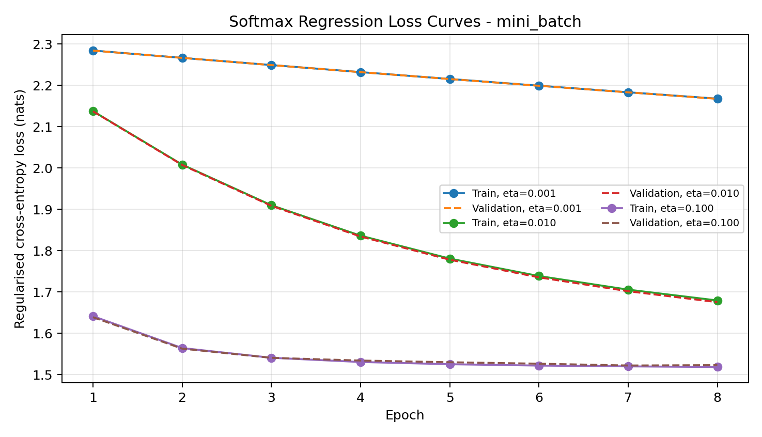
Figure 7. Mini-batch SGD loss curves.
SGD at eta=0.1000 fluctuates and ends with validation loss 6.2345, much worse than eta=0.0010. Mini-batch SGD reaches validation loss 1.5232 at eta=0.1000 in 3.1803 seconds for eight epochs. Batch GD is stable but changes slowly for small learning rates because this implementation makes one batch update per epoch.
The runtimes are measured per epoch for strategies with different numbers of updates; they are not an equal-update comparison. The observed behaviour is consistent with the need to tune learning rates and account for feature scaling/conditioning.Task 9 - Organise and examine experimental performance (3 marks)

9.1 Accuracy and macro-F1 across dataset scales
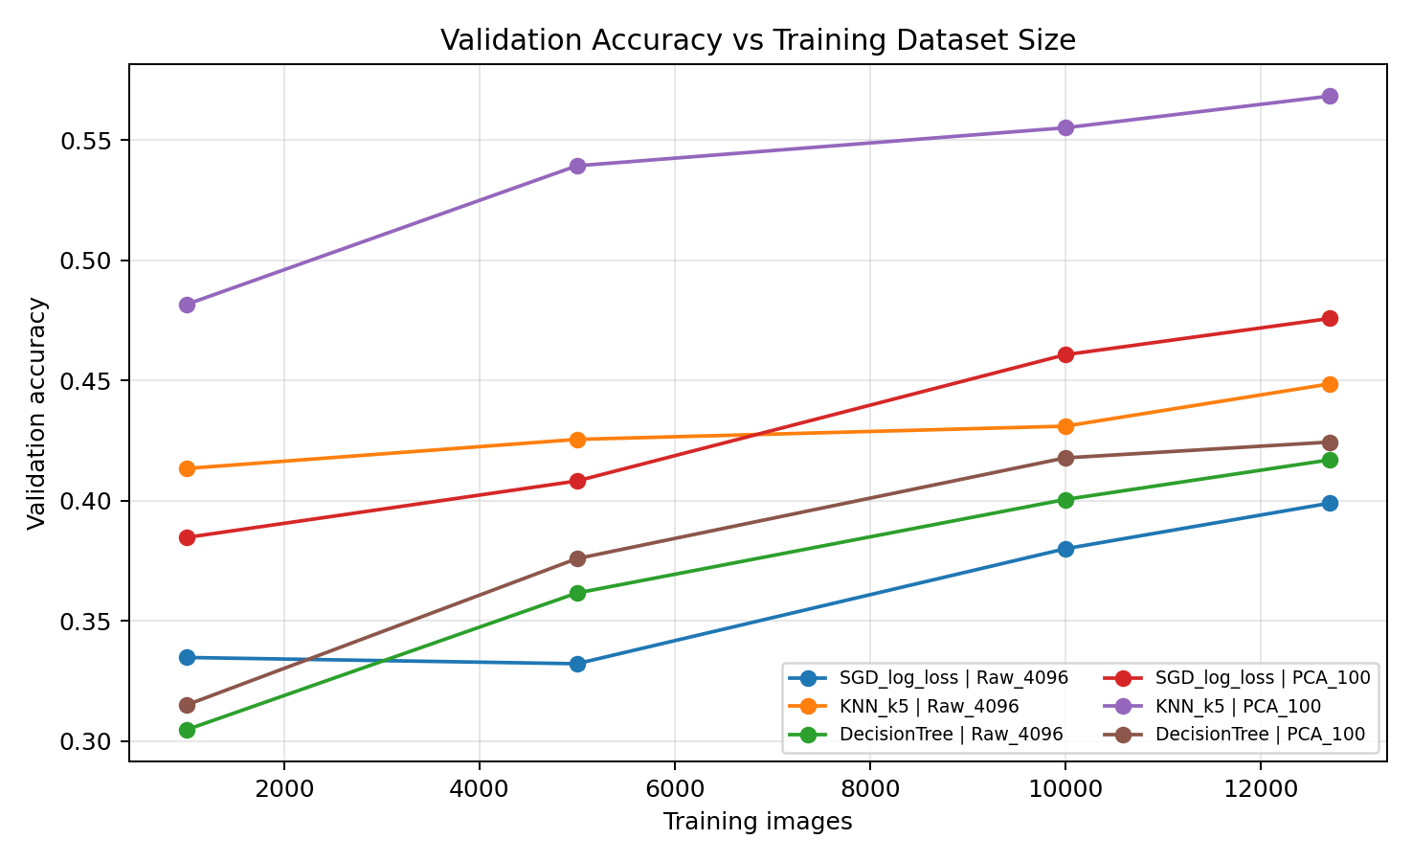
Figure 8. Validation accuracy for all models and dataset sizes.
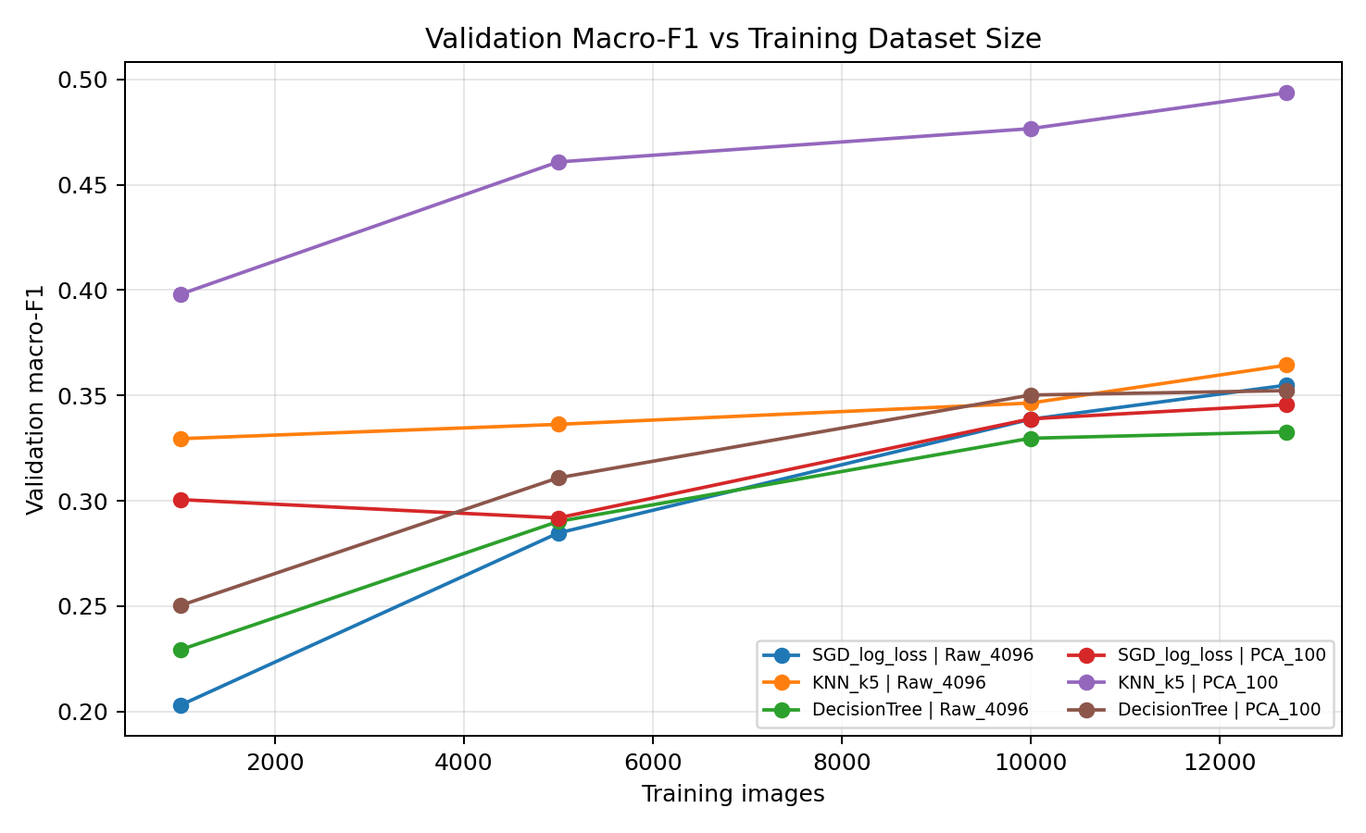
Figure 9. Validation macro-F1 for all models and dataset sizes.
For model size 12,712, k-NN with PCA-100 is best among the tested configurations at accuracy 0.5683 and macro-F1 0.4936. Its measured accuracy rises from 0.4816 at 1,000 training images to 0.5683 at 12,712. The other models also generally improve with more examples, although some metrics are not monotonic.

9.2 Raw-feature quality results
Training images | Model | Accuracy | Macro-F1
1000 | SGD log loss | 0.3348 | 0.2030
1000 | k-NN | 0.4134 | 0.3295
1000 | Decision tree | 0.3047 | 0.2293
5000 | SGD log loss | 0.3322 | 0.2847
5000 | k-NN | 0.4255 | 0.3363
5000 | Decision tree | 0.3616 | 0.2902
10000 | SGD log loss | 0.3800 | 0.3387
10000 | k-NN | 0.4310 | 0.3464
10000 | Decision tree | 0.4005 | 0.3297
12712 | SGD log loss | 0.3990 | 0.3549
12712 | k-NN | 0.4486 | 0.3644
12712 | Decision tree | 0.4170 | 0.3327

9.3 PCA-100 quality results
Training images | Model | Accuracy | Macro-F1
1000 | SGD log loss | 0.3847 | 0.3006
1000 | k-NN | 0.4816 | 0.3980
1000 | Decision tree | 0.3150 | 0.2503
5000 | SGD log loss | 0.4082 | 0.2919
5000 | k-NN | 0.5393 | 0.4608
5000 | Decision tree | 0.3759 | 0.3109
10000 | SGD log loss | 0.4607 | 0.3389
10000 | k-NN | 0.5551 | 0.4766
10000 | Decision tree | 0.4178 | 0.3502
12712 | SGD log loss | 0.4758 | 0.3456
12712 | k-NN | 0.5683 | 0.4936
12712 | Decision tree | 0.4244 | 0.3523

9.4 Full-scale cost and model-complexity measurements
The next two tables separate model quality from complexity because the count types differ between algorithms. All serialized sizes in these tables are decimal MB, computed as file bytes / 1,000,000.
n | Model | Fit s | Val predict s | Complexity count/type | Size MB
1000 | SGD | 13.5546 | 0.0164 | 40,970 coefficients | 0.1651
1000 | k-NN | 0.0030 | 0.9246 | 4,097,000 stored values | 16.3929
1000 | Tree | 5.2078 | 0.0073 | 387 nodes | 0.0571
5000 | SGD | 77.5224 | 0.0177 | 40,970 coefficients | 0.1651
5000 | k-NN | 0.0114 | 4.3628 | 20,485,000 stored values | 81.9609
5000 | Tree | 28.7363 | 0.0068 | 1,757 nodes | 0.2544
10000 | SGD | 164.5771 | 0.0936 | 40,970 coefficients | 0.1651
10000 | k-NN | 0.0613 | 21.9737 | 40,970,000 stored values | 163.9209
10000 | Tree | 63.6722 | 0.0082 | 3,105 nodes | 0.4485
12712 | SGD | 213.6941 | 0.0169 | 40,970 coefficients | 0.1651
12712 | k-NN | 0.0376 | 12.2001 | 52,081,064 stored values | 208.3760
12712 | Tree | 78.7767 | 0.0064 | 4,063 nodes | 0.5865

n | Model | Fit s | Val predict s | Complexity count/type | Size MB
1000 | SGD | 0.3211 | 0.0014 | 1,010 coefficients | 0.0053
1000 | k-NN | 0.0012 | 0.0347 | 101,000 stored values | 0.4089
1000 | Tree | 0.1639 | 0.0014 | 477 nodes | 0.0701
5000 | SGD | 1.9705 | 0.0038 | 1,010 coefficients | 0.0053
5000 | k-NN | 0.0018 | 0.2726 | 505,000 stored values | 2.0409
5000 | Tree | 1.6144 | 0.0015 | 2,021 nodes | 0.2924
10000 | SGD | 3.3236 | 0.0012 | 1,010 coefficients | 0.0053
10000 | k-NN | 0.0018 | 0.3006 | 1,010,000 stored values | 4.0809
10000 | Tree | 2.6363 | 0.0012 | 3,893 nodes | 0.5620
12712 | SGD | 3.7198 | 0.0012 | 1,010 coefficients | 0.0053
12712 | k-NN | 0.0030 | 0.3923 | 1,283,912 stored values | 5.1874
12712 | Tree | 4.2239 | 0.0012 | 4,889 nodes | 0.7054

The counts are algorithm-specific proxies, not directly comparable parameter counts: SGD counts learned coefficients and intercepts; the tree counts nodes; k-NN counts stored feature values and labels. k-NN inference time and storage rise with the number of training examples. PCA-100 k-NN at full size stores about 5.1874 decimal MB, slightly above the 5 MB target, while its PCA transformation has a separate cost.

9.5 Confusion matrix and class-level behaviour
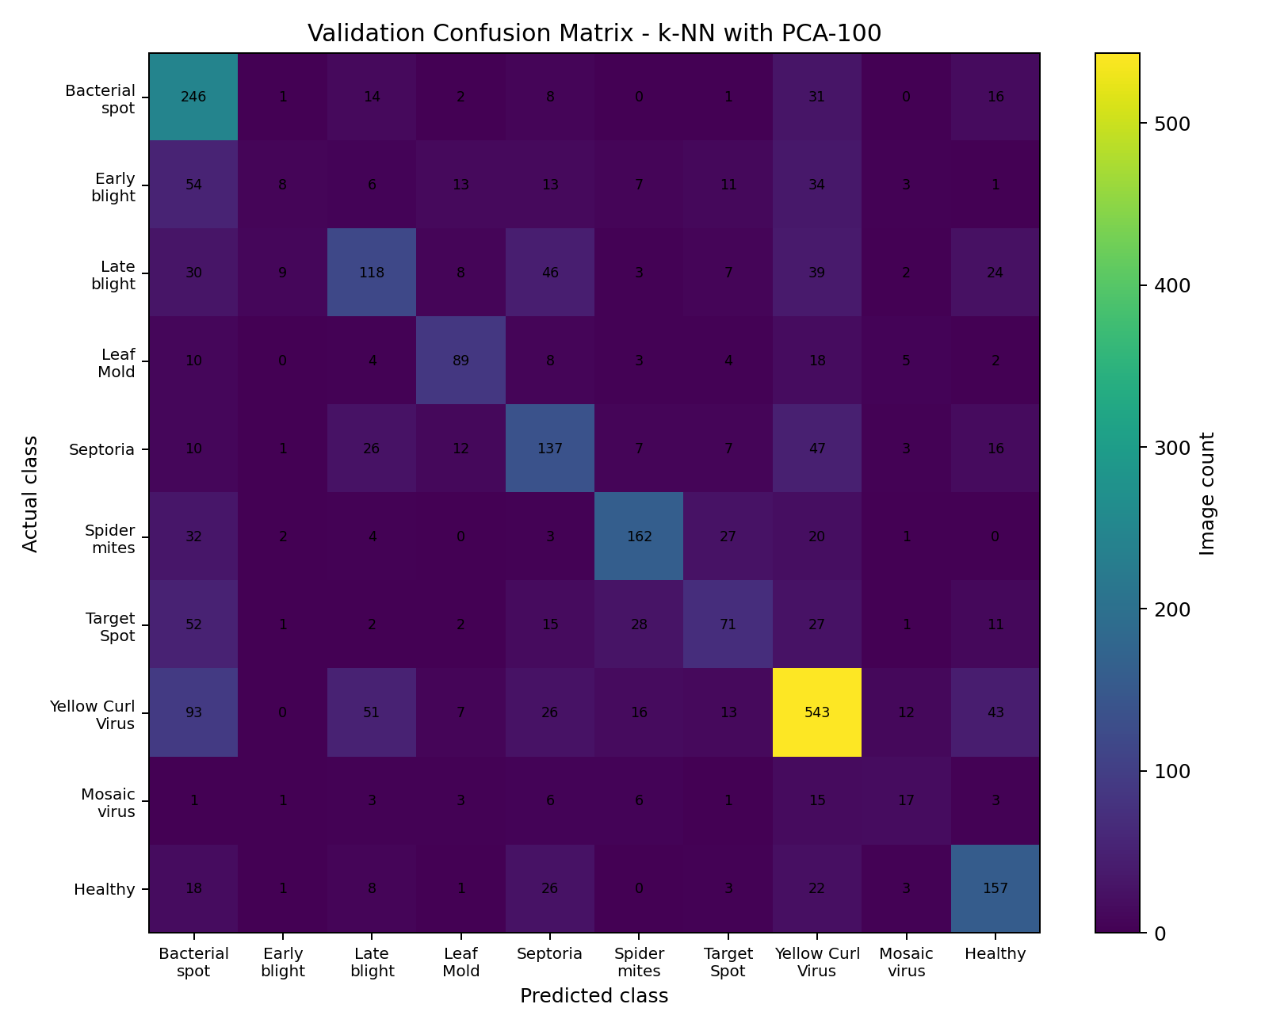
Figure 10. Confusion matrix for k-NN with PCA-100 on the 2,724-image tomato validation set.
Actual class | Predicted class | Count
Yellow Leaf Curl Virus | Bacterial Spot | 93
Early Blight | Bacterial Spot | 54
Target Spot | Bacterial Spot | 52
Yellow Leaf Curl Virus | Late Blight | 51
Septoria Leaf Spot | Yellow Leaf Curl Virus | 47
Late Blight | Septoria Leaf Spot | 46
Yellow Leaf Curl Virus | Healthy | 43
Late Blight | Yellow Leaf Curl Virus | 39
Early Blight | Yellow Leaf Curl Virus | 34
Spider Mites | Bacterial Spot | 32

Class | Precision | Recall | F1 | Support
Early Blight | 0.3333 | 0.0533 | 0.0920 | 150
Tomato Mosaic Virus | 0.3617 | 0.3036 | 0.3301 | 56
Target Spot | 0.4897 | 0.3381 | 0.4000 | 210
Late Blight | 0.5000 | 0.4126 | 0.4521 | 286
Septoria Leaf Spot | 0.4757 | 0.5150 | 0.4946 | 266
Leaf Mold | 0.6496 | 0.6224 | 0.6357 | 143
Spider Mites | 0.6983 | 0.6454 | 0.6708 | 251
Healthy | 0.5751 | 0.6569 | 0.6133 | 239
Yellow Leaf Curl Virus | 0.6822 | 0.6754 | 0.6788 | 804
Bacterial Spot | 0.4505 | 0.7712 | 0.5688 | 319

The most serious class-level weakness is Early Blight recall: 8 of 150 Early Blight validation images are correct, giving 8 / 150 = 0.0533. Only 8 of 24 images predicted as Early Blight are correct, giving precision 8 / 24 = 0.3333. This is why accuracy alone is inadequate for disease screening.

Task 10 - Compare theoretical expectations with experimental behaviour (3 marks)
Expectation | Measured evidence | Interpretation
Variance retained does not determine class accuracy exactly | PCA-100 retains 81.8237% variance for the tomato training set; k-NN accuracy rises from 0.4486 raw to 0.5683 after PCA | PCA retains variance, not necessarily class-discriminative information; classification must be measured directly
Model conditioning and learning rates influence convergence | PCA-256 covariance condition number 789.2001; SGD at eta=0.1000 gave validation loss 6.2345 with fluctuations | Optimisation is sensitive to step size; Task 8 standardised its PCA coordinates, so it is not a direct unstandardised conditioning test
High capacity can increase variance and generalisation gap | Depth-32 tree gap 0.4768; bootstrap variance 0.5137 versus 0.0027 at depth 2 | Both experiments indicate high-capacity tree predictions are more sensitive to training-sample choice
A model can match marginal class frequencies without good predictions | Raw decision tree KL(p||q)=0.0010 but accuracy 0.4170 and per-image CE=20.7338 | Marginal probability distribution comparisons do not replace per-example loss and classification metrics

Overall, theory and experiments broadly agree, but they answer different questions. Reconstruction variance concerns image variation; classification accuracy concerns separation of labels; covariance conditioning concerns optimisation geometry; and bias-variance experiments concern sensitivity to the sampled training data.

Task 11 - Analyse whether deep learning is justified (4 marks)

11.1 High dimensionality and classical-model limitations
Samples per raw feature = N / d = 12712 / 4096 = 3.1035
The raw training matrix has only 3.1035 training samples per input feature. This illustrates the high-dimensional setting in which distance-based models can struggle to find useful neighbours and linear models may not capture complex image patterns.
PCA-100 reduces the representation by 97.5586% and improves k-NN accuracy by 0.1197 (11.9700 percentage points), yet the best baseline reaches only 0.5683 accuracy and 0.4936 macro-F1. Early Blight recall is 0.0533. Thus, the best tuned baseline still has a class-specific failure that matters for a screening application.

11.2 Local constancy, smoothness and manifold structure
k-NN follows a local-constancy assumption: nearby feature vectors should share labels. PCA-100 improved its result, suggesting that the lower-dimensional metric space is more useful for this model on this dataset. Nevertheless, flattening loses the explicit 2-D pixel arrangement, and PCA captures linear directions rather than learned nonlinear image features. Disease patterns may depend on spots, texture, edges and spatial relationships across the leaf.
A compact convolutional neural network could learn local features and combine them into higher-level patterns. This is a reason to test deep learning against the current baselines. No CNN was trained in the recorded experiments, so the report does not claim that deep learning has already achieved higher accuracy. The evidence justifies a controlled CNN experiment, not a direct claim of superiority.

11.3 Trade-offs
Classical models are easier to inspect and some are small, but the current results are weak. Deep learning may learn richer image representations but usually requires additional training and deployment work. The next comparison should use the same fixed split, report macro-F1 and per-class recall, and measure actual deployment size and single-image latency.

Task 12 - Analyse the impact of changed requirements (8 marks)

A. Impact analysis (2 marks)
The problem changes from 10 tomato classes to 38 crop-disease classes and introduces 20% noisy training labels. The 38-class training split contains 38,013 images, validation contains 8,146 and test contains 8,146. The dataset was converted to 64 x 64 grayscale (4,096 features), and PCA-100 retained 85.2584% of training variance.
Maximum entropy for K classes: H_max = log2(K)
For K = 38, H_max = log2(38) = 5.2479 bits. Measured class entropy is 4.8249 bits for training and 4.8252 bits for validation; each has normalised entropy 0.9194. The most common validation class is Orange___Haunglongbing_(Citrus_greening), with 826 of 8,146 images, so the majority baseline accuracy is 0.1014.
The noise generator changed 7,603 of 38,013 training labels, giving a measured noise fraction of 20.0011%. Validation and test labels were unchanged. The class distribution entropy and majority baseline depend on the label distribution, but sensitivity/specificity concepts from binary classification are not the metric used for this 38-class experiment.

B. Re-examination of the original conclusion (2 marks)
Configuration | Validation accuracy | Validation macro-F1 | Saved pipeline MB | Kaggle p95 latency (ms)
SGD log loss, clean, PCA-100 | 0.3712 | 0.2645 | 1.5524 | 0.5641
SGD log loss, noisy, PCA-100 | 0.3520 | 0.2344 | 1.5522 | 0.3858
Modified Huber, noisy, PCA-100 | 0.2615 | 0.1582 | 1.5522 | 0.3984
Modified Huber, noisy, PCA-64 | 0.2701 | 0.1556 | 0.9986 | 0.5357
k-NN, noisy, PCA-100 | 0.3679 | 0.2510 | 15.7618 | 11.5936

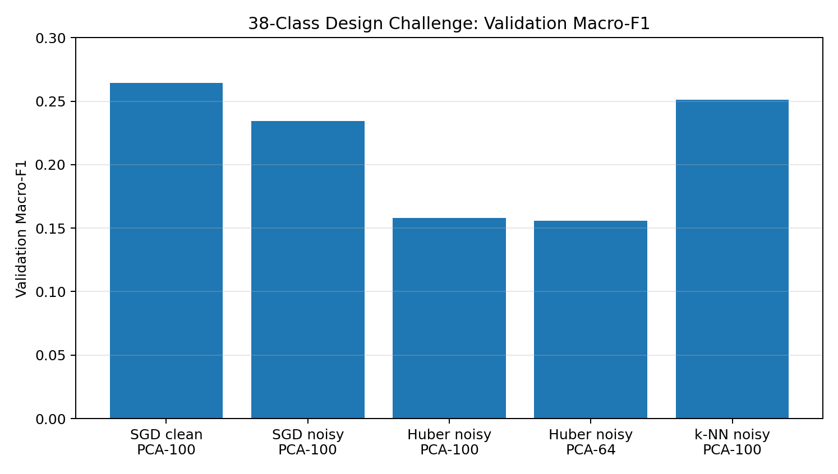
Figure 11. Validation Macro-F1 for the five 38-class configurations.
The noisy SGD model loses 0.3712 - 0.3520 = 0.0192 accuracy after the training labels are corrupted, and macro-F1 falls from 0.2645 to 0.2344. Four SGD configurations fit the measured artifact-size and Kaggle p95 proxies; k-NN exceeds the 5 MB file-size proxy at 15.7618 MB. However, these are saved-file size and Kaggle latency proxies, not proof of target-phone RAM or latency.

C. Adaptation options (2 marks)
Option 1 - modified Huber loss: for PCA-100 with noisy labels, validation accuracy is 0.2615 compared with 0.3520 for log-loss SGD, a difference of -0.0905. Macro-F1 also falls from 0.2344 to 0.1582. The selected modified-Huber configuration did not help in this experiment.
Option 2 - reduce PCA dimension to 64: the modified-Huber artifact falls from 1.5522 MB at 100 components to 0.9986 MB at 64 components. The relative saved-file reduction is (1.5522 - 0.9986) / 1.5522 x 100 = 35.6640%. Macro-F1 is 0.1556 for PCA-64, slightly lower than 0.1582 for PCA-100, so this smaller setting saves space but did not improve class-balanced performance.
Option 3 - replace k-NN with a linear classifier for deployment: k-NN has better validation accuracy than noisy SGD (0.3679 vs 0.3520) but its saved pipeline is 15.7618 MB, above the 5 MB target. Noisy SGD is much smaller and faster in the Kaggle proxy, but its predictive performance remains inadequate.
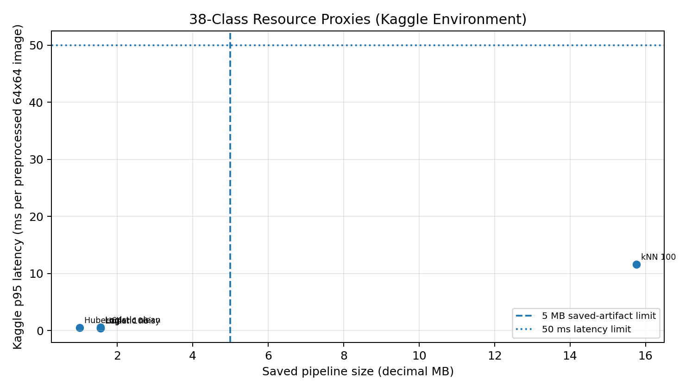
Figure 12. Saved pipeline size and Kaggle p95 latency proxy; phone performance must be measured separately.

D. Evidence-based conclusion (2 marks)
The selected noisy-label configuration is SGD with log loss and PCA-100, chosen as the highest validation Macro-F1 among the tested noisy-label configurations that met both measured proxies. Its validation accuracy is 0.3520 and Macro-F1 is 0.2344. The held-out test accuracy is 0.3451 and test Macro-F1 is 0.2266. The saved pipeline is 1.5522 decimal MB, and its p95 timing proxy is 0.3858 ms per already-resized 64 x 64 image in Kaggle.
Final Task 12 decision: redesign before deployment. The measurements support the storage and timing proxy of the selected compact SGD pipeline, but classification quality is too low for dependable screening, and the optimiser reported convergence warnings. The next iteration should address label quality, train to convergence, evaluate compact learned image features (including a small CNN), then benchmark complete end-to-end inference and peak memory on a representative low-cost smartphone. Because that device benchmark was not performed here, the 50 ms / 5 MB requirement is not yet conclusively verified.

Overall conclusion and remaining limitations
The experiments show that representation, optimisation, capacity and class distribution materially affect crop-disease classification. PCA-100 substantially reduces feature count and improves the tested k-NN baseline; nonetheless, class-level errors and low macro-F1 remain. The high-capacity decision tree overfits in the tested settings, and the bootstrap experiment shows much greater variance for the depth-32 tree. The 38-class label-noise experiment further reduces the quality of a compact SGD model.
The evidence supports a redesign rather than deployment of the current system. Two limitations must be carried into any final submission: (1) several SGD fits reached their iteration limit, so these comparisons should be rerun with convergence addressed; and (2) target-smartphone latency and peak memory were not measured. Also, the PCA component-image figure should be inspected in Kaggle so its visual interpretation can be completed accurately. No CNN benchmark was performed, so deep learning is a justified next experiment rather than a proven winner in this report.
Appendix A - Captured Kaggle output records
The following records summarise key printed values from the Kaggle cells shared during the assessment workflow. They are included to preserve the calculation evidence next to the reproducibility code. Runtimes may vary when cells are rerun.

A1. Dataset and preprocessing outputs
TOTAL DATASET: classes=38; images=54305
TOMATO EXPERIMENT: classes=10; images=18160
tomato_train=(12712,4096); tomato_val=(2724,4096); tomato_test=(2724,4096)
38-class train=(38013,4096); validation=(8146,4096); test=(8146,4096)
One image=(64,64); flattened image=(4096,); batch of 32=(32,4096)
First image norms: L1=1631.4549; L2=27.6263; Linfinity=0.6824
NumPy norm verification passed for all three norms.

A2. PCA outputs
k | Explained variance (%) | Relative reconstruction error
5 | 52.1264 | 0.7058
10 | 60.0481 | 0.6483
20 | 67.1677 | 0.5885
50 | 75.8431 | 0.5063
100 | 81.8237 | 0.4433
150 | 85.1243 | 0.4036
200 | 87.3225 | 0.3748
256 | 89.0371 | 0.3510

2x2 covariance C=[[0.02932759,0.02667736],[0.02667736,0.02894818]]
Manual eigenvalues: lambda_1=0.0558; lambda_2=0.0025
Eigenvectors (columns): [[-0.7096,0.7046],[-0.7046,-0.7096]]
Frobenius decomposition error: 0.0000000000; NumPy verification passed.
PCA 64-component fit times (s): n=1000:2.7361; n=5000:4.4388; n=10000:4.4004; n=12712:5.7493

A3. Numerical stability output
Logits: [1000.0, 999.0, 995.0]
Naive exponentials: [inf, inf, inf]; naive probabilities: [nan, nan, nan]
Stable shifted logits: [0.0, -1.0, -5.0]
Stable probabilities: [0.7275, 0.2676, 0.0049]; sum=1.0000
Stable log-sum-exp=1000.3182; retained PCA-256 condition number=789.2001

A4. Capacity / bootstrap / MLE-MAP output
Capacity | Depth | Train error | Validation error | Gap
C1 | 2 | 0.6573 | 0.6553 | -0.0020
C2 | 4 | 0.5753 | 0.5815 | 0.0062
C3 | 8 | 0.4541 | 0.5209 | 0.0668
C4 | 16 | 0.1340 | 0.5734 | 0.4394
C5 | 32 | 0.0944 | 0.5712 | 0.4768

Model | Bias-squared proxy | Variance | Mean Brier loss
Depth 2 | 0.7851 | 0.0027 | 0.7878
Depth 32 | 0.6166 | 0.5137 | 1.1303

n | s | MLE | MAP Beta(2,2) | Absolute difference
100 | 28 | 0.2800 | 0.2843 | 0.0043
500 | 155 | 0.3100 | 0.3108 | 0.0008
1000 | 279 | 0.2790 | 0.2794 | 0.0004
5000 | 1451 | 0.2902 | 0.2903 | 0.0001
12712 | 3750 | 0.2950 | 0.2950 | 0.0000

A5. Optimisation final output
Strategy | eta | Train loss | Validation loss | Gap
Batch | 0.0010 | 2.3011 | 2.3011 | 0.0000
Batch | 0.0100 | 2.2881 | 2.2880 | -0.0001
Batch | 0.1000 | 2.1673 | 2.1670 | -0.0003
SGD | 0.0010 | 1.5173 | 1.5219 | 0.0046
SGD | 0.0100 | 1.6821 | 1.6883 | 0.0063
SGD | 0.1000 | 6.3960 | 6.2345 | -0.1614
Mini-batch | 0.0010 | 2.1680 | 2.1676 | -0.0004
Mini-batch | 0.0100 | 1.6797 | 1.6756 | -0.0041
Mini-batch | 0.1000 | 1.5187 | 1.5232 | 0.0045

A6. Task 12 output
38-class training entropy=4.8249 bits; validation entropy=4.8252 bits; max entropy=5.2479 bits.
Normalised entropy=0.9194; majority class Orange___Haunglongbing_(Citrus_greening).
Majority baseline accuracy=0.1014 for training and validation.
Noisy training labels changed=7603/38013; measured noise rate=20.0011%.
PCA100 cumulative explained variance=85.2584%.
Selected noisy-label SGD log-loss PCA100: validation accuracy=0.3520; validation macro-F1=0.2344.
Selected held-out test accuracy=0.3451; test macro-F1=0.2266.
Saved pipeline size=1.5522 decimal MB; Kaggle p95 latency proxy=0.3858 ms per already-resized image.
Models emitted convergence warnings when maximum iteration count was reached.

Appendix B - Consolidated reproducibility code
The code listing below consolidates the main preprocessing, verification and experimental cells into one Kaggle-oriented source file. It expects the PlantVillage dataset to be attached at the path shown in the code or the processed arrays saved under /kaggle/working/agriVision. Captured outputs from the user-executed cells are recorded in Appendix A. The code has been syntax-checked locally but has not been rerun against the Kaggle dataset in this authoring environment.
Source listing: AgriVision_Assessment1_Code.py (618 lines).
0001 # CSA47 Deep Learning - CO1 Assessment 1 (AgriVision)
0002 # Consolidated reproducibility code for Kaggle Notebooks.
0003 #
0004 # Prerequisites:
0005 # 1. Attach the PlantVillage dataset in Kaggle.
0006 # 2. Run the dataset-manifest, split and preprocessing cells from the workflow,
0007 # or create the required arrays in /kaggle/working/agriVision.
0008 # 3. Set OUT to the directory containing those arrays.
0009 #
0010 # Outputs reported in the accompanying assessment report are captured from the
0011 # user's Kaggle execution. Timing values may vary on rerun and should not be
0012 # expected to match exactly across notebook sessions or hardware.
0013
0014 from pathlib import Path
0015 from time import perf_counter, perf_counter_ns
0016 import json
0017 import gc
0018 import warnings
0019
0020 import numpy as np
0021 import pandas as pd
0022 import matplotlib.pyplot as plt
0023 import joblib
0024
0025 from sklearn.decomposition import PCA
0026 from sklearn.model_selection import train_test_split
0027 from sklearn.preprocessing import StandardScaler
0028 from sklearn.linear_model import SGDClassifier
0029 from sklearn.neighbors import KNeighborsClassifier
0030 from sklearn.tree import DecisionTreeClassifier
0031 from sklearn.metrics import (
0032 accuracy_score, precision_recall_fscore_support,
0033 confusion_matrix, f1_score
0034 )
0035 from sklearn.exceptions import ConvergenceWarning
0036
0037 OUT = Path('/kaggle/working/agriVision')
0038 OUT.mkdir(parents=True, exist_ok=True)
0039 IMAGE_EXTENSIONS = {'.jpg', '.jpeg', '.png', '.bmp'}
0040 RANDOM_STATE = 42
0041
0042 # %% [markdown]
0043 # DATASET MANIFEST AND PREPROCESSING
0044 # This cell is needed if the manifests / processed arrays do not already exist.
0045
0046 # %%
0047 DATA_ROOT = Path('/kaggle/input/plantvillage-dataset/plantvillage dataset')
0048 COLOR_DIR = DATA_ROOT / 'color'
0049
0050 if COLOR_DIR.is_dir():
0051 records = []
0052 for class_dir in sorted(COLOR_DIR.iterdir()):
0053 if not class_dir.is_dir():
0054 continue
0055 for image_path in class_dir.iterdir():
0056 if image_path.is_file() and image_path.suffix.lower() in IMAGE_EXTENSIONS:
0057 records.append({
0058 'path': str(image_path),
0059 'label': class_dir.name,
0060 'crop_group': 'tomato' if class_dir.name.startswith('Tomato___') else 'other'
0061 })
0062 manifest = pd.DataFrame(records)
0063 if manifest.empty:
0064 raise ValueError('No color image files were found.')
0065 manifest.to_csv(OUT / 'manifest_all38.csv', index=False)
0066 tomato_df = manifest[manifest['crop_group'] == 'tomato'].reset_index(drop=True)
0067 all38_df = manifest.reset_index(drop=True)
0068 print('Color dataset classes:', manifest['label'].nunique())

0069 print('Color dataset images:', len(manifest))
0070 print('Tomato images:', len(tomato_df))
0071 else:
0072 print('Color source folder not found. Reuse existing saved arrays if available.')
0073
0074 # 70/15/15 stratified splits. This is an experimental choice, not a prescribed
0075 # split in the assessment.
0076 def make_splits(frame, seed=RANDOM_STATE):
0077 train_val, test = train_test_split(
0078 frame, test_size=0.15, random_state=seed, stratify=frame['label']
0079 )
0080 train, val = train_test_split(
0081 train_val, test_size=(0.15 / 0.85), random_state=seed + 1,
0082 stratify=train_val['label']
0083 )
0084 return tuple(x.reset_index(drop=True) for x in (train, val, test))
0085
0086
0087 def preprocess_frame(frame, label_to_id, split_name, size=(64, 64)):
0088 from PIL import Image
0089 from tqdm.auto import tqdm
0090 X = np.empty((len(frame), size[0] * size[1]), dtype=np.uint8)
0091 y = np.empty(len(frame), dtype=np.int64)
0092 for i, row in enumerate(tqdm(frame.itertuples(index=False), total=len(frame), desc=split_name)):
0093 try:
0094 with Image.open(row.path) as im:
0095 gray = im.convert('L').resize(size, Image.Resampling.LANCZOS)
0096 X[i] = np.asarray(gray, dtype=np.uint8).reshape(-1)
0097 y[i] = label_to_id[row.label]
0098 except Exception as exc:
0099 raise RuntimeError(f'Failed image: {row.path}') from exc
0100 return X, y
0101
0102 # If the arrays already exist, do not rebuild unnecessarily.
0103 required_tomato = [
0104 'X_train_uint8.npy', 'y_train.npy', 'X_val_uint8.npy', 'y_val.npy',
0105 'X_test_uint8.npy', 'y_test.npy', 'tomato_class_names.json'
0106 ]
0107 if not all((OUT / f).is_file() for f in required_tomato) and 'tomato_df' in globals():
0108 tomato_train, tomato_val, tomato_test = make_splits(tomato_df)
0109 tomato_class_names = sorted(tomato_df['label'].unique())
0110 tomato_label_to_id = {name: i for i, name in enumerate(tomato_class_names)}
0111 for split_name, frame in [('train', tomato_train), ('val', tomato_val), ('test', tomato_test)]:
0112 X, y = preprocess_frame(frame, tomato_label_to_id, f'tomato_{split_name}')
0113 np.save(OUT / f'X_{split_name}_uint8.npy', X)
0114 np.save(OUT / f'y_{split_name}.npy', y)
0115 with open(OUT / 'tomato_class_names.json', 'w', encoding='utf-8') as f:
0116 json.dump(tomato_class_names, f, indent=2)
0117
0118 # Build 38-class arrays when they are not already saved.
0119 required_38 = [
0120 'X38_train_uint8.npy', 'y38_train.npy', 'X38_val_uint8.npy',
0121 'y38_val.npy', 'X38_test_uint8.npy', 'y38_test.npy',
0122 'all38_class_names.json'
0123 ]
0124 if not all((OUT / f).is_file() for f in required_38) and 'all38_df' in globals():
0125 all38_train, all38_val, all38_test = make_splits(all38_df)
0126 class_names_38 = sorted(all38_df['label'].unique())
0127 label_to_id_38 = {name: i for i, name in enumerate(class_names_38)}
0128 for split_name, frame in [('train', all38_train), ('val', all38_val), ('test', all38_test)]:
0129 X, y = preprocess_frame(frame, label_to_id_38, f'all38_{split_name}')
0130 np.save(OUT / f'X38_{split_name}_uint8.npy', X)
0131 np.save(OUT / f'y38_{split_name}.npy', y)
0132 with open(OUT / 'all38_class_names.json', 'w', encoding='utf-8') as f:
0133 json.dump(class_names_38, f, indent=2)
0134
0135 # %% [markdown]
0136 # TASK 1 - REPRESENTATION AND NORMS

0137
0138 # %%
0139 X_train_u8 = np.load(OUT / 'X_train_uint8.npy')
0140 y_train = np.load(OUT / 'y_train.npy')
0141 y_val = np.load(OUT / 'y_val.npy')
0142 y_test = np.load(OUT / 'y_test.npy')
0143 with open(OUT / 'tomato_class_names.json', encoding='utf-8') as f:
0144 tomato_class_names = json.load(f)
0145
0146 x = X_train_u8[0].astype(np.float64) / 255.0
0147 L1 = np.sum(np.abs(x))
0148 L2 = np.sqrt(np.sum(x ** 2))
0149 Linf = np.max(np.abs(x))
0150 assert np.isclose(L1, np.linalg.norm(x, ord=1))
0151 assert np.isclose(L2, np.linalg.norm(x, ord=2))
0152 assert np.isclose(Linf, np.linalg.norm(x, ord=np.inf))
0153 print('TASK 1 NORMS')
0154 print('Features:', len(x), 'L1:', f'{L1:.4f}', 'L2:', f'{L2:.4f}', 'Linf:', f'{Linf:.4f}')
0155 print('Shapes: image=(64,64), vector=(4096,), batch=(32,4096), training=', X_train_u8.shape)
0156
0157 # %% [markdown]
0158 # TASK 2 - PCA / EIGENVALUES / RECONSTRUCTION
0159
0160 # %%
0161 X_train = X_train_u8.astype(np.float32) / 255.0
0162 X_val_u8 = np.load(OUT / 'X_val_uint8.npy')
0163 X_val = X_val_u8.astype(np.float32) / 255.0
0164
0165 pca_file = OUT / 'tomato_pca_256.joblib'
0166 if pca_file.exists():
0167 pca = joblib.load(pca_file)
0168 else:
0169 pca = PCA(n_components=256, svd_solver='randomized', random_state=42, iterated_power=4)
0170 t0 = perf_counter(); pca.fit(X_train); print('PCA fit seconds:', f'{perf_counter()-t0:.4f}')
0171 joblib.dump(pca, pca_file)
0172
0173 singular_values = pca.singular_values_
0174 eigenvalues = singular_values ** 2 / (len(X_train) - 1)
0175 cumulative = np.cumsum(pca.explained_variance_ratio_)
0176 print('First ten singular values:', np.round(singular_values[:10], 4))
0177 print('First ten covariance eigenvalues:', np.round(eigenvalues[:10], 4))
0178
0179 ks = np.array([5, 10, 20, 50, 100, 150, 200, 256])
0180 rng = np.random.default_rng(42)
0181 ids = rng.choice(len(X_val), size=min(200, len(X_val)), replace=False)
0182 X_eval = X_val[ids]
0183 Xc = X_eval - pca.mean_
0184 Z = pca.transform(X_eval)
0185 recon_rows = []
0186 for k in ks:
0187 reconstructed = Z[:, :k] @ pca.components_[:k]
0188 err = np.linalg.norm(Xc - reconstructed, ord='fro') / np.linalg.norm(Xc, ord='fro')
0189 recon_rows.append({'k': int(k), 'explained_variance_pct': 100 * cumulative[k-1], 'relative_reconstruction_error': err})
0190 recon_df = pd.DataFrame(recon_rows)
0191 recon_df.to_csv(OUT / 'pca_reconstruction_results.csv', index=False)
0192 print(recon_df.round(4).to_string(index=False))
0193
0194 fig, ax = plt.subplots(figsize=(7.5, 4.2)); ax.plot(ks, 100*cumulative[ks-1], marker='o')
0195 ax.set_title('Cumulative Explained Variance vs PCA Components'); ax.set_xlabel('Components k'); ax.set_ylabel('Explained variance (%)'); ax.grid(True, alpha=.3); fig.tight_layout(); fig.savefig(OUT/'pca_explained_variance.png', dpi=180); plt.show()
0196 fig, ax = plt.subplots(figsize=(7.5, 4.2)); ax.plot(ks, recon_df['relative_reconstruction_error'], marker='o')
0197 ax.set_title('Validation Reconstruction Error vs PCA Components'); ax.set_xlabel('Components k'); ax.set_ylabel('Relative Frobenius error'); ax.grid(True, alpha=.3); fig.tight_layout(); fig.savefig(OUT/'pca_reconstruction_error.png', dpi=180); plt.show()
0198
0199 # Visualise leading principal components as 64 x 64 coefficient images.
0200 fig, axes = plt.subplots(2, 3, figsize=(9, 6))
0201 for pc, ax in enumerate(axes.flat):
0202 ax.imshow(pca.components_[pc].reshape(64, 64), cmap='coolwarm')
0203 ax.set_title(f'PC {pc+1}'); ax.axis('off')
0204 fig.suptitle('Leading PCA Components of Tomato Leaf Images')

0205 fig.tight_layout(); fig.savefig(OUT/'pca_component_images.png', dpi=180); plt.show()
0206
0207 # Measure PCA fitting cost at the required dataset scales for 64 components.
0208 pca_timing_rows = []
0209 for sample_n in sorted(set([1000, 5000, 10000, len(X_train)])):
0210 if sample_n == len(X_train): X_sub = X_train
0211 else: X_sub = X_train[np.random.default_rng(42+sample_n).choice(len(X_train), size=sample_n, replace=False)]
0212 timed_pca = PCA(n_components=64, svd_solver='randomized', random_state=42, iterated_power=3)
0213 t0 = perf_counter(); timed_pca.fit(X_sub); elapsed = perf_counter()-t0
0214 pca_timing_rows.append({'Training_images': sample_n, 'Components': 64, 'Fit_time_seconds': elapsed,
0215 'Explained_variance_pct': 100*np.sum(timed_pca.explained_variance_ratio_)})
0216 pca_time_df = pd.DataFrame(pca_timing_rows)
0217 pca_time_df.to_csv(OUT/'pca_fit_time_by_dataset_size.csv', index=False)
0218 print('PCA fitting times by sample size:')
0219 print(pca_time_df.round(4).to_string(index=False))
0220
0221 # A real 2x2 covariance subproblem; eigenvalues and vectors are checked by NumPy.
0222 variances = np.var(X_train, axis=0)
0223 i = int(np.argmax(variances)); ci = X_train[:, i] - X_train[:, i].mean()
0224 covs = ((X_train - X_train.mean(axis=0)).T @ ci) / (len(X_train) - 1); covs[i] = 0
0225 j = int(np.argmax(np.abs(covs)))
0226 C = np.cov(X_train[:, [i, j]], rowvar=False, ddof=1)
0227 vals, Q = np.linalg.eigh(C); order = np.argsort(vals)[::-1]; vals = vals[order]; Q = Q[:, order]
0228 print('2x2 covariance matrix:\n', C)
0229 print('Eigenvalues:', np.round(vals, 4)); print('Eigenvectors (columns):\n', np.round(Q, 4))
0230 print('Reconstruction Frobenius error:', f'{np.linalg.norm(C-Q@np.diag(vals)@Q.T, ord="fro"):.10f}')
0231
0232 # %% [markdown]
0233 # TASKS 3 AND 5 - BASELINE MODELS AND INFORMATION THEORY
0234
0235 # %%
0236 from sklearn.metrics import log_loss
0237
0238 def build_model(name):
0239 if name == 'SGD_log_loss':
0240 return SGDClassifier(loss='log_loss', alpha=0.0001, max_iter=100, tol=1e-3, random_state=42)
0241 if name == 'KNN_k5':
0242 return KNeighborsClassifier(n_neighbors=5, weights='distance', algorithm='brute', n_jobs=-1)
0243 if name == 'DecisionTree':
0244 return DecisionTreeClassifier(max_depth=20, min_samples_leaf=2, random_state=42)
0245 raise ValueError(name)
0246
0247 def info_metrics(y_true, probs, n_classes):
0248 eps = 1e-12
0249 p = np.bincount(y_true, minlength=n_classes).astype(np.float64) / len(y_true)
0250 q = np.clip(probs.mean(axis=0), eps, None); q /= q.sum()
0251 mask = p > 0
0252 H = -np.sum(p[mask] * np.log2(p[mask]))
0253 Hpq = -np.sum(p[mask] * np.log2(q[mask]))
0254 KLpq = np.sum(p[mask] * np.log2(p[mask] / q[mask]))
0255 KLqp = np.sum(q[mask] * np.log2(q[mask] / p[mask]))
0256 return {'H_true_bits': H, 'marginal_cross_entropy_bits': Hpq,
0257 'KL_p_to_q_bits': KLpq, 'KL_q_to_p_bits': KLqp,
0258 'identity_gap': abs(Hpq - (H + KLpq))}
0259
0260 # Uses PCA-100 and raw representations, matching the original experiment.
0261 Z_train100 = pca.transform(X_train)[:, :100].astype(np.float32)
0262 Z_val100 = pca.transform(X_val)[:, :100].astype(np.float32)
0263 results = []
0264 for rep, (Xa, Xv) in {
0265 'Raw_4096': (X_train, X_val),
0266 'PCA_100': (Z_train100, Z_val100)
0267 }.items():
0268 for name in ['SGD_log_loss', 'KNN_k5', 'DecisionTree']:
0269 model = build_model(name); t0 = perf_counter()
0270 with warnings.catch_warnings(record=True) as caught:
0271 warnings.simplefilter('always', ConvergenceWarning)
0272 model.fit(Xa, y_train)

0273 fit_s = perf_counter() - t0
0274 t0 = perf_counter(); preds = model.predict(Xv); predict_s = perf_counter() - t0
0275 accuracy = accuracy_score(y_val, preds)
0276 prec, rec, f1, _ = precision_recall_fscore_support(y_val, preds, average='macro', zero_division=0)
0277 row = {'Model': name, 'Representation': rep, 'Accuracy': accuracy, 'Macro_precision': prec, 'Macro_recall': rec, 'Macro_F1': f1, 'Training_time_seconds': fit_s, 'Validation_prediction_seconds': predict_s}
0278 if hasattr(model, 'predict_proba'):
0279 probs = model.predict_proba(Xv)
0280 aligned = np.zeros((len(Xv), len(tomato_class_names)), dtype=float)
0281 for idx, cls in enumerate(model.classes_): aligned[:, int(cls)] = probs[:, idx]
0282 row.update(info_metrics(y_val, aligned, len(tomato_class_names)))
0283 results.append(row)
0284 joblib.dump(model, OUT / f'{name}_{rep}.joblib')
0285 print(name, rep, 'accuracy=', f'{accuracy:.4f}', 'macroF1=', f'{f1:.4f}', 'fit_s=', f'{fit_s:.4f}', 'predict_s=', f'{predict_s:.4f}')
0286 del model; gc.collect()
0287 baselines = pd.DataFrame(results)
0288 baselines.to_csv(OUT / 'baseline_reproduction_results.csv', index=False)
0289 print(baselines.round(4).to_string(index=False))
0290
0291 # %% [markdown]
0292 # TASK 4 - NUMERICAL STABILITY AND CONDITIONING
0293
0294 # %%
0295 z = np.array([1000.0, 999.0, 995.0])
0296 with np.errstate(over='ignore', invalid='ignore', divide='ignore'):
0297 naive = np.exp(z) / np.exp(z).sum()
0298 m = np.max(z); stable_exp = np.exp(z-m); stable = stable_exp / stable_exp.sum()
0299 lse = m + np.log(stable_exp.sum())
0300 print('Naive softmax:', naive)
0301 print('Stable probabilities:', np.round(stable, 4), 'sum=', f'{stable.sum():.4f}')
0302 print('Stable log-sum-exp:', f'{lse:.4f}')
0303 assert np.all(np.isfinite(stable)) and np.isclose(stable.sum(), 1)
0304 condition_number = pca.explained_variance_[0] / pca.explained_variance_[-1]
0305 print('Condition number retained PCA-256 covariance subspace:', f'{condition_number:.4f}')
0306
0307 # %% [markdown]
0308 # TASK 6 - CAPACITY CURVE (also maps to the extra Part (e) plot instruction)
0309
0310 # %%
0311 cap_rows = []
0312 capacities = {'C1': 2, 'C2': 4, 'C3': 8, 'C4': 16, 'C5': 32}
0313 for label, depth in capacities.items():
0314 model = DecisionTreeClassifier(max_depth=depth, min_samples_leaf=2, random_state=42)
0315 t0 = perf_counter(); model.fit(Z_train100, y_train); fit_s = perf_counter() - t0
0316 tr_error = 1 - accuracy_score(y_train, model.predict(Z_train100))
0317 va_error = 1 - accuracy_score(y_val, model.predict(Z_val100))
0318 cap_rows.append({'Capacity': label, 'Depth': depth, 'Training_error': tr_error,
0319 'Validation_error': va_error, 'Generalisation_gap': va_error-tr_error, 'Fit_time': fit_s})
0320 cap_df = pd.DataFrame(cap_rows)
0321 cap_df.to_csv(OUT / 'capacity_error_results.csv', index=False)
0322 print(cap_df.round(4).to_string(index=False))
0323 best_idx = int(np.argmin(cap_df['Validation_error'].to_numpy()))
0324 fig, ax = plt.subplots(figsize=(8, 5))
0325 ax.axvspan(-.5, 1.5, alpha=.10, label='Underfitting region (C1-C2)')
0326 ax.axvspan(2.5, 4.5, alpha=.08, label='Overfitting region (C4-C5)')
0327 ax.plot(range(5), cap_df['Training_error'], marker='o', label='Training error')
0328 ax.plot(range(5), cap_df['Validation_error'], marker='s', label='Validation error')
0329 ax.scatter([best_idx], [cap_df.iloc[best_idx]['Validation_error']], marker='*', s=170, label=f"Optimal tested capacity: {cap_df.iloc[best_idx]['Capacity']}")
0330 ax.vlines(best_idx, cap_df.iloc[best_idx]['Training_error'], cap_df.iloc[best_idx]['Validation_error'], linestyles='dashed', label=f"Generalisation gap = {cap_df.iloc[best_idx]['Generalisation_gap']:.4f}")
0331 ax.set_xticks(range(5), [f"{c}\n(depth={d})" for c,d in zip(cap_df['Capacity'],cap_df['Depth'])])
0332 ax.set_xlabel('Model capacity'); ax.set_ylabel('Classification error rate'); ax.set_title('Training and Validation Error vs Model Capacity (C1-C5)')
0333 ax.grid(True, alpha=.3); ax.legend(fontsize=8); fig.tight_layout(); fig.savefig(OUT/'capacity_training_validation_error.png', dpi=200); plt.show()
0334
0335 # %% [markdown]
0336 # TASK 7 - BOOTSTRAP BIAS / VARIANCE AND MLE / MAP
0337
0338 # %%
0339 Z_train = Z_train100; Z_val = Z_val100
0340 n_classes = len(tomato_class_names); Y_val = np.eye(n_classes)[y_val]

0341 rng = np.random.default_rng(42); B = 10; bv_rows = []
0342 for name, depth in [('Low capacity (depth 2)', 2), ('High capacity (depth 32)', 32)]:
0343 prediction_replicas = []
0344 for b in range(B):
0345 idx = rng.integers(0, len(Z_train), size=len(Z_train))
0346 model = DecisionTreeClassifier(max_depth=depth, min_samples_leaf=2, random_state=1000+b)
0347 model.fit(Z_train[idx], y_train[idx]); raw = model.predict_proba(Z_val)
0348 aligned = np.zeros((len(Z_val), n_classes))
0349 for col, cls in enumerate(model.classes_): aligned[:, int(cls)] = raw[:, col]
0350 prediction_replicas.append(aligned)
0351 P = np.stack(prediction_replicas)
0352 meanP = P.mean(axis=0)
0353 bias2 = np.mean(np.sum((meanP-Y_val)**2, axis=1))
0354 variance = np.mean(np.sum(np.var(P, axis=0, ddof=0), axis=1))
0355 brier = np.mean(np.sum((P-Y_val[None,:,:])**2, axis=2))
0356 bv_rows.append({'Model':name, 'Replicas':B, 'Bias_squared_proxy':bias2, 'Variance':variance, 'Mean_Brier_loss':brier, 'Residual':brier-bias2-variance})
0357 print(pd.DataFrame(bv_rows).round(4).to_string(index=False))
0358
0359 # Beta(2,2) prior for a class proportion
0360 with open(OUT/'tomato_class_names.json', encoding='utf-8') as f: names = json.load(f)
0361 target_id = names.index('Tomato___Tomato_Yellow_Leaf_Curl_Virus')
0362 rows=[]; rng = np.random.default_rng(2026)
0363 for n in sorted(set([100,500,1000,5000,len(y_train)])):
0364 subset = y_train if n == len(y_train) else y_train[rng.choice(len(y_train),size=n,replace=False)]
0365 s = int(np.sum(subset == target_id)); mle=s/n; mapv=(s+1)/(n+2)
0366 rows.append({'n':n,'s':s,'MLE':mle,'MAP_Beta_2_2':mapv,'Absolute_difference':abs(mle-mapv)})
0367 print(pd.DataFrame(rows).round(4).to_string(index=False))
0368
0369 # %% [markdown]
0370 # TASK 8 - SOFTMAX REGRESSION GRADIENTS AND OPTIMISERS
0371
0372 # %%
0373 # Loss: J = -mean(log(p_true)) + (lambda/2)*||W||_F^2
0374 # Gradients: dW = X.T @ (P-Y)/N + lambda*W; db = mean(P-Y).
0375 def stable_softmax(logits):
0376 shifted = logits - logits.max(axis=1, keepdims=True)
0377 expz = np.exp(shifted)
0378 return expz / expz.sum(axis=1, keepdims=True)
0379
0380 def loss_values(X, y, W, b, reg=1e-4, batch_size=1024):
0381 total = np.zeros(W.shape[0], dtype=float)
0382 n_total = len(y)
0383 for start in range(0, n_total, batch_size):
0384 end = min(start + batch_size, n_total)
0385 xb, yb = X[start:end], y[start:end]
0386 for r in range(W.shape[0]):
0387 logits = xb @ W[r] + b[r]
0388 m = logits.max(axis=1, keepdims=True)
0389 lse = m[:, 0] + np.log(np.exp(logits-m).sum(axis=1))
0390 total[r] += np.sum(lse - logits[np.arange(len(yb)), yb])
0391 return total/n_total + 0.5*reg*np.sum(W*W, axis=(1,2))
0392
0393 # Standardise PCA coordinates using train-only statistics, as in the experiment.
0394 scaler100 = StandardScaler()
0395 Xs_train = scaler100.fit_transform(Z_train100).astype(np.float32)
0396 Xs_val = scaler100.transform(Z_val100).astype(np.float32)
0397 rates = np.array([0.001, 0.01, 0.1]); epochs = 8; batch_size = 128; reg = 1e-4
0398 rng = np.random.default_rng(42)
0399 optimizer_summary = []; optimizer_histories = {}; optimizer_times = []
0400
0401 for strategy in ['batch', 'sgd', 'mini_batch']:
0402 W = np.zeros((len(rates), Xs_train.shape[1], len(tomato_class_names)), dtype=np.float64)
0403 b = np.zeros((len(rates), len(tomato_class_names)), dtype=np.float64)
0404 hist = {'train': [], 'val': []}; t0 = perf_counter()
0405 for epoch in range(epochs):
0406 perm = rng.permutation(len(Xs_train))
0407 if strategy == 'batch': batches = [np.arange(len(Xs_train))]
0408 elif strategy == 'mini_batch': batches = [perm[i:i+batch_size] for i in range(0,len(perm),batch_size)]

0409 else: batches = [perm[i:i+1] for i in range(len(perm))]
0410 for idx in batches:
0411 xb, yb = Xs_train[idx], y_train[idx]; bn = len(yb)
0412 logits = np.einsum('nd,rdc->rnc', xb, W) + b[:,None,:]
0413 P = stable_softmax(logits.reshape(-1, logits.shape[-1])).reshape(logits.shape)
0414 E = P.copy()
0415 E[np.arange(len(rates))[:,None], np.arange(bn)[None,:], yb[None,:]] -= 1.0
0416 gradW = np.einsum('nd,rnc->rdc', xb, E)/bn + reg*W
0417 gradb = E.mean(axis=1)
0418 W -= rates[:,None,None]*gradW
0419 b -= rates[:,None]*gradb
0420 if not np.isfinite(W).all() or not np.isfinite(b).all():
0421 raise FloatingPointError(f'Non-finite parameters for {strategy}')
0422 hist['train'].append(loss_values(Xs_train, y_train, W, b, reg))
0423 hist['val'].append(loss_values(Xs_val, y_val, W, b, reg))
0424 elapsed = perf_counter()-t0
0425 optimizer_histories[strategy] = hist
0426 optimizer_times.append({'Strategy':strategy,'Epochs':epochs,'Runtime_seconds':elapsed,'Runtime_per_epoch_seconds':elapsed/epochs})
0427 for ri, eta in enumerate(rates):
0428 optimizer_summary.append({'Strategy':strategy,'Learning_rate':eta,
0429 'Final_train_loss':hist['train'][-1][ri], 'Final_validation_loss':hist['val'][-1][ri],
0430 'Final_generalisation_gap':hist['val'][-1][ri]-hist['train'][-1][ri]})
0431 np.save(OUT/f'softmax_{strategy}_W.npy',W); np.save(OUT/f'softmax_{strategy}_b.npy',b)
0432
0433 opt_df = pd.DataFrame(optimizer_summary); opt_df.to_csv(OUT/'softmax_final_loss_results.csv',index=False)
0434 time_df = pd.DataFrame(optimizer_times); time_df.to_csv(OUT/'softmax_optimizer_timing.csv',index=False)
0435 print(opt_df.round(4).to_string(index=False)); print(time_df.round(4).to_string(index=False))
0436
0437 for strategy, hist in optimizer_histories.items():
0438 fig, ax = plt.subplots(figsize=(8, 5))
0439 for ri, eta in enumerate(rates):
0440 ax.plot(range(1,epochs+1),[h[ri] for h in hist['train']],marker='o',label=f'Train eta={eta:.3f}')
0441 ax.plot(range(1,epochs+1),[h[ri] for h in hist['val']],linestyle='--',label=f'Validation eta={eta:.3f}')
0442 ax.set_title(f'Softmax Regression Loss Curves - {strategy}'); ax.set_xlabel('Epoch')
0443 ax.set_ylabel('Regularised cross-entropy loss (nats)'); ax.grid(True,alpha=.3); ax.legend(fontsize=8,ncol=2)
0444 fig.tight_layout(); fig.savefig(OUT/f'softmax_loss_{strategy}.png',dpi=180); plt.show()
0445
0446 # %% [markdown]
0447 # TASK 9 - PERFORMANCE AT REQUIRED DATASET SCALES
0448
0449 # %%
0450 from sklearn.metrics import classification_report
0451
0452 scales = sorted(set([1000, 5000, 10000, len(y_train)]))
0453 model_names = ['SGD_log_loss', 'KNN_k5', 'DecisionTree']
0454 scale_rows=[]; class_metric_rows=[]; best_confusion = None
0455 for rep, (Xa_full, Xv) in {'Raw_4096':(X_train,X_val),'PCA_100':(Z_train100,Z_val100)}.items():
0456 for n in scales:
0457 if n == len(y_train): idx = np.arange(len(y_train))
0458 else:
0459 idx, _ = train_test_split(np.arange(len(y_train)),train_size=n,stratify=y_train,random_state=100+n)
0460 Xa, ya = Xa_full[idx], y_train[idx]
0461 for name in model_names:
0462 mdl=build_model(name); t0=perf_counter()
0463 with warnings.catch_warnings(record=True) as cw:
0464 warnings.simplefilter('always', ConvergenceWarning); mdl.fit(Xa,ya)
0465 fit_s=perf_counter()-t0
0466 t0=perf_counter(); pred=mdl.predict(Xv); inf_s=perf_counter()-t0
0467 acc=accuracy_score(y_val,pred)
0468 pr,rc,f1,_=precision_recall_fscore_support(y_val,pred,labels=np.arange(len(tomato_class_names)),average='macro',zero_division=0)
0469 counts,typ = (mdl.coef_.size+mdl.intercept_.size,'coefficients+intercepts') if hasattr(mdl,'coef_') else ((mdl.tree_.node_count,'tree nodes') if hasattr(mdl,'tree_') else (mdl._fit_X.size+len(mdl._y),'stored features+labels'))
0470 model_path = OUT / f'task9_{name}_{rep}_n{n}.joblib'
0471 joblib.dump(mdl, model_path)
0472 artifact_mb = model_path.stat().st_size / 1_000_000
0473 scale_rows.append({'Training_images':n,'Representation':rep,'Model':name,'Accuracy':acc,'Macro_precision':pr,'Macro_recall':rc,'Macro_F1':f1,'Training_time_seconds':fit_s,'Validation_inference_seconds':inf_s,'Complexity_count':counts,'Complexity_type':typ,'Serialized_model_MB':artifact_mb})
0474 pcr,pcrr,pcf,pcs=precision_recall_fscore_support(y_val,pred,labels=np.arange(len(tomato_class_names)),average=None,zero_division=0)
0475 for ci,cname in enumerate(tomato_class_names):
0476 class_metric_rows.append({'Training_images':n,'Representation':rep,'Model':name,'Class':cname,'Precision':pcr[ci],'Recall':pcrr[ci],'F1':pcf[ci],'Support':pcs[ci]})

0477 cm = confusion_matrix(y_val, pred, labels=np.arange(len(tomato_class_names)))
0478 cm_df = pd.DataFrame(cm, index=tomato_class_names, columns=tomato_class_names)
0479 cm_df.index.name = 'Actual'
0480 cm_df.to_csv(OUT/f'confusion_{name}_{rep}_n{n}.csv')
0481 if best_confusion is None or f1 > best_confusion['Macro_F1']:
0482 best_confusion = {'Macro_F1': f1, 'Model': name, 'Representation': rep,
0483 'Training_images': n, 'matrix': cm.copy()}
0484 print(n,rep,name,'accuracy=',f'{acc:.4f}','macroF1=',f'{f1:.4f}','fit=',f'{fit_s:.4f}','predict=',f'{inf_s:.4f}')
0485 del mdl; gc.collect()
0486 scale_df=pd.DataFrame(scale_rows); class_df=pd.DataFrame(class_metric_rows)
0487 scale_df.to_csv(OUT/'task9_model_performance_all_scales.csv',index=False)
0488 class_df.to_csv(OUT/'task9_per_class_metrics.csv',index=False)
0489 print(scale_df.round(4).to_string(index=False))
0490 print('Best validation Macro-F1 configuration:', {k:v for k,v in best_confusion.items() if k != 'matrix'})
0491 best_cm = best_confusion['matrix']
0492 best_cm_df = pd.DataFrame(best_cm, index=tomato_class_names, columns=tomato_class_names)
0493 best_cm_df.index.name = 'Actual'; best_cm_df.to_csv(OUT/'task9_best_validation_confusion.csv')
0494 fig, ax = plt.subplots(figsize=(9,7)); im=ax.imshow(best_cm,aspect='auto'); fig.colorbar(im,ax=ax,label='Image count')
0495 short=['Bacterial\nspot','Early\nblight','Late\nblight','Leaf\nMold','Septoria','Spider\nmites','Target\nSpot','Yellow Curl\nVirus','Mosaic\nvirus','Healthy']
0496 ax.set_xticks(range(len(short)),short,fontsize=8); ax.set_yticks(range(len(short)),short,fontsize=8)
0497 ax.set_xlabel('Predicted class'); ax.set_ylabel('Actual class'); ax.set_title('Validation Confusion Matrix - Best Macro-F1 configuration')
0498 for ii in range(best_cm.shape[0]):
0499 for jj in range(best_cm.shape[1]): ax.text(jj,ii,str(best_cm[ii,jj]),ha='center',va='center',fontsize=7)
0500 fig.tight_layout(); fig.savefig(OUT/'task9_confusion_matrix.png',dpi=180); plt.show()
0501 # Most common class confusions excluding the diagonal.
0502 conf_rows=[]
0503 for ii in range(best_cm.shape[0]):
0504 for jj in range(best_cm.shape[1]):
0505 if ii != jj and best_cm[ii,jj] > 0:
0506 conf_rows.append({'Actual_class':tomato_class_names[ii], 'Predicted_class':tomato_class_names[jj], 'Misclassified_images':int(best_cm[ii,jj])})
0507 conf_df=pd.DataFrame(conf_rows).sort_values('Misclassified_images',ascending=False)
0508 print('Top 10 confusions:'); print(conf_df.head(10).to_string(index=False))
0509
0510 for metric,ylabel,title,file in [('Accuracy','Validation accuracy','Validation Accuracy vs Training Dataset Size','task9_accuracy_vs_scale.png'),('Macro_F1','Validation macro-F1','Validation Macro-F1 vs Training Dataset Size','task9_macro_f1_vs_scale.png')]:
0511 fig,ax=plt.subplots(figsize=(9,5))
0512 for rep in ['Raw_4096','PCA_100']:
0513 for name in model_names:
0514 ss=scale_df[(scale_df.Representation==rep)&(scale_df.Model==name)].sort_values('Training_images')
0515 ax.plot(ss.Training_images,ss[metric],marker='o',label=f'{name} | {rep}')
0516 ax.set_xlabel('Training images'); ax.set_ylabel(ylabel); ax.set_title(title); ax.grid(True,alpha=.3); ax.legend(fontsize=7,ncol=2)
0517 fig.tight_layout(); fig.savefig(OUT/file,dpi=180); plt.show()
0518
0519 # %% [markdown]
0520 # TASK 12 - 38-CLASS LABEL NOISE AND DESIGN CHALLENGE
0521
0522 # %%
0523 from sklearn.preprocessing import StandardScaler
0524
0525 need38 = ['X38_train_uint8.npy','y38_train.npy','X38_val_uint8.npy','y38_val.npy','X38_test_uint8.npy','y38_test.npy','all38_class_names.json']
0526 if not all((OUT/f).exists() for f in need38):
0527 raise FileNotFoundError('Run the 38-class preprocessing cell first.')
0528 X38tr_u8=np.load(OUT/'X38_train_uint8.npy'); X38v_u8=np.load(OUT/'X38_val_uint8.npy'); X38t_u8=np.load(OUT/'X38_test_uint8.npy')
0529 y38tr=np.load(OUT/'y38_train.npy').astype(int); y38v=np.load(OUT/'y38_val.npy').astype(int); y38t=np.load(OUT/'y38_test.npy').astype(int)
0530 with open(OUT/'all38_class_names.json',encoding='utf-8') as f: names38=json.load(f)
0531 N38=len(names38)
0532
0533 # Fit PCA only on training data, then fit scaling stats only on transformed train.
0534 pca38=PCA(n_components=100,svd_solver='randomized',random_state=42,iterated_power=3)
0535 t0=perf_counter(); Xfit=X38tr_u8.astype(np.float32)/255.0; pca38.fit(Xfit); pca_fit=perf_counter()-t0
0536
0537 def xform38(U,k):
0538 components=pca38.components_[:k].astype(np.float32); mean=pca38.mean_.astype(np.float32)
0539 output=np.empty((len(U),k),dtype=np.float32)
0540 for st in range(0,len(U),512):
0541 en=min(st+512,len(U)); xb=U[st:en].astype(np.float32)/255.0
0542 output[st:en]=(xb-mean)@components.T
0543 return output
0544

0545 Z38tr100=xform38(X38tr_u8,100); Z38v100=xform38(X38v_u8,100); Z38t100=xform38(X38t_u8,100)
0546 scaler38=StandardScaler(); Z38tr100=scaler38.fit_transform(Z38tr100).astype(np.float32); Z38v100=scaler38.transform(Z38v100).astype(np.float32); Z38t100=scaler38.transform(Z38t100).astype(np.float32)
0547 print('38-class PCA fit seconds:',f'{pca_fit:.4f}')
0548 print('PCA100 cumulative explained variance:',f'{100*pca38.explained_variance_ratio_.sum():.4f}%')
0549
0550 # Exactly about 20% of training labels are changed. Validation/test are untouched.
0551 rng=np.random.default_rng(42); noisy38=y38tr.copy(); m=int(round(.20*len(noisy38))); changed=rng.choice(len(noisy38),size=m,replace=False); offsets=rng.integers(1,N38,size=m); noisy38[changed]=(noisy38[changed]+offsets)%N38
0552 noise_rate=np.mean(noisy38!=y38tr)
0553 print('Corrupted labels:',int(np.sum(noisy38!=y38tr)),'/',len(noisy38),'noise rate:',f'{100*noise_rate:.4f}%')
0554 np.save(OUT/'all38_train_labels_noisy20.npy',noisy38)
0555
0556 configs=[
0557 ('SGD_log_loss_clean_PCA100','log_loss',100,'clean'),
0558 ('SGD_log_loss_noisy20_PCA100','log_loss',100,'noisy'),
0559 ('SGD_modified_huber_noisy20_PCA100','modified_huber',100,'noisy'),
0560 ('SGD_modified_huber_noisy20_PCA64','modified_huber',64,'noisy'),
0561 ('KNN_noisy20_PCA100','knn',100,'noisy')]
0562
0563 def make38(kind):
0564 if kind=='log_loss': return SGDClassifier(loss='log_loss',alpha=1e-4,max_iter=100,tol=1e-3,random_state=42)
0565 if kind=='modified_huber': return SGDClassifier(loss='modified_huber',alpha=1e-4,max_iter=100,tol=1e-3,random_state=42)
0566 if kind=='knn': return KNeighborsClassifier(n_neighbors=5,weights='distance',algorithm='brute',n_jobs=-1)
0567 raise ValueError(kind)
0568
0569 def one_image_predict(raw_u8, k, model):
0570 flat=raw_u8.astype(np.float32).reshape(1,-1)/255.0
0571 transformed=(flat-pca38.mean_.astype(np.float32))@pca38.components_[:k].astype(np.float32).T
0572 scaled=(transformed-scaler38.mean_[:k].astype(np.float32))/scaler38.scale_[:k].astype(np.float32)
0573 return model.predict(scaled)[0]
0574
0575 lat_rng=np.random.default_rng(2026); lat_idx=lat_rng.choice(len(X38v_u8),size=min(100,len(X38v_u8)),replace=False)
0576 challenge_rows=[]; saved_models={}
0577 for name,kind,k,label_source in configs:
0578 Xtr=Z38tr100[:,:k]; Xv=Z38v100[:,:k]; Xt=Z38t100[:,:k]
0579 yfit=y38tr if label_source=='clean' else noisy38
0580 model=make38(kind); t0=perf_counter()
0581 with warnings.catch_warnings(record=True) as caught:
0582 warnings.simplefilter('always',ConvergenceWarning); model.fit(Xtr,yfit)
0583 fit_s=perf_counter()-t0
0584 warn='; '.join(str(w.message) for w in caught if issubclass(w.category,ConvergenceWarning))
0585 t0=perf_counter(); val_pred=model.predict(Xv); batch_predict=perf_counter()-t0
0586 acc=accuracy_score(y38v,val_pred); pr,rc,f1,_=precision_recall_fscore_support(y38v,val_pred,labels=np.arange(N38),average='macro',zero_division=0)
0587 artifact={'pca_mean':pca38.mean_.astype(np.float32),'pca_components':pca38.components_[:k].astype(np.float32),'scaler_mean':scaler38.mean_[:k].astype(np.float32),'scaler_scale':scaler38.scale_[:k].astype(np.float32),'model':model,'n_components':k,'classes':names38}
0588 artifact_path=OUT/f'{name}.joblib'; joblib.dump(artifact,artifact_path,compress=3); size_mb=artifact_path.stat().st_size/1_000_000
0589 for ii in lat_idx[:5]: one_image_predict(X38v_u8[ii],k,model)
0590 lats=[]
0591 for ii in lat_idx:
0592 t0=perf_counter_ns(); one_image_predict(X38v_u8[ii],k,model); lats.append((perf_counter_ns()-t0)/1_000_000)
0593 p50=float(np.percentile(lats,50)); p95=float(np.percentile(lats,95))
0594 challenge_rows.append({'Configuration':name,'Training_labels':label_source,'Loss_or_model':kind,'PCA_components':k,'Validation_accuracy':acc,'Validation_macro_precision':pr,'Validation_macro_recall':rc,'Validation_macro_F1':f1,'Classifier_fit_seconds':fit_s,'Validation_batch_prediction_seconds':batch_predict,'Pipeline_latency_mean_ms':float(np.mean(lats)),'Pipeline_latency_p50_ms':p50,'Pipeline_latency_p95_ms':p95,'Saved_pipeline_MB_decimal':size_mb,'Meets_5MB_artifact_limit':size_mb<=5.0,'Meets_50ms_Kaggle_p95_proxy':p95<=50.0,'Convergence_warning':warn})
0595 saved_models[name]={'model':model,'artifact':artifact,'path':artifact_path,'k':k}
0596 print(name,'accuracy=',f'{acc:.4f}','MacroF1=',f'{f1:.4f}','fit=',f'{fit_s:.4f}','sizeMB=',f'{size_mb:.4f}','p50ms=',f'{p50:.4f}','p95ms=',f'{p95:.4f}')
0597 if warn: print('Convergence warning:',warn)
0598 del model,artifact; gc.collect()
0599
0600 challenge_df=pd.DataFrame(challenge_rows); challenge_df.to_csv(OUT/'task12_38class_adaptation_results.csv',index=False)
0601 print(challenge_df[['Configuration','Validation_accuracy','Validation_macro_F1','Pipeline_latency_p50_ms','Pipeline_latency_p95_ms','Saved_pipeline_MB_decimal','Meets_5MB_artifact_limit','Meets_50ms_Kaggle_p95_proxy']].round(4).to_string(index=False))
0602
0603 # Select the best noisy-label setting that meets the measured artifact and latency proxies.
0604 eligible=challenge_df[(challenge_df.Training_labels=='noisy')&challenge_df.Meets_5MB_artifact_limit&challenge_df.Meets_50ms_Kaggle_p95_proxy]
0605 if eligible.empty:
0606 print('No noisy-label configuration passed both measured proxy limits.')
0607 else:
0608 chosen=eligible.sort_values('Validation_macro_F1',ascending=False).iloc[0]; name=chosen['Configuration']; mdl=saved_models[name]['model']; k=saved_models[name]['k']
0609 test_pred=mdl.predict(Z38t100[:,:k]); test_acc=accuracy_score(y38t,test_pred); _,_,test_f1,_=precision_recall_fscore_support(y38t,test_pred,labels=np.arange(N38),average='macro',zero_division=0)
0610 print('Selected:',name,'test_accuracy=',f'{test_acc:.4f}','test_macroF1=',f'{test_f1:.4f}')
0611
0612 # Entropy and majority-class baseline for train/validation.

0613 for split, labels in [('Training',y38tr),('Validation',y38v)]:
0614 counts=np.bincount(labels,minlength=N38).astype(float); p=counts/counts.sum(); mask=p>0
0615 H=-np.sum(p[mask]*np.log2(p[mask])); Hmax=np.log2(N38); majority=int(np.argmax(counts))
0616 print(split,'entropy_bits=',f'{H:.4f}','max_entropy_bits=',f'{Hmax:.4f}','normalised_entropy=',f'{H/Hmax:.4f}','majority_class=',names38[majority],'majority_accuracy=',f'{counts[majority]/counts.sum():.4f}')
0617
0618 # End of consolidated reproducibility code.

