Olist E-Commerce Analysis
Why Are Customers Unhappy, and Why Don't They Come Back?
Data Analytics Case Study | Tools: BigQuery SQL · Tableau · Google Sheets

Phase 1 - Ask

Business Task Statement
Olist, a Brazilian e-commerce marketplace, is experiencing low customer retention. As a junior data analyst, I have been assigned to investigate the root causes of poor customer satisfaction and identify how negative experiences impact repeat purchase behaviour.

Problem to Solve
What causes customers to leave bad reviews on Olist, and how does poor experience drive customers away from returning?

Key Stakeholders
Olist's customer experience team and operations team

Guiding Questions
- What drives low review scores?
- Which product categories receive the most negative reviews?
- What percentage of customers place a second order?
- Do customers with poor experiences return less often?
- What is the estimated revenue lost due to poor customer experience?

Phase 2 - Prepare

Dataset Overview
The dataset is from Kaggle Brazilian E-Commerce Public Dataset by Olist. It has 9 CSV files, and I am going to use 5 of them to solve my business problem. It has about 2 years of data from September 2016 to October 2018.

Tables | Rows
orders | 99,441
Order_reviews | 99,224
Customers | 99,441
Order_items | 112,650
products | 32,951
olist_prod_english | 71

Key findings of the data:
- 96,478 out of 99,441 orders (97%) were delivered
- Happy customers (4-5 stars): 76,470 – 77%
- Unhappy customers (1-2 stars): 14,575 - 15%
- Neutral (3 stars): 8,179 - 8%

Key Data Notes:
The customers table has two ID columns: customer_id (unique per order, changes every time) and customer_unique_id (stays constant for the same person across orders). For retention analysis (Q3), customer_unique_id must be used, using customer_id would incorrectly show 0% repeat customers.

Tables Used
- orders - core order facts & delivery timestamps
- order_reviews - customer review scores and comments
- customers - customer IDs and location
- order_items - physical basket breakdown of what was inside each transaction.
- products - metadata catalog of all items sold on the platform.
- olist_prod_english - English translation of product category names

Data Limitations
- Reviews in Portuguese - customer comment text could not be analyzed to identify specific complaint reasons
- No seller or delivery partner data used - we couldn't identify whether specific sellers or couriers drive poor experiences
- Data covers 2016–2018 only - some customers may have returned after the dataset ends, meaning true retention could be slightly higher
- One review per order - we can't tell if the review reflects the product, delivery, or seller specifically
- No customer demographics - age, gender, income not available, limiting segmentation analysis

Phase 3 - Process

Tools Used
BigQuery for data cleaning and SQL queries. Google Sheets for exports and summaries. Tableau for visualizations.

Cleaning Steps
Checked all 6 tables for nulls, duplicates, and invalid values using SQL in BigQuery.

Key issues found and handled:
- 610 products (1.9%) had missing category names, handled inline using COALESCE() in analysis queries rather than creating a separate cleaned table.
- 789 review_ids were linked to two different valid orders with identical review content, confirmed as a platform quirk, not an error. Kept all rows since order_id is the relevant unique identifier.
- 8 orders marked "delivered" had a null delivery date, excluded from delivery-delay calculations (<0.01% of delivered orders).
- Also noted: customer_id is unique per order, while customer_unique_id persists across orders, required for accurate retention analysis in Q3.
No other data quality issues (duplicates, invalid prices, impossible dates, or out-of-range review scores) were found.

Phase 4 - Analyze

Analysis 1 - Delivery Time vs. Review Score

Orders with 1-star reviews had a 36.62% late delivery rate, compared to only 1.86% for 5-star reviews. The pattern is consistent across all scores, as late delivery rate increases, and review score decreases. This strongly suggests that late delivery is the strongest measurable driver of poor customer satisfaction.

Limitations:
- Reviews are in Portuguese - we couldn't analyze the text/comments to find other complaint patterns (e.g. "broken product", "wrong item")
- No seller data used - certain sellers might consistently get bad reviews, but we didn't analyze seller performance as a factor
- Time period - data is from 2016-2018, so findings may not reflect current customer behavior
- One review per order - we can't tell if the review is about the product, the delivery, or the seller specifically. Olist doesn't separate these.
- This analysis measured only one factor (delivery timing). Other likely drivers such as product quality, damaged items, and delivery personnel behavior could not be measured as the dataset does not capture these variables.

SQL QUERY –

SELECT review_score,
COUNT(*) AS total_orders,
COUNT(CASE WHEN DATE_DIFF(order_delivered_customer_date, order_estimated_delivery_date, DAY)>0 THEN 1 END) AS late_orders,

ROUND(
COUNT(CASE WHEN DATE_DIFF(order_delivered_customer_date, order_estimated_delivery_date, DAY)>0 THEN 1 END)
/ COUNT(*) * 100 ,2) AS perc_of_late_orders

FROM `dic-app-455521.Olist.olist_order_reviews` r
INNER JOIN `dic-app-455521.Olist.olist_orders` o
ON r.order_id= o.order_id
WHERE order_status = 'delivered' AND order_delivered_customer_date IS NOT NULL
GROUP BY review_score
ORDER BY review_score DESC;

QUERY RESULTS

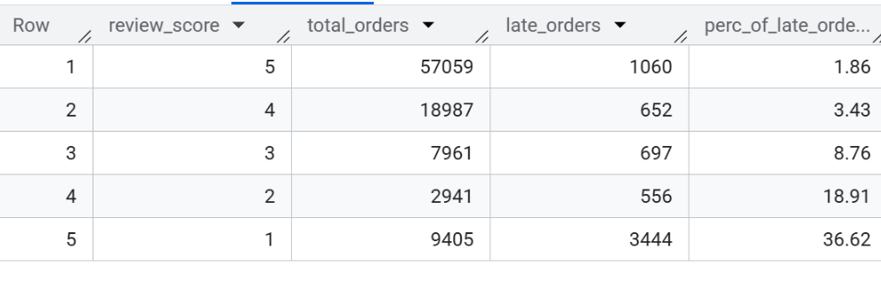

Analysis 2 – Which product category receives most negative reviews?

Analyzed 59 product categories with at least 50 reviews. Fashion male clothing (28.24%), office furniture (26.08%), and fixed telephony (25.57%) had the highest proportion of negative reviews. However, bed_bath_table and furniture_decor represent the greatest business risk, combining 19% negative review rates with the highest order volumes, resulting in 2,110 and 1,620 unhappy customers respectively. Categories with fewer than 50 reviews were excluded for statistical reliability. Note: 610 products with missing category names were also excluded from this analysis.

Limitations:

Review score alone doesn't tell us why a category performs poorly

610 products with missing categories were excluded

Categories under 50 reviews excluded for reliability

SQL QUERY –

SELECT
ROUND(AVG(review_score), 2) AS avg_review_score,
COUNT(*) AS total_reviews,
ROUND(COUNT(CASE WHEN review_score <= 2 THEN 1 END) * 100.0 / COUNT(*), 2) AS pct_negative_reviews,
t.product_category_name_english AS category_name
FROM `dic-app-455521.Olist.olist_order_items` i
JOIN `dic-app-455521.Olist.olist_order_reviews` r
ON i.order_id = r.order_id
JOIN `dic-app-455521.Olist.olist_products` p
ON i.product_id = p.product_id
JOIN `dic-app-455521.Olist.olist_prod_english` t
ON p.product_category_name = t.product_category_name
GROUP BY category_name
HAVING COUNT(*) >= 50
ORDER BY pct_negative_reviews DESC;

QUERY RESULTS
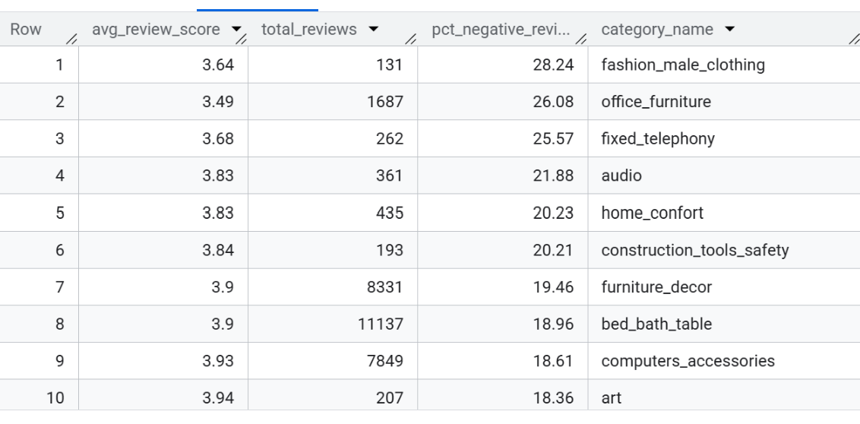

Analysis 3 - Customer Retention Rate
Only 3.00% of customers (2,801 out of 93,358) placed more than one order on Olist. This means 97% of customers never returned after their first purchase, a significant retention problem for the business.

Limitations:
- The dataset only covers 2016–2018. Some customers may have returned after the data collection period ended, meaning true retention could be slightly higher than measured.

SQL QUERY –

SELECT
COUNT(*) AS total_customers,
COUNTIF(tot_orders > 1) AS repeat_customers,
ROUND(COUNTIF(tot_orders > 1) * 100.0 / COUNT(*), 2) AS repeat_pct
FROM (
SELECT customer_unique_id,
COUNT(*) AS tot_orders
FROM `dic-app-455521.Olist.olist_customers` c
JOIN `dic-app-455521.Olist.olist_orders` o
ON c.customer_id=o.customer_id
WHERE order_status = 'delivered'
GROUP BY customer_unique_id
);
QUERY RESULTS

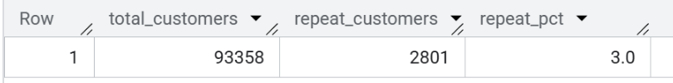

Analysis 4 - Return Rate by Review Score
Customers with higher review scores return at a higher rate. 5-star customers have a 2.70% return rate, nearly double the 1.48% return rate of 1-star customers. This confirms that poor experience negatively impacts retention.
However, an unexpected pattern was observed: 1-star customers (1.48%) returned slightly more than 2-star (1.27%) and 3-star (1.30%) customers. The reason cannot be determined from this dataset alone, possible explanations include dissatisfied customers receiving compensation and returning, or simply random variation given the small sample sizes involved.

Overall conclusion: Happy customers are almost twice as likely to return as unhappy ones.

Limitations:
- Overall return rates are very low across all scores (1-3%), making small differences less statistically significant
- We cannot determine why customers returned or didn't, no data on promotions, coupons, or customer outreach
- A customer may have left a bad review but still returned for a different product category

SQL QUERY –
SELECT review_score,
COUNT(*) AS total_customers,
COUNTIF(tot_orders>1) AS repeat_customers,
ROUND(COUNTIF(tot_orders>1) * 100.00/ COUNT(*),2) AS return_rate_pct
FROM(

SELECT customer_unique_id, review_score,

COUNT(*) AS tot_orders
FROM `dic-app-455521.Olist.olist_orders` o
JOIN `dic-app-455521.Olist.olist_customers` c
ON o.customer_id = c.customer_id
JOIN `dic-app-455521.Olist.olist_order_reviews` r
ON o.order_id=r.order_id
WHERE order_status= 'delivered'
GROUP BY customer_unique_id, review_score
)
GROUP BY review_score
ORDER BY review_score DESC
;
QUERY RESULTS
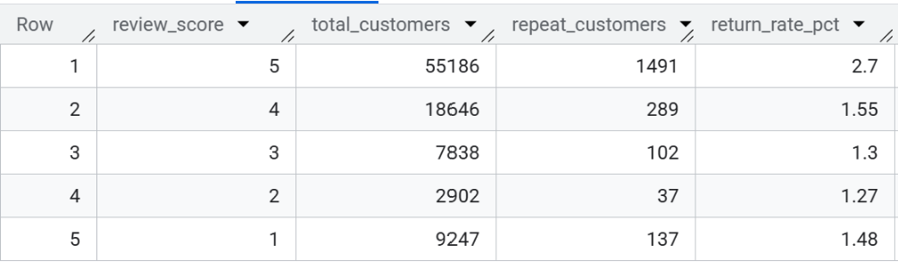

Analysis 5 - Revenue Lost to Poor Experience
Methodology:
Revenue lost was estimated using three components:
- Unhappy customers (1-2 star reviews) = 14,575
- Return rate gap = difference between happy (2.70%) and unhappy (1.375%) customer return rates = 1.325%
- Average order value = $137.75 (total order value per order, not per item)

Formula: Unhappy customers × Return rate gap × Average order value

Finding:
Olist loses an estimated $26,602 in potential revenue due to poor customer experience. This represents the additional revenue that would have been generated if unhappy customers had returned at the same rate as satisfied (5-star) customers.

Limitations - this is a conservative underestimate because:
- Only 1-2 star customers were counted as "unhappy”, 3-star customers also return less than happy customers but were excluded
- We assumed each retained customer places only one additional order, in reality loyal customers place multiple orders over time
- Average order value was used, some unhappy customers may have been high-value spenders
- Word of mouth effect not accounted for, unhappy customers may discourage potential new customers from joining the platform
Overall conclusion: The true revenue impact of poor customer experience is likely significantly higher than $26,602.

SQL QUERY –

SELECT
unhappy_customers,
avg_order_value,
return_rate_gap,
ROUND(unhappy_customers * return_rate_gap * avg_order_value, 2) AS estimated_revenue_lost
FROM (
SELECT
COUNTIF(review_score <= 2) AS unhappy_customers,
(SELECT ROUND(AVG(sum_price), 2) FROM (
SELECT order_id, SUM(price) AS sum_price
FROM `dic-app-455521.Olist.olist_order_items`
GROUP BY order_id
)) AS avg_order_value,
0.01325 AS return_rate_gap -- 2.70% - 1.375%
FROM `dic-app-455521.Olist.olist_order_reviews`
);

QUERY RESULTS

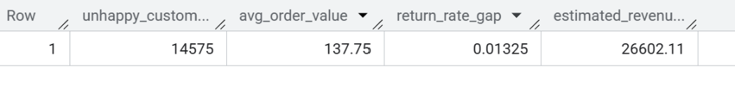

Phase 5 - Share

Visualizations
Olist Analysis Public Dashboard

Key Findings
- Late delivery drives bad reviews - 36.62% of 1-star orders were late vs only 1.86% of 5-star orders
- Worst categories - office_furniture (26.08% negative reviews) and bed_bath_table (most impacted -2,110 unhappy customers)
- Only 3% of customers return - extremely low retention across the board
- Happy customers return twice as often - 2.70% vs 1.375% for unhappy customers
- $26,602 estimated revenue lost - conservative minimum

Phase 6 - Act

Recommendations
1. Improve delivery speed and reliability
36.62% of 1-star orders were delivered late compared to only 1.86% of 5-star orders. Olist should work with sellers to set more realistic delivery estimates and prioritize logistics partnerships that reduce delivery delays, particularly for high-volume categories.
2. Investigate and fix underperforming categories
Fashion male clothing (28.24%), office furniture (26.08%), and fixed telephony (25.57%) have the highest proportion of unhappy customers. Olist should audit sellers in these categories for quality issues and consider stricter seller standards or customer guarantees.
3. Prioritize bed_bath_table and furniture_decor
Despite not having the worst percentages, these two categories affect the most customers (2,110 and 1,620 unhappy customers respectively). Fixing experience here has the highest business impact.
4. Invest in customer retention programs
Only 3% of customers return. Olist should introduce loyalty incentives — discount codes after first purchase, follow-up emails, or personalized recommendations — to encourage repeat purchases.
5. Address the $26,602+ revenue gap
This is a conservative estimate of lost revenue. Even small improvements in retention among unhappy customers could recover significant revenue over time.

Limitations
- Data is from 2016-2018 - findings may not reflect Olist's current operations or customer behavior
- Revenue lost ($26,602) is a conservative estimate - true impact is likely much higher as we only counted one lost return order per unhappy customer
- No behavioral data - we can't tell why customers didn't return (price, competition, one-time need, etc.)
- Reviews in Portuguese - couldn't analyze comment text to find specific complaint patterns
- Causation vs correlation - late delivery correlates with bad reviews, but we can't confirm it's the sole cause

Next Steps
- Analyze seller performance - identify which specific sellers are driving the most negative reviews and late deliveries
- Translate and analyze review comments - use Portuguese NLP tools to extract specific complaint themes from review text
- Extend the analysis to payments data - investigate whether payment method or installment plans affect satisfaction
- Track retention over a longer time period - the 2016-2018 dataset limits our retention findings; more recent data would give a clearer picture

