Sephora Skincare Analysis
What Drives Skincare Product Success on Sephora?

Google Data Analytics Professional Certificate - Capstone Case Study
Tools: Google Sheets · BigQuery SQL · Tableau Public

Phase 1 — Ask

Business Task Statement
A new skincare brand, SkinLab, wants to launch on Sephora and wants to know what drives the success of a skincare product. As a junior data analyst, I have been assigned to identify the major factors that drive product ratings, customer engagement on Sephora’s platform.

Problem to Solve
What drives a skincare product’s success on Sephora and what does a new brand need to prioritize to compete.

Key Stakeholders
Marketing team of a fictional startup called SkinLab

Guiding Questions
- Does price affect customer ratings - do expensive products rate higher?
- Which product category (moisturizers, serums, treatments) performs best?
- Which brands consistently receive the highest customer engagement?
- What price range delivers the best value - high ratings at reasonable cost?

Phase 2 — Prepare

Dataset Overview
The dataset is from Kaggle Sephora Products and Skincare . There are 6 CSV files in total. I have used only the product_info.csv file because it contains all the necessary data to answer my guiding questions. The file has 8,495 rows and 27 columns.

Columns Used
- product_name - Name of the product
- brand_name - Brand the product belongs to
- primary_category - Main product category (e.g. Skincare, Fragrance)
- secondary_category - Second category in the breadcrumb section (e.g. moisturizers, eye care)
- price_usd - Listed price in US dollars
- rating - Average customer rating (0–5)
- loves_count - The number of people who have marked this product as a favorite
- reviews - Total number of customer reviews

Data Limitations
The given product info dataset doesn’t have any sales information which can’t help me answer questions like “Does higher price equals to higher sales”.

Phase 3 — Process

Tools Used
Google Sheets for data cleaning. BigQuery for SQL queries. Tableau for visualizations.

Cleaning Steps
- Added secondary_category column to capture skincare subcategories such as Moisturizers, Serums and Treatments
- Removed 10 blank rows from secondary_category column
- Created price_category column grouping products into Budget (under $20), Mid-range ($20–$60) and Luxury (above $60)
- Created rating_rounded column rounding ratings to 2 decimal places for cleaner analysis
- Duplicated working_data and filtered to Skincare products only to create skincare_data sheet
- Final skincare dataset contains 2,351 rows ready for analysis

Phase 4 — Analyze

Analysis 1 — Price vs. Rating
Using Pivot table in Google Sheets, I calculated the average rating for each price category. Budget products are 4.12 stars, mid-range products are 4.23 stars and luxury products are 4.27 stars. While luxury products rate slightly higher than budget products, the difference is minimal, only 0.15 stars. This suggests that price alone does not significantly impact perceived quality on Sephora. A new brand like SkinLab doesn't necessarily need to price their products high to be well rated. A good quality budget or mid-range product can perform almost as well as a luxury one.
PIVOT TABLE-
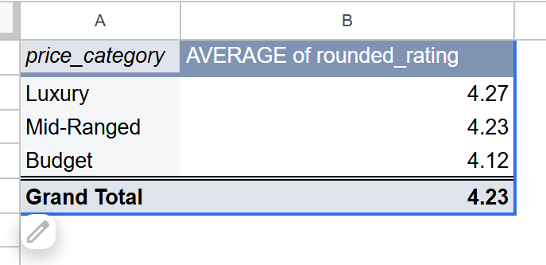

SQL QUERY –
SELECT
price_category,
ROUND(AVG(rounded_rating), 2) AS avg_rating,
COUNT(*) AS total_products
FROM `dic-app-455521.sephora_skincare_data.skincare_products`
GROUP BY price_category
ORDER BY avg_rating DESC
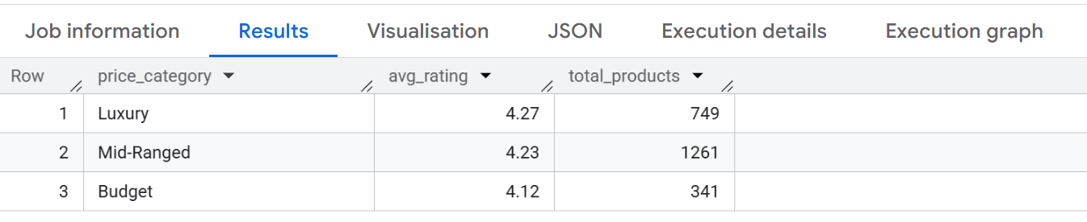
This confirms our findings from pivot table

Analysis 2 — Top Performing Categories
For this analysis, category performance is measured by average customer rating, as it reflects overall customer satisfaction with products in each category.
Cleansers and Treatments have the highest average ratings at 4.31 stars, indicating strong customer satisfaction and proven demand in these categories. This makes them attractive entry points for a new brand. However, Self Tanners have the lowest average rating at 3.99 stars, suggesting customers are not fully satisfied with existing products, presenting an opportunity for a new brand to differentiate and capture market share by offering a superior product.
SkinLab could consider launching in Cleansers or Treatments to enter a proven market, or target Self Tanners to fill an existing gap. The final decision should depend on SkinLab's product expertise and competitive advantage.
PIVOT TABLE-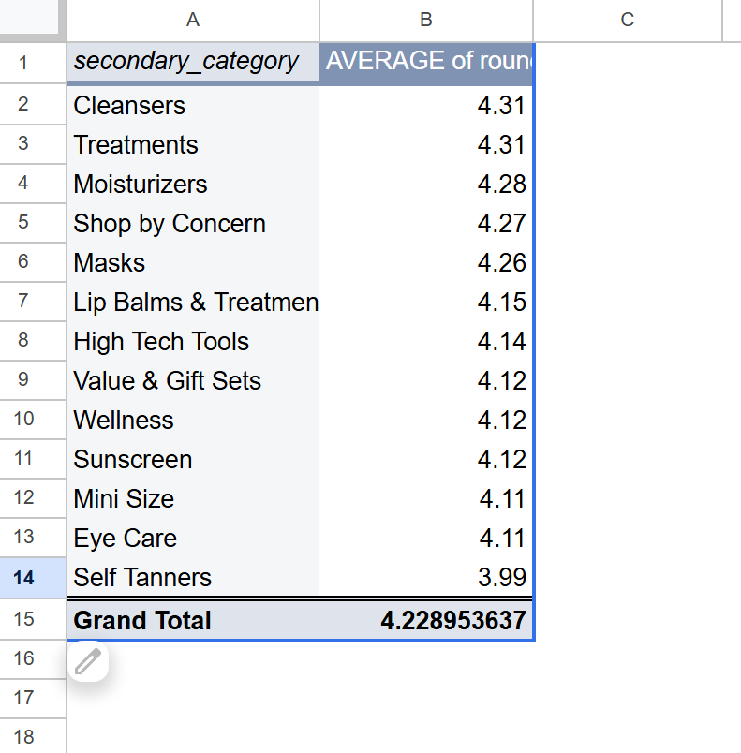
SQL QUERY-
SELECT
secondary_category,
ROUND(AVG(rating), 2) AS avg_rating,
COUNT(*) AS total_products
FROM `dic-app-455521.sephora_skincare_data.skincare_products`
GROUP BY secondary_category
ORDER BY avg_rating DESC
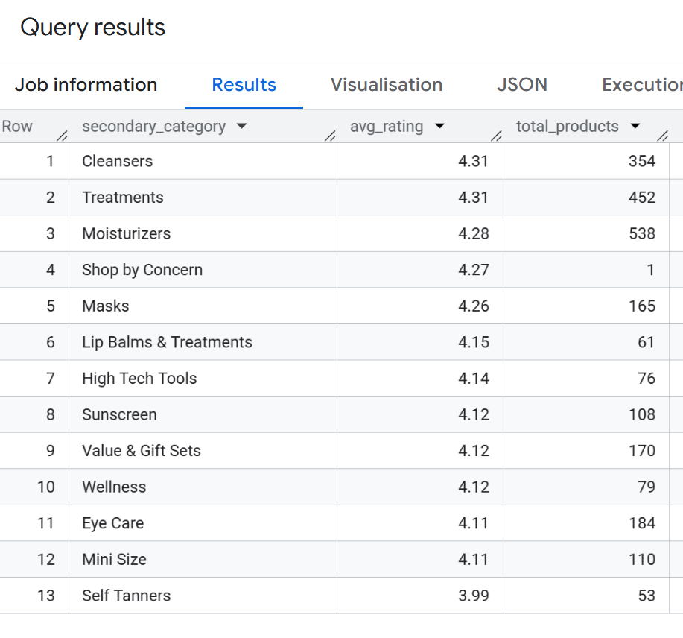
This confirms our findings from pivot table.

Analysis 3 — Top Brands by Customer Engagement
The most loved brand at Sephora is The Ordinary, with an average loves count of 147K, which is also affordable with an average price of just $12, whereas Tatcha, being a luxury brand, has comparatively lower customer engagement with an average product price of $60, which clearly shows that a skincare brand doesn't need to price its products high in order to be more loved, which also confirms our findings from Guiding Question 1. This suggests that SkinLab should consider pricing their products in the budget to mid-range category to maximize customer engagement.

PIVOT TABLE-
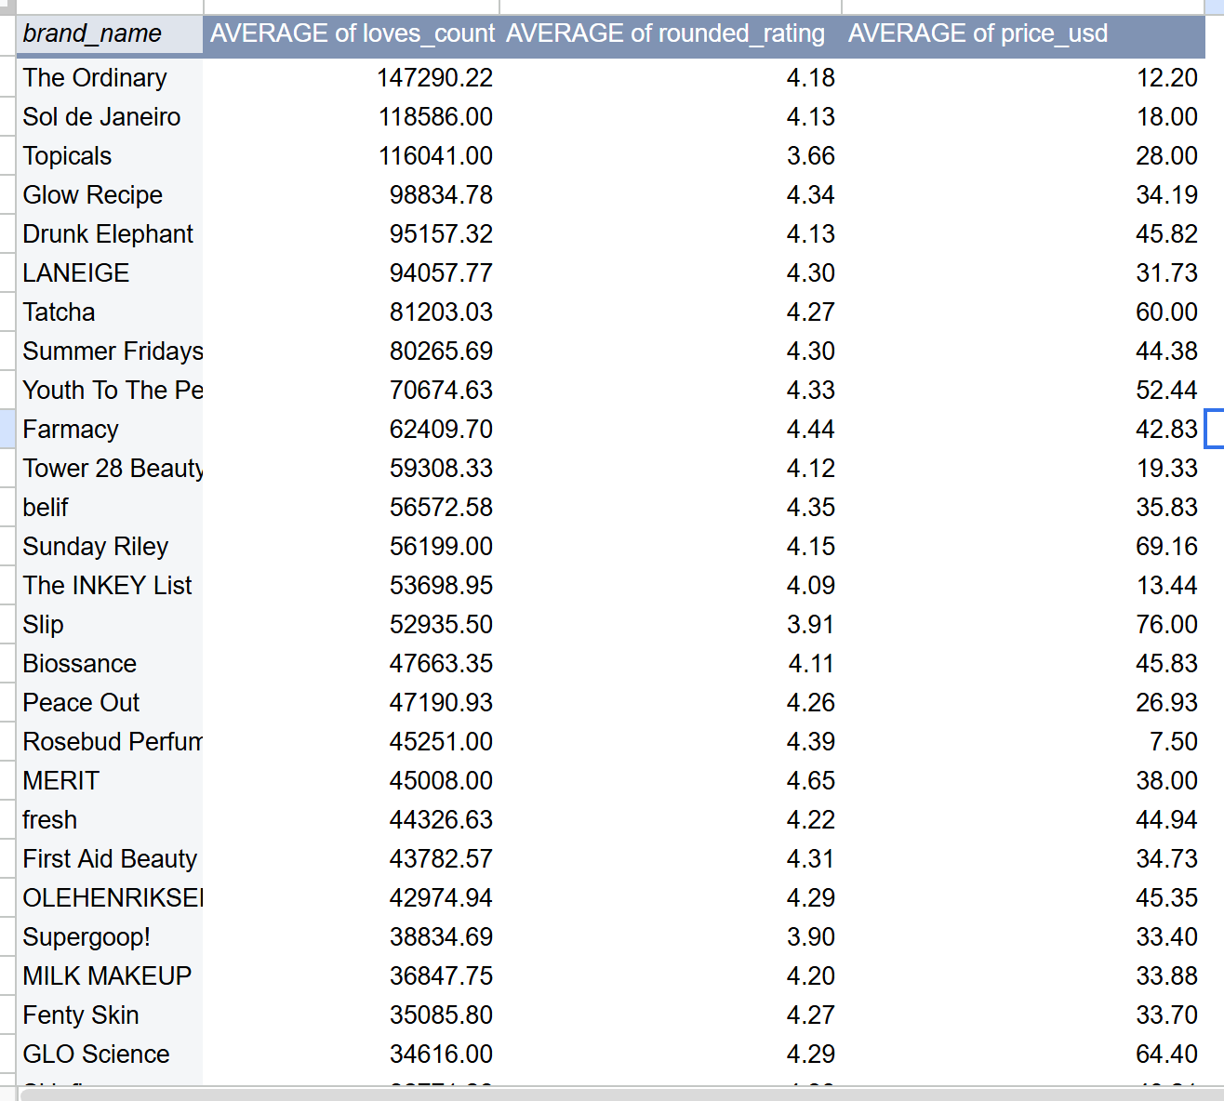
SQL QUERY-
SELECT
brand_name,
ROUND(AVG(loves_count), 2) AS avg_love_count,
ROUND(AVG(rating), 2) AS avg_rating,
ROUND(AVG(price_usd), 2) AS avg_price
FROM `dic-app-455521.sephora_skincare_data.skincare_products`
GROUP BY brand_name
ORDER BY avg_love_count DESC
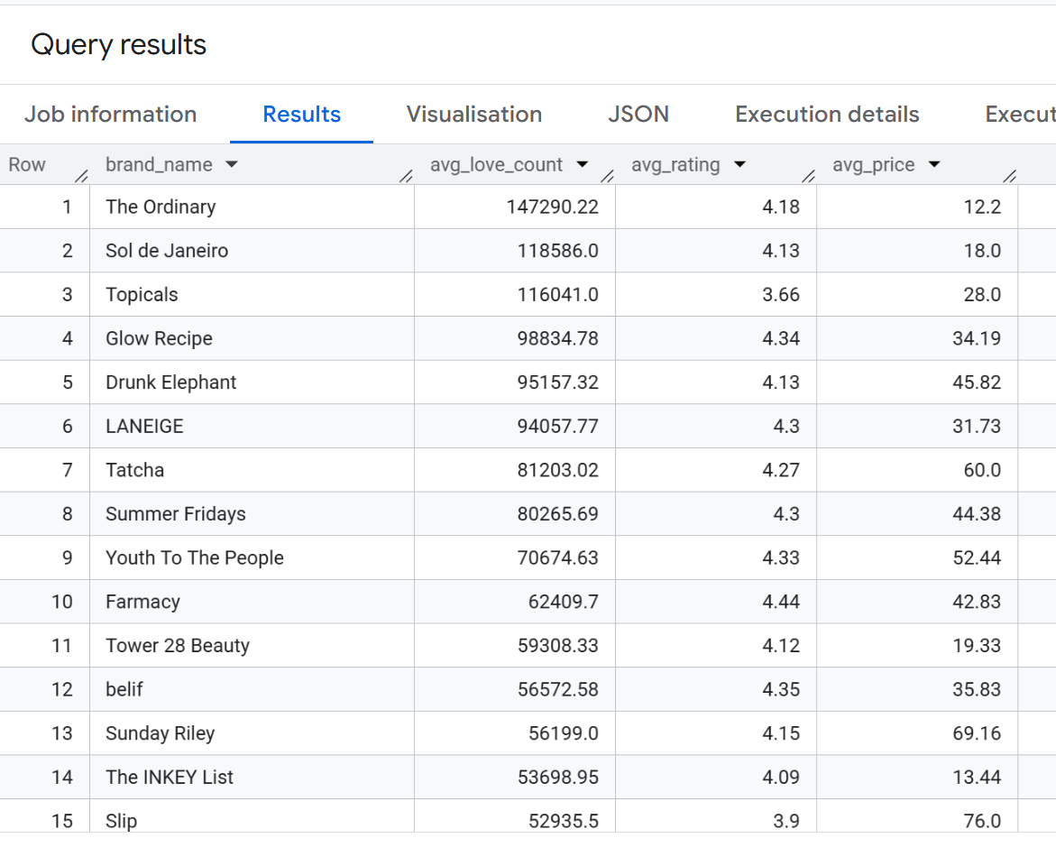

Analysis 4 — What price range delivers the best value, high ratings at reasonable cost?
For this analysis, value is defined as a combination of customer satisfaction (measured by average rating) and customer engagement (measured by average loves_count) relative to price. A price category that delivers high ratings and high engagement at a lower price point is considered the best value for a new brand entering the market
Budget-friendly products appear to deliver the best overall value, with an average of 46K loves from customers while maintaining ratings that are very close to those of luxury products. Although luxury products have a slightly higher average rating of 4.27, the difference in ratings between budget and luxury categories is minimal. In contrast, the difference in customer engagement is substantial, as luxury products receive only 19K loves on average compared to 46K for budget products.
This suggests that customers perceive budget-friendly products as offering a strong balance between quality and affordability. While higher-priced products may achieve marginally better ratings, they do not generate a proportional increase in customer engagement. As a result, price does not appear to be a major driver of customer satisfaction or product popularity.
These findings reinforce the conclusions from Analyses 1 and 3, which showed that higher pricing is not necessary for a skincare product to be well received by consumers. Based on this analysis, SkinLab should consider positioning its products within the budget to mid-range price range. This strategy would allow the brand to remain accessible to a larger customer base while still achieving strong customer satisfaction and engagement.
PIVOT TABLE-
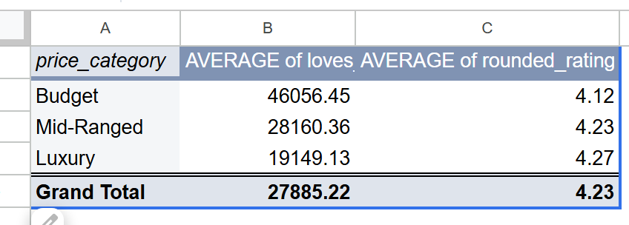
SQL QUERY-
SELECT
price_category,
ROUND(AVG(loves_count),2 ) AS avg_love_count,
ROUND(AVG(rating),2) AS avg_rating,
COUNT(*) AS total_products,
ROUND(AVG(price_usd),2) AS avg_price
FROM `dic-app-455521.sephora_skincare_data.skincare_products`
GROUP BY price_category
ORDER BY avg_love_count DESC
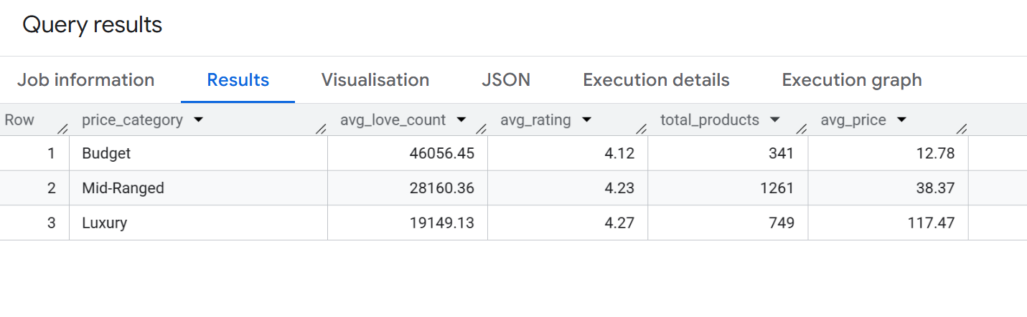

Phase 5 — Share

Visualizations
The complete analysis has been visualized in an interactive Tableau dashboard combining all key findings:
Sephora Skincare Analysis Tableau Public Dashboard
The dashboard includes:
- Chart 1: Average Rating by Price Category
- Chart 2: Top 10 Performing Categories
- Chart 3: Top 10 Skincare Brands by Engagement
- Chart 4: Average Customer Engagement by Price Category

Key Findings
- A product does not have to be highly priced to get more love from customers.
- When breaking down product categories, consumers are happiest with their daily routine staples. Cleansers and Treatments tied for the highest average rating on the entire dashboard at 4.31 stars, making them the safest, most proven entry points for a new brand.
- Budget-friendly products receive significantly higher customer engagement, with an average of 46,056 loves compared to just 19,149 for luxury products, proving that affordability drives popularity on Sephora.
- The Ordinary leads all skincare brands with an average of 147,290 loves per product at just $12 average price, reinforcing that accessible pricing builds the most loyal customer base.

Phase 6 — Act

Recommendations
- Launch with a Cleanser or a targeted Treatment: These two categories tie for the highest average customer satisfaction on the entire platform at 4.31 stars. Starting here offers a highly reliable, proven market entry point because consumers are consistently happiest with these daily routine staples.
- Target Self-Tanners to fill a major market gap: If the brand wants a high-reward opportunity to disrupt the market, Self Tanners sit at the very bottom of the leaderboard with a low 3.99-star average. This sub-4.0 rating shows that customers are genuinely unsatisfied with existing options on the shelves, creating an open invitation for a new brand to step in and solve their complaints.
- Price products in the Budget to Mid-Range tier ($12–$25): Budget products bring in a massive average of 46K loves, compared to just 19K loves for luxury items. Since the satisfaction gap between budget (4.12 stars) and luxury (4.27 stars) is a tiny 0.15 stars, pricing affordably allows you to capture maximum community hype and volume without sacrificing perceived quality.

Limitations
- Loves_count and rating are used as proxies for product success since actual sales data is unavailable. The data also reflects a snapshot in time and may not represent current trends
- The analysis is limited to products currently listed on Sephora and may not reflect the broader skincare market.

Next Steps
- Incorporate actual sales data to validate findings.
- Track rating and engagement trends over time to identify emerging categories.

