open msy2 from search bar

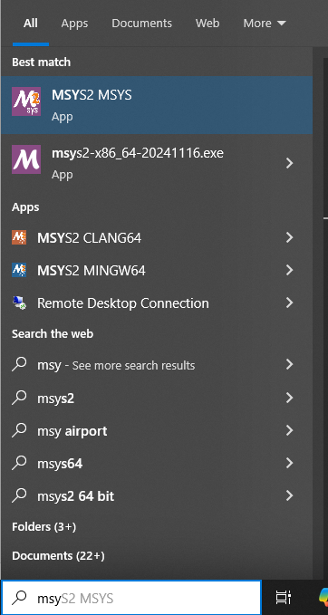

Copy “cd /c/Users/DELL/Desktop/cew_2_backup” and paste it in bash  
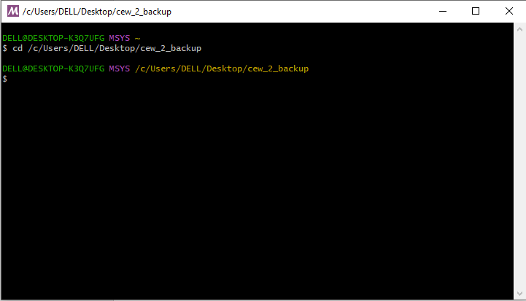

Run command “gcc main.c -I /c/msys64/mingw64/include -L /c/msys64/mingw64/lib -lcurl -o main.exe”

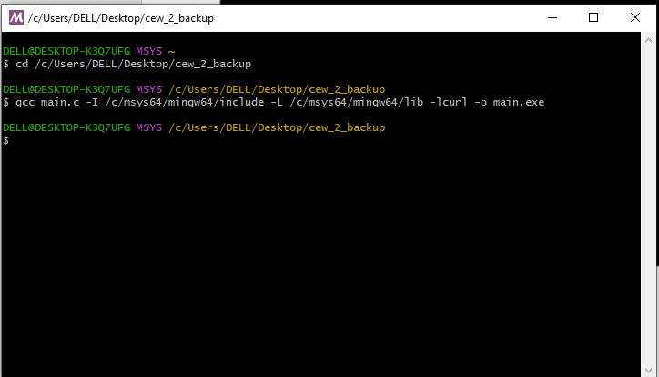

No error means program compiled successfully.

Now you will see main.exe file in the folder in my case it’s the one with size 438KB.

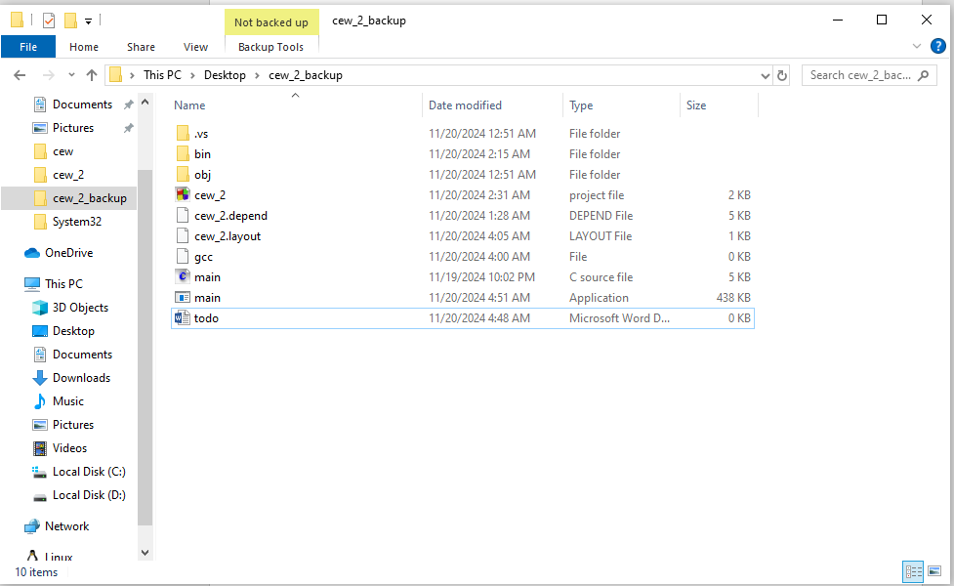

Now double click the main application file it will run and you will see 4 other files in your folder

