Exp No:1

21|01|2025 Program To Clean ,Handle and apply Preprocessing techniques in the google trends dataset

Aim:

To Write a program which handles,loads,cleans the Google Trends time series dataset and to apply and implement some preprocessing Techniques

Procedure and code:

1.Import the necessary libraries

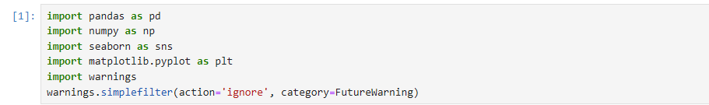

2.Read the dataset and get the information about the google trends dataset using the info()

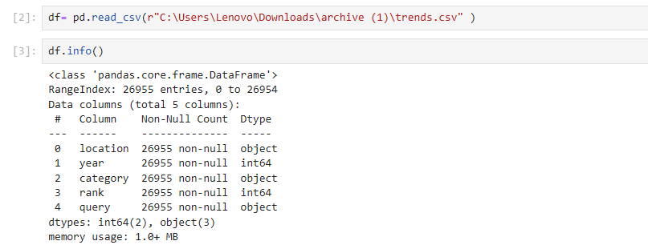

3.Use describe() to get a standard summary about the dataset to explore the dataset

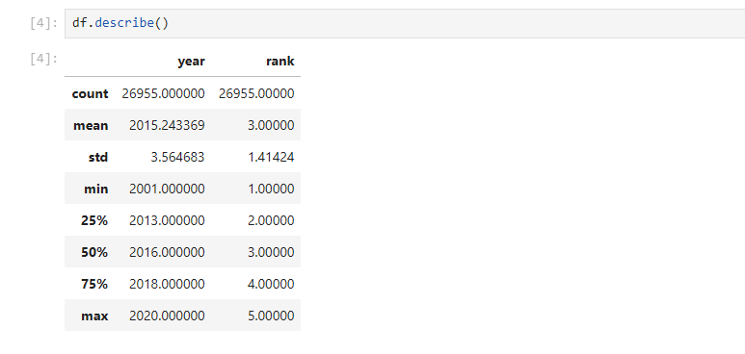

4.Check for missing values in each columns of the dataset

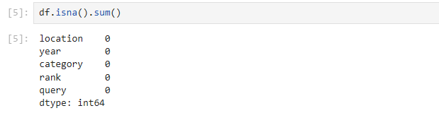

5.Check for duplicates in the dataset and drop it



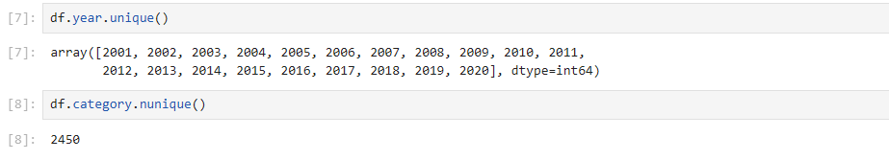

6.Use grid() to visualize the dataset to explore the google trends dataset

