**REAL TIME FALL ​DETECTION APP**

Team number- STREPC 1245

Team Name- Bits N’ Bytes

Team Leader-Vineet Alok

Team members- Sania , Neha, Ripudaman

Institution- The Northcap University

Mentor- Dr Nidhi Malik

**Agenda**

* Challenge
* Problem statement
* Research work
* Workflow
* Solution
* Use cases/Applicability
* Business Model Canvas
* Credits

**Challenge**

To create a system that can detect falls with high accuracy, respond quickly and effectively, and provide a user-friendly experience that can be trusted and adopted by the elderly and people with mobility issues.

**Problem statement**

* **Description of the Idea:** Accidents related to falling or car accidents is a major issue in India
* It is important that a person that suffers an accident is aided as quickly as possible.
* Unable to call for help as the person can be injured or unconscious.
* Purpose: to examine the possibility of using sensors available in smartphones to implement an application for fall detection.
* Send an automatic alert notification could be of great use.

**Research work**

* How Rishabh Pant was rescued: 'The car had already caught sparks so I and the conductor rushed to get him out'
* Globally, an average of 37.3 million people suffer from injuries related to a fall each year, which are severe enough to seek medical attention.
* Out of these, no less than an estimated 640000 individuals die as a direct consequence of the fall.

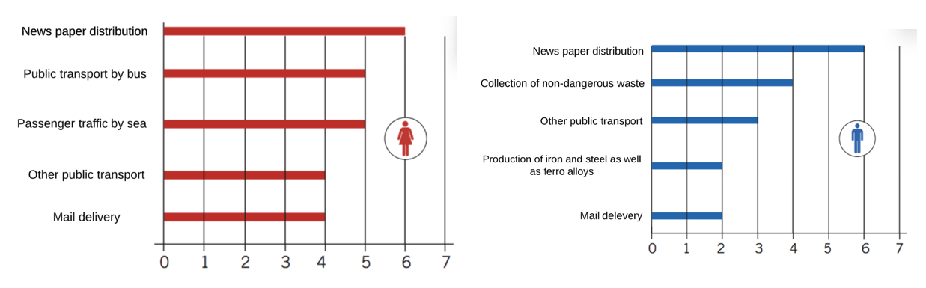

Fig:1 Work areas with most reported fall accidents from standing level. Amount per 1000 employed women and men respectively

**Workflow**

**Solution**

* A fall detection app is a mobile application designed to detect and respond to falls, by using sensors in a smartphone or wearable device.
* It can alert emergency contacts or send a call for help in case of a fall.
* Provide a fast and reliable way to get help in the event of a fall, especially for elderly or vulnerable individuals who may have trouble getting up after a fall or calling for help.
* The application will read real-time data using smartphone sensors and location services.
* Accelerometer and gyroscope data signals are then fed to a model. The model detects anomalies in the data and predicts a fall.
* After a fall is predicted an alert notification will be sent to the user and if the user does not respond, an SOS will be sent to the emergency contact.

**Solution   
(code snippets)**

* Isolation Forest Training Model

**USE CASES / APPLICABILITY**

* **Elderly Care**
* **Health Monitoring**
* **Sports & Adventure Activities**
* **Industrial Safety**
* **Smart Homes**

**Business Model Canvas**

