- Scenario: You are working on a project that involves analyzing a dataset
containing information about houses in a neighborhood. The dataset is stored in a
CSV file, and you have imported it into a NumPy array named house_data. Each
row of the array represents a house, and the columns contain various features
such as the number of bedrooms, square footage, and sale price.
Question: Using NumPy arrays and operations, how would you find the average
sale price of houses with more than four bedrooms in the neighborhood?
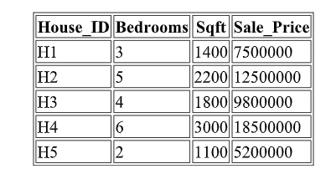
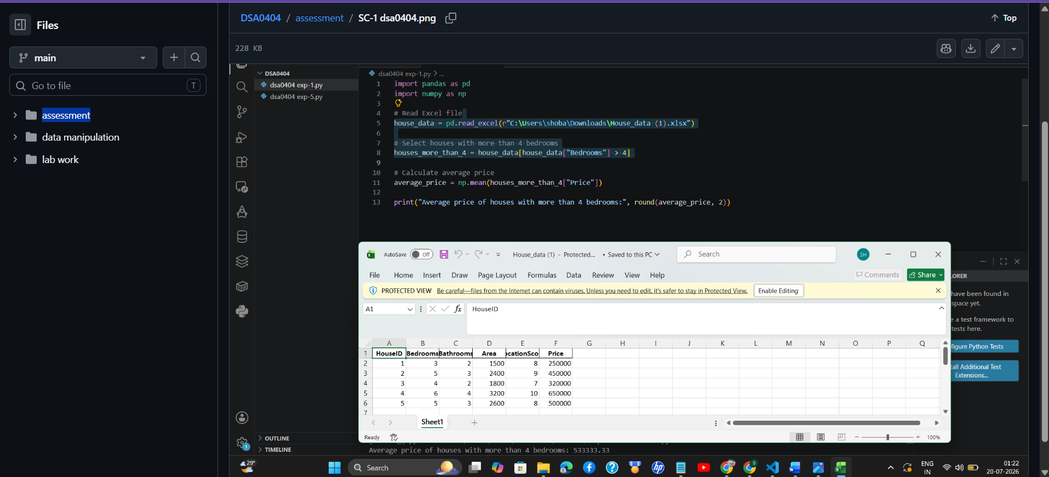

- Scenario: An email service provider wants to automatically classify incoming
emails as spam or non-spam. Each email is represented using features such as
number of links, number of capitalized words, and total email length. Historical
email data is labeled as spam (1) or not spam (0).
Question:
Develop a Logistic Regression model using the given features.
Predict whether a newly received email is spam or not.
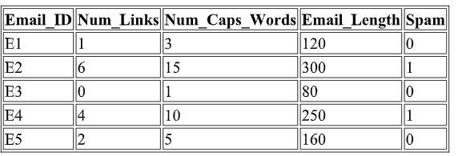
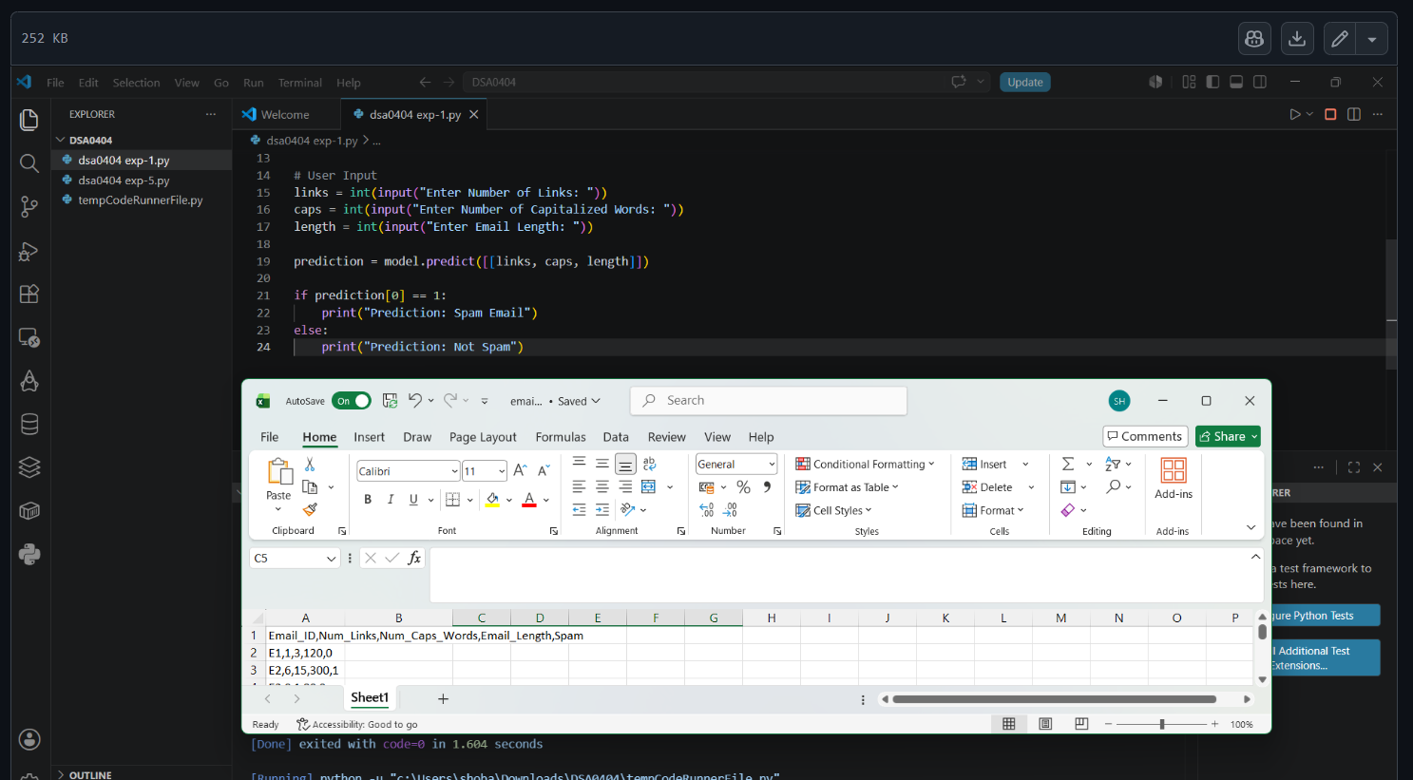

- Scenario: Linear Regression for Car Resale Price PredictionYou are a data
analyst at a used-car marketplace. You want to predict the resale price of a car
based on features such as car age (years), total kilometers driven, and engine
capacity (cc). You have a dataset containing past car listings with these features
and their final selling prices.
Question: Write a Python program that loads the dataset containing Age,
Kms_Driven, Engine_CC, and Resale_Price, trains a Linear Regression model
using scikit-learn, accepts user input for a new car, and predicts the estimated
resale price.
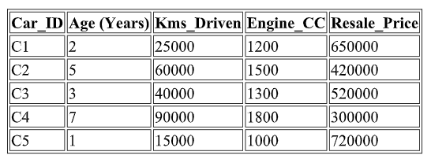
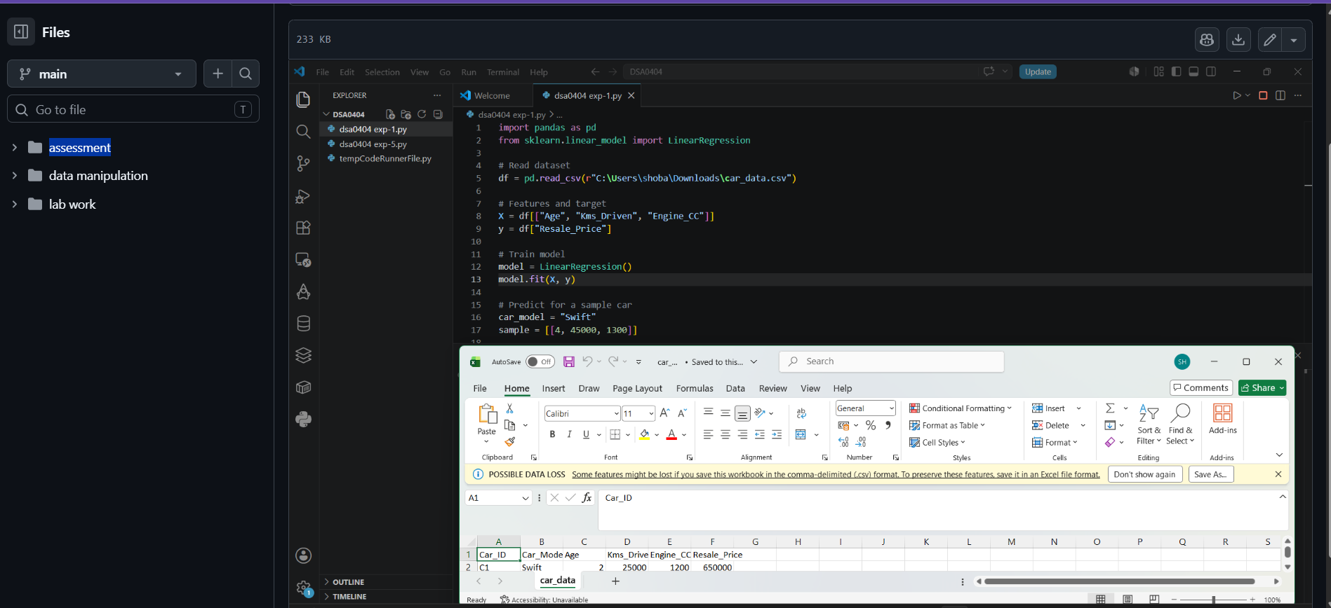

- Scenario: Loan Approval (CART Classification): A bank wants to decide
whether to approve or reject a loan application. The decision depends on features
like income, credit score, and existing loans. Past applications are labeled as
Approved (1) or Rejected (0).
Question: Using CART, build a Decision Tree Classifier for loan approval.
Predict the class for a new applicant and display the decision rules.
