5. Pandas Program to Create a Bar Plot of Trading Volume

Aim
To create a bar chart representing the trading volume of Alphabet Inc. stock.

Algorithm
- Import Pandas and Matplotlib.
- Read the stock dataset.
- Filter the required dates.
- Plot the trading volume using a bar chart.
- Display the graph.
Date | Open | High | Low | Close | Volume
2023-01-02 | 89 | 91 | 88 | 90 | 2500000
2023-01-03 | 90 | 93 | 89 | 92 | 2700000
2023-01-04 | 92 | 93 | 90 | 91 | 2600000
2023-01-05 | 91 | 96 | 90 | 95 | 2900000
2023-01-06 | 95 | 97 | 94 | 96 | 3000000

Code
import pandas as pdimport matplotlib.pyplot as plt
df = pd.read_csv("alphabet_stock.csv")
df["Date"] = pd.to_datetime(df["Date"])
filtered = df[(df["Date"] >= "2023-01-02") &
(df["Date"] <= "2023-01-06")]
plt.figure(figsize=(8,5))
plt.bar(filtered["Date"].dt.strftime("%Y-%m-%d"), filtered["Volume"])
plt.title("Alphabet Trading Volume")
plt.xlabel("Date")
plt.ylabel("Volume")
plt.xticks(rotation=45)
plt.show()

Output
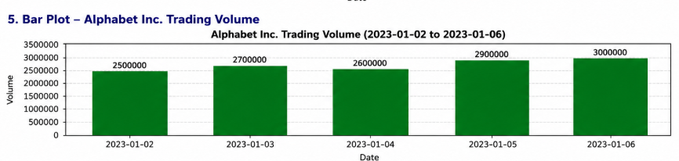
A bar chart displaying the trading volume of Alphabet Inc. stock for the selected dates.

Result
Thus, the trading volume bar chart was created successfully.

6. Pandas Program to Create a Scatter Plot of Trading Volume vs Stock Price

Aim
To create a scatter plot showing the relationship between trading volume and stock price.

Algorithm
- Import Pandas and Matplotlib.
- Read the stock dataset.
- Filter the required dates.
- Plot trading volume on the X-axis.
- Plot closing stock price on the Y-axis.
- Display the graph.
Alphabet Stock Dataset (alphabet_stock.csv)
Date | Open | High | Low | Close | Volume
2023-01-02 | 89 | 91 | 88 | 90 | 2500000
2023-01-03 | 90 | 93 | 89 | 92 | 2700000
2023-01-04 | 92 | 93 | 90 | 91 | 2600000
2023-01-05 | 91 | 96 | 90 | 95 | 2900000
2023-01-06 | 95 | 97 | 94 | 96 | 3000000

Code
import pandas as pdimport matplotlib.pyplot as plt
df = pd.read_csv("alphabet_stock.csv")
df["Date"] = pd.to_datetime(df["Date"])
filtered = df[(df["Date"] >= "2023-01-02") &
(df["Date"] <= "2023-01-06")]
plt.figure(figsize=(8,5))
plt.scatter(filtered["Volume"], filtered["Close"], s=100)
plt.title("Trading Volume vs Closing Price")
plt.xlabel("Trading Volume")
plt.ylabel("Closing Price")
plt.grid(True)
plt.show()

Output
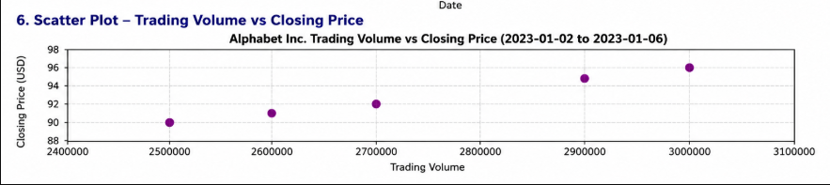

A scatter plot showing the relationship between trading volume and the closing stock price of Alphabet Inc.

Result
Thus, the scatter plot illustrating the relationship between trading volume and stock price was created successfully.

