19. Dimensions and Column Names of World Alcohol Consumption Dataset
Aim
To write a Pandas program to display the dimensions/shape of the World Alcohol Consumption dataset and extract its column names.
Dataset
A simplified version of the World Alcohol Consumption dataset is shown below:
Country | Beer_Servings | Spirit_Servings | Wine_Servings | Total_Litres
Afghanistan | 0 | 0 | 0 | 0.0
Albania | 89 | 132 | 54 | 4.9
Algeria | 25 | 0 | 14 | 0.7
Andorra | 245 | 138 | 312 | 12.4
Angola | 217 | 57 | 45 | 5.9

Python code:
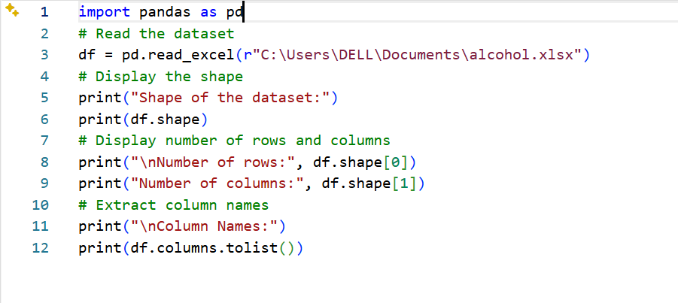
Output:
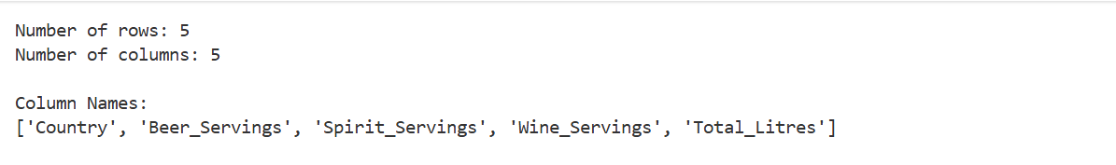

Result:
The dimensions and column names of the World Alcohol Consumption dataset were successfully displayed.

20. Find the Index of a Given Substring in a DataFrame Column
Aim:
To write a Pandas program to find the index/position of a given substring in a DataFrame column.
Index | Name | City
0 | Anu | Chennai
1 | Bala | Madurai
2 | Cathy | Coimbatore
3 | David | Chennai
4 | Esha | Bangalore

Python code:
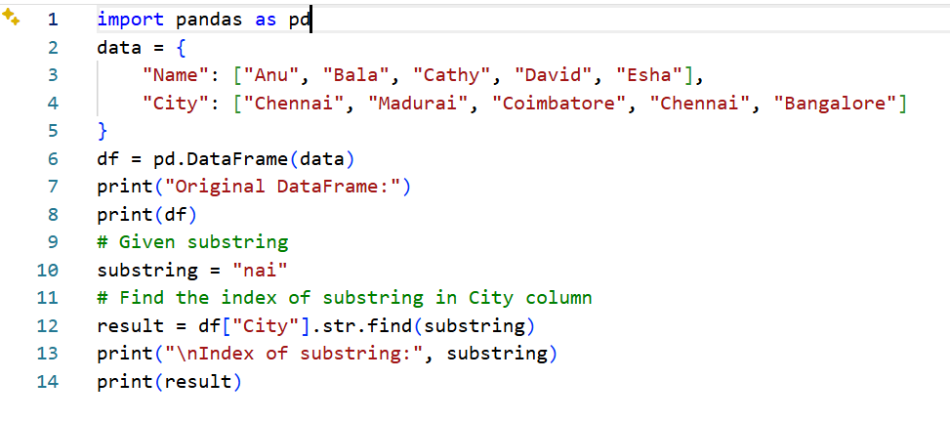
Output
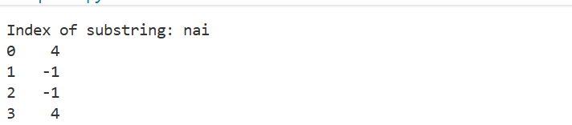
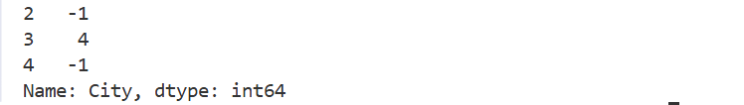
Result:
The index position of the specified substring was successfully found using the Pandas str.find() function.

