21. Swap the Cases of a Character Column
Aim
To write a Pandas program to swap the cases of characters in a specified column of a DataFrame.
Dataset
Name | City
Anu | Chennai
Bala | MADURAI
Cathy | Coimbatore
David | CHENNAI
Esha | Bangalore

Python code:
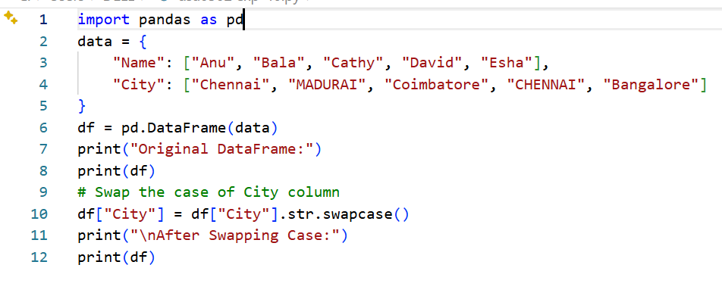
Output
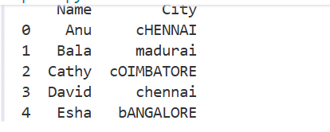
Result:
The cases of characters in the specified column were successfully swapped.
22. Draw a Line with Labels and Title
Aim
To write a Python program to draw a line chart with suitable labels for the X-axis, Y-axis, and title.
Dataset
X | Y
1 | 2
2 | 4
3 | 6
4 | 8
5 | 10

Python code:
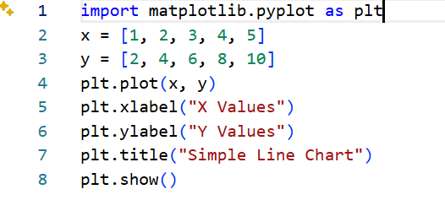
Output:
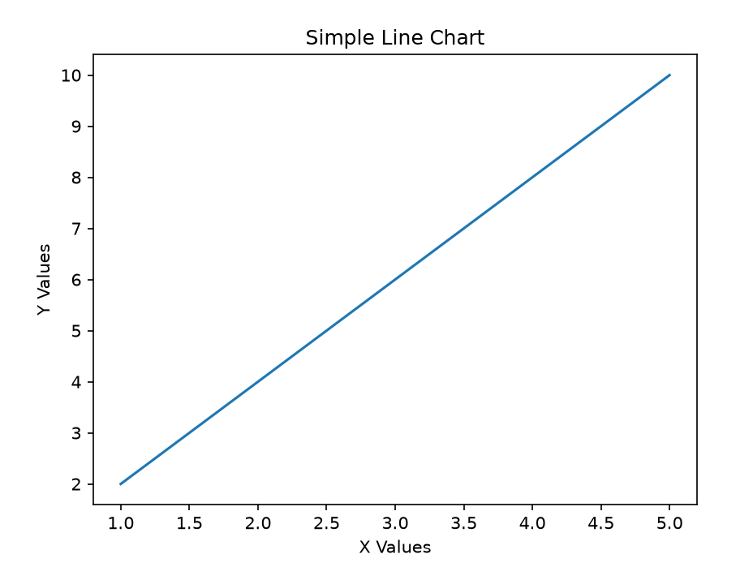
Result:
A line chart was successfully created with appropriate axis labels and title.

