23. Draw a Line Using Axis Values from a Text File
Aim
To write a Python program to read axis values from a text file and draw a line chart with suitable labels and title.
Dataset
X | Y
1 | 2
2 | 4
3 | 6
4 | 8
5 | 10

Python code:
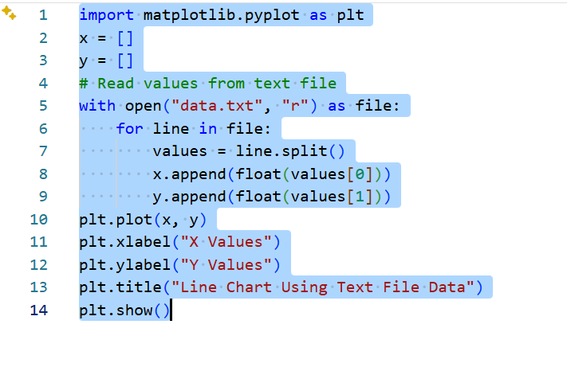
Output:
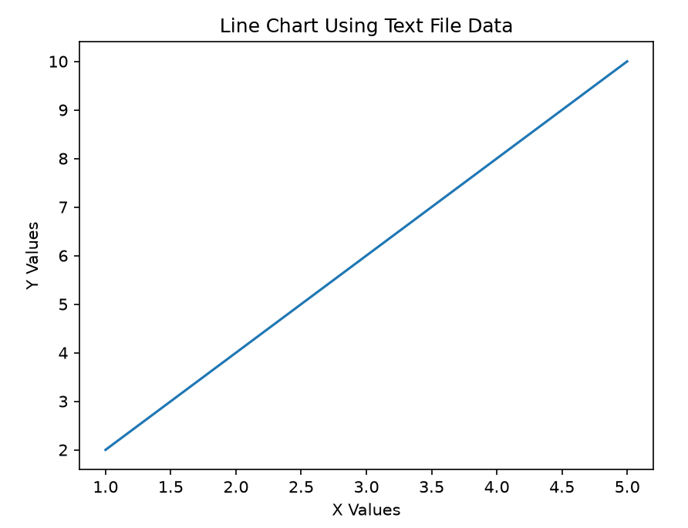

Result:
The data was successfully read from a text file and represented using a line chart.
24. Draw Line Charts of Financial Data
Aim
To write a Python program to draw a line chart representing financial data.
Dataset
Month | Opening | Closing
Jan | 100 | 105
Feb | 105 | 110
Mar | 110 | 108
Apr | 108 | 115
May | 115 | 120
Jun | 120 | 125

Python code:
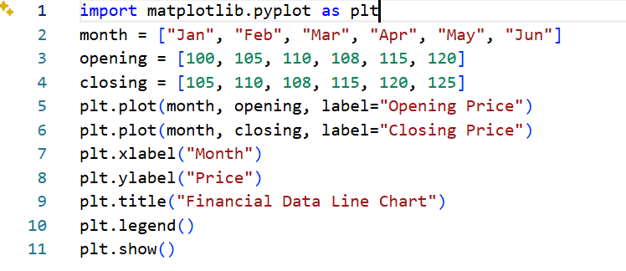
Output:
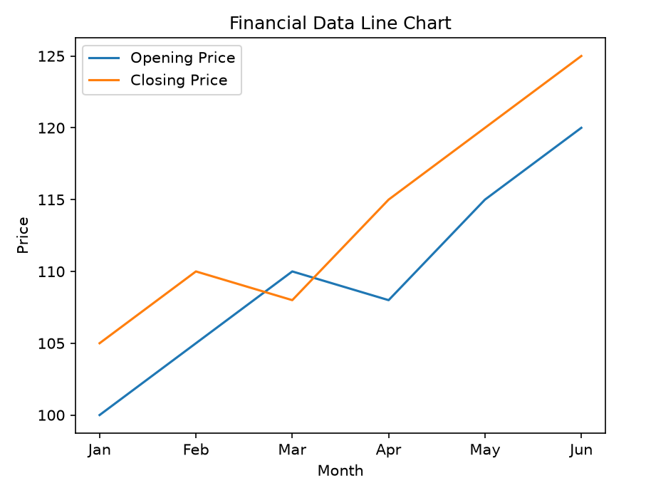
Result:
The financial data was successfully represented using line charts.

