25. Plot Two or More Lines with Legends, Widths and Colors
Aim
To write a Python program to plot two or more lines with legends, different line widths, and colors.
Dataset
X | Line 1 | Line 2
1 | 1 | 5
2 | 4 | 4
3 | 9 | 3
4 | 16 | 2
5 | 25 | 1

Python code:
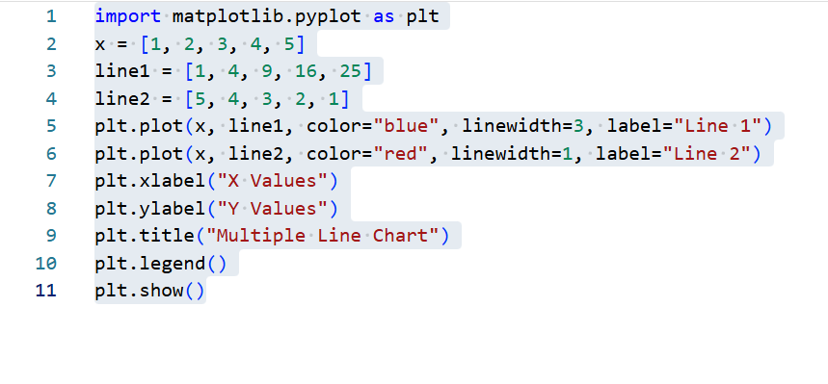
Output:
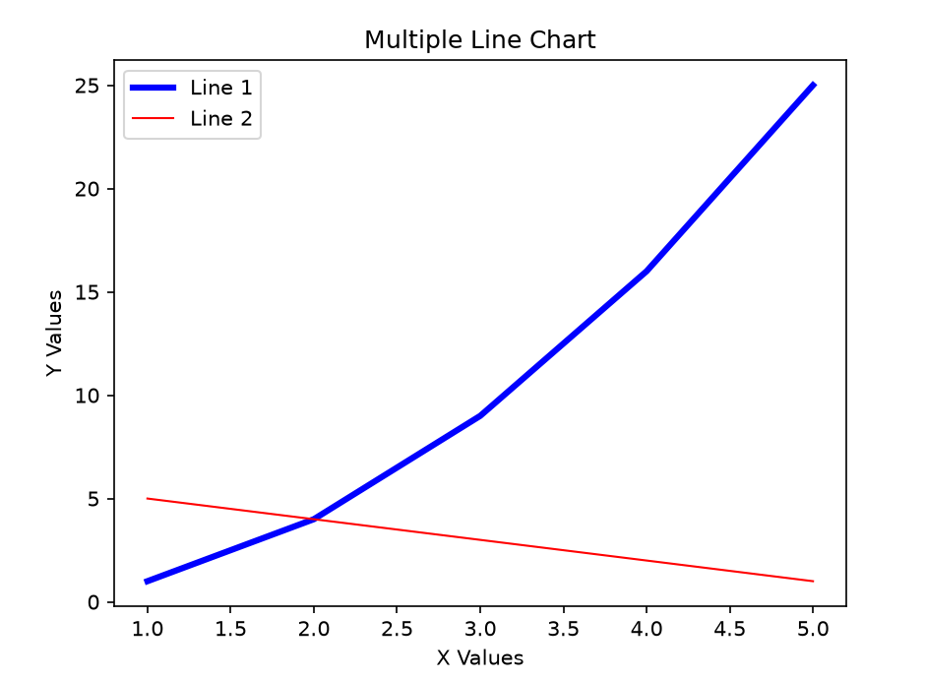
Result:
Multiple lines were successfully plotted with different widths, colors, and legends.

26. Create Multiple Plots
Aim
To write a Python program to create multiple plots in a single figure.
Dataset

X | Y1 | Y2
1 | 1 | 5
2 | 4 | 4
3 | 9 | 3
4 | 16 | 2
5 | 25 | 1
Python code
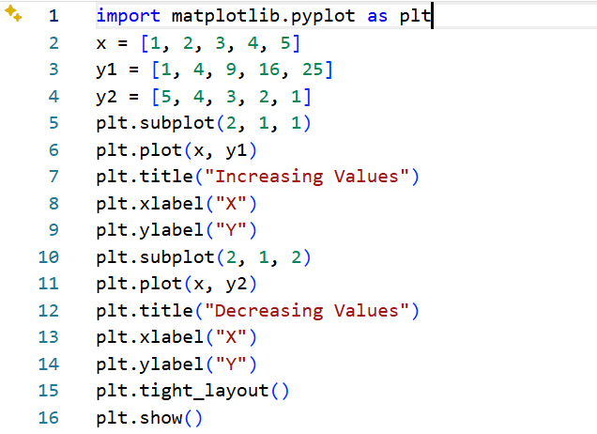
Output
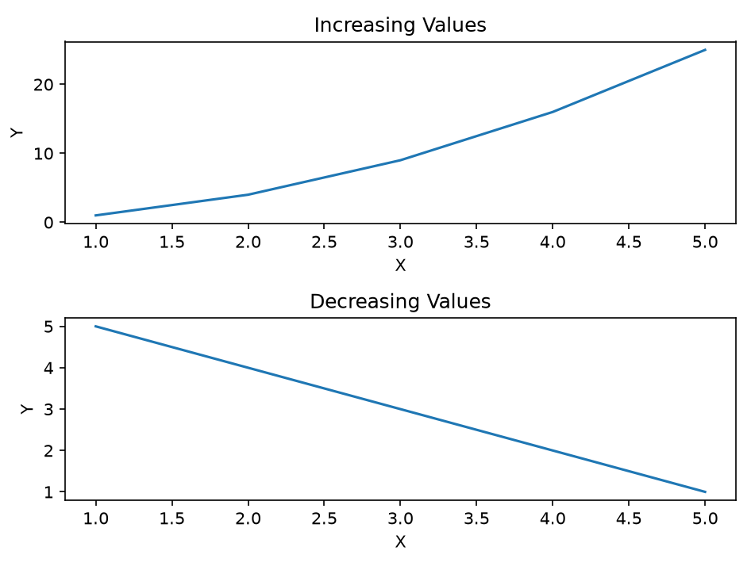
Result
Multiple plots were successfully created using subplot().

