27. Bar Chart of Popularity of Programming Languages
Aim
To write a Python program to display a bar chart representing the popularity of programming languages.
Dataset
Programming Language | Popularity
Python | 90
Java | 75
C++ | 65
JavaScript | 80
C | 60

Python code:
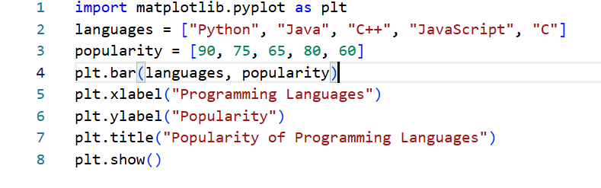
Output:
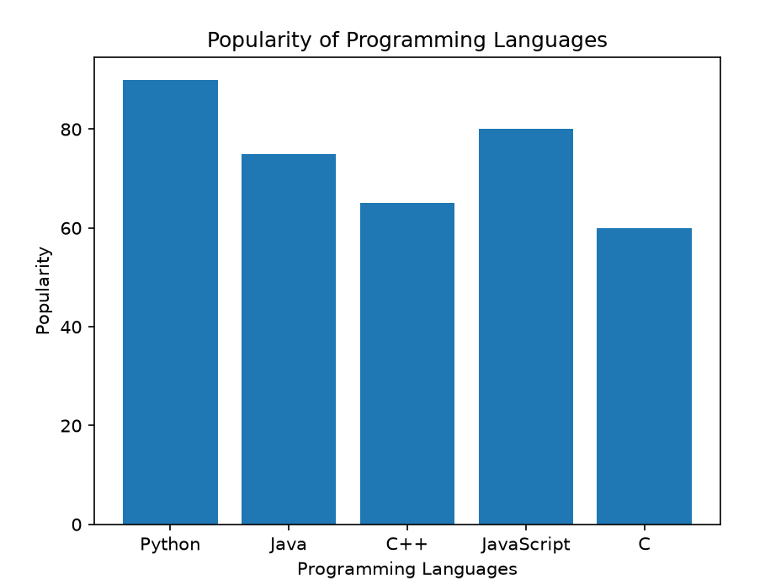
Result
The popularity of programming languages was successfully represented using a bar chart.

28. Horizontal Bar Chart of Programming Languages
Aim
To write a Python program to display a horizontal bar chart showing the popularity of programming languages.
Dataset
Programming Language | Popularity
Python | 90
Java | 75
C++ | 65
JavaScript | 80
C | 60

Python code:
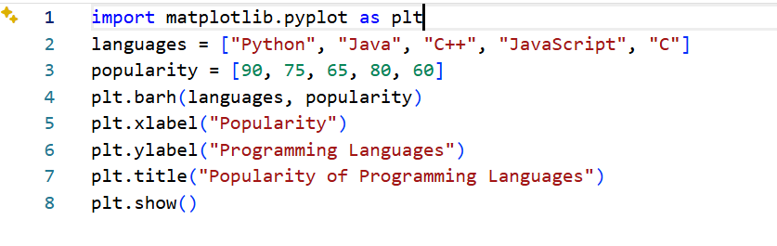
Output:
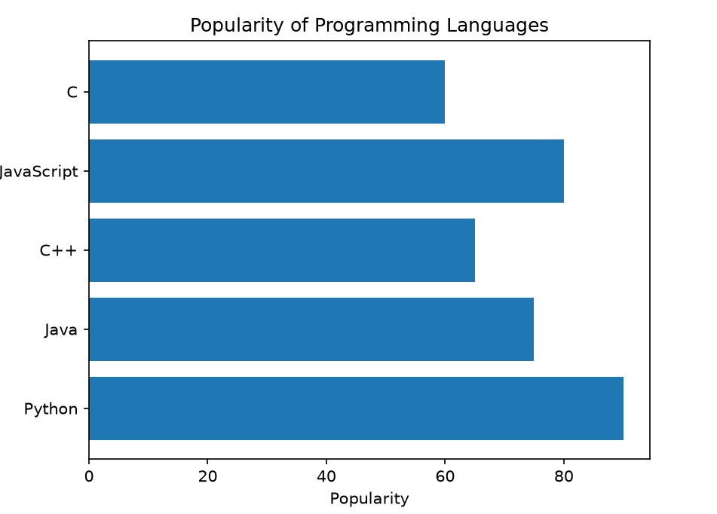
Result
A horizontal bar chart was successfully created using barh().

