29. Bar Chart with Different Colors
Aim
To write a Python program to display a bar chart of programming language popularity using different colors for each bar.
Dataset
Programming Language | Popularity
Python | 90
Java | 75
C++ | 65
JavaScript | 80
C | 60

Python code
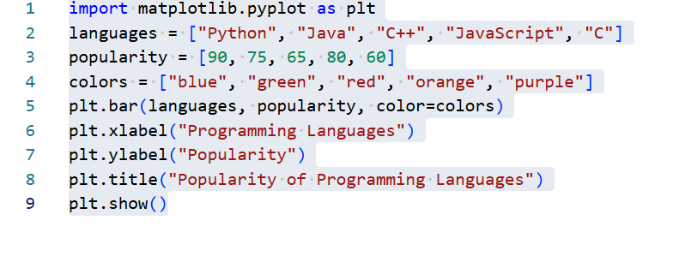

Output
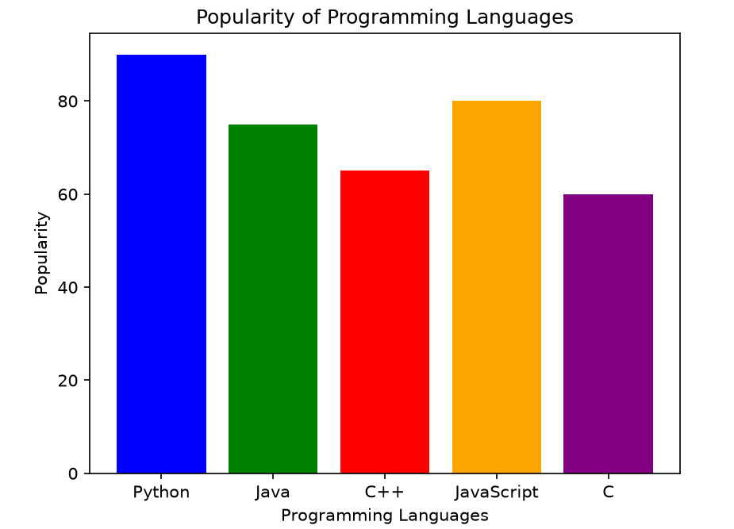
Result
A colored bar chart was successfully created to represent programming language popularity.

30. Bar Plot of Scores by Group and Gender
Aim
To write a Python program to create a bar plot showing scores by group and gender using multiple X-values on the same chart.
Dataset
Group | Men | Women
Group A | 75 | 80
Group B | 65 | 70
Group C | 85 | 90
Group D | 70 | 75
Python code:
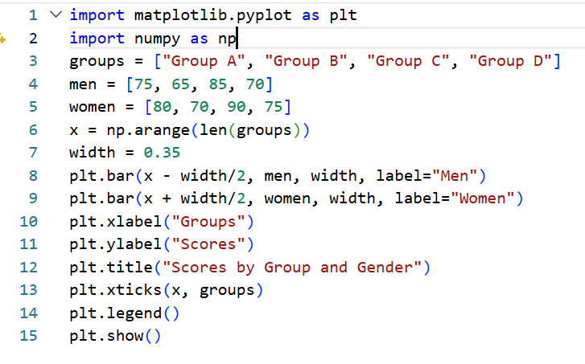
Output:
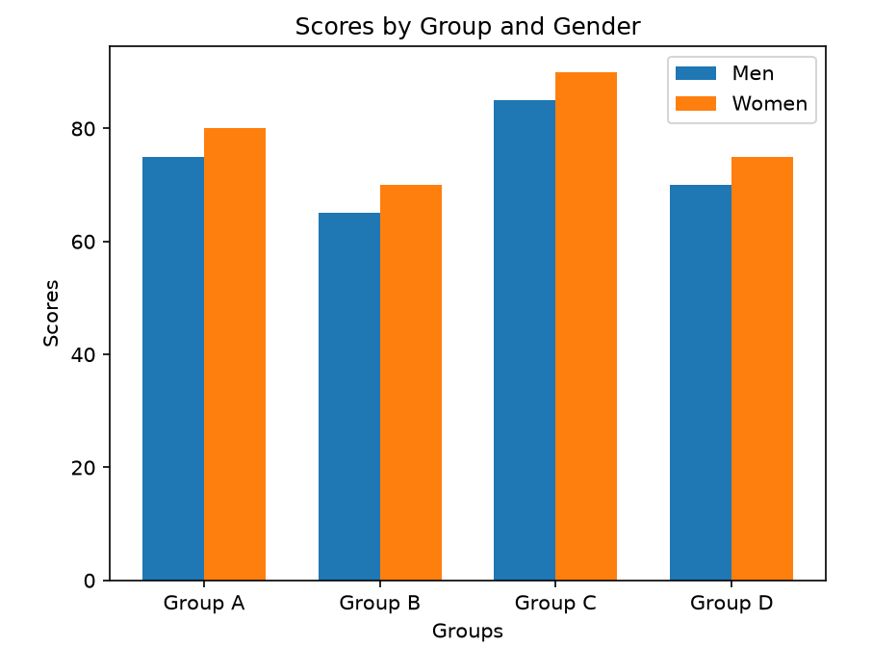
Result:
The scores of men and women were successfully represented using multiple X-values on the same bar chart.

