31. Stacked Bar Plot with Error Bars
Aim
To write a Python program to create a stacked bar plot with error bars.
Dataset
Group | Boys | Girls | Boys Error | Girls Error
A | 40 | 35 | 3 | 2
B | 50 | 45 | 4 | 3
C | 45 | 50 | 3 | 4
D | 60 | 55 | 5 | 3

Python code:
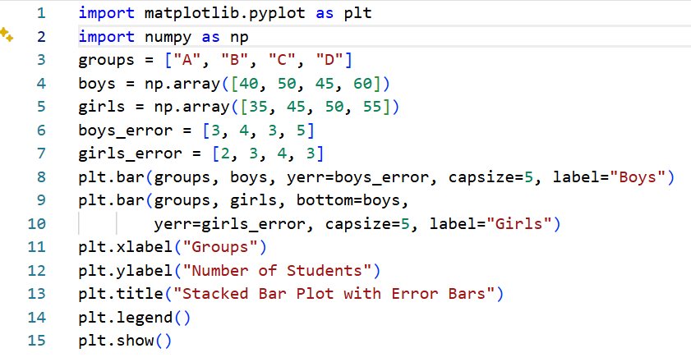
Output:
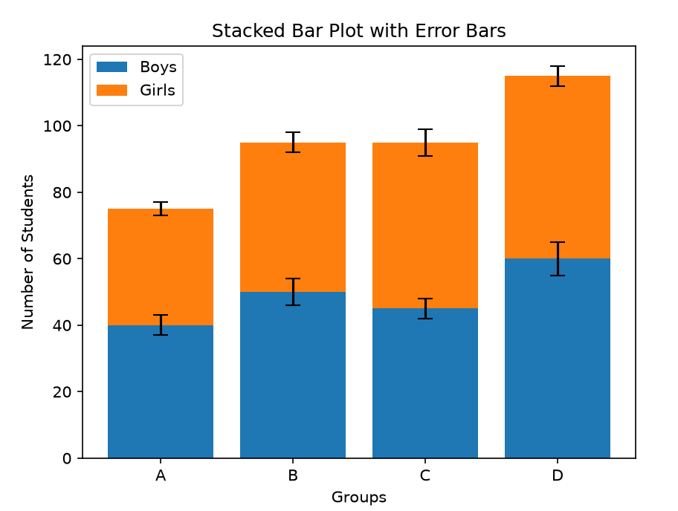
Result:
A stacked bar plot with error bars was successfully created.

32. Scatter Graph Using Random Distribution
Aim
To write a Python program to draw a scatter graph using randomly distributed X and Y values.
Dataset:
X | Y
Random | Random
Random | Random
Random | Random
Random | Random
Random | Random

Python
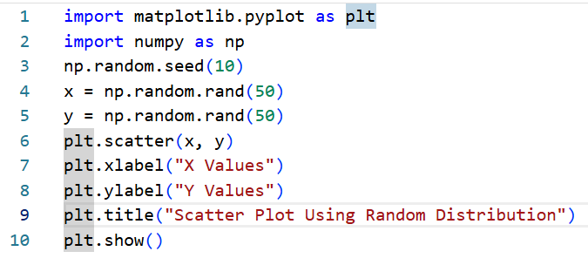
Output
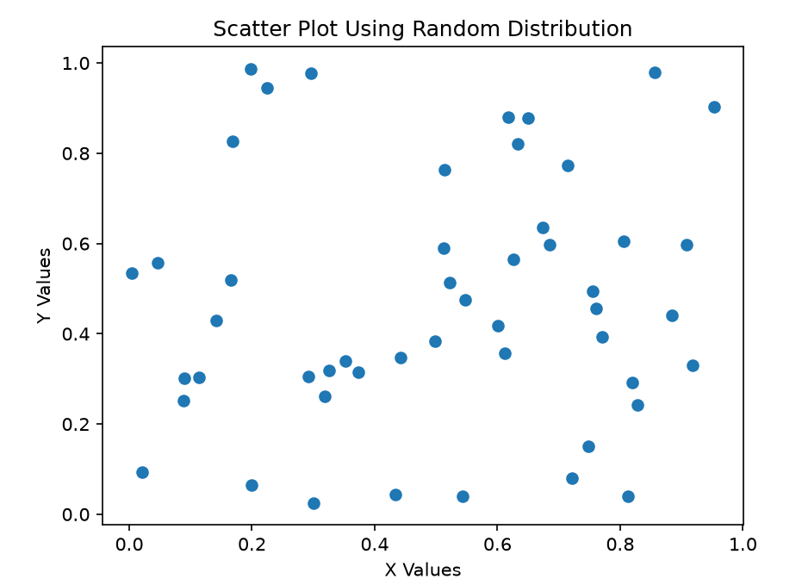
Result
A scatter graph was successfully created using random X and Y distributions.

