33. Scatter Plot with Empty Circles
Aim
To write a Python program to draw a scatter plot using random distributions with empty circles.
Dataset
Random X and Y values are generated using NumPy.
Python code:
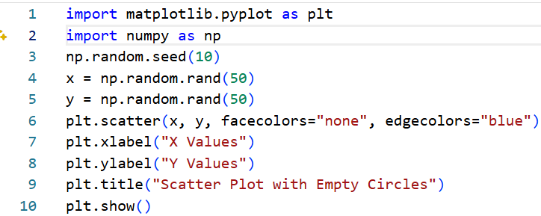
Output:
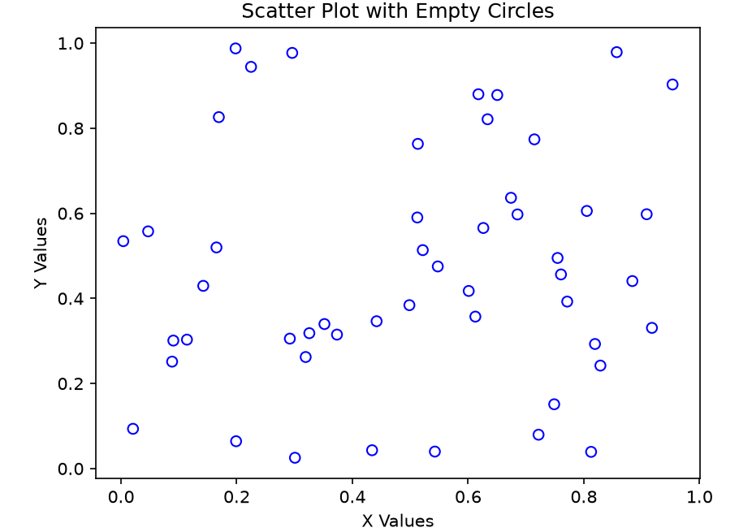
Result:
A scatter plot is displayed with randomly distributed empty circle markers.

34. Scatter Plot with Balls of Different Sizes
Aim
To write a Python program to create a scatter plot using random distributions and represent the points with different sizes.
Dataset
Random X, Y, and size values are generated.
X | Y | Size
Random | Random | Random
Random | Random | Random
Random | Random | Random
Random | Random | Random
Python
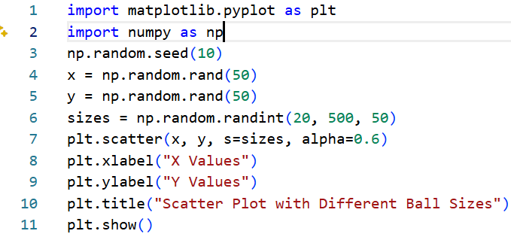

Output:
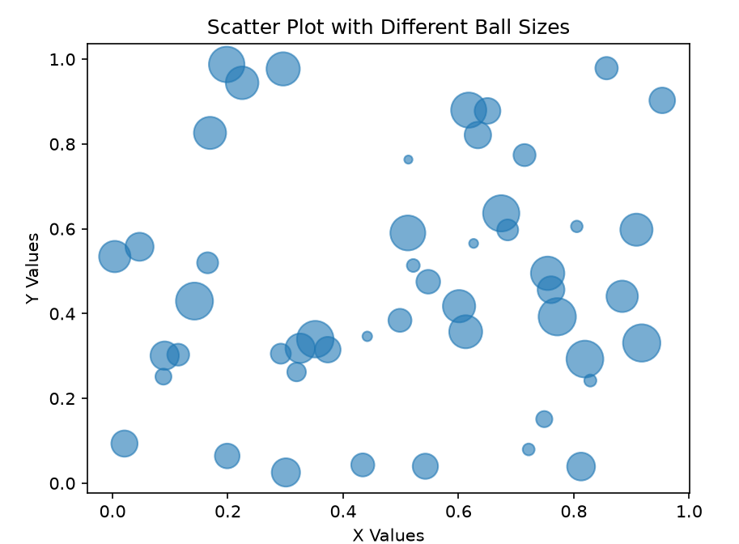
Result:
A scatter plot with randomly generated points of different sizes was successfully created.

