35. Scatter Plot Comparing Two Subject Marks
Aim
To write a Python program to draw a scatter plot comparing marks obtained in two subjects.
Dataset

Student | Mathematics | Science
Anu | 85 | 80
Bala | 72 | 75
Cathy | 90 | 88
David | 65 | 70
Esha | 78 | 82
Farhan | 92 | 95
Gita | 60 | 65
Hari | 88 | 84

Python code:
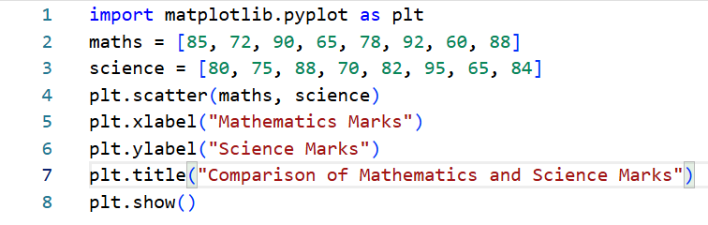
Output
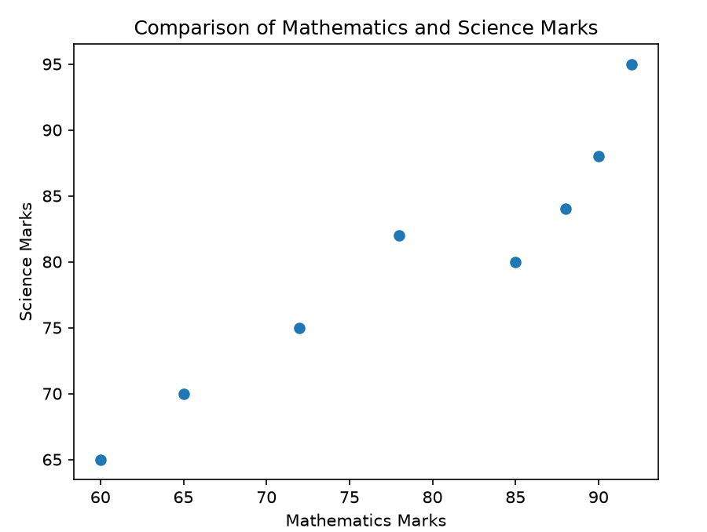
Result:
The relationship between Mathematics and Science marks was successfully represented using a scatter plot.

Dataset
36. Scatter Plot for Three Groups Comparing Weights and Heights
Aim
To write a Python program to draw a scatter plot for three different groups comparing their weights and heights.
Dataset
Group | Height (cm) | Weight (kg)
Group A | 150 | 50
Group A | 155 | 53
Group A | 160 | 55
Group B | 165 | 60
Group B | 170 | 65
Group B | 175 | 68
Group C | 180 | 72
Group C | 185 | 78
Group C | 190 | 82

Python code:

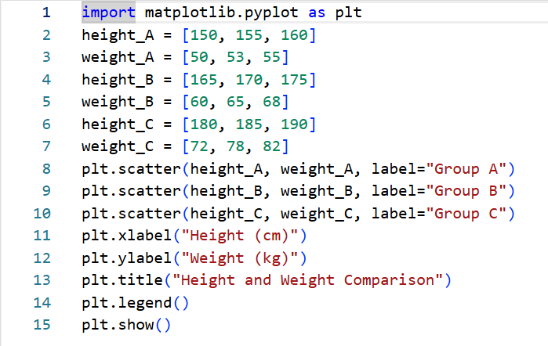

Output
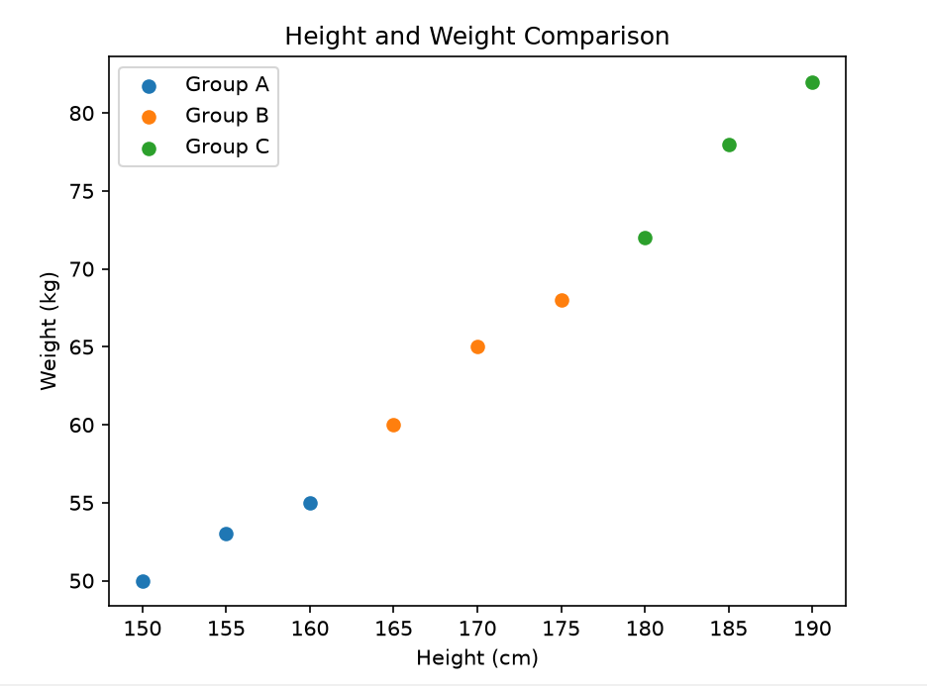
Result:
The heights and weights of three groups were successfully compared using a scatter plot.

