37. Create a DataFrame from a Dictionary
Aim
To write a Pandas program to create a DataFrame from a dictionary and display it.
Dataset
Name | Age | Marks
Anu | 20 | 85
Bala | 21 | 78
Cathy | 20 | 90
David | 22 | 75

Python code:
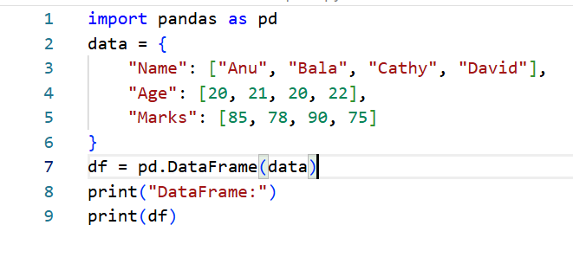
Output
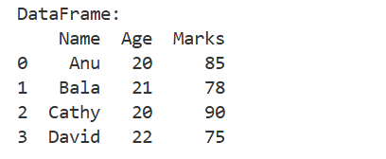

Result
A DataFrame was successfully created from a dictionary and displayed.

38. DataFrame with Index Labels
Aim
To write a Pandas program to create and display a DataFrame from dictionary data with specified index labels.
Dataset
Index | Name | Age | Marks
S1 | Anu | 20 | 85
S2 | Bala | 21 | 78
S3 | Cathy | 20 | 90
S4 | David | 22 | 75
Python code
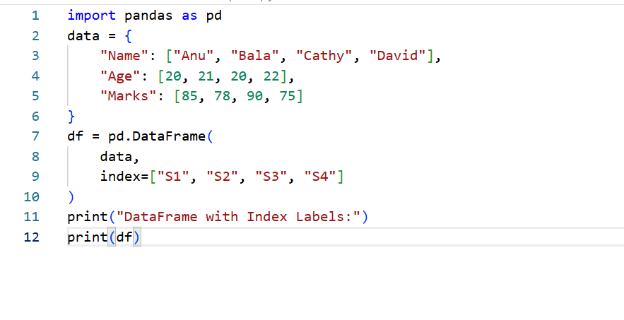
Output
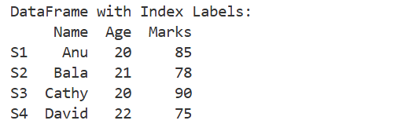
Result
A DataFrame was successfully created with specified index labels.

