39. Get the First 3 Rows of a DataFrame
Aim
To write a Pandas program to retrieve and display the first three rows of a given DataFrame.
Dataset
Name | Age | Marks
Anu | 20 | 85
Bala | 21 | 78
Cathy | 20 | 90
David | 22 | 75
Esha | 21 | 88

Python code
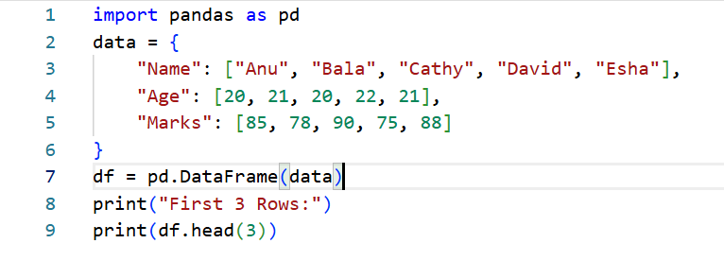
Output
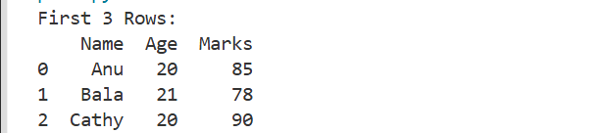

Result
The first three rows of the DataFrame were successfully displayed using head(3).

40. Select Name and Score Columns
Aim
To write a Pandas program to select the Name and Score columns from a given DataFrame.
Dataset
Name | Age | Score | City
Anu | 20 | 85 | Chennai
Bala | 21 | 78 | Madurai
Cathy | 20 | 90 | Coimbatore
David | 22 | 75 | Chennai
Esha | 21 | 88 | Bangalore

Python code
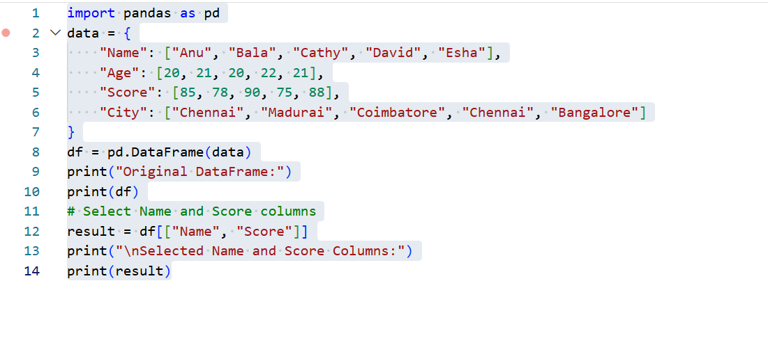
Output
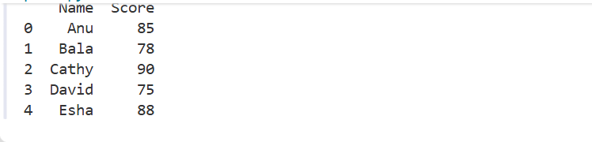
Result
The Name and Score columns were successfully selected from the DataFrame.

