17.Write a Pandas program to split the following dataframe by school code and get mean, min, and max value of age for each school.

Aim:
To split a Pandas DataFrame based on school code and calculate the mean, minimum, and maximum age for each school.
Dataset:
School_Code | Name | Age
101 | Arun | 15
101 | Bala | 16
102 | Charan | 14
102 | David | 15
103 | Esha | 17
103 | Farah | 16

Python code:
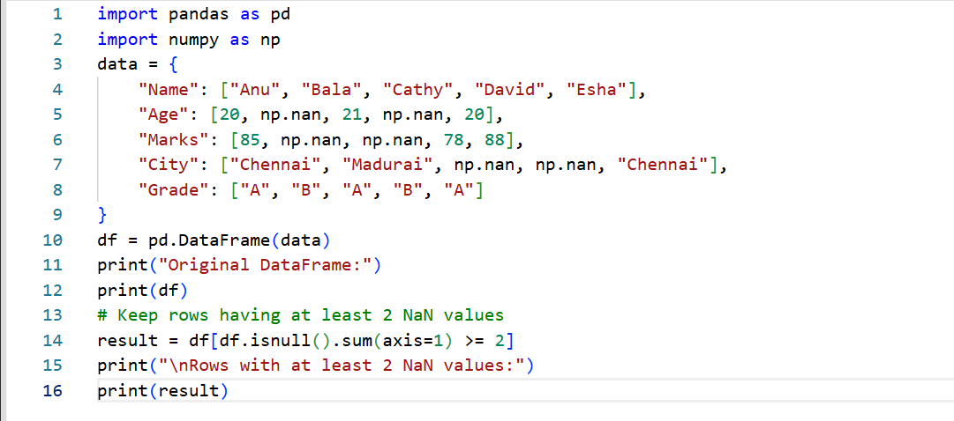
Output:
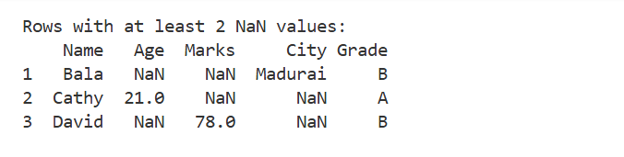
Result:
The Pandas program successfully splits the DataFrame based on School_Code and calculates the mean, minimum, and maximum age for each school. The program displays the age statistics separately for each school code.
18. Split DataFrame into Groups Based on School Code and Class
Aim:
To split a Pandas DataFrame into groups based on school code and class using the groupby() function.
Dataset
School_Code | Class | Name
101 | 10 | Arun
101 | 10 | Bala
101 | 11 | Charan
102 | 10 | David
102 | 11 | Esha
102 | 11 | Farah

Python code:

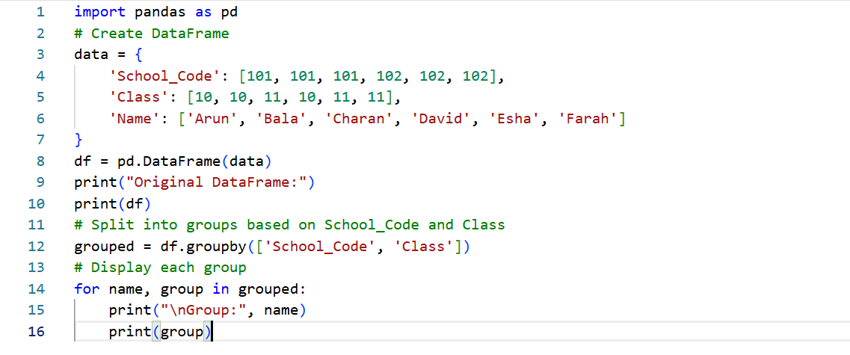
Output:
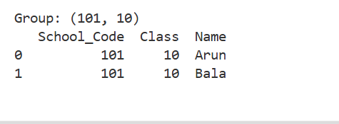
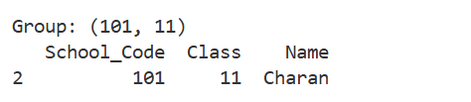
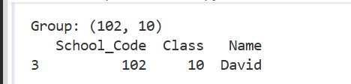
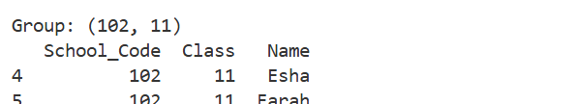

Result:
The Pandas program successfully splits the DataFrame into groups based on School_Code and Class. Each group contains the students belonging to the same school and class, allowing the data to be analyzed separately for each group.

