SIMATS ENGINEERING (SAVEETHA SCHOOL OF ENGINEERING)
Department of Computer Science and Engineering
CO1_AT3 — VISUALIZATION DESIGN EXERCISE

Course Code: | DSA06 | Course Title: | Data Handling and Visualization
CO Assessed: | CO1 – Precision (BL2) | Assessment: | Assessment Tool 3 – Visualization Design
Weightage: | 40% of CIA | Total Marks: | 20 (2 Questions × 10 Marks)
CO1 Statement: | Understand the fundamental concepts, principles, and techniques of data visualization.(BL2)
Student Name: | Sania Herbert | Reg. No.: | 192324062
Section / Batch: | 2023/AI&DS | Date: | 08.08.26

Code of Conduct
I Sania Herbert(192324062) certify that this submission is my original work and that I have adhered to the guidelines specified for this assessment. I understand that any violation of academic integrity rules will result in disciplinary action.

Signature of the Student: Sania

Instructions
- This assessment contains 2 questions, each carrying 10 marks. Total: 20 Marks.
- No negative marking. Unanswered questions carry zero marks.
- No calculators or electronic devices permitted.
- Duration: 60 minutes.

Annexure A – VISUALIZATION DESIGN

ASSESSMENT RUBRIC
AT3 — Visualization Design Exercise
CO1 · BT3: Apply ·
This rubric is used to assess student responses to the AT3 Visualization Design Exercise problems, in which students design and justify a complete visualization (chart type, aesthetic mappings, scales, coordinate systems, and/or color scheme) for a given dataset or design brief.

Criteria | Weightage | Level 4 – Exemplary | Level 3 – Proficient | Level 2 – Developing | Level 1 – Beginning
Understanding of Concepts | 25% | Demonstrates thorough, accurate understanding of chart types, aesthetic mappings, scales, coordinate systems, and color scales, and correctly identifies which apply to the given design scenario. | Good understanding of the relevant design concepts, with only minor gaps in selecting appropriate chart types, aesthetic mappings, or scales. | Basic understanding of design concepts, but with some misconceptions about appropriate chart types, aesthetics, or scales for the scenario. | Poor understanding of core design concepts; proposes chart types or mappings that are fundamentally unsuited to the data.
Explanation | 25% | Provides detailed, well-reasoned justification for every design decision, explicitly connecting each choice to the properties of the data and the scenario. | Provides clear justification for design decisions, with adequate reasoning for most sub-questions. | Justification is limited or superficial; design choices are stated without sufficient reasoning. | Little or no justification provided; design choices appear arbitrary or unexplained.
Application | 20% | Effectively applies visualization design principles to produce a complete, appropriate, and well-reasoned design solution for the specific scenario. | Applies design principles to produce an appropriate solution, with only minor errors or missed refinements. | Limited application of design principles; the proposed design partially addresses the scenario but has notable weaknesses. | Fails to apply appropriate design principles; the proposed design does not suit the scenario or data.
Organization | 15% | The design proposal is clearly structured, addressing each sub-question (a, b, c) in a logical sequence with coherent flow throughout. | The proposal is organized and addresses each sub-question, with only minor issues in flow or clarity. | Basic structure; sub-questions are addressed but the proposal lacks clarity or a logical sequence. | Poorly organized; the proposal is incoherent, and sub-questions are left unaddressed or answered out of order.
Accuracy | 10% | All design choices — chart type, aesthetic mapping, scale, coordinate system, and/or color scheme — are completely accurate and well-suited to the data. | Mostly accurate design choices, with only minor omissions or a small error in one part of the proposal. | Partially correct; some design elements are missing, mismatched to the data, or incorrect. | Design choices are largely incorrect or inappropriate, with major gaps in matching the visualization to the data.

Scoring Guide
For each criterion, award a performance level (1–4) based on the descriptors above. Multiply the level achieved (as a percentage of 4, i.e., Level 4 = 100%, Level 3 = 75%, Level 2 = 50%, Level 1 = 25%) by the criterion's weightage, then sum across all five criteria to obtain the total score out of 100%.

Faculty In-charge | Course Coordinator | Head of Department
Signature: _______________ | Signature: _______________ | Signature: _______________
Date: ___________________ | Date: ___________________ | Date: ___________________

Que-5:
Scenario: An online store wants to visualize the relationship between Product Price (numeric) and
Number of Units Sold (numeric) across 150 products, also noting each products Category (nominal, 5 categories).
a) Design a chart that reveals the relationship between price and units sold while distinguishing category.
b) Justify your aesthetic choice for encoding Category (color vs. shape vs. small multiples).
c) What scale (linear or logarithmic) would you use for each axis if prices range from $5 to $5,000? Justify.

Product_ID | Category | Product_Price | Units_Sold
P001 | Electronics | 5 | 831
P002 | Clothing | 5.24 | 1016
P003 | Books | 5.49 | 1153
P004 | Home | 5.75 | 739
P005 | Toys | 6.02 | 875
P006 | Electronics | 6.3 | 744
P007 | Clothing | 6.6 | 909
P008 | Books | 6.92 | 1031
P009 | Home | 7.25 | 661
P010 | Toys | 7.59 | 782
P011 | Electronics | 7.95 | 665
P012 | Clothing | 8.33 | 813
P013 | Books | 8.72 | 923
P014 | Home | 9.14 | 591
P015 | Toys | 9.57 | 700
P016 | Electronics | 10.02 | 595
P017 | Clothing | 10.5 | 728
P018 | Books | 11 | 826
P019 | Home | 11.52 | 529
P020 | Toys | 12.06 | 627
P021 | Electronics | 12.64 | 533
P022 | Clothing | 13.24 | 651
P023 | Books | 13.87 | 739
P024 | Home | 14.52 | 473
P025 | Toys | 15.21 | 560
P026 | Electronics | 15.93 | 477
P027 | Clothing | 16.69 | 583
P028 | Books | 17.48 | 661
P029 | Home | 18.31 | 424
P030 | Toys | 19.18 | 501
P031 | Electronics | 20.09 | 426
P032 | Clothing | 21.04 | 521
P033 | Books | 22.04 | 591
P034 | Home | 23.09 | 379
P035 | Toys | 24.18 | 449
P036 | Electronics | 25.33 | 382
P037 | Clothing | 26.53 | 466
P038 | Books | 27.79 | 529
P039 | Home | 29.11 | 339
P040 | Toys | 30.49 | 401
P041 | Electronics | 31.94 | 341
P042 | Clothing | 33.46 | 417
P043 | Books | 35.04 | 473
P044 | Home | 36.71 | 303
P045 | Toys | 38.45 | 359
P046 | Electronics | 40.27 | 305
P047 | Clothing | 42.18 | 373
P048 | Books | 44.19 | 424
P049 | Home | 46.28 | 271
P050 | Toys | 48.48 | 321
P051 | Electronics | 50.78 | 273
P052 | Clothing | 53.19 | 334
P053 | Books | 55.71 | 379
P054 | Home | 58.36 | 243
P055 | Toys | 61.12 | 287
P056 | Electronics | 64.03 | 244
P057 | Clothing | 67.06 | 299
P058 | Books | 70.25 | 339
P059 | Home | 73.58 | 217
P060 | Toys | 77.07 | 257
P061 | Electronics | 80.73 | 219
P062 | Clothing | 84.56 | 267
P063 | Books | 88.57 | 303
P064 | Home | 92.77 | 194
P065 | Toys | 97.18 | 230
P066 | Electronics | 101.79 | 196
P067 | Clothing | 106.62 | 239
P068 | Books | 111.68 | 271
P069 | Home | 116.98 | 174
P070 | Toys | 122.53 | 206
P071 | Electronics | 128.34 | 175
P072 | Clothing | 134.43 | 214
P073 | Books | 140.81 | 243
P074 | Home | 147.49 | 156
P075 | Toys | 154.49 | 184
P076 | Electronics | 161.82 | 157
P077 | Clothing | 169.5 | 192
P078 | Books | 177.54 | 217
P079 | Home | 185.97 | 139
P080 | Toys | 194.79 | 165
P081 | Electronics | 204.04 | 140
P082 | Clothing | 213.72 | 171
P083 | Books | 223.86 | 194
P084 | Home | 234.48 | 125
P085 | Toys | 245.61 | 147
P086 | Electronics | 257.26 | 125
P087 | Clothing | 269.47 | 153
P088 | Books | 282.26 | 174
P089 | Home | 295.65 | 111
P090 | Toys | 309.68 | 132
P091 | Electronics | 324.38 | 112
P092 | Clothing | 339.77 | 137
P093 | Books | 355.89 | 156
P094 | Home | 372.78 | 100
P095 | Toys | 390.47 | 118
P096 | Electronics | 409 | 100
P097 | Clothing | 428.41 | 123
P098 | Books | 448.74 | 139
P099 | Home | 470.03 | 89
P100 | Toys | 492.33 | 106
P101 | Electronics | 515.69 | 90
P102 | Clothing | 540.17 | 110
P103 | Books | 565.8 | 125
P104 | Home | 592.65 | 80
P105 | Toys | 620.77 | 94
P106 | Electronics | 650.23 | 80
P107 | Clothing | 681.08 | 98
P108 | Books | 713.4 | 111
P109 | Home | 747.25 | 71
P110 | Toys | 782.71 | 85
P111 | Electronics | 819.85 | 72
P112 | Clothing | 858.76 | 88
P113 | Books | 899.5 | 100
P114 | Home | 942.19 | 64
P115 | Toys | 986.9 | 76
P116 | Electronics | 1033.73 | 64
P117 | Clothing | 1082.78 | 79
P118 | Books | 1134.16 | 89
P119 | Home | 1187.98 | 57
P120 | Toys | 1244.35 | 68
P121 | Electronics | 1303.4 | 58
P122 | Clothing | 1365.25 | 70
P123 | Books | 1430.03 | 80
P124 | Home | 1497.89 | 51
P125 | Toys | 1568.97 | 61
P126 | Electronics | 1643.42 | 51
P127 | Clothing | 1721.4 | 63
P128 | Books | 1803.09 | 71
P129 | Home | 1888.65 | 46
P130 | Toys | 1978.27 | 54
P131 | Electronics | 2072.14 | 46
P132 | Clothing | 2170.47 | 56
P133 | Books | 2273.46 | 64
P134 | Home | 2381.35 | 41
P135 | Toys | 2494.35 | 48
P136 | Electronics | 2612.71 | 41
P137 | Clothing | 2736.69 | 50
P138 | Books | 2866.55 | 57
P139 | Home | 3002.57 | 37
P140 | Toys | 3145.05 | 43
P141 | Electronics | 3294.29 | 37
P142 | Clothing | 3450.61 | 45
P143 | Books | 3614.35 | 51
P144 | Home | 3785.86 | 33
P145 | Toys | 3965.51 | 39
P146 | Electronics | 4153.68 | 33
P147 | Clothing | 4350.78 | 40
P148 | Books | 4557.24 | 46
P149 | Home | 4773.49 | 29
P150 | Toys | 5000 | 35

Tableau construction
- Open Tableau and connect your dataset.
- Create a new worksheet.
- Drag Product Price → Columns.
- Drag Units Sold → Rows.
- In the Marks card, select Circle.
- Drag Category → Color.
- Drag Product Name/Product ID → Detail if necessary so that each product appears as an individual point.
- Add a suitable title.
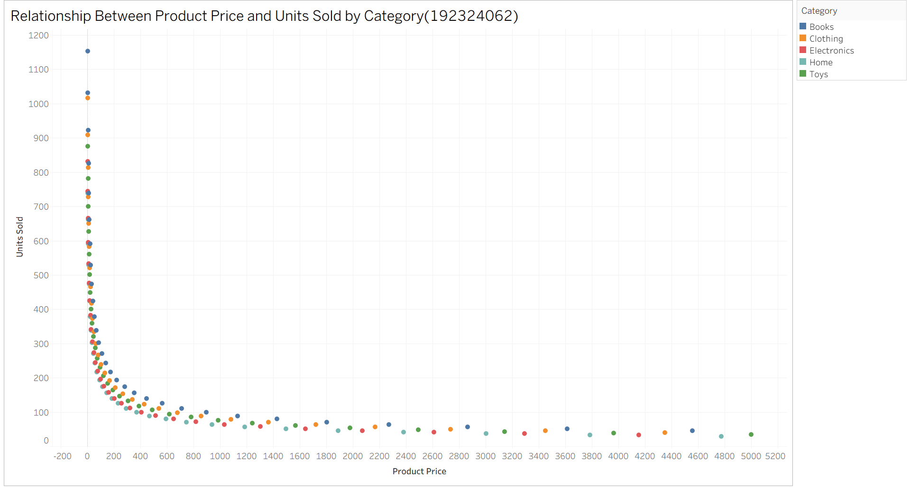
Each product becomes one point:
- X-axis = Price
- Y-axis = Units Sold
- Color = Category
This allows you to identify whether higher prices are associated with higher or lower sales and whether the relationship differs between categories.
b) Which aesthetic should encode Category?
Best choice: Color
I would use color to distinguish the five product categories.
Why color?
There are only 5 nominal categories, so color provides an immediate visual distinction while allowing all 150 products to remain visible in the same scatter plot
c) Linear or logarithmic scale?
The price range is:
Calculate the ratio:
So the maximum price is 1,000 times the minimum price.
Recommended scale
Logarithmic scale for Product Price.
Why?
A linear scale would give equal visual space to equal absolute changes:
$0 → $1000 → $2000 → $3000 → $4000 → $5000
This makes the lower-price products between $5 and $100 extremely compressed.
A logarithmic scale instead represents multiplicative changes:
$5 → $10 → $50 → $100 → $500 → $1000 → $5000
This provides much better visibility across the extremely wide price range.

Problem 15 :
Scenario: You are designing a dashboard to show a companys profit or loss for each of its 12 regional
branches in a given month.
a) Design a color scheme for this chart. Which type of color scale would you use, and why?
b) Specify what color you would assign to a branch with exactly zero profit/loss, and justify this choice.
c) Describe how you would visually distinguish a branch with a small loss from one with a large loss using your
color scale.
Branch | Profit_Loss
North | 25,000
South | -12,000
East | 5,000
West | -45,000
Central | 0
Northeast | 18,000
Northwest | -3,000
Southeast | 42,000
Southwest | -75,000
Metro | 8,000
Coastal | -25,000
Inland | 15,000
Part A — Design the Color Scheme
Requirement
Which type of color scale would you use, and why?
Use a Diverging Color Scale.
You want:
Loss ← Zero → Profit
For example:
Dark Red → Light Red → Gray → Light Green → Dark Green
Tableau Steps
Step 1 — Connect the dataset
- Open Tableau.
- Select Microsoft Excel.
- Open:
Problem_15_Regional_Profit_Loss.xlsx
- Select the sheet.
- Click Sheet 1.

Step 2 — Create the basic chart
Drag:
Branch → Rows
Then:
Profit_Loss → Columns
Your chart should now look like a horizontal bar chart.
Step 3 — Change Marks to Bar
On the Marks card:
Automatic → Bar

Step 4 — Add color
Drag:
Profit_Loss → Color
You should now see the bars colored according to their profit/loss values.

Step 5 — Select Diverging Colors
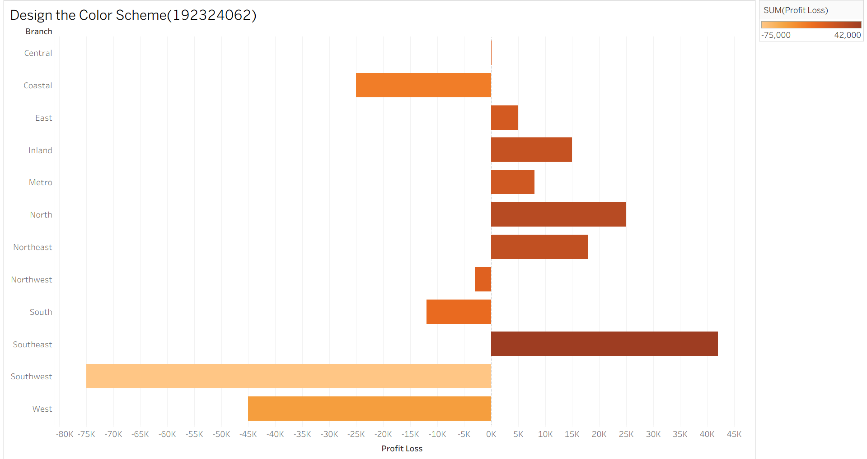
b) Zero profit/loss
A branch with exactly zero profit/loss would be assigned neutral gray. Gray represents neither profit nor loss and clearly identifies the break-even point between the two sides of the diverging scale.

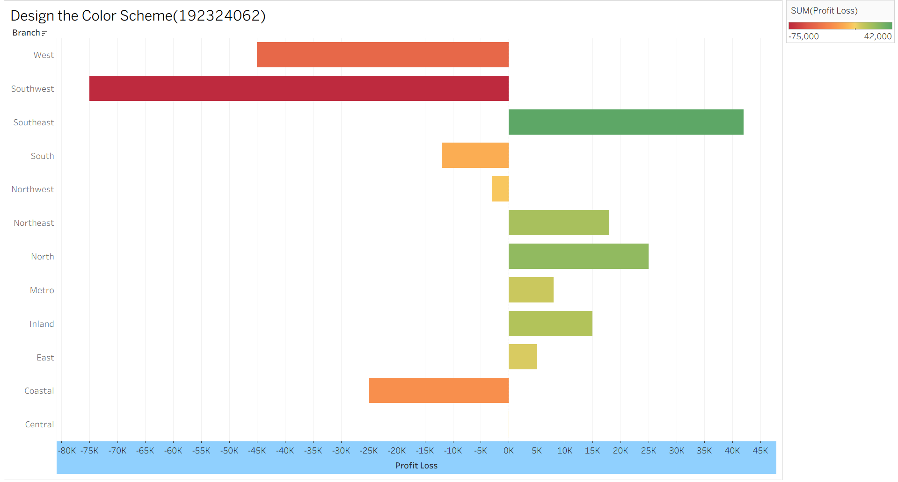
c) Small vs large loss
Losses would be represented using different intensities of red. A small loss would use a light red shade, while a large loss would use a dark red shade. Therefore, the magnitude of the loss can be identified immediately from the color intensity. For example, −$3,000 would be light red, while −$75,000 would be dark red.

