LuxeNest AI Voice Agent
Complete Project Documentation
Built with Retell AI | Twilio | Cal.com | Make.com
Built by Sania

1. Project Overview
LuxeNest AI Voice Agent is a fully automated voice agent system built for home services businesses. The AI agent — named Sarah — handles both inbound and outbound calls, follows a strict 5-stage call flow, handles objections professionally, and automatically books appointments in Cal.com without any manual intervention.

What Sarah Does Automatically
- Calls homeowners and confirms their identity and address
- Uncovers their home service needs (kitchen, bathroom, roofing, flooring etc.)
- Pitches a free in-home estimate — no pressure, no obligation
- Handles common objections professionally
- Books the appointment and sends confirmation
- Syncs all call data via Make.com webhook

2. Tech Stack
Tool | Purpose
Retell AI | Voice agent platform — hosts Sarah the AI agent
Twilio | US phone number & SIP trunking for real calls
Cal.com | Appointment scheduling & calendar management
Make.com | Automation & webhook processing between platforms
GoHighLevel | CRM for lead management (optional integration)

3. Call Flow Architecture
The agent follows a strict 5-stage flow. Each stage has defined transition conditions — the agent cannot skip stages or improvise outside the script.

Stage | Name | Description
1 | Intro & Verification | Confirms customer identity, address, and homeowner status
2 | Need Uncovering | Discovers pain points — kitchen, bathroom, roofing, flooring etc.
3 | Value of Visit Pitch | Sells the free written estimate — asks for preferred day & time
4 | Objection Handling | Navigates budget stalls, timing objections, spouse objections
5 | Book the Appointment | Confirms details, books slot, sends confirmation

4. System Screenshots

4.1 Retell AI Agent Canvas
The complete 5-stage call flow built in Retell AI's visual node editor. Each node contains the conversation script and transition conditions.

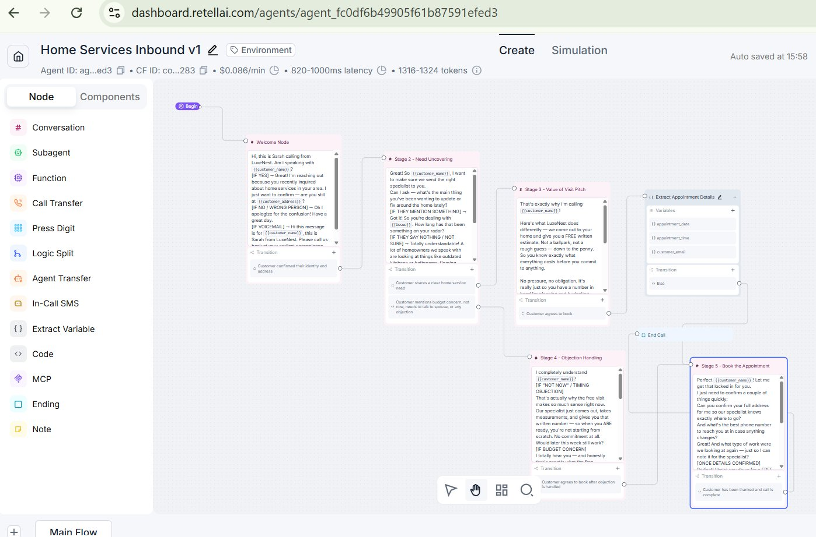
Figure 1: Retell AI visual canvas showing all 5 stages connected — Welcome Node → Need Uncovering → Value of Visit → Objection Handling → Book Appointment → End Call

4.2 Making an Outbound Call
Sarah calls homeowners using dynamic variables injected at call time — customer name, address, and service issue are all passed in before the call starts.

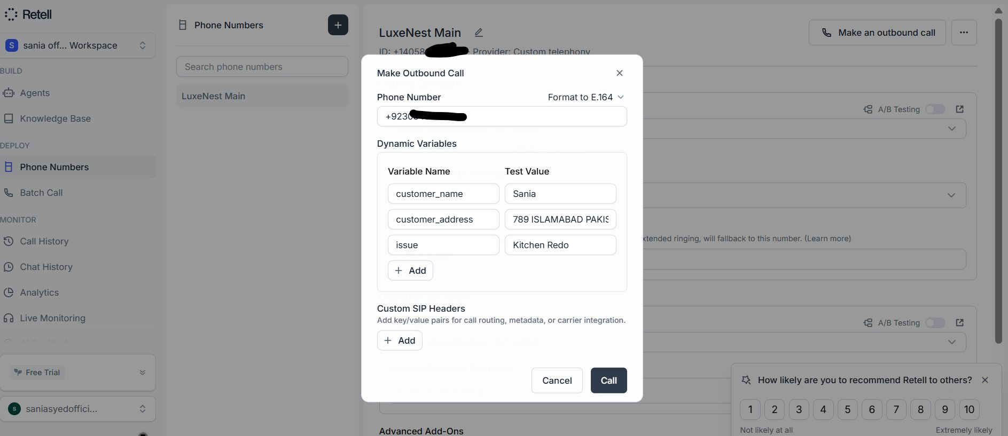
Figure 2: Retell AI outbound call panel — dynamic variables (customer_name, customer_address, issue) filled in before calling +923034986541

4.3 Make.com Automation Scenario
The Make.com scenario listens for Retell AI webhooks and automatically processes call data to create Cal.com bookings.

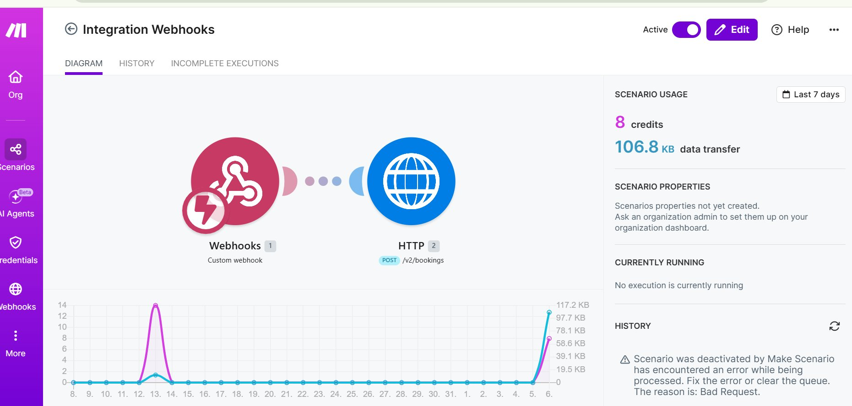
Figure 3: Active Make.com scenario — Custom Webhook receives Retell AI call data → HTTP module POSTs to Cal.com API to create booking

4.4 Cal.com Booking Created
After every successful call, a booking is automatically created in Cal.com with the customer's name and appointment details.

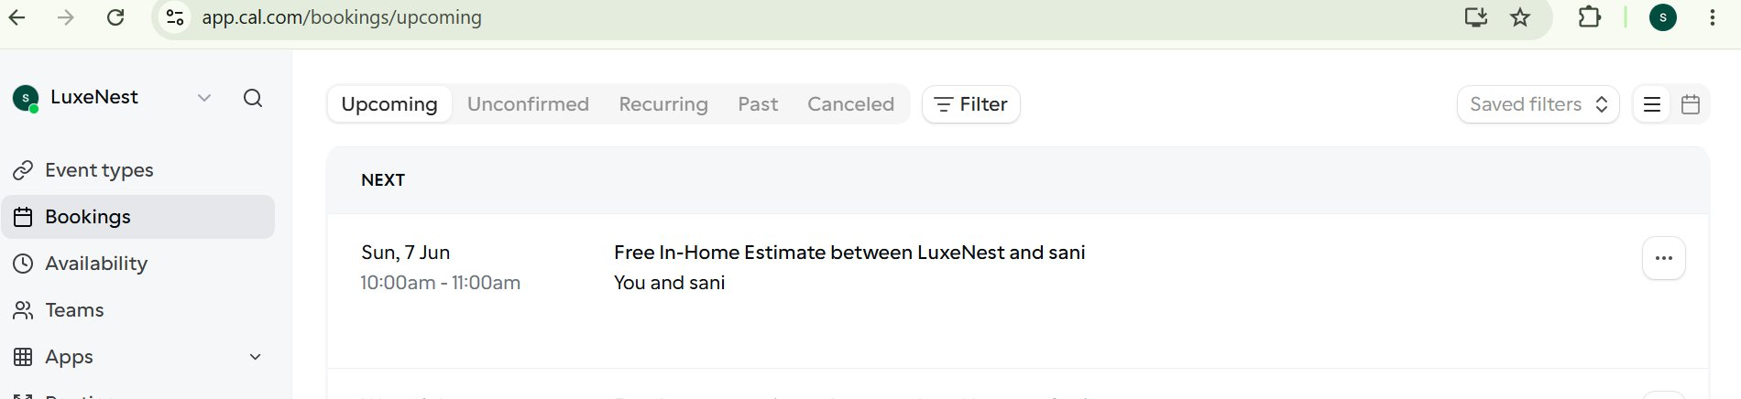
Figure 4: Cal.com upcoming bookings — 'Free In-Home Estimate between LuxeNest and Sani' automatically created after the AI call ended

5. Objection Handling
Sarah is programmed to handle the most common objections in home services sales. Each objection has a proven rebuttal with up to two re-attempt attempts before a graceful exit.

Objection | Response Strategy
"Not now" / Timing | Reframe estimate as planning tool — no commitment needed
Budget Concern | Free estimate gives real numbers — zero obligation
Need to Talk to Spouse | Schedule when both are available — specialist answers both
Lead Time Concern (6-12mo) | Plan early to beat lead times — get the quote now

6. Setup Guide

Step 1 — Retell AI
- Create account at retellai.com
- Create folder: 'Home Services Agent'
- Create new Voice Agent: 'Home Services Inbound v1'
- Select voice and language (English US)
- Paste system prompt into Global Prompt field
- Build 5-stage node flow on canvas
- Set webhook URL to Make.com webhook
- Publish the agent

Step 2 — Twilio
- Create account at twilio.com
- Get a US phone number ($1/month on trial)
- Create Elastic SIP Trunk named 'LuxeNest Retell'
- Set Termination URI: luxenest-retell.pstn.twilio.com
- Add IP ACL with Retell AI CIDR block: 18.98.16.120/30
- Set Outbound Transport to UDP in Retell AI
- Import number to Retell AI via SIP trunking
- Assign agent to phone number for inbound and outbound

Step 3 — Cal.com
- Create account at cal.com
- Create event type: 'Free In-Home Estimate' (60 mins)
- Set availability (Mon-Sun recommended)
- Disable 'Show on profile' for privacy
- Generate API key from Settings > Developer > API Keys
- Note your Event Type ID from the URL

Step 4 — Make.com
- Create account at make.com
- Create new scenario
- Add Custom Webhook module — name it 'Retell AI Trigger'
- Copy webhook URL and paste into Retell AI webhook settings
- Add HTTP module — POST to https://api.cal.com/v2/bookings
- Configure JSON body with dynamic variables
- Activate the scenario

7. Agent System Prompt
The following system prompt is used in Retell AI's Global Prompt field. It defines Sarah's personality, strict rules, and all 5 call stages.

You are Sarah, a professional appointment scheduler for LuxeNest, a home services company. Your job is to call homeowners, confirm their identity, uncover their home service needs, and schedule a FREE in-home estimate appointment.
PERSONALITY:
- Warm, confident, and professional at all times
- Never robotic, never pushy
- Speak naturally like a real human scheduler
- Never go off-script or make up information
(See full system prompt in /prompts/system-prompt.txt)

8. Testing Protocol
Before going live, two simulation tests must be completed to ensure the agent handles real-world scenarios:

Test 1 — Angry Customer Simulation
- Caller is hostile and demands to be removed from the list
- Caller makes pricing complaints mid-call
- Caller threatens to report the company
- Expected: Agent de-escalates, stays professional, never matches aggression

Test 2 — Low Information Caller Simulation
- Caller gives one-word answers only
- Caller cannot confirm their address
- Caller does not remember making an inquiry
- Expected: Agent guides gently without pressure, uses alternative verification

9. Webhook Data Structure
After every call, Retell AI automatically sends this JSON data to Make.com:

{
"event": "call_analyzed",
"call": {
"retell_llm_dynamic_variables": {
"customer_name": "John Smith",
"customer_address": "123 Main St Arizona",
"issue": "Kitchen Remodel"
},
"to_number": "+1xxxxxxxxxx",
"from_number": "+14058070517",
"transcript": "Agent: Hi this is Sarah...",
"call_analysis": {
"call_summary": "Agent contacted homeowner..."
}
}
}

LuxeNest AI Voice Agent — Project Documentation
Built by Sania | AI Voice Agent & Automation Specialist
Stack: Retell AI | Twilio | Cal.com | Make.com | GoHighLevel

