Fundamentals of Machine Learning

Sania Fatima

2023-09-10

library(tinytex)  
getwd()

## [1] "C:/Users/Sania fatima/Desktop/FML"

setwd("C:/Users/Sania fatima/Desktop/FML")  
Sania<-read.csv("Example 1.csv")  
hist(Sania$Tallness)

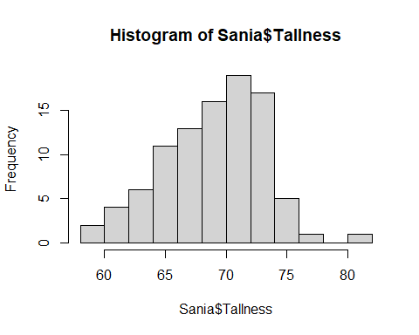

plot(Sania$Tallness,Sania$Weight)

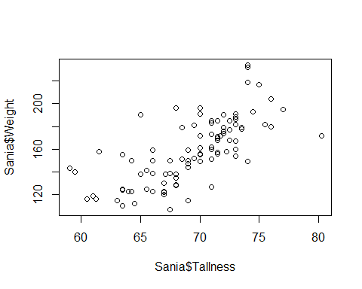

summary(Sania)

## Serial.No. Gender Age Tallness   
## Min. : 1.0 Length:95 Min. :20.00 Min. :59.00   
## 1st Qu.:24.5 Class :character 1st Qu.:22.00 1st Qu.:67.00   
## Median :48.0 Mode :character Median :23.00 Median :70.00   
## Mean :48.0 Mean :24.32 Mean :69.33   
## 3rd Qu.:71.5 3rd Qu.:26.00 3rd Qu.:72.12   
## Max. :95.0 Max. :40.00 Max. :80.25   
## Weight BMI   
## Min. :107.0 Min. :17.00   
## 1st Qu.:138.0 1st Qu.:21.00   
## Median :158.0 Median :23.00   
## Mean :158.7 Mean :23.08   
## 3rd Qu.:179.0 3rd Qu.:25.00   
## Max. :234.0 Max. :32.00

summary(Sania$BMI)

## Min. 1st Qu. Median Mean 3rd Qu. Max.   
## 17.00 21.00 23.00 23.08 25.00 32.00

Sania1<-log10(Sania$BMI)  
summary(Sania1)

## Min. 1st Qu. Median Mean 3rd Qu. Max.   
## 1.230 1.322 1.362 1.360 1.398 1.505