EmployeeMS(Capstone Project)

Register:

* User needs to register themselves before logging in if they are not registered user. User can be of two type: admin and normal.
* In this Project admin user is hardcoded as username – sania123 and password – 123456. We can create as many normal user as we want by using this below registration form. Normal user I created using form is username – john12 and password - 123456

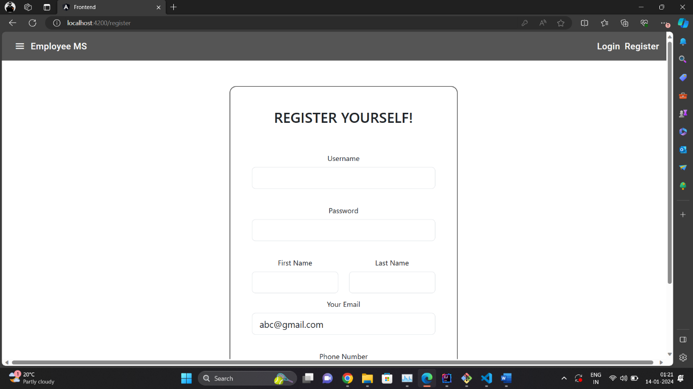

Login:

* After registration user will have username and password, they can use it to login in to EmployeeMS. Here first we will login using admin credentials.

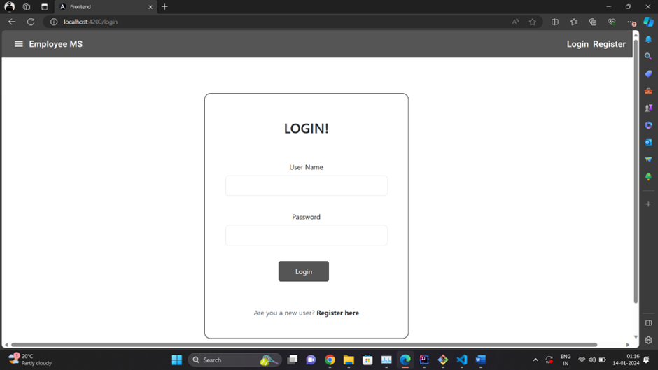

* Admin’s dashboard will open once login with admins’s credential.
* All the below menu will only be accessed by the Admin.
* ‘Admin’ role will have more authority compared to the ‘Normal’ role.
* Admin can add new employee, remove employee, update details of the existing employee, find employe by using employee id as well as employee name.

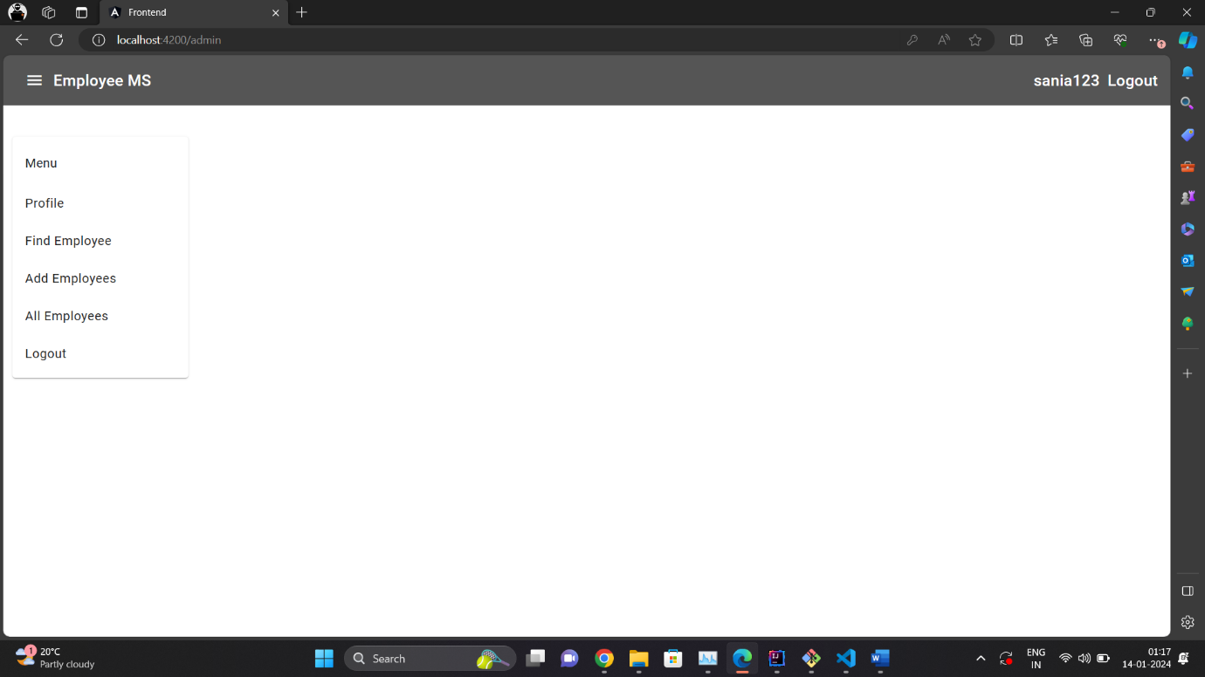

Profile:

* We will get current user’s details including username, userid, role and status

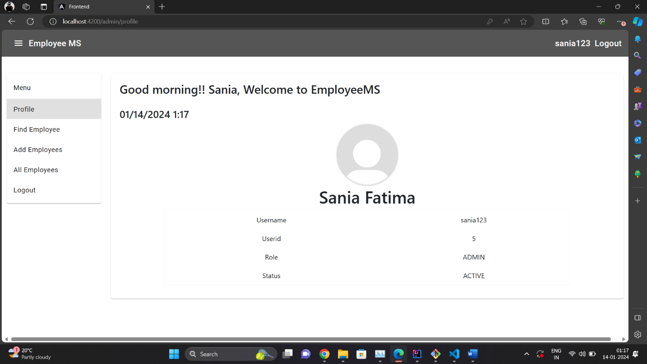

Find Employee:

* user will be able to search employee based on employee id as well as employee name

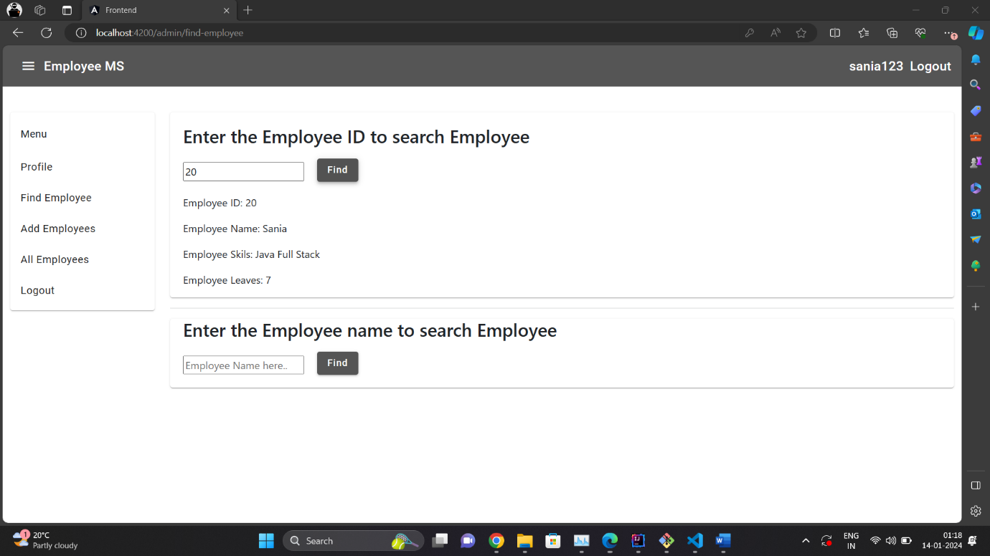

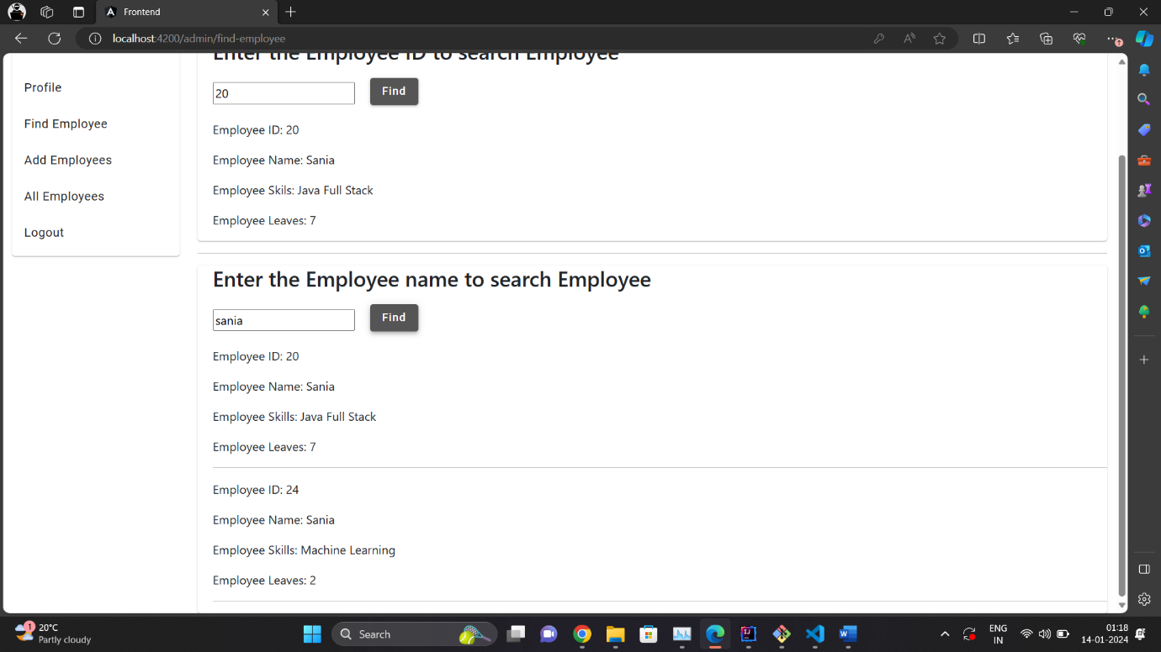

Add Employee:

* User(admin) can also add new employee here.
* User(Admin) will have to enter the employee name, employee skills and employee leaves to add new employee.
* Employee id will get auto-generated in a sequential manner.

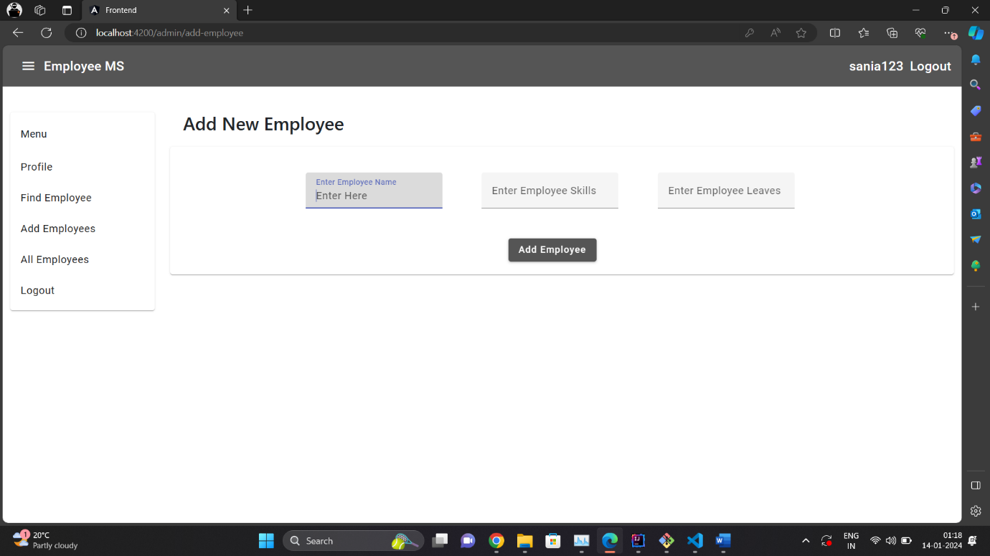

All Employee:

* All the employees present in the database will appear here.
* User(Admin) can see all the employees here.
* User(Admin) can delete employee details from here permanently and can update details as well

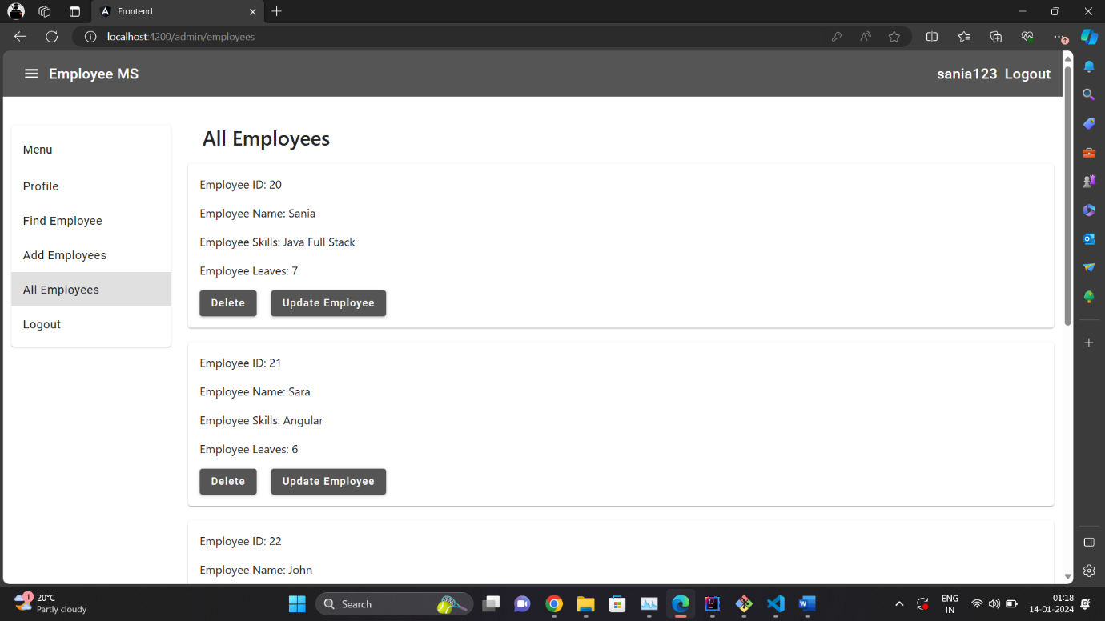

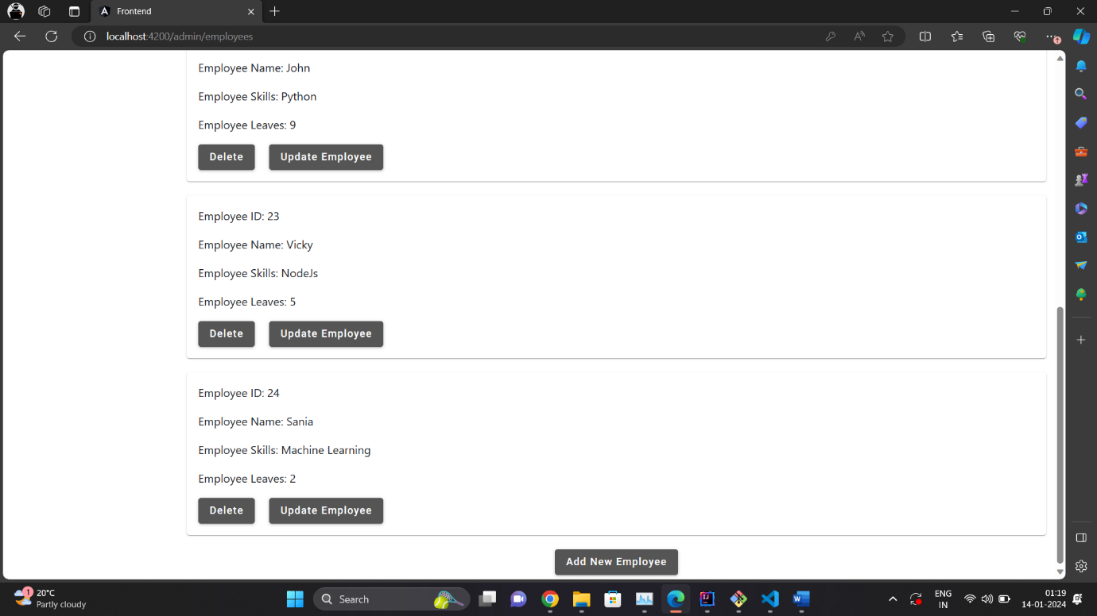

Update Employee:

* User(Admin) can update employees details like employee’s leave or employee’s skills

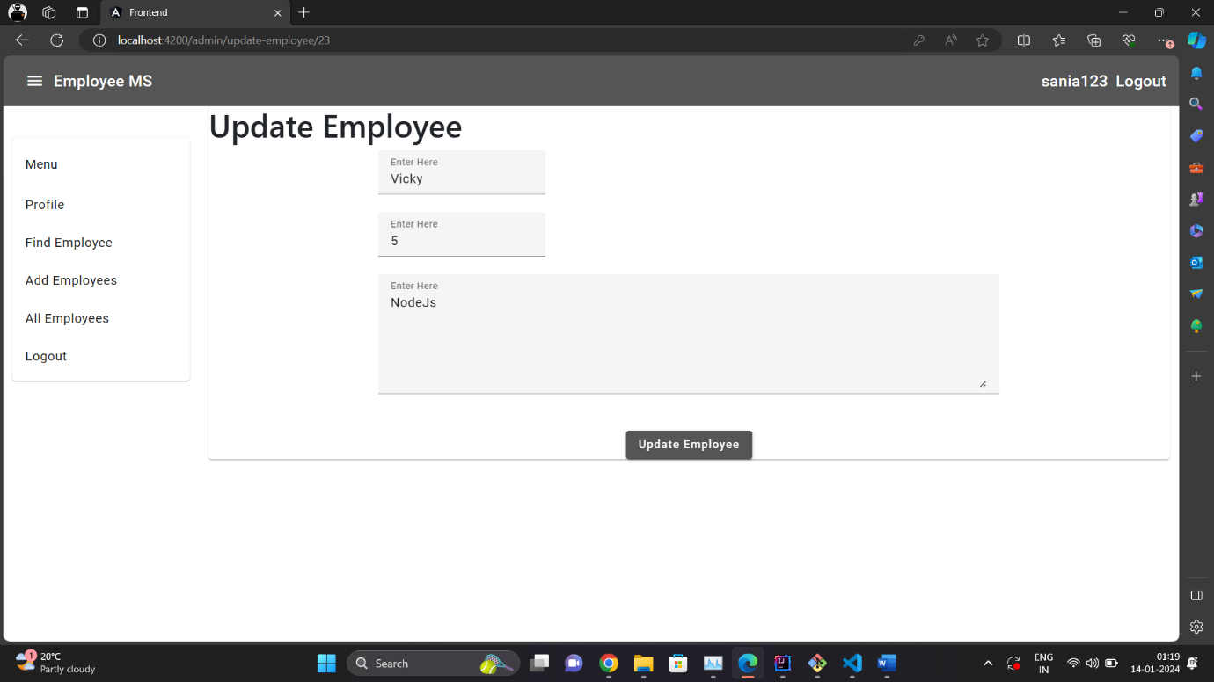

* Normal user’s dashboard will open once login with normal’s credential.
* Menu will be accessed by the User(Normal).
* ‘Normal’ role will have less authority compared to the ‘Admin’ role.
* Normal can see all the employees present in the database and find employee by using employee id as well as employee name.

Profile:

* We will get current user’s details including username, userid, role and status

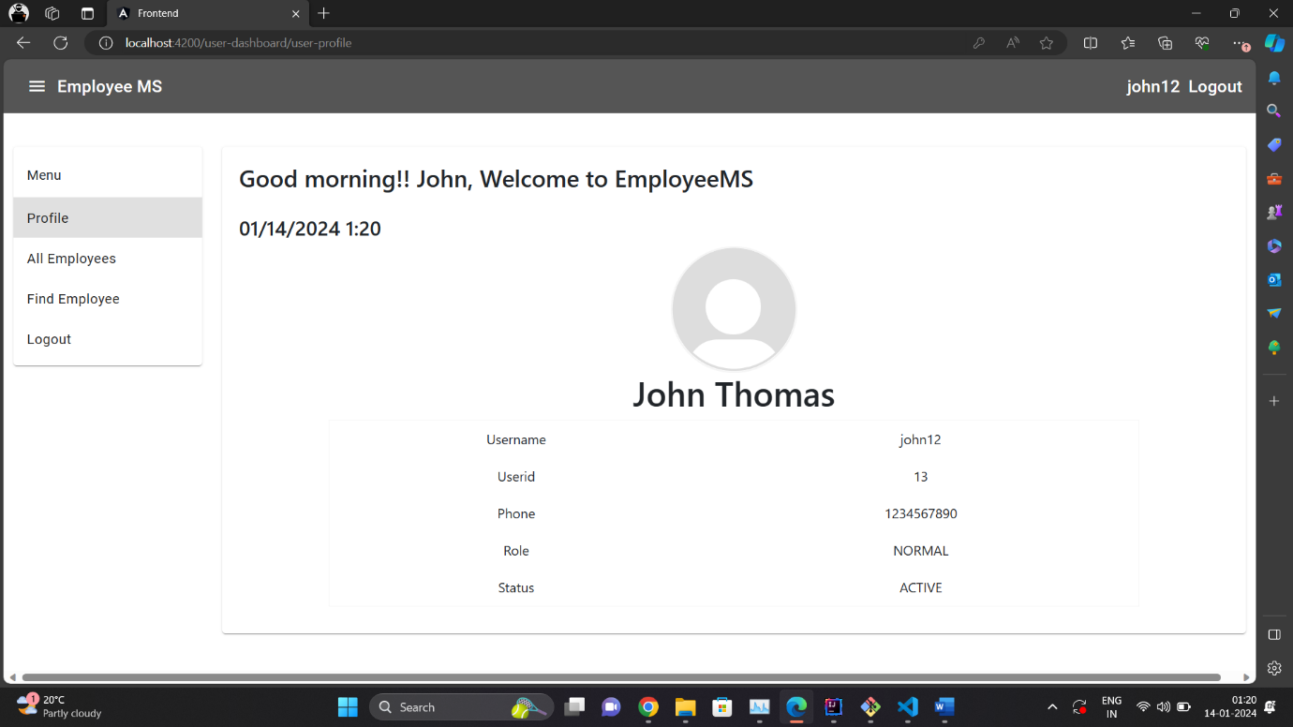

All Employees:

* All the employees present in the database will appear here.
* User(Normal) can see all the employees with details of each employee like employee id, employee name, employee skills, employee leaves.

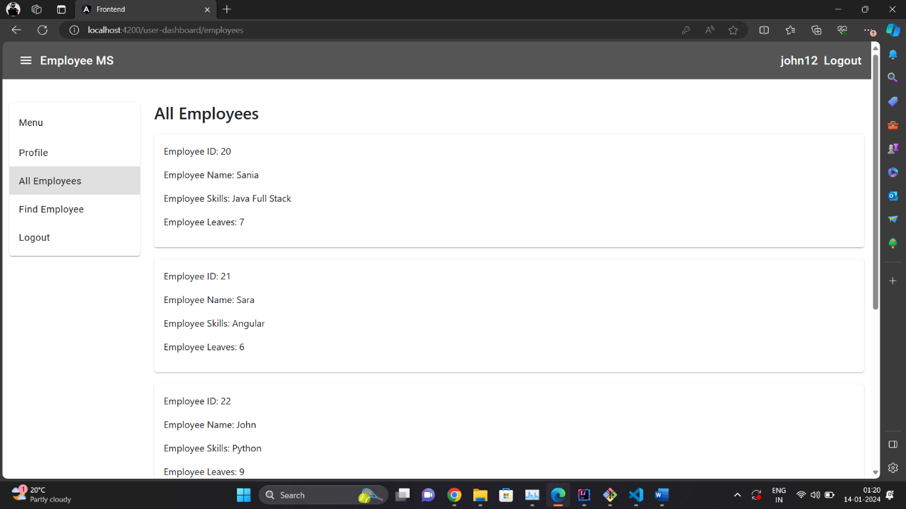

Find Employee:

* User(Normal) will be able to search employee based on employee id as well as employee name

