Lab#3

event

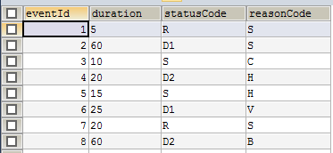

status

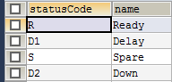

readyreason



sparereason



delayreason



downreason



Query:

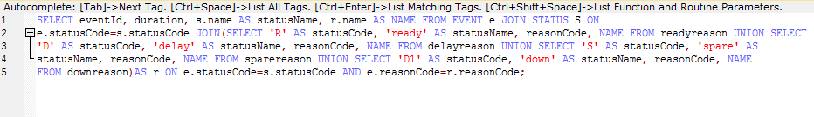

Query Output:

