**Lab#4**

Objective: To learn report generation in OLTP systems.

Task#01:

Generate an OLTP system report which displays the following results:

1. **Total sales in a month** (Use only order table).
2. **Profit/loss in a month** (Use product (to account for purchasing costs), expenditure as well as order tables).
3. **Highest selling product of the month**(By highest sold quantity)
4. **Lowest selling product of the month**(By lowest sold quantity)

**customer table**

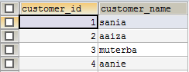

**expenditure table**

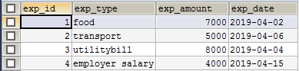

**order table**

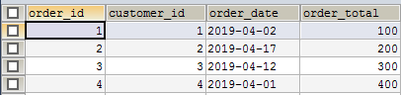

**order_details table**

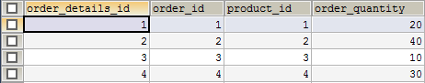

**product table**

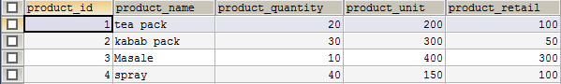

**reportstr(stored procedure)**

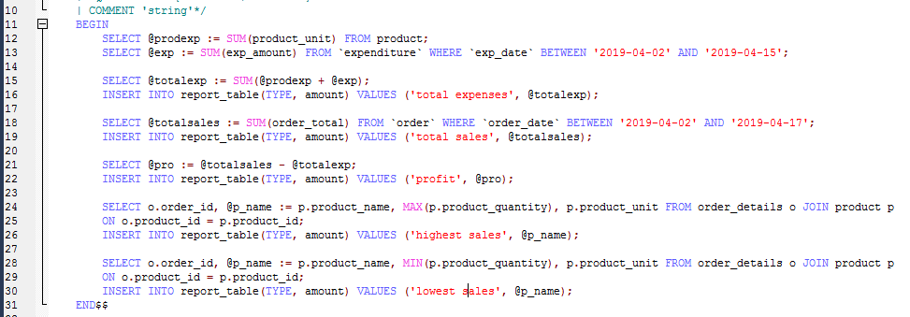



**report_table**

