

**Software Quality Engineering**

**Project Deliverable 1**

|  |  |
| --- | --- |
| Name | Sania Nisar  Ayesha Haroon  Mahrukh Muzzamil  Muneha Adan  Aman Zeeshan |
| Roll No | 21L-6065  21L-6116  21L-6084  21L-6112  21L-5785 |
| Section | BSE-5A |
| Submitted to | Mr. Zeeshan Rana |

3 errors were identified in AdminController.java file those were:

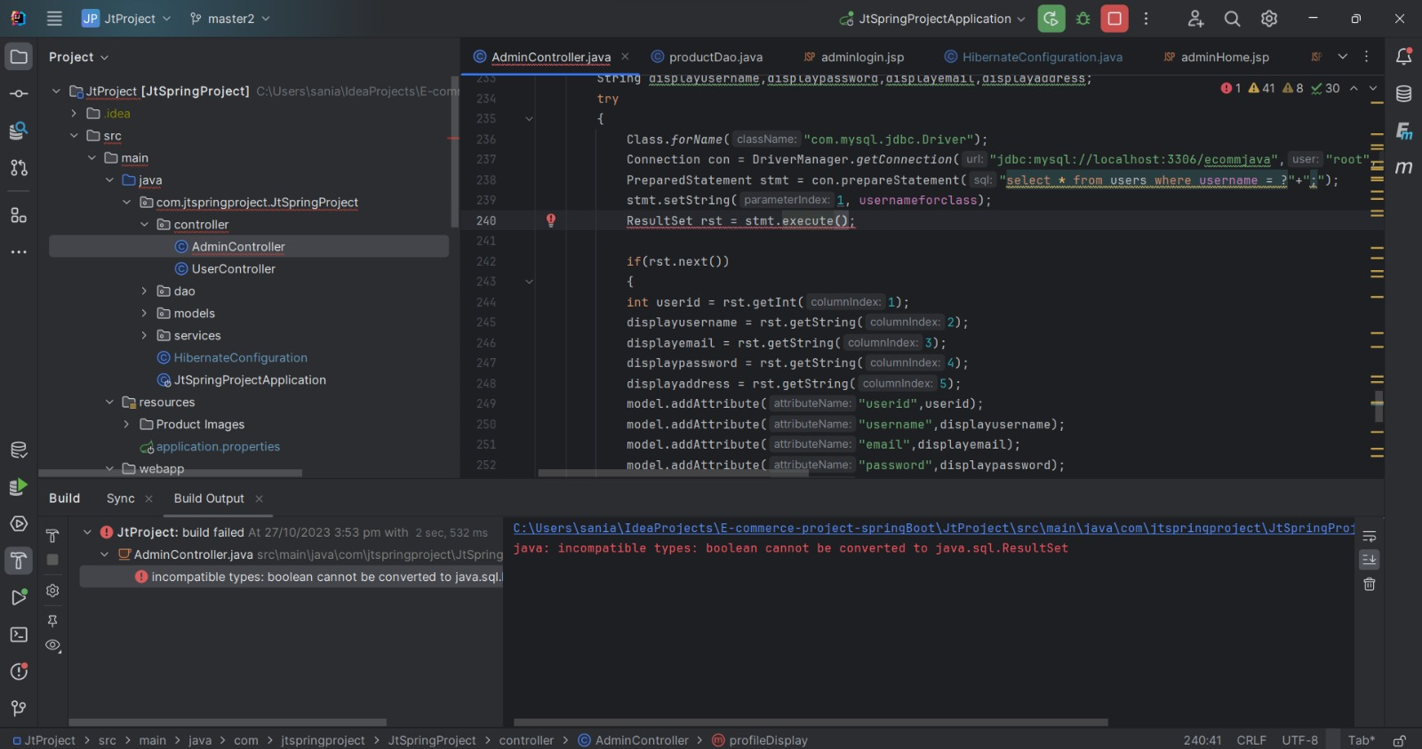

Correction made:

Another correction was made in the same file, where 2 table names in sql queries were not correct:

And here too:

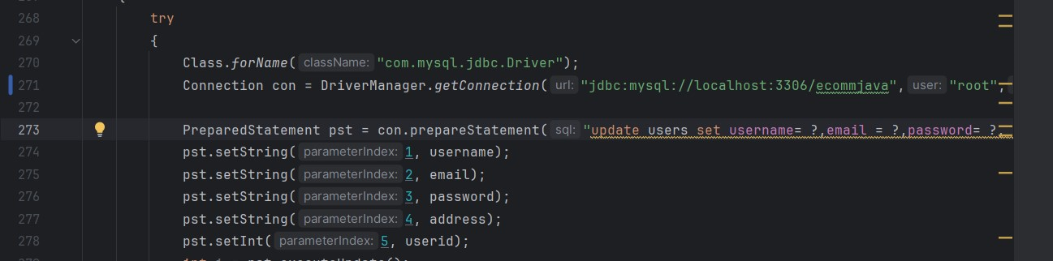

Corrections were made as:

And

