[1]

Microgrids to Enhance Resiliency of a Distribution System

(Dec. 2018)

Sanij Gyawali

*Bradley* *Department of Electrical and Computer Engineering*

Virginia Tech, Blacksburg, VA

*Abstract*— Enhancing the resilience of distribution system to power outages is very important to keep the critical loads on. Hardening measures such as upgraded structures and redundant transmission routes can be an effective but expensive solution. Smart measures such as microgrids can act as emergency sources to provide power to the critical loads. This paper proposes a distribution system resiliency enhancement using microgrids. Critical loads such as hospitals, water supply plants, and data centers are known in a distribution system. But, the number of microgrids, locations and capacities are to be found. A case study research method is presented with resiliency enhancement as a main objective function. The modified IEEE 37-node system with 6 tie lines is used to implement this method. Depending on the number, priority and placement of the critical loads in a distribution system, number of microgrids can be presumed. For this presumed number of microgrids, individual case studies are performed placing them at different trial positions on a grid. Each of these topologies are studied and compared based on the resilience matrix. This is achieved in MATLAB using Dijkstra’s algorithm. Once a topology with highest resilience function following all the operational and generational constraints is placed, capacity of the microgrids can be obtained by adding all the loads and lines losses on its path to critical load/s. Finally, nomograms such as look up tables is generated with switching sequences for dealing with faults on the given system.

*Index Terms*—Distribution System restoration (DSR), microgrids, resilience, and resiliency.

# INTRODUCTION

**P**ower outages have been the problem ever since movement of electricity in bulk (transmission), and the delivery of electricity (distribution) to customers has started. Now that the transmission and distribution system is bigger and more complex, power outages have become inevitable. Equipment failures, extreme weather conditions, fallen trees, accidents and wildlife are few causes of power outages. Among these, extreme weather conditions such as hurricanes,

floods and blizzards seem to have the highest impact on distribution systems with extensive outage periods. Hurricane

Sandy effected 24 states including the entire Eastern Seaboard. More than 8.5 million households and business with tens of millions of people experienced power outage [1]. It took days or even weeks to restore power in some areas with more than US $65 billion of totaled estimated damages. Therefore, grid resilience, which is the capability of the grid to withstand such high impact, low probability events, is necessary for the distribution system. After such disaster, a resilient system can work out some plan to restore loads starting from some high priority critical loads. The critical loads are loads associated with the lives of humans. Some of critical loads are hospitals, water stations and data centers.

Studies on distribution system service restoration include the development of restoration algorithms such as concept of spanning tree [2] and optimal energizing strategy for critical loads using microgrids [3], [4]. Microgrid is a localized group of electricity resources and loads which can work in synchronism with the traditional grid but can also disconnect to an island mode. The island mode operational feature of the microgrid is very useful in restoration of critical loads.

In this paper, concepts from aforementioned papers is utilized to propose a restoration method using microgrids with a main objective of enhancing resiliency of distribution system. A conceptual resilience curve is taken from [5]. The main objective of the approach is to optimize the locations, numbers and capacities of the of microgrids based on the resiliency factor from [5]. This paper is utilizing the concept of graph-theoretic approach to solve for multiple faults unlike [2]. The approach of [4] is used as a guideline trying to solve the problem at hand. The critical load restoration is worked as a constrained two-objective optimization problem. One to maximize the resilience function (1) and another to minimize the cost of the microgrids (2). Operational, generational resource and topological constraints are considered. Concepts of restoration tree and critical load paths are used to transform the critical load restoration problem to two-objective optimization problem. This optimization problem is solved to find the adjusted numbers, locations and capacities of the microgrids. Finally, restorative actions which is the switching sequences to revive the critical loads is determined. The contributions of the proposed method:

1. This method deals with multiple faults which is the major cause for outages.
2. Critical loads with basic societal values are restored. These loads bear high priority whereas non-critical loads have low priority.

The remainder of this paper is organized as follows. Section II describes the formulation of the critical load restoration problem. Section III develops a technical approach. In section IV, feasibility arguments are made and studied. Section V has the outline of the computation and testing to be performed. Section VI deals with the tasks and schedules for the completion of the project. Lastly, section VII has expected output in it.

# Problem formulation

Electrical faults can occur due to natural disasters causing a long outage in distribution system. This implies a number of critical loads are powerless. In many such cases, it takes days before the utility re-establishes its infrastructure. Nevertheless, distributed energy resources (DER) such as microgrids that are locally available, may be able to serve the critical loads by reconfigurating the remaining distribution network. As microgrids can be operated in an islanded mode, islands with critical loads in them can be configurated. These island would be interrupted islands, that is they are electrically disconnected from rest of the distribution network.

A simple binary priority level is used. Critical loads have 1 priority whereas non-critical loads are having 0 priority level. This is because one of the optimization problem for this project is the minimizing the cost of microgrids. Hence, main focus is given to the recovery of critical loads. The other objective function is the value of Resilence(R). This helps to pick the optimum numbers and locations for the microgrids.

1. Objective

* Maximize Resilience (R)

Resilience is evaluated by the integral of the performance function over the specific time period, i.e,

Ri=, (1)

Where,Fi(t)=wi*Si

wi= weight/priority level of ith load

Si= load value of ith load

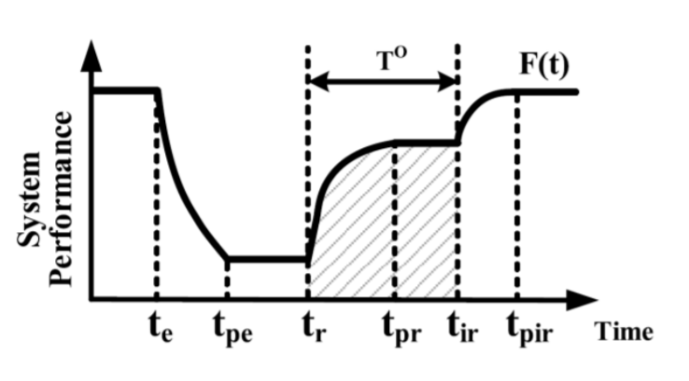

Figure 1. A conceptual resilience curve

* Minimize total cost of microgrids (C)

Min[Cost(C)∝N*R] (2)

Where, N= Number of microgrids

R = Ratings of microgrids

1. Constraints

Equality Constraints: On solving the unbalanced power flow, we get the real and reactive power. They should satisfy the following power flow equations:



Where, Pi and Qi are the net active and reactive power injections in node i, Vi is the voltage of node i, Gij­ and Bij are the real and reactive components of the admittance matrix branch between node i and node j whereas θij is difference in voltage angle between node i and j.

Inequality Constraints:

**i**. Constraints of node voltage: The voltage should be between the following limits:

Vmin≤ Vu≤ Vmax

Where Vmin , Vmax are the lower and upper limit of bus voltage. Vu is voltage magnitude at bus u.

i.e. 0.95≤ Vu≤ 1.05 pu

**ii**. Constraints of line current: The current through each line should be between the following limits:

Iij ≤ Imax

Where, Iij is the actual current flowing between line i and j. Imax is the maximum allowable line current. There are four different configurations of lines used with four different current limit.

i.e. Imax can be 698 A or 483 A or 230 A or 156 A depending on the line configurations.

**iii**. The steady state output power for each microgrid should not exceed its rated capacity.

Pk ≤ Pmax,k

Qk ≤ Qmax,k

Where, Pk and Qk is the active and reactive power output by microgrid k. Pmax,k and Qmax,k is the active and reactive power ratings of the microgrid k.

**iv**. Generation resource constraints: In this project, diesel generator is used as a microgrid, a model of which is shown in figure 3. The generation resource is diesel. The amount of energy that the generator can produce rely on the quantity of diesel. The stock for diesel can be limited which can constraint generation capability.

Generation resource constraint plays an important role for microgrids with local loads. This project assumes microgrid has no local loads. So, the quantity of diesel in stock is fixed just enough to fuel a definite number of days. The number of days is predetermined.

Other Constraints:

The radial network structure is always maintained; which means no loops are expected in the distributed network. Maintaining the radial structure helps to simplify synchronization and load sharing among microgrids. Also radial structure simplifies relay settings for the protection against potential faults.

# technical approach

In this section, the approach towards the objective is proposed. Section III-A and III-B deal with the selection of number of microgrids and location of microgrids. Section III-C presents a graph-theoretic algorithm for the critical load restoration problem. Section III-D presents computing of microgrids power rating. Before these, below are some of the assumptions made in this study:

1. All lines are equally prone to fault.
2. All critical loads are equally weighted. Non-critical loads have zero weight.
3. Detection of these faulted zones is outside the scope. It is assumed faulted sections are detected via an outage management system.
4. One critical load to be served by only one microgrid.

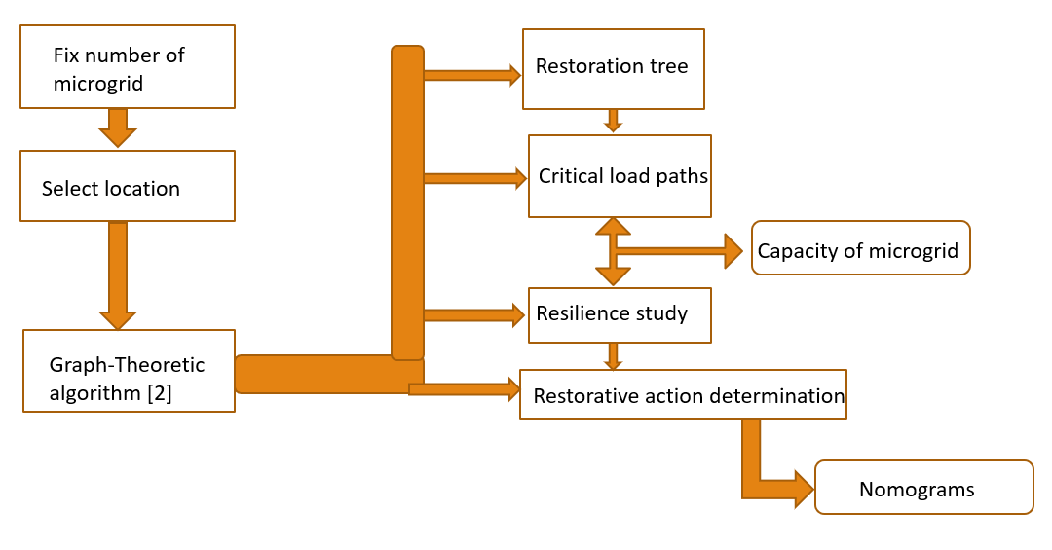

Figure 2. Operational Flowchart

1. Numbers of microgrids

Since there are 3 critical loads, 3 microgrids can be placed as dedicated supply Source. But, It’s expensive. So, Case Studies using 2 and 1 microgrids are performed. Comparison on the basis of cost and resilience matrix has been made. A simplified model of microgrid is shown below.

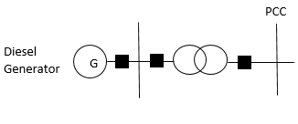

Figure 3. A simplified microgrid model

1. Location of microgrids

Three microgrids are right on the nodes of critical loads. In case of two and one microgrids, there are several options. Each feasible options are taken and studied.

1. Graph Theoretic Algorithm

In here, the after faulted distribution system is modeled as graph G= (V,E), where source node is modeled as the vertex and feeder lines as edges. Source node can be either the feeder supply or microgrid supply depending upon what is available. The feeder lines are a radial ones connecting the source to one or more critical loads. These graphs are called restoration trees. Below are examples of restoration trees connecting the same source and critical load via different paths.

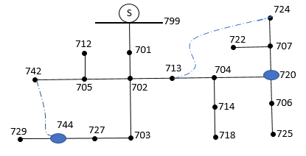

Figure 4a. Tree 1

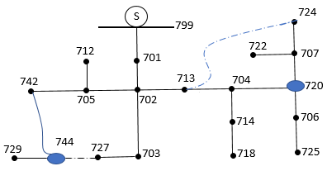

Figure 4b. Tree 2

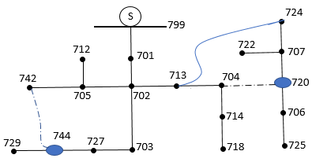

Figure 4c. Tree 3

An algorithm has been developed to find out different restoration trees options. Then, resilience matrix is calculated for different load paths and compared to get the one with highest resilience factor. This algorithm is based on Dijkstra’s shortest path algorithm. Dijkstra gave an algorithm to find the quickest distance between two nodes. For a graph G(V,E), every edge E has some weight in it representing the distance between the two connecting nodes. The way Dijkstra’s algorithm works is clear from the below pseudo code.

*Input to dijkstra=(Network,start,finish):*

*N= set of nodes in Network*

*Every nodes n $∈$ N*

*//Now Initialization*

*next(n)= $∞$*

*former(n)= 0*

*distance(start) = 0*

*while N is not empty*

*m= node in N with least next(m)*

*N=N-m*

*If m==finish*

*break;*

*for every closest node n of m:*

*temp= next(m)+width(m,n)*

*if temp<next(n):*

*next(n)= temp*

*former(n)=m*

next() has the shortest distance

former() has the shortest path in reverse

1. Ratings of microgrids

Once the most resilient path is confirmed, the restorative action associated with it is determined. Then, Power rating of the microgrid is calculated based on the summation of loads on the most resilient path.

Capacity $=\sum_{i=1}^{n}{Pi}$ (3)

After all this, we are left with three sets of optimized microgrids location and capacity- the one with three, two and one microgrids. Finally, the one with lower value of C with higher value of R is chosen.

# Methodology

A. Relating Dijkstra’s algorithm with resiliency curve

Since, Dijkstra’s algorithm is utilized, the first step was to find the relation between shortest distance and the resiliency function. So, the conceptual resiliency curve from figure 1 can be tailored for the task in hand as,

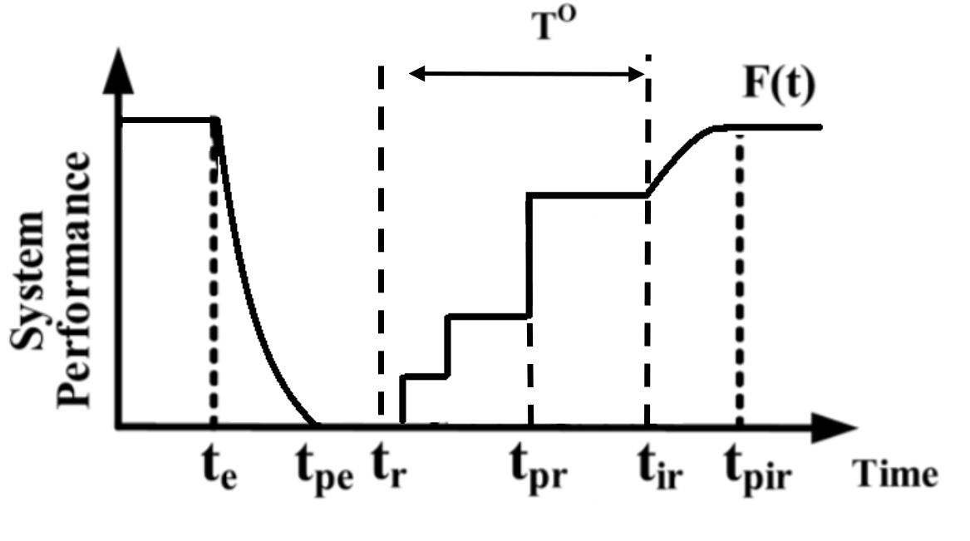

Figure 5. New Resiliency Curve

The area of the curve within time T0 is to be maximized, which will happen if the three critical loads are powered quicker. So, if the distance between the nodes in Dijkstra’s algorithm is replaced with switching time, the same algorithm can be used to find the shortest time to reach critical loads. The project utilizing IEEE 37 node system whose conductors are all underground. This means every switch in the system should be a Remote-Control Switch (RCS).

Now, an assumption is made that when there is an outage and feeder is cut off, every RCS in the system is initially OPENED. This may not be practical but serves a good purpose to solve problem in hand. Suppose that to operate a RCS, it takes tRCS = 12 secs. Also, it is safe to allow some time interval between two consecutive switching actions. This helps to dampen the dynamics induced from the closing of a switch. Suppose that time be tin= 1 minute. These time intervals are empirically chosen. So, between two switching operations, there is 1.2 minutes interval. This is designated as the weight of every edge in Dijkstra’s algorithm. Hence, the shortest path is equivalent to the shortest time and ultimately higher area in resiliency curve. This is implemented in algorithm in the definition Network as in the pseudo code.

B. Resiliency calculation

i) With 3 microgrid: Three dedicated microgrids for three critical loads will just take 0.2 minutes for recovering three critical loads. Figure 6 below shows this process.

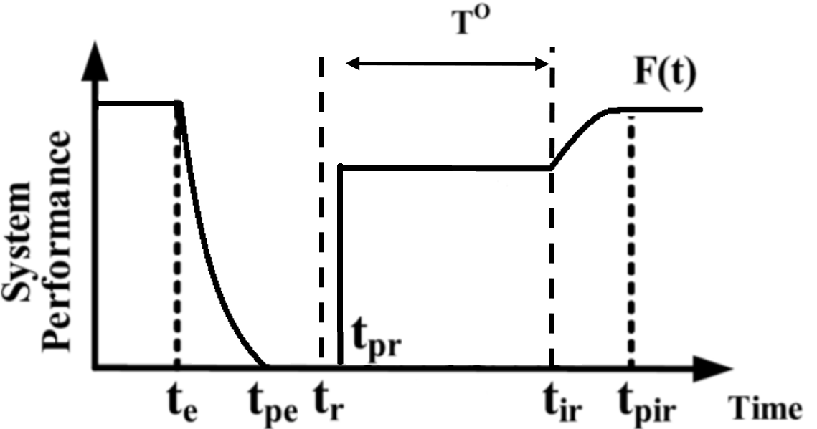

Figure 6. Curve for 3 microgrid

Here, T0 is the time between start of restoration(tr) and start of infrastructure recovery(tir). Let T0 be a constant time of 30 minutes. Taking longer time reduces the significance of fast switching as both fast and slow recovery scheme can have similar resilience. This time can be figured out from historical outage recovery time.

Therefore, Resilience(R3) = 253 KW*(30-.2)/60hr

= 125.7 KWhr

Rating of each microgrids should be larger than total sum of demands on each phase.

Demand at node 720 =85+40j kVA= 93.9415∠25.20 KVA

Size of microgrid at 720 = 95 KVA 0.9 PF

Similarly,

TABLE 1: 3 microgrid sizing

|  |  |  |  |
| --- | --- | --- | --- |
| Node | 720 | 744 | 738 |
| Demand | 93.9415∠25.20 KVA | 46.96∠26.570 | 140.43∠26.2 |
| Size | 95 KVA 0.9 PF | 50 KVA 0.9 PF | 145 KVA 0.9 PF |

ii) With 1 microgrid: Unlike with 3 microgrid, there are many options to place single microgrid. Using Dijkstra’s algorithm, 34 such places are tested. These microgrids are assumed to be resiliency microgrids i.e. feeder is completely out. So, all three critical loads are to be supplied from a single microgrid. Now, a matrix is developed to represent this system. It is a symmetric matrix. If two nodes have line between them either a tie-line or regular conductor, that element will be 1.2 and every other element are zero. An example topology with graph matrix is given below.

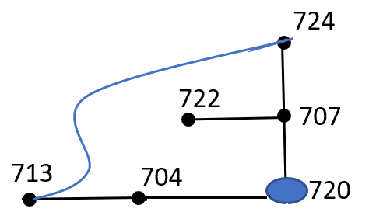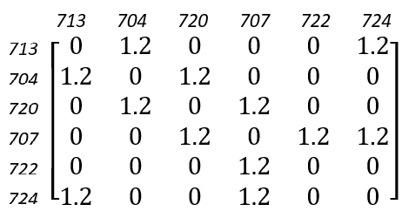

Figure 7. A sample topology and graph matrix

The result from the algorithm for the most resilient microgrid position comes out to be at node 731. Total time taken for powering all three critical loads is 13.8 minutes. First critical load at 720 is powered after 3.8 minutes, 6.2 minutes after that critical load at 744 is powered and finally after another 3.8 minutes, last critical load at 738 is powered. This configuration is tested for all operational constraints using Gridlab-d. Figure 5 works represents resiliency curve for this configuration. So, the resilience is calculated as,

R1 =85*(30-3.8)/60+42*(30-10)/60+126*(30-13.8)/60

= 85.17 KWhr

After position is set, now all possible paths to reach critical loads is determined. Out of them, one without tie-line in it is chosen to run power flow and fix the size of the microgrid. This is done by inspection and the logic behind avoiding tie-lines is that the path containing tie-lines is regarded as alternative path when regular path is faulted. So, while sizing the microgrid, regular path to critical load is taken. Table 2 shows the paths chosen. The result of power flow is 818.58∠25.940 KVA total 3-phase demand. So, the size of the microgrid is chosen as 825 KVA 0.9 PF

TABLE 2: Paths chosen for microgrid sizing

|  |  |
| --- | --- |
| Critical loads at | Paths |
| 720 | 731-709-730-703-702-713-704-720 |
| 744 | 731-709-730-703-727-744 |
| 738 | 731-709-708-733-734-737-738 |

iii)With 2 microgrids

The same routine is followed as for 1 microgrid positioning but instead of 34 positions, (34,34) combination of positions is studied. A modified Dijkstra’s algorithm is utilized to compare all the possible combinations. Comparisons are made based on the minimum time taken to power all the critical loads. Resultant minimum time is 7.4 minutes. Quite a number of combinations got this time. Among them, two most repeating positions are selected. This is done by plain inspection. The final selection is node 744 and node 738. These two nodes happen to have critical loads themselves. So, it makes sense to why these positions powered all critical loads in minimum time. Both critical loads at 744 and 738 are restored in just 0.2 minutes as they have different sources. After another 7.2 minutes, remaining critical load at 420 is restored. Figure 8 shows the resilience nature for this configuration. The resilience matrix is calculated as,

R2 = [(42+126)*29.8+85*22.8]/60 = 115.74 KWhr

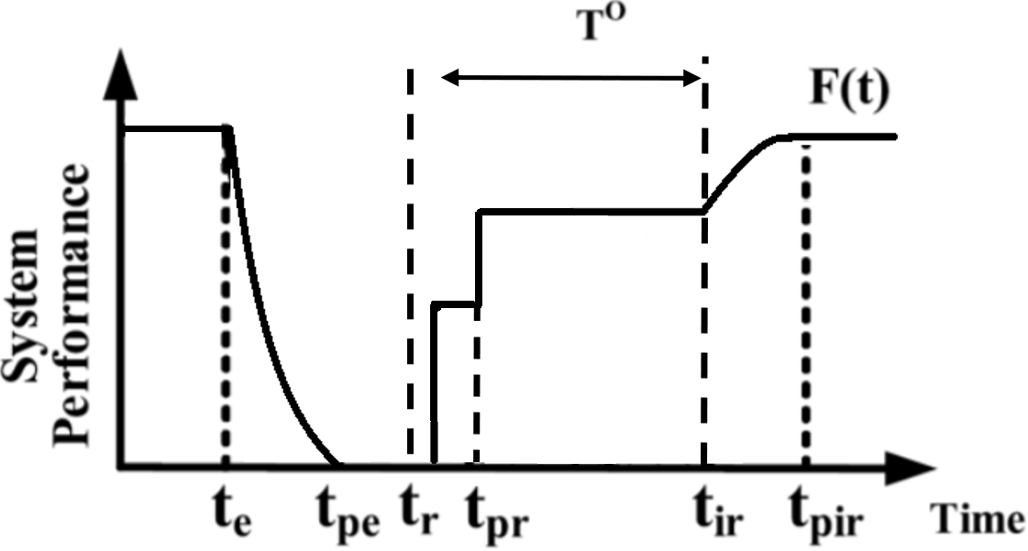

Figure 8. Curve for 2 microgrids

After position is set, now possible paths to reach critical loads is determined. Out of them, one without tie-line in it is selected to run power flow and fix the size of microgrid. This is again done by inspection and logic behind leaving tie-lines out is to size the microgrid using regular paths. Table 3 shows the paths chosen. It is seen that only microgrid at 744 is responsible for load at 720 and microgrid at 738 is acting like a dedicated supply just to its node. It’s better to increase the redundancy by sizing the second microgrid just enough to supply load at 720, if needed, through the shortest path. The result of the power flow is 236∠25.60 KVA total 3-phase demand at node 744. Similarly, at node 738, total 3-phase demand is 282.06∠25.70 KVA. The power flow also shows that all the operational constraints are fulfilled. Table 4 shows the sizing of microgrids.

TABLE 3: Paths chosen for microgrid sizing

|  |  |
| --- | --- |
| Critical loads at | Paths |
| 720 | 744-727-703-702-713-704-720 OR  738-711-741-731-725-706-720 |
| 744 | 744 |
| 738 | 738 |

TABLE 4: Microgrids rating

|  |  |
| --- | --- |
| Position | Rating |
| 744 | 245 KVA 0.9 PF |
| 738 | 290 KVA 0.9 PF |

# RESULT

Here, above three configurations are placed side by side and compared in terms of number of microgrids, size of microgrid, and resilience obtained.

# feasibility argument

In this section, the feasibility of this project is studied. The objective of this project is to find an optimized numbers, locations and capacities of microgrids. These are estimated based on the resilience function (1) and cost function (2). Section III presented with the operational steps***.*** Here, feasibility of each step is studied.

Since, there are three critical loads in the distribution system, the highest number of microgrids studied is three. It is not reasonable to have numbers of microgrids higher than critical loads as the priority for non-critical loads is 0. That means resilience function do not increase even if more non-critical loads are revived. Also, high number of microgrids mean high cost which is undesirable. Nonetheless, the number can be less, that is 1 or 2. These three cases are the only feasible cases in this project.

For the locations, each case is studied on all possible locations. For 3 microgrid system, the only reasonable locations are the node where the critical loads are present. For other cases, there are multiple availabe location. Each of these locations are studied.

Finally, all of these cases are examined based on our two objective functions which gives the optimized locations and numbers of microgrids. Then, the optimized capacity is determined in such a way that each selected microgrid is able to supply the critical load, all non-critical loads in the path and the line loss.

The solution satisfies all the operational constraints which has been checked using power flow calculations in Gridlab-d.

# computation and testing

An algorithm is developed to figure out the restoration tree. This algorithm is implemented in MATLAB and each case is studied separately. Power flow testings are done using Gridlab-d. For power flow calculation in Gridlab-d, the generator bus in a microgrid is modeled as a slack bus i.e. as a constant voltage bus.

# expected outcome

At the end of this project, the two-folds objective functions helps to realize the optimum numbers, locations and capacities of the microgrids. These solutions are conforming all the constraints mentioned. Also, Nomograms are developed. Look-up tables with switching sequences for critical load restoration in case of faults. An example is given below:-

*Case name: IEEE37/IEEE_37node.*

*Fault section: 42 - 6*

*Critical load restoration is successful.*

*The optimal switching sequence is as follows.*

*Open: switch(42 – 6) Close: switch(35 – 36)*

ACKNOWLEDGEMENT

The author would like to thank Dr. Chen-Ching Liu and Dr. Jing Xie for their continuous support in this project.

# Reference

[1] N. C. Abi-Samra, “One Year Later: Superstorm Sandy Underscores Need for a Resilient Grid - IEEE Spectrum.” [Online]. Available: https://spectrum.ieee.org/energy/the-smarter-grid/one-year-later-superstorm-sandy-underscores-need-for-a-resilient-grid. [Accessed: 23-Oct-2018].

[2] J. Li, X.-Y. Ma, C.-C. Liu, and K. P. Schneider, “Distribution System Restoration With Microgrids Using Spanning Tree Search,” *IEEE Trans. Power Syst.*, vol. 29, no. 6, pp. 3021–3029, Nov. 2014.

[3] H. Gao, Y. Chen, Y. Xu, and C. C. Liu, “Resilience-Oriented Critical Load Restoration Using Microgrids in Distribution Systems,” *IEEE Trans. Smart Grid*, vol. 7, no. 6, pp. 2837–2848, 2016.

[4] Y. Xu, C.-C. Liu, K. P. Schneider, F. K. Tuffner, and D. T. Ton, “Microgrids for Service Restoration to Critical Load in a Resilient Distribution System,” *IEEE Trans. Smart Grid*, vol. 9, no. 1, pp. 426–437, Jan. 2018.

[5] M. Panteli and P. Mancarella, “The Grid: Stronger, Bigger, Smarter?: Presenting a Conceptual Framework of Power System Resilience,” *IEEE Power Energy Mag.*, vol. 13, no. 3, pp. 58–66, May 2015.

**Sanij Gyawali** received the B.E degree in electrical engineering from Tribhuwan University, Lalitpur, Nepal, in 2015. He is currently pursuing his M.S. degree at Virginia Tech. His research interests include distribution system restoration and microgrids.

1.