

Course: Application Development and Deployment and

Course Code: CSI3025

Name: Sanika Chavan

Reg No: 20MIC0021

**LAB-FAT**

Implement a CI/CD pipeline with the following real-world scenario:

**Scenario:** Integrate a basic security check.  
**Task:** Use an action like actions/snyk to run a basic security vulnerability scan on your project dependencies after building the code.

Steps:

1] Get the Snyk Action from Github Marketplace Action

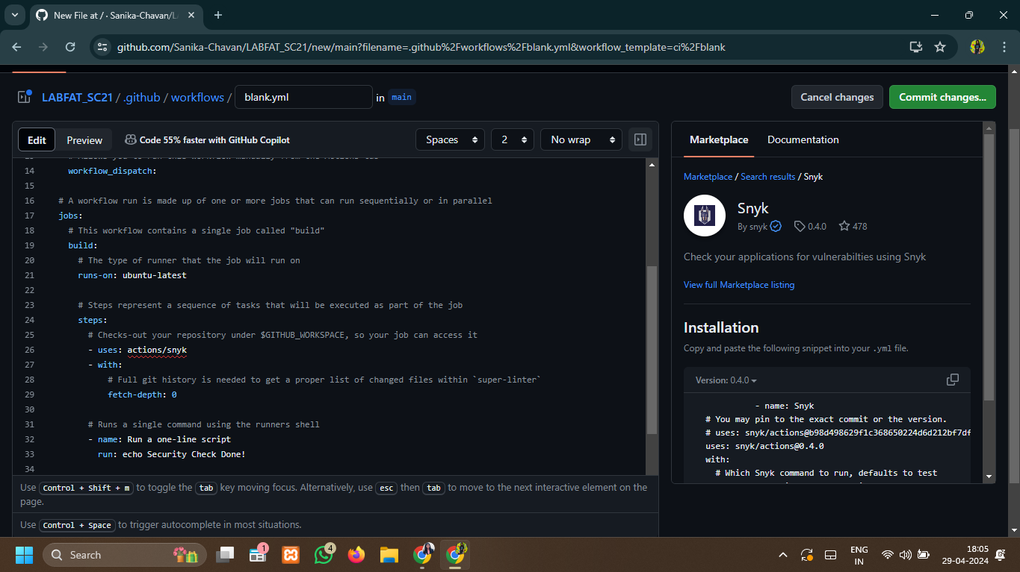

2] Create a .yml file for Workflow

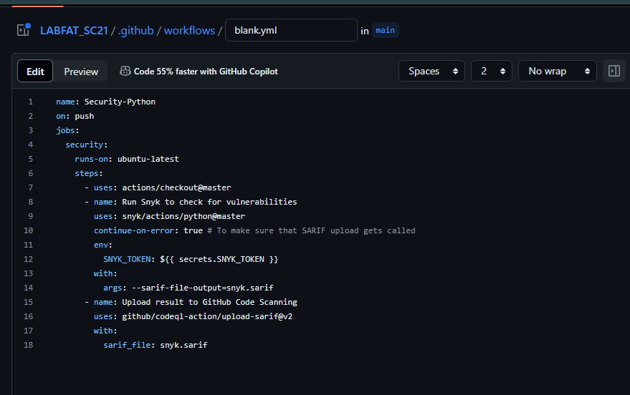

3] Throws an error if snyk account is not authenticated

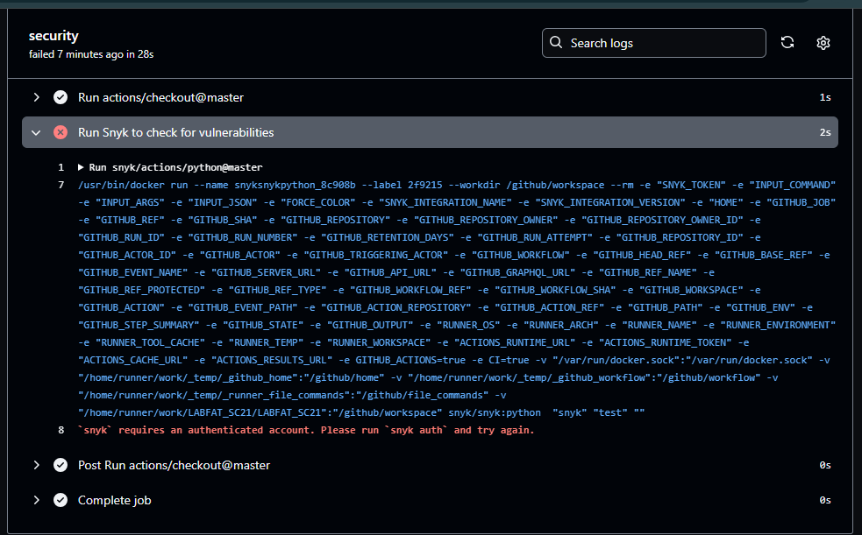

4] To solve the error install snyk and run the command ‘synk auth’

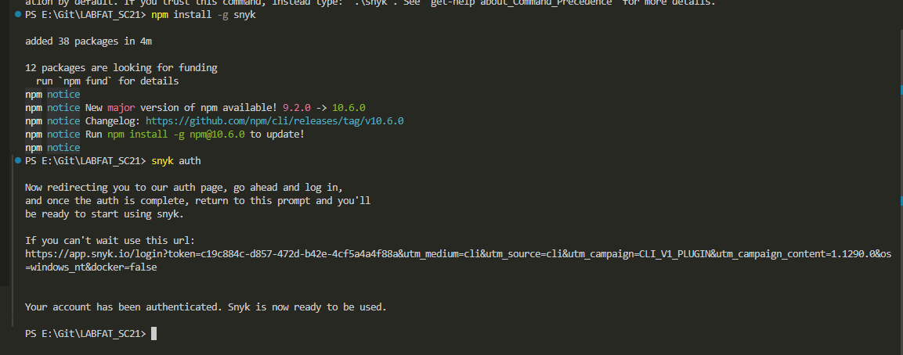

5] I’m authenticated and snyk actions check for vulnerabilities in my Repositories:

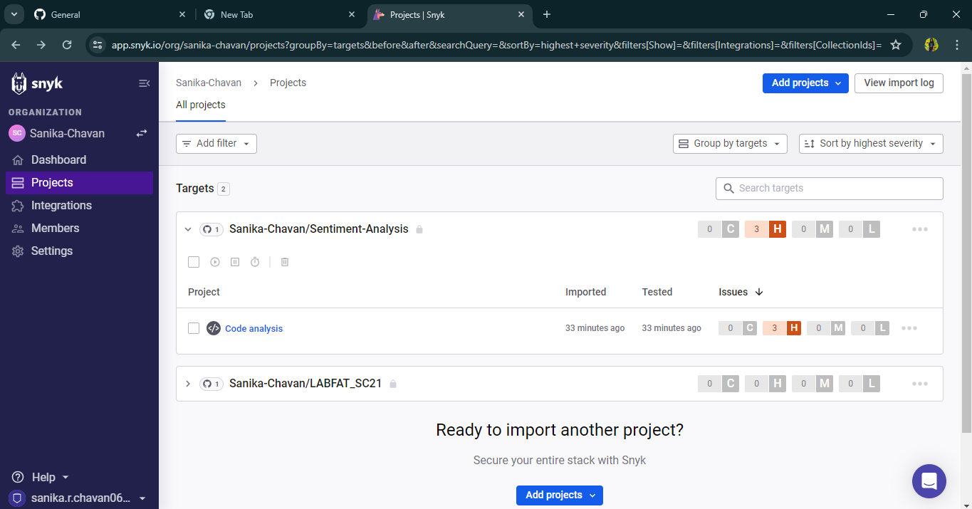

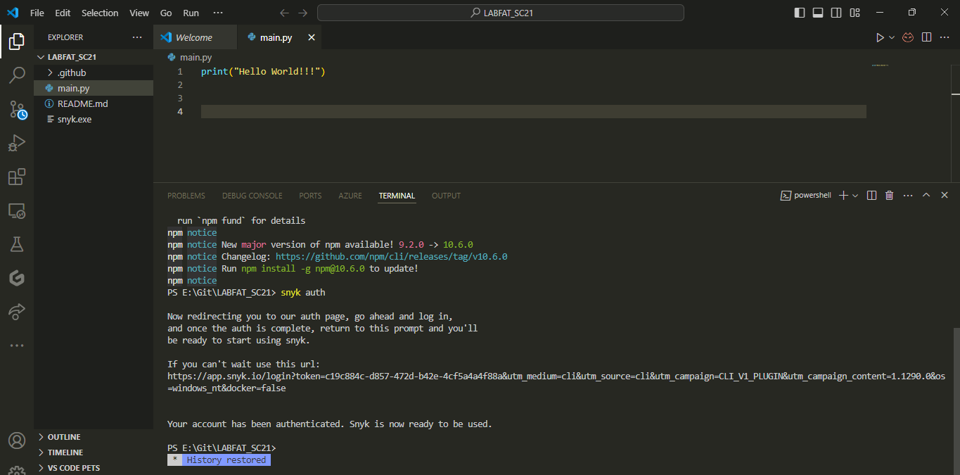

GIthub Repo Link:

<https://github.com/Sanika-Chavan/LABFAT_SC21>

Best Practices:

* Make sure every repository contains a CI/CD workflow
* Workflows should be monitored
* Names should be descriptive
* Secure sensitive information using Github secrets
* Workflow timeouts should be set