mysql> create database mydb;

Query OK, 1 row affected (0.00 sec)

mysql> use mydb;

Database changed

mysql> CREATE TABLE emp

-> (

-> id int,

-> fname VARCHAR(100),

-> lname VARCHAR(100)

-> );

Query OK, 0 rows affected (0.08 sec)

mysql> INSERT into emp values (1,'tom','jerry');

Query OK, 1 row affected (0.03 sec)

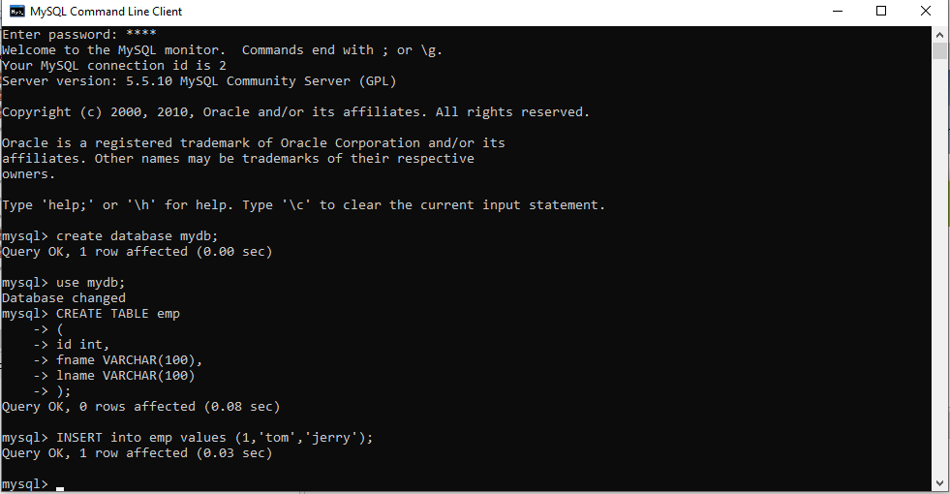

// selectdemo

/\*

\* Click nbfs://nbhost/SystemFileSystem/Templates/Licenses/license-default.txt to change this license

\* Click nbfs://nbhost/SystemFileSystem/Templates/Classes/Main.java to edit this template

\*/

package selectdemo;

import java.sql.\*;

public class SelectDemo {

/\*\*

\* @param args the command line arguments

\*/

public static void main(String[] args) {

try

{

Class.forName("com.mysql.jdbc.Driver");

Connection con=DriverManager.getConnection("jdbc:mysql://localhost:3306/mydb","root","root");

Statement stmt=con.createStatement();

ResultSet rs=stmt.executeQuery("select\* from emp");

while(rs.next())

System.out.println(rs.getInt(1)+" "+rs.getString(2)+" "+rs.getString(3));

con.close();

}

catch(Exception e)

{

System.out.println(e);

}

}

} 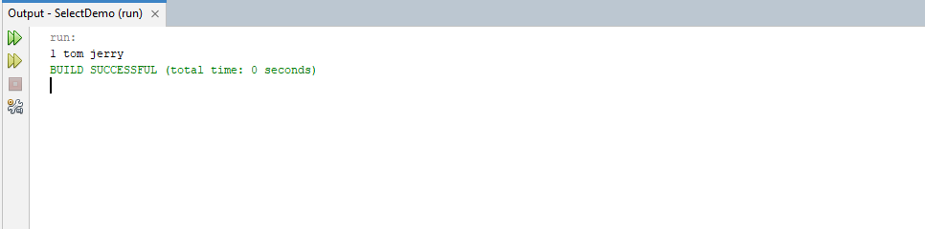

//EmpInsertDemo

/\*

\* Click nbfs://nbhost/SystemFileSystem/Templates/Licenses/license-default.txt to change this license

\* Click nbfs://nbhost/SystemFileSystem/Templates/Classes/Main.java to edit this template

\*/

package empinsertdemo;

import java.sql.\*;

public class EmpInsertDemo {

public static void main(String[] args) {

try

{

Class.forName("com.mysql.jdbc.Driver");

Connection con=DriverManager.getConnection("jdbc:mysql://localhost:3306/mydb","root","root");

Statement stmt=con.createStatement();

stmt.execute("INSERT INTO emp (id,fname,lname)" +"VALUES(30,'mickey','mouse')");

System.out.println("data inserted successfully");

con.close();

}

catch(Exception e)

{

System.out.println(e);

}

}

} 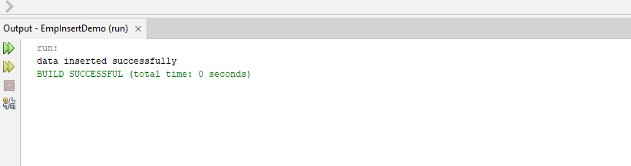

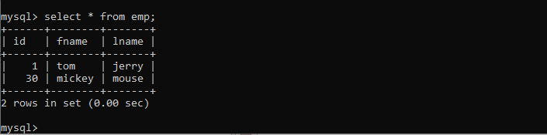

//EmpDeleteDemo

/\*

\* Click nbfs://nbhost/SystemFileSystem/Templates/Licenses/license-default.txt to change this license

\* Click nbfs://nbhost/SystemFileSystem/Templates/Classes/Main.java to edit this template

\*/

package empdeletedemo;

import java.sql.\*;

public class EmpDeleteDemo {

public static void main(String[] args) {

try

{

Class.forName("com.mysql.jdbc.Driver");

Connection con=DriverManager.getConnection("jdbc:mysql://localhost:3306/mydb","root","root");

Statement stmt=con.createStatement();

stmt.execute("DELETE FROM emp WHERE id=1" );

System.out.println("Data deleted successfully");

con.close();

}

catch(Exception e)

{

System.out.println(e);

}

}

}

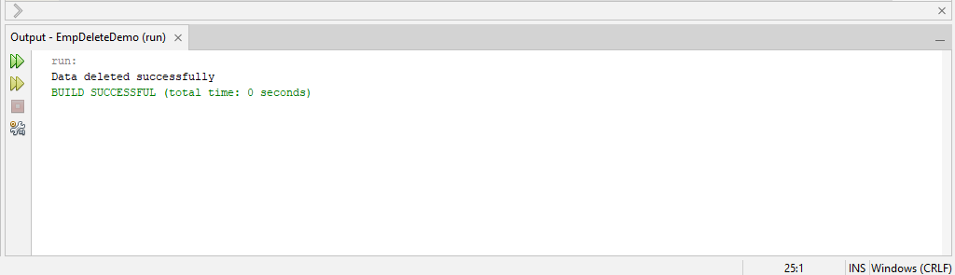 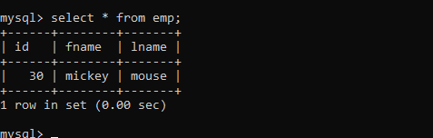

For update

package empdeletedemo;

import java.sql.\*;

public class EmpDeleteDemo {

public static void main(String[] args) {

try

{

Class.forName("com.mysql.jdbc.Driver");

Connection con=DriverManager.getConnection("jdbc:mysql://localhost:3306/mydb","root","root");

Statement stmt=con.createStatement();

//stmt.execute("DELETE FROM emp WHERE id=1" );

stmt.execute("UPDATE emp SET fname='shubhechha',lname='gadhave' WHERE id=1" );

System.out.println("Data updated successfully");

con.close();

}

catch(Exception e)

{

System.out.println(e);

}

}

}

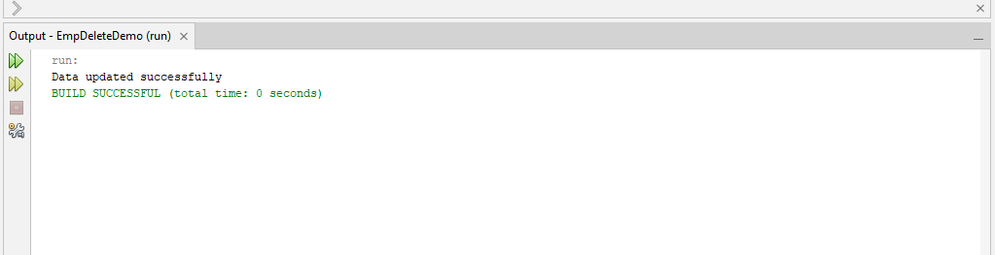 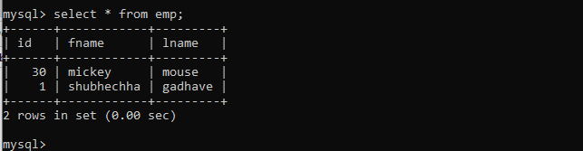

//Deletion

/\*

\* Click nbfs://nbhost/SystemFileSystem/Templates/Licenses/license-default.txt to change this license

\* Click nbfs://nbhost/SystemFileSystem/Templates/Classes/Main.java to edit this template

\*/

package empdeletedemo;

import java.sql.\*;

public class EmpDeleteDemo {

public static void main(String[] args) {

try

{

Class.forName("com.mysql.jdbc.Driver");

Connection con=DriverManager.getConnection("jdbc:mysql://localhost:3306/mydb","root","root");

Statement stmt=con.createStatement();

int rs = stmt.executeUpdate("DELETE FROM emp WHERE id=1" );

if(rs==1){

//stmt.execute("UPDATE emp SET fname='shubhechha',lname='gadhave' WHERE id=1" );

System.out.println("Data updated successfully");

}

else{

System.out.println("id not found");

}

con.close();

}

catch(Exception e)

{

System.out.println(e);

}

}

}

