

**K .J.Somaiya Polytechnic, Mumbai-77**

**Batch No: C2**

**Enrollment No.: FCOG19126**

**Experiment No: 2**

**Experiment Name: Write a program to design a form using all AWT components**



**K .J.Somaiya Polytechnic, Mumbai-77**

**Experiment No.2**

**Experiment Name: Write a program to design a form using all AWT components**

**Objective**

**O18RA63.1. Create GUI using different swing & AWT components.**

**Write a program to implement following Form Structure using AWT controls and any layout manager.(Add any five dates ,months and years in DOB)**

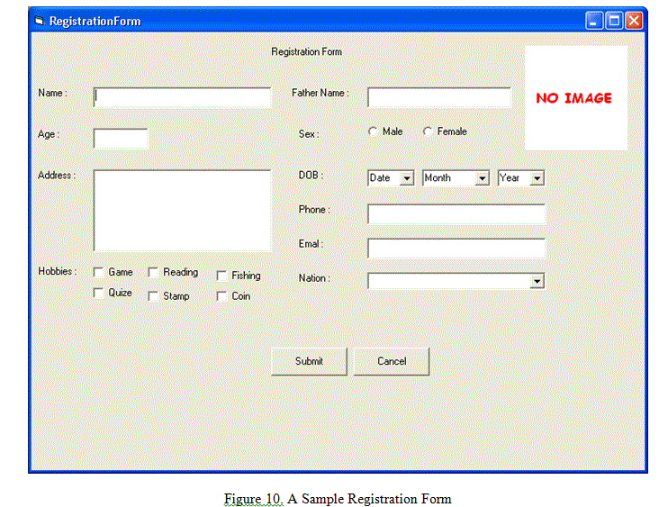

**Implementation :**

Program

|  |
| --- |
| import java.awt.*;  class AjPract {  public static void main(String[] args) throws Exception {  Frame f1 = new Frame("Registration Form");  Label l1 = new Label("Registration Form", Label.CENTER);  l1.setBounds(330, 70, 100, 20);  Panel p1 = new Panel();  p1.setBounds(650, 90, 120, 125);  p1.setFocusable(true);  p1.setLayout(null);  Label txt = new Label("NO IMAGE");  txt.setForeground(Color.red);  txt.setBounds(25, 20, 100, 80);  txt.setFont(new Font("new times roman", Font.BOLD, 14));  p1.add(txt);  Label l2 = new Label("Name:");  l2.setBounds(50, 130, 40, 20);  TextField t1 = new TextField();  t1.setBounds(100, 130, 215, 20);  Label l3 = new Label("Fathers Name: ");  l3.setBounds(335, 130, 90, 20);  TextField t2 = new TextField();  t2.setBounds(425, 130, 215, 20);  Label l0 = new Label("Age:");  l0.setBounds(50, 190, 35, 20);  TextField t3 = new TextField();  t3.setBounds(100, 190, 60, 20);  Label l5 = new Label("Address:");  l5.setBounds(45, 250, 55, 20);  TextField ta = new TextField(5);  ta.setBounds(105, 250, 215, 90);  Label l7 = new Label("Phone:");  l7.setBounds(335, 290, 65, 20);  TextField t4 = new TextField();  t4.setBounds(425, 290, 215, 20);  Label l8 = new Label("Email:");  l8.setBounds(335, 320, 70, 20);  TextField t5 = new TextField();  t5.setBounds(425, 320, 215, 20);  Label l9 = new Label("Nation:");  l9.setBounds(335, 360, 40, 20);  Choice nat = new Choice();  nat.setBounds(425, 360, 215, 20);  Label l4 = new Label("Sex:");  l4.setBounds(335, 190, 50, 20);  CheckboxGroup cbg = new CheckboxGroup();  Checkbox c1 = new Checkbox("Male", cbg, false);  c1.setBounds(425, 190, 42, 20);  Checkbox c2 = new Checkbox("Female", cbg, false);  c2.setBounds(500, 190, 57, 20);  Label l6 = new Label("DOB:");  l6.setBounds(335, 250, 40, 20);  Choice date = new Choice();  date.setBounds(425, 250, 60, 20);  for (int i = 1; i <= 31; ++i)  date.add(String.valueOf(i));  Choice month = new Choice();  for (int i = 1; i <= 12; ++i)  month.add(String.valueOf(i));  month.setBounds(500, 250, 60, 20);  Choice year = new Choice();  for (int i = 1970; i <= 2021; ++i)  year.add(String.valueOf(i));  year.setBounds(580, 250, 60, 20);  Label l10 = new Label("Hobbies:");  l10.setBounds(45, 360, 60, 20);  Checkbox c3 = new Checkbox("Game");  c3.setBounds(105, 360, 50, 20);  Checkbox c4 = new Checkbox("Reading");  c4.setBounds(165, 360, 65, 20);  Checkbox c5 = new Checkbox("Fishing");  c5.setBounds(240, 360, 70, 20);  Checkbox c6 = new Checkbox("Quiz");  c6.setBounds(105, 385, 40, 20);  Checkbox c7 = new Checkbox("Stamp");  c7.setBounds(165, 385, 52, 20);  Checkbox c8 = new Checkbox("Coin");  c8.setBounds(240, 385, 52, 20);  Button b1 = new Button("Submit");  b1.setBounds(300, 450, 70, 30);  Button b2 = new Button("Cancel");  b2.setBounds(380, 450, 70, 30);  f1.setLayout(null);  f1.add(l0);  f1.add(l1);  f1.add(l2);  f1.add(l3);  f1.add(l4);  f1.add(l5);  f1.add(l6);  f1.add(l7);  f1.add(l8);  f1.add(l9);  f1.add(l10);  f1.add(t1);  f1.add(t2);  f1.add(t3);  f1.add(t4);  f1.add(t5);  f1.add(p1);  f1.add(c1);  f1.add(c2);  f1.add(c3);  f1.add(c4);  f1.add(c5);  f1.add(c6);  f1.add(c7);  f1.add(c8);  f1.add(ta);  f1.add(date);  f1.add(month);  f1.add(year);  f1.add(nat);  f1.setSize(500, 500);  f1.setVisible(true);  f1.setBackground(new Color(235, 230, 230));  Thread.sleep(30000);  f1.dispose();  }  } |

Output

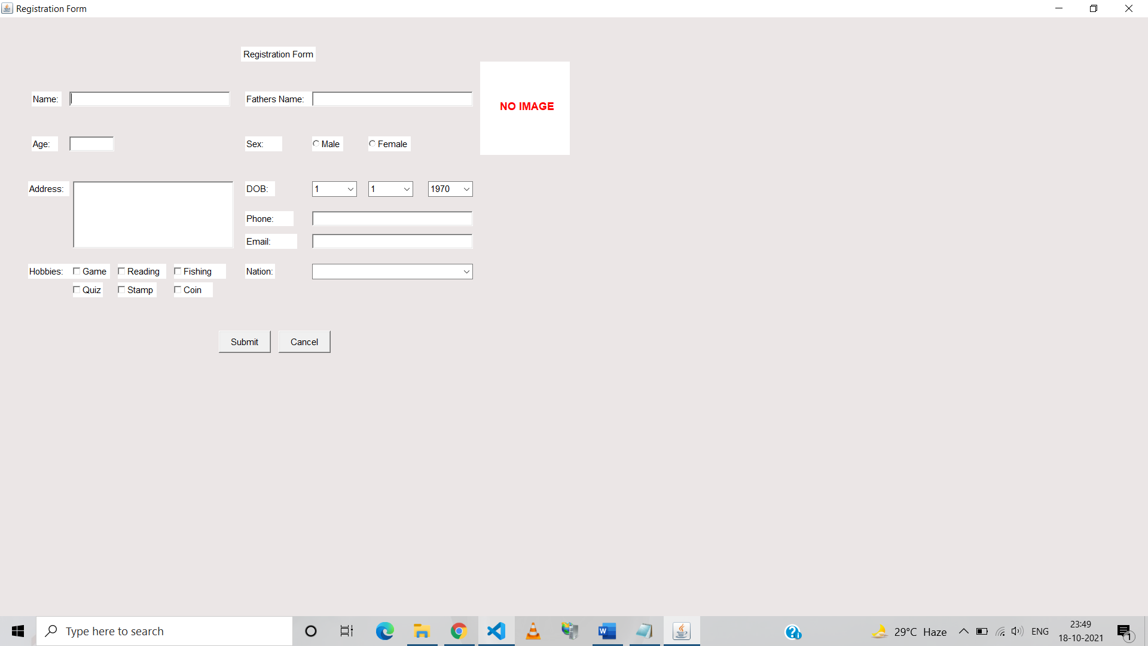

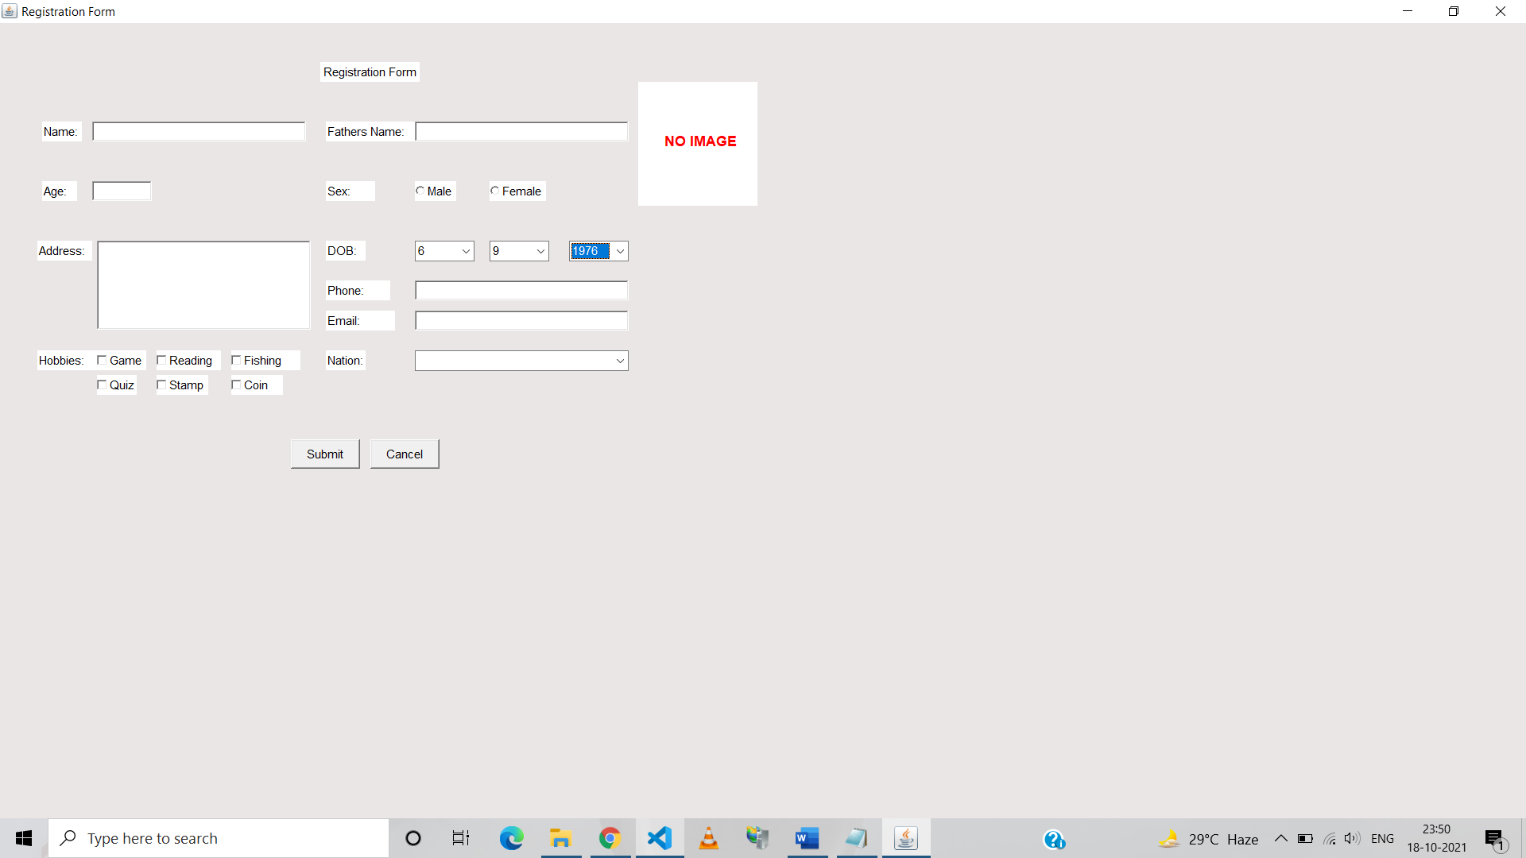

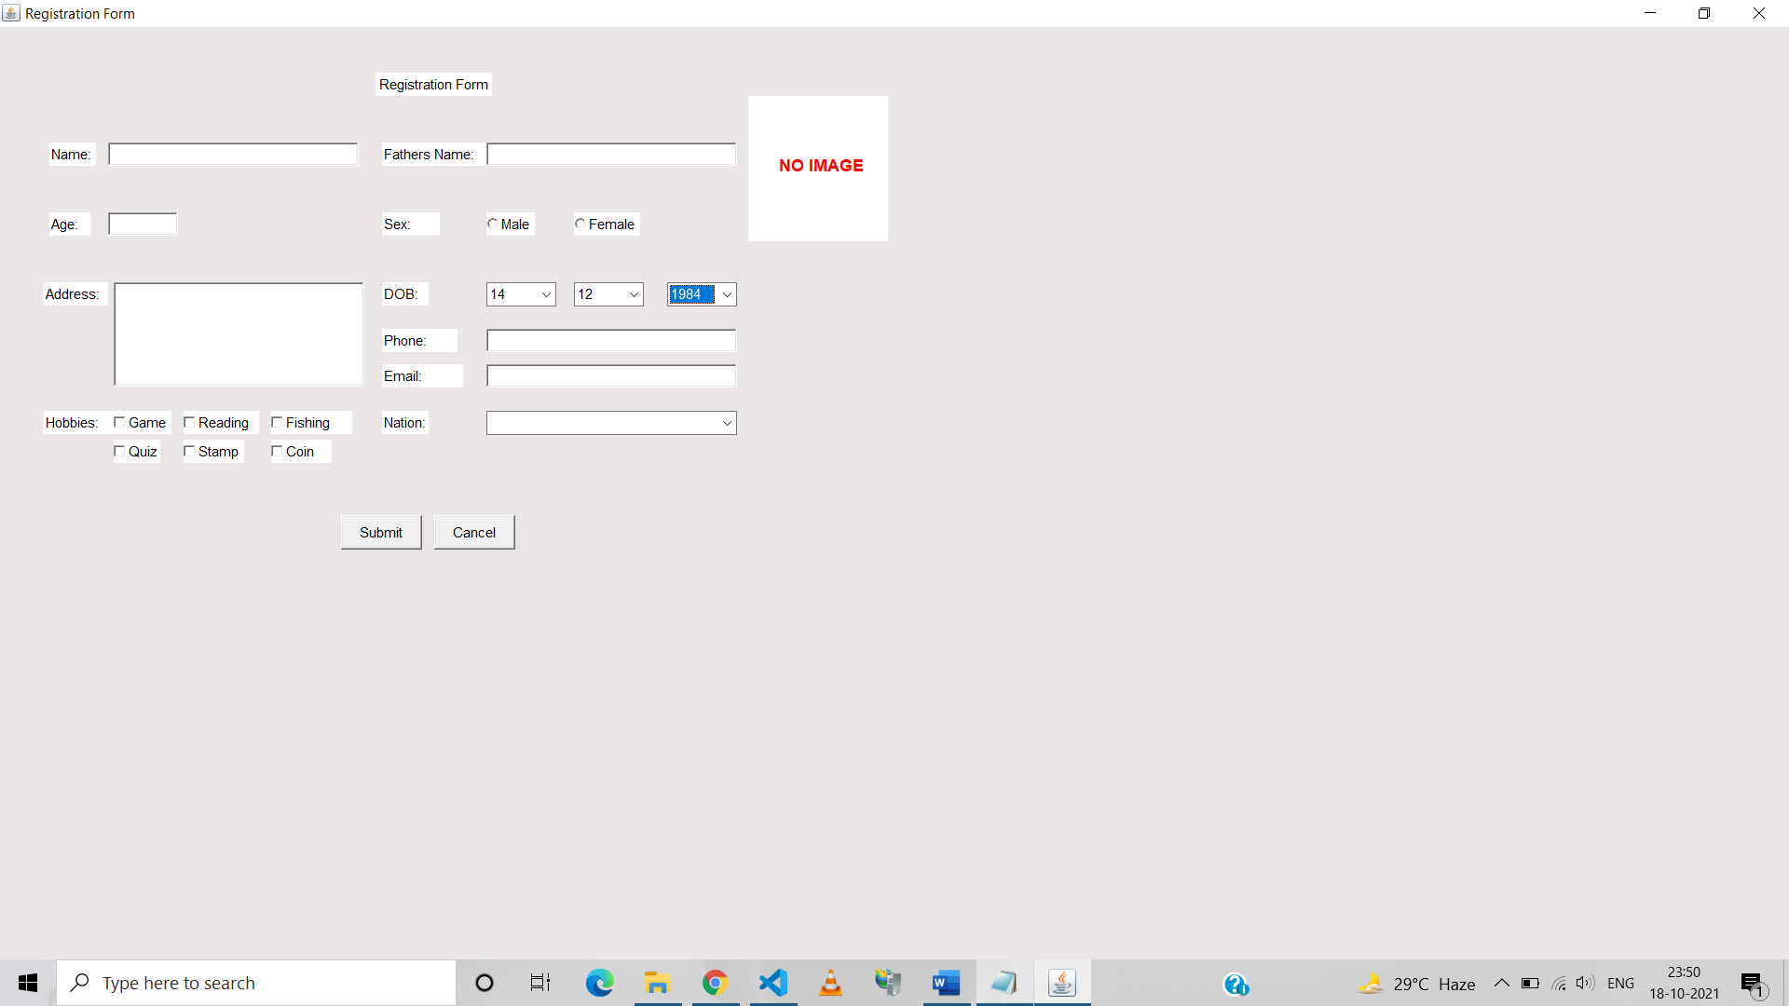

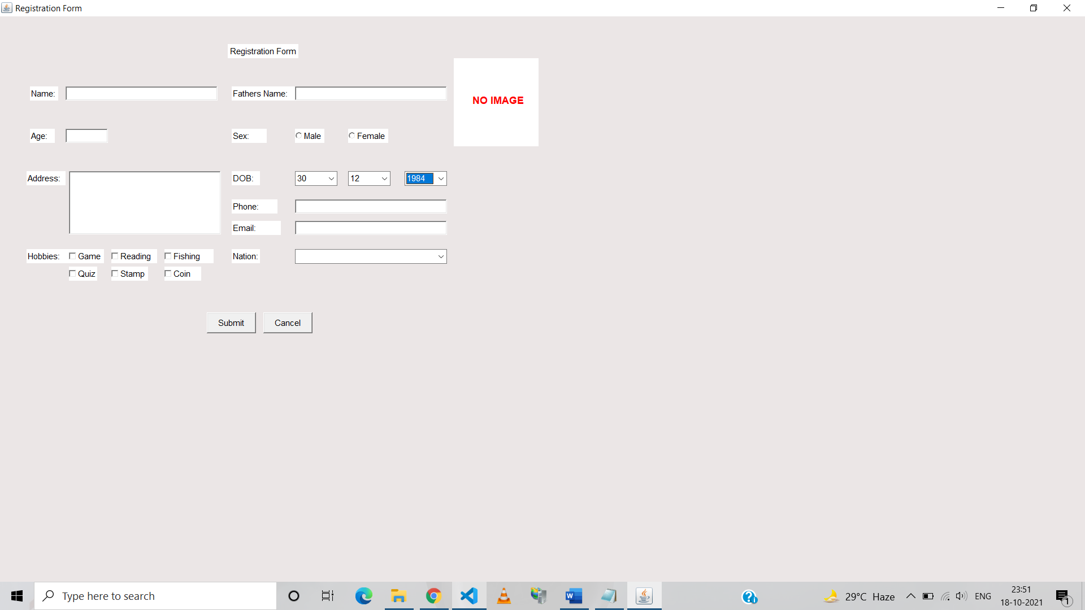

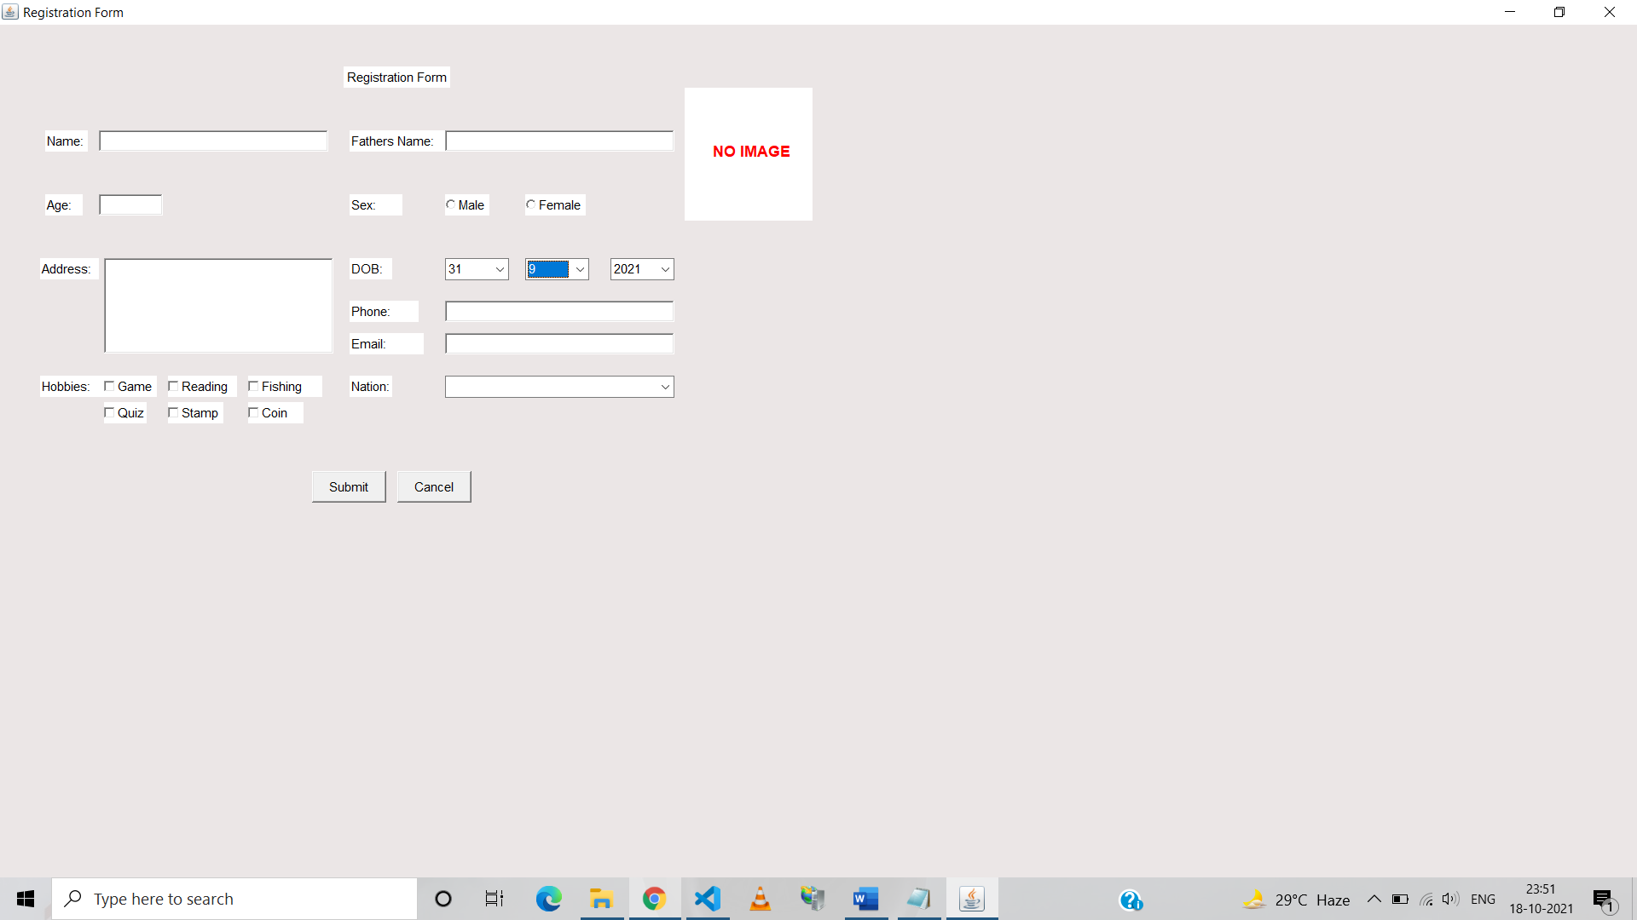

**Conclusion-** Thus, we have learnt how to design form using AWT components.