

**K .J.Somaiya Polytechnic, Mumbai-77**

**Batch No: C2**

**Enrollment No.: FCOG19126**

**Experiment No: 7**

**Experiment Name: Write a program to display a Jlabel on JFrame**



**K .J.Somaiya Polytechnic, Mumbai-77**

**Experiment No.07**

**Experiment Name: Write a program to display a Jlabel on JFrame**

**Objective**

**O18RA63.1. Create GUI using different swing & AWT components.**

**Implementation :**

|  |
| --- |
| import javax.swing.*;  class Labels{  public static void main(String[] args) {  JFrame f = new JFrame("Labels in Frame");  JLabel n1 = new JLabel("First Label");  JLabel n2 = new JLabel();  n1.setBounds(50,50,100,30);  n2.setBounds(180,50,100,30);  f.add(n1); f.add(n2);  f.setSize(400,400);  f.setLayout(null);  n2.setText("Second Label");  f.setDefaultCloseOperation(JFrame.EXIT_ON_CLOSE);  f.setVisible(true);  }  } |

Output:

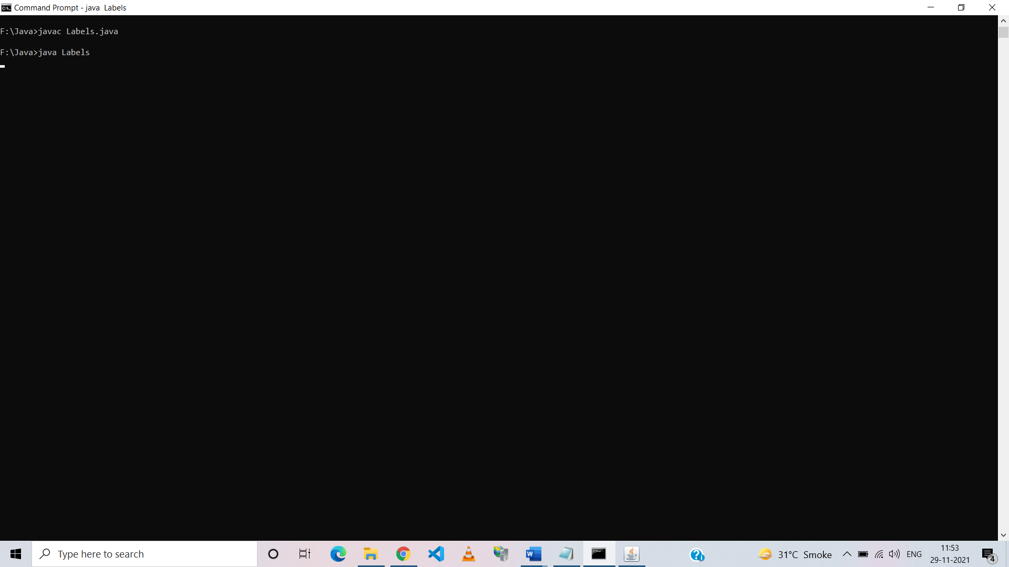

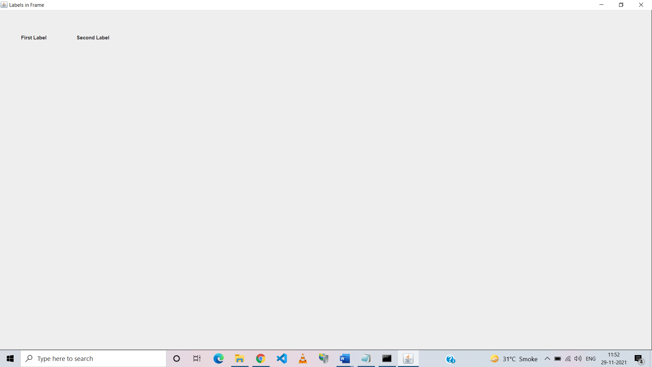

**Conclusion-** Thus, we have implemented a program to display JLabel on JFrame.