

INTERNAL ASSIGNMENT – 02
Comparative Study and Implementation of Generative AI Models

Submitted by-

Amruta Kanase : 202401110042

Sanika Mane : 202401110047

Tanishka Tapkir : 202401110071

1. Introduction and Objectives

Generative models learn what data looks like, rather than just labelling it, so that they can rebuild an input or create new examples that look like they came from the same source. In this assignment we compared four of them on face images: an Autoencoder (AE), a Variational Autoencoder (VAE), a Deep Convolutional GAN (DCGAN) and a pretrained Diffusion Model. Our aim was to see in practice how they differ in output quality, training behaviour and computing time.
Objectives:
(1) understand how each model is built and trained;
(2) run all four in a Colab notebook and record their real outputs, losses and times;
(3) compare their strengths, weaknesses and uses.

2. Dataset and Experimental Setup

We used the Labeled Faces in the Wild (LFW) dataset. The notebook downloads it, shuffles the image paths and keeps 3,000 images. Each image is converted to RGB, resized to 64 × 64 and scaled to the range [0, 1], giving an array of shape (3000, 64, 64, 3). This is split into 2,700 training and 300 validation images. AE, VAE and DCGAN were trained from scratch with TensorFlow/Keras. The diffusion model was not trained: we used the pretrained segmind/tiny-sd model (PyTorch, Hugging Face Diffusers) on a GPU for inference only.
Colab notebook: https://colab.research.google.com/drive/1t1PBKGPbLAadVUDPFQuYTkzCqsJB8EHi?usp=sharing
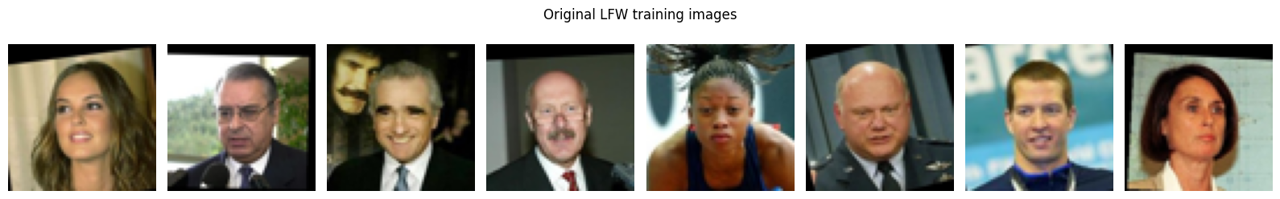
Figure 1: Sample LFW training images (notebook output)
Table 1: Experimental settings
Model | Approach | Key settings
AE | Trained, 10 epochs | 128-d latent; MSE loss
VAE | Trained, 10 epochs | 128-d latent; BCE (summed) + KL loss
DCGAN | Trained, 30 epochs | 100-d noise; BCE adversarial loss; label smoothing, input noise, BatchNorm, Dropout
Diffusion | Pretrained, inference | segmind/tiny-sd; 20 steps; guidance scale 7.0

3. Practical Implementation and Results (Task 2)

3.1 Autoencoder (AE)
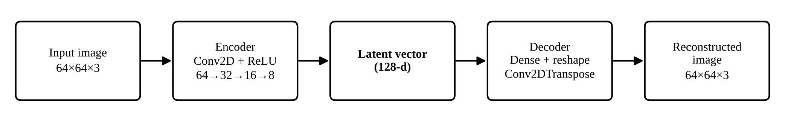
Figure 2: Autoencoder architecture
The encoder uses three convolution layers (64 → 32 → 16 → 8) and a dense layer to squeeze each image into a 128-number latent vector. The decoder rebuilds the image with transposed convolutions. Training minimises the Mean Squared Error, MSE = (1/N) Σ (xᵢ − x̂ᵢ)². Over 10 epochs (31.1 s), validation loss fell from 0.0548 to 0.0144 and training loss from 0.0714 to 0.0130. The reconstructions keep the face shape, skin tone and lighting but lose fine detail. That blur is typical of MSE, which rewards a safe "average" image.
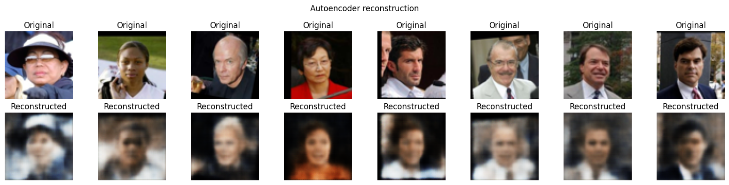
Figure 3: Original (top) vs AE reconstruction (bottom) (notebook output)
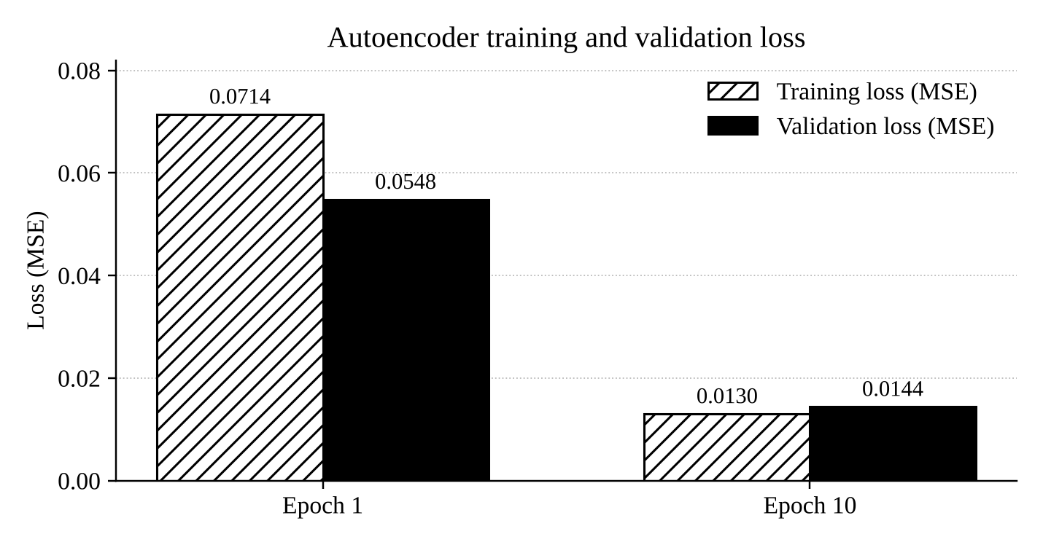
Figure 4: AE training and validation loss, epoch 1 vs epoch 10

3.2 Variational Autoencoder (VAE)
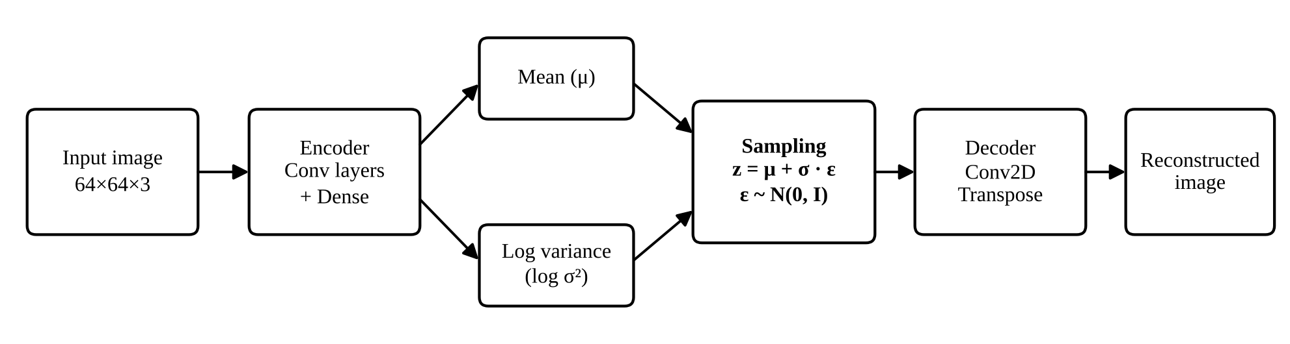
Figure 5: VAE architecture
Instead of a single point, the VAE encoder outputs a mean μ and log variance log σ² for each image. A latent vector is sampled as z = μ + σ · ε with ε ~ N(0, I) (the reparameterization trick), which keeps the network trainable by backpropagation. The loss is L = L_reconstruction + L_KL. The KL term pulls the latent space towards a standard normal distribution, so new faces can be sampled from it. After 10 epochs (20.5 s), the total loss was 6,772.4150 (reconstruction 6,681.3657, KL 91.0485). The reconstructions were smoother than the AE's, the price of a well-organised latent space.
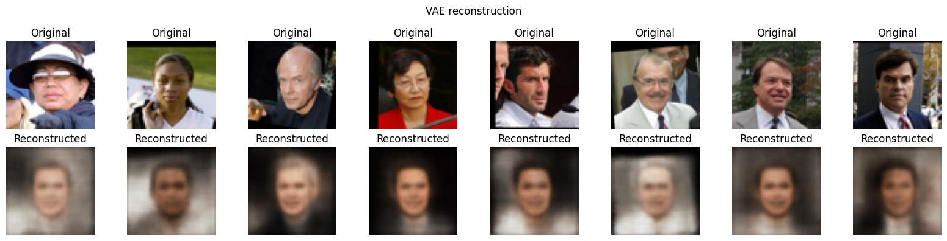
Figure 6: Original (top) vs VAE reconstruction (bottom) (notebook output)

3.3 Deep Convolutional GAN (DCGAN)
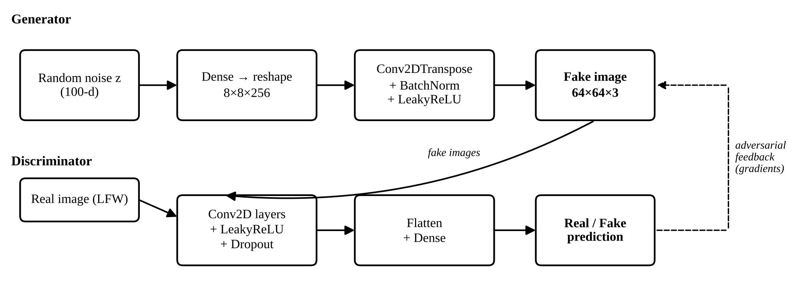
Figure 7: DCGAN generator and discriminator
A generator turns 100-d random noise into a 64 × 64 image, and a discriminator tries to tell real images from fake ones. The two are trained in turn on the objective min_G max_D E[log D(x)] + E[log(1 − D(G(z)))]. After 30 epochs (333.6 s), the generator loss was 0.7858 and the discriminator loss 1.3831. Both losses jumped around in the first few epochs and then levelled off, with the discriminator settling near ln 4 ≈ 1.386, which means it could no longer reliably separate real from fake. The samples kept improving after the losses flattened: by epoch 30 they were clearly face-like, though with visible artefacts.
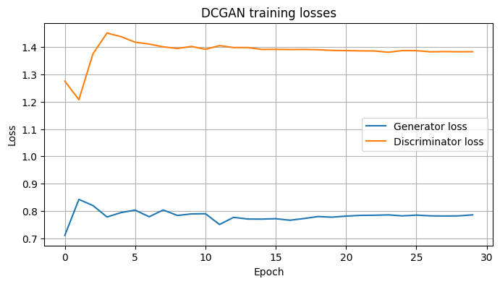  Figure 8: DCGAN losses over 30 epochs (notebook output) | 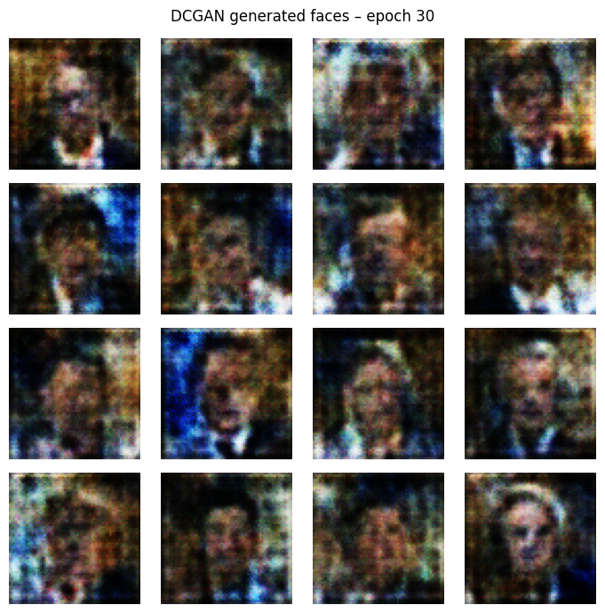  Figure 9: DCGAN samples at epoch 30 (notebook output)

3.4 Diffusion Model (pretrained)

A diffusion model learns to reverse a gradual noising process. Starting from random noise, a U-Net guided by the text prompt removes noise over many steps, and a VAE decoder turns the result into an image. Using segmind/tiny-sd with 20 steps and guidance scale 7.0, the prompt "A realistic portrait photograph of a person, soft natural daylight, neutral background, high detail." produced a detailed portrait in about 3.34 s. This is far sharper than our other outputs, but the comparison is not like-for-like: the model was pretrained on a huge dataset and never saw LFW.
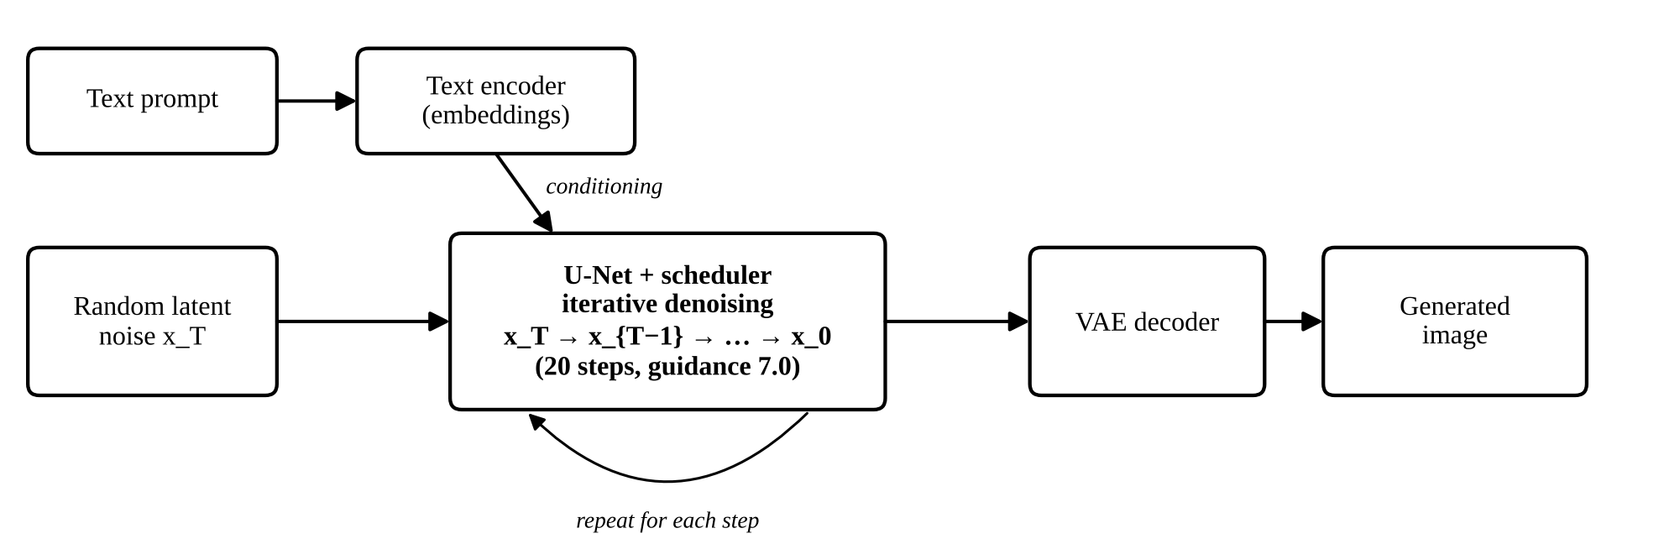
Figure 10: Text-to-image diffusion workflow


Figure 11: Portrait generated by segmind/tiny-sd (notebook output)

4. Comparative Study of the Four Models (Task 1)

Table 2 brings together the comparison required by Task 1: working principle, architecture and major components, advantages, limitations, applications, and how the outputs differed in our experiment.
Table 2: Comparison of AE, VAE, DCGAN and pretrained Diffusion Model
Criterion | Autoencoder (AE) | Variational AE (VAE) | DCGAN | Diffusion (pretrained)
Working principle | Compresses an image to a latent vector and rebuilds it; minimises MSE | Encodes image as a distribution (μ, σ); samples z = μ + σ·ε; loss = reconstruction + KL | Generator creates fakes from noise; discriminator separates real/fake; trained adversarially | Learns to remove noise step by step; starts from noise and denoises, guided by a text prompt
Architecture and major components | Conv encoder → 128-d latent → transposed-conv decoder | Conv encoder → μ and log σ² → sampling layer → decoder | Generator (dense + transposed conv) and discriminator (conv + dense) | Text encoder, U-Net, noise scheduler, VAE decoder
Advantages | Simple, fast, stable training | Smooth latent space; can sample new images | Creates new, sharper images | Highest quality; prompt control
Limitations | Blurry; loses fine detail | Even smoother/softer outputs | Unstable training; artefacts; mode collapse | Heavy compute; may not follow prompt exactly
Applications | Compression, denoising, anomaly detection | Representation learning, data augmentation | Face synthesis, data augmentation | Text-to-image, design, concept art
Output in our experiment | Reconstruction close to input but blurred (val. MSE 0.0144) | Smoother reconstruction, less detail (loss 6,772.4; KL 91.0) | New 64×64 faces with visible artefacts | Detailed, realistic 512×512 portrait

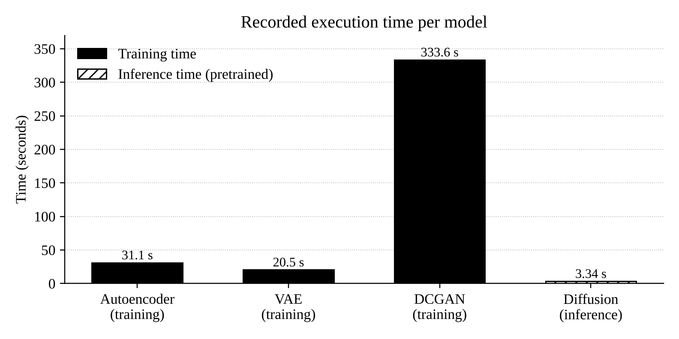
Figure 12: Execution time: training (solid) vs inference (hatched)
DCGAN took more than ten times as long as the AE or VAE, because it updates two networks per step and ran for 30 epochs instead of 10. The diffusion time covers generating one image with already-trained weights, so it should not be compared with the training times. The loss values cannot be compared across models either. The AE's MSE is averaged per pixel, the VAE's loss is summed over all pixels plus a KL term, and the GAN losses only describe how the two networks are doing against each other. So a VAE loss of 6,772 is not "worse" than an AE loss of 0.0144. The only fair cross-model comparison is the images themselves.

5. Output Analysis

5.1 Activity A – Image Reconstruction (CO3)
- AE kept face position, shape, skin tone and lighting, but hair texture, eye detail and background edges were blurred. Validation MSE fell from 0.0548 to 0.0144 (31.1 s).
- VAE outputs were smoother and less detailed than AE; faces look "averaged". The KL term organises the latent space, which allows sampling but costs sharpness (20.5 s).
- Neither model showed strong distortion; the main difference is loss of detail, which is larger in the VAE.

5.2 Activity B – Image Generation (CO4)
- DCGAN produced new face-like images that do not exist in the dataset, but with low resolution (64 × 64), colour noise and distortions. Losses settled at G = 0.7858, D = 1.3831 (training 333.6 s).
- Diffusion produced a far more realistic and detailed portrait in about 3.34 s for the prompt "A realistic portrait photograph of a person, soft natural daylight, neutral background, high detail." Its advantage comes from large-scale pretraining, so the comparison is not like-for-like.
- Overall: realism and detail: Diffusion > DCGAN; faithfulness to input: AE > VAE. Loss values were not compared across models because each uses a different loss function and scale.

5.3 Limitations
Only 3,000 images at 64 × 64; short training runs; quality judged visually, with no FID/SSIM; the diffusion model was pretrained rather than trained by us; and each experiment was run once.

6. Group Reflection and AI Usage (Task 3)
AI tools used: Claude, for concept explanations, understanding the notebook code, building the comparison table and structuring and writing this report. All experiments were run by the group in Google Colab.
Table 3: Important prompts used
Purpose | Prompt (summary)
Concepts | "Explain the working of AE, VAE, DCGAN and diffusion models with architecture and loss functions in simple terms."
Code | "Explain this Colab notebook cell by cell and why the VAE uses the reparameterization trick."
Comparison | "Compare AE, VAE, DCGAN and Stable Diffusion on working principle, architecture, advantages, limitations and applications in one table."
Report | "Analyse my executed notebook and generate a structured report using only the actual results; do not invent values."

Verification process: every number in this report (losses, epochs, times, dataset sizes) was checked against the executed notebook output; model explanations were cross-checked with the original papers (Kingma & Welling 2014; Goodfellow et al. 2014; Radford et al. 2016; Ho et al. 2020) and the TensorFlow and Hugging Face Diffusers documentation; screenshots are taken directly from the notebook. AI-suggested statements that could not be verified were removed.
Key learning outcomes: how encoder–decoder models compress and rebuild images; why VAE outputs are smoother; how adversarial training works and why GAN losses do not show image quality; how diffusion models generate images from noise using a prompt; and why training time and inference time must be compared separately.
Table 4: Contribution of each member
Member | Contribution
Sanika , Tanishka | Ran the AE and VAE experiments, captured reconstruction screenshots and wrote the Activity A analysis. Studied CO3 models in depth.
Tanishka , Amruta | Ran the DCGAN and pretrained diffusion experiments, captured generated outputs and loss graph, and wrote the Activity B analysis.
Amruta , Sanika | Prepared the comparative table, documented AI tools, prompts and verification, compiled the report and PPT.

7. Conclusion
Each model suits a different job. AE and VAE are good for reconstruction and learning compact representations, DCGAN for generating new images from a specific dataset, and diffusion models for high-quality, prompt-controlled generation if the computing cost is acceptable. With more data, higher resolution, longer training and proper metrics such as FID, the trained models could be compared much more rigorously, and fine-tuning a diffusion model on LFW would make the comparison fair.

References
[1] G. B. Huang et al., "Labeled Faces in the Wild," UMass Amherst, Tech. Rep. 07-49, 2007. https://vis-www.cs.umass.edu/lfw/
[2] D. P. Kingma and M. Welling, "Auto-Encoding Variational Bayes," ICLR, 2014.
[3] I. Goodfellow et al., "Generative Adversarial Nets," NeurIPS, 2014.
[4] A. Radford, L. Metz and S. Chintala, "Unsupervised Representation Learning with Deep Convolutional GANs," ICLR, 2016.
[5] J. Ho, A. Jain and P. Abbeel, "Denoising Diffusion Probabilistic Models," NeurIPS, 2020.
[6] Segmind, "segmind/tiny-sd," Hugging Face. https://huggingface.co/segmind/tiny-sd
[7] Project Colab notebook (Generative AI Assignment 02). https://colab.research.google.com/drive/1t1PBKGPbLAadVUDPFQuYTkzCqsJB8EHi?usp=sharing

