PRACTICAL REPORT

AWS IAM User, Group and CLI Setup
SkillPilote Practical

1. Aim
To create an IAM user and user group in AWS, attach the required permissions, and configure AWS CLI on Windows to verify the identity and check S3 bucket access.

2. Tools and Requirements
- An AWS account with access to the AWS Management Console
- AWS Identity and Access Management (IAM)
- AWS CLI installed on Windows
- Windows PowerShell
- Internet connection

3. Procedure

Step 1: Open IAM user groups
Sign in to the AWS Management Console. Open IAM from Services, then select User groups under Access Management.
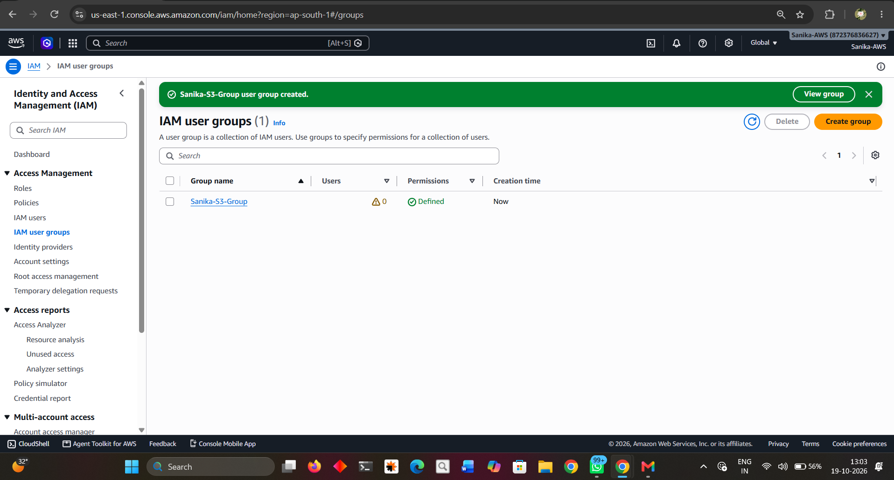
Figure 1. IAM user groups page.

Step 2: Create the IAM group
Select Create group and enter the group name Sanika-S3-Group. Select the appropriate permissions policy required for the practical, then create the group.
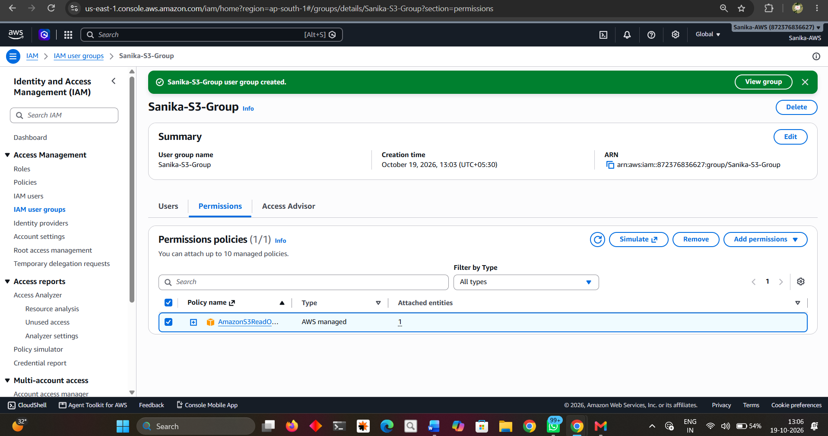
Figure 2. Sanika-S3-Group created with a permissions policy attached.

Step 3: Enter IAM user details
Open IAM Users and choose Create user. Enter the username user_sanika. The supplied screenshot shows console access enabled and a custom console password selected. Keep passwords private and do not include them in public repositories.
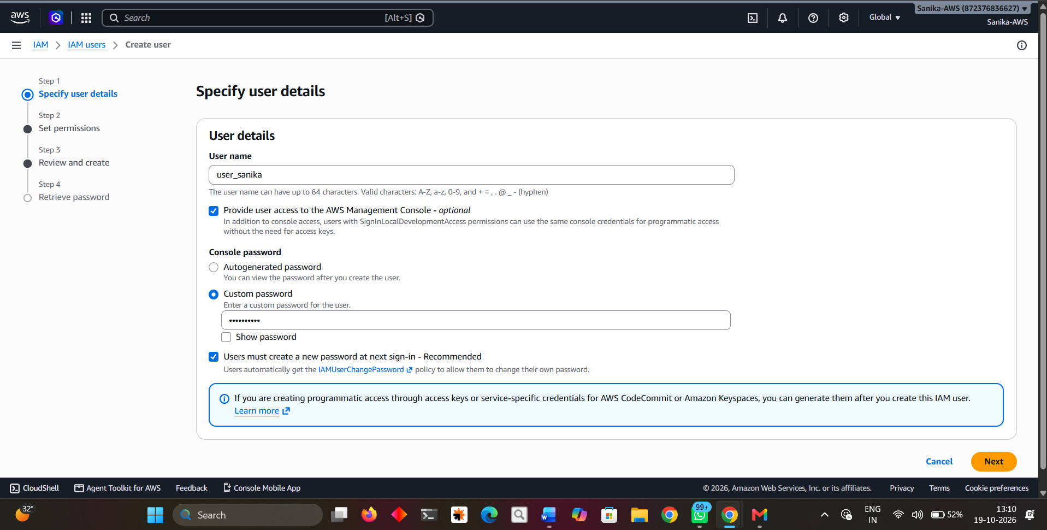
Figure 3. User details entered for user_sanika.

Step 4: Review permissions and create the user
Review the user details and permissions summary. The screenshot shows the IAMUserChangePassword policy and the Sanika-S3-Group group listed in the summary. Confirm the details and select Create user.
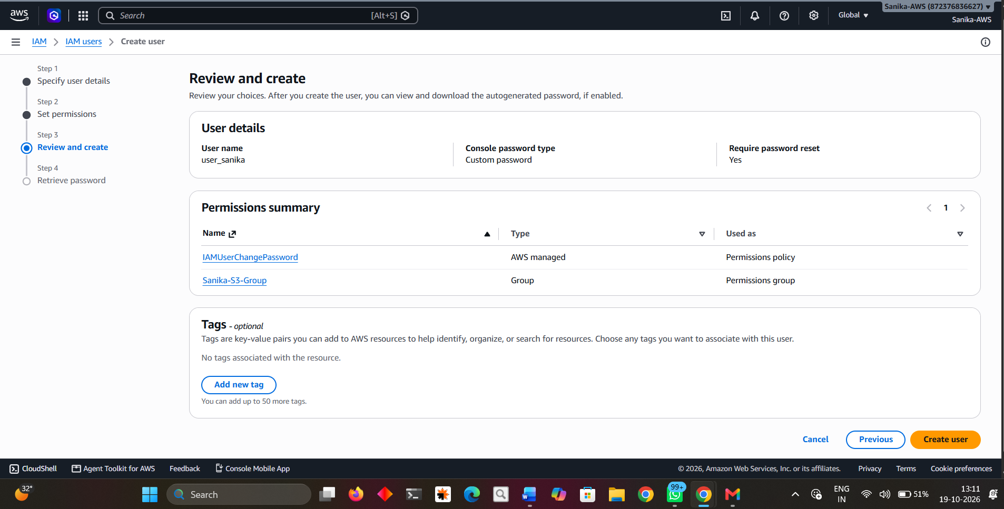
Figure 4. Review and create screen.

Step 5: Confirm user creation
After AWS confirms successful creation, verify the username. The console password is masked in the supplied screenshot; do not reveal or publish the password.
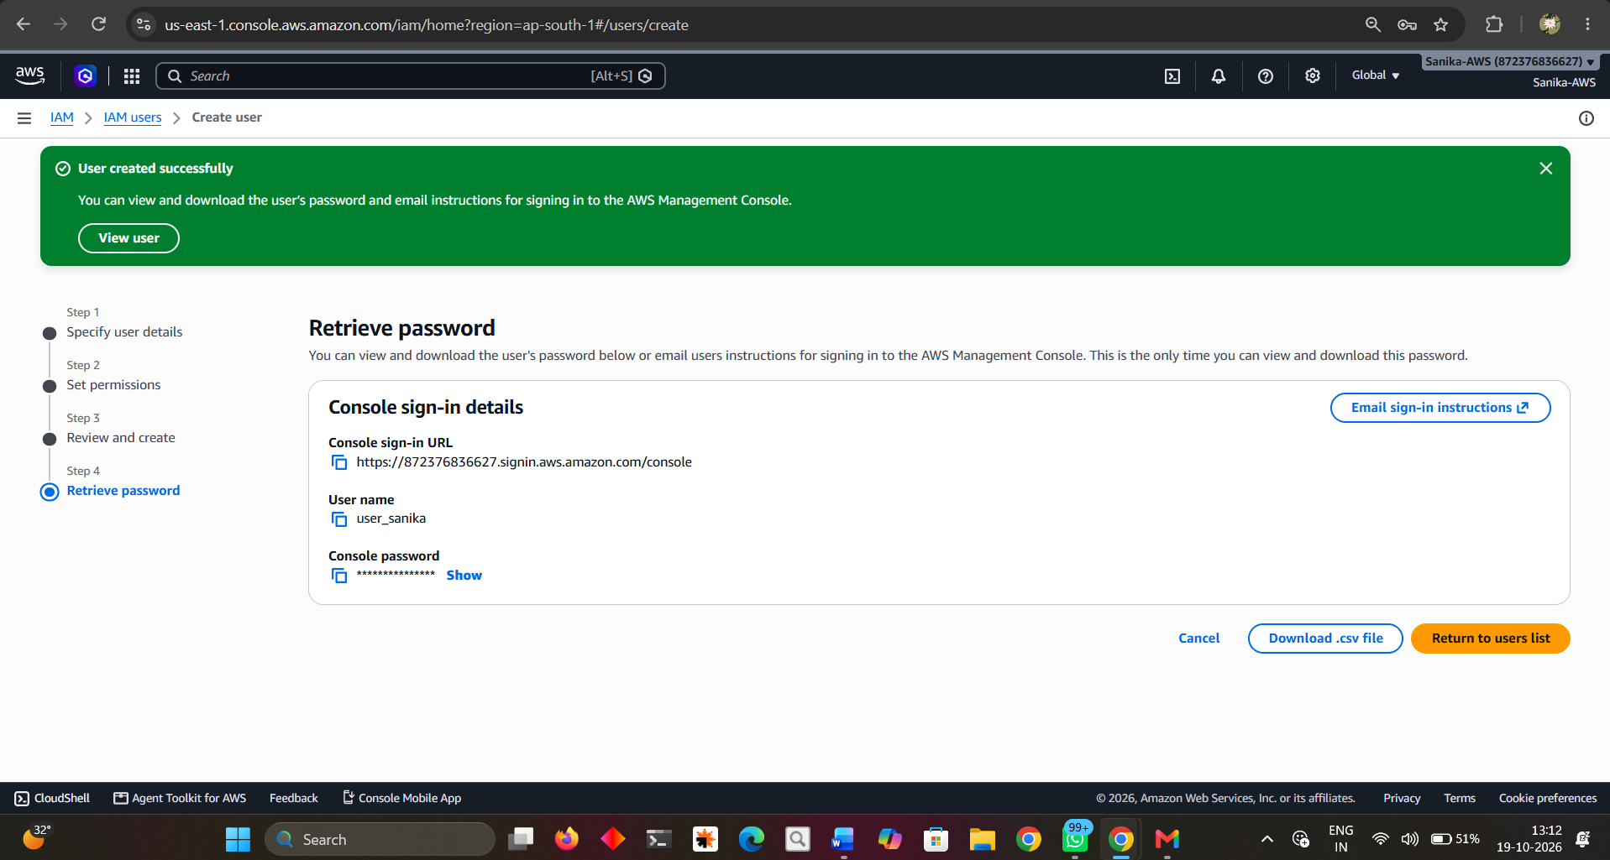
Figure 5. AWS confirms that the user was created successfully.

Step 6: Verify the IAM user list
Return to IAM Users and confirm that user_sanika appears in the user list.
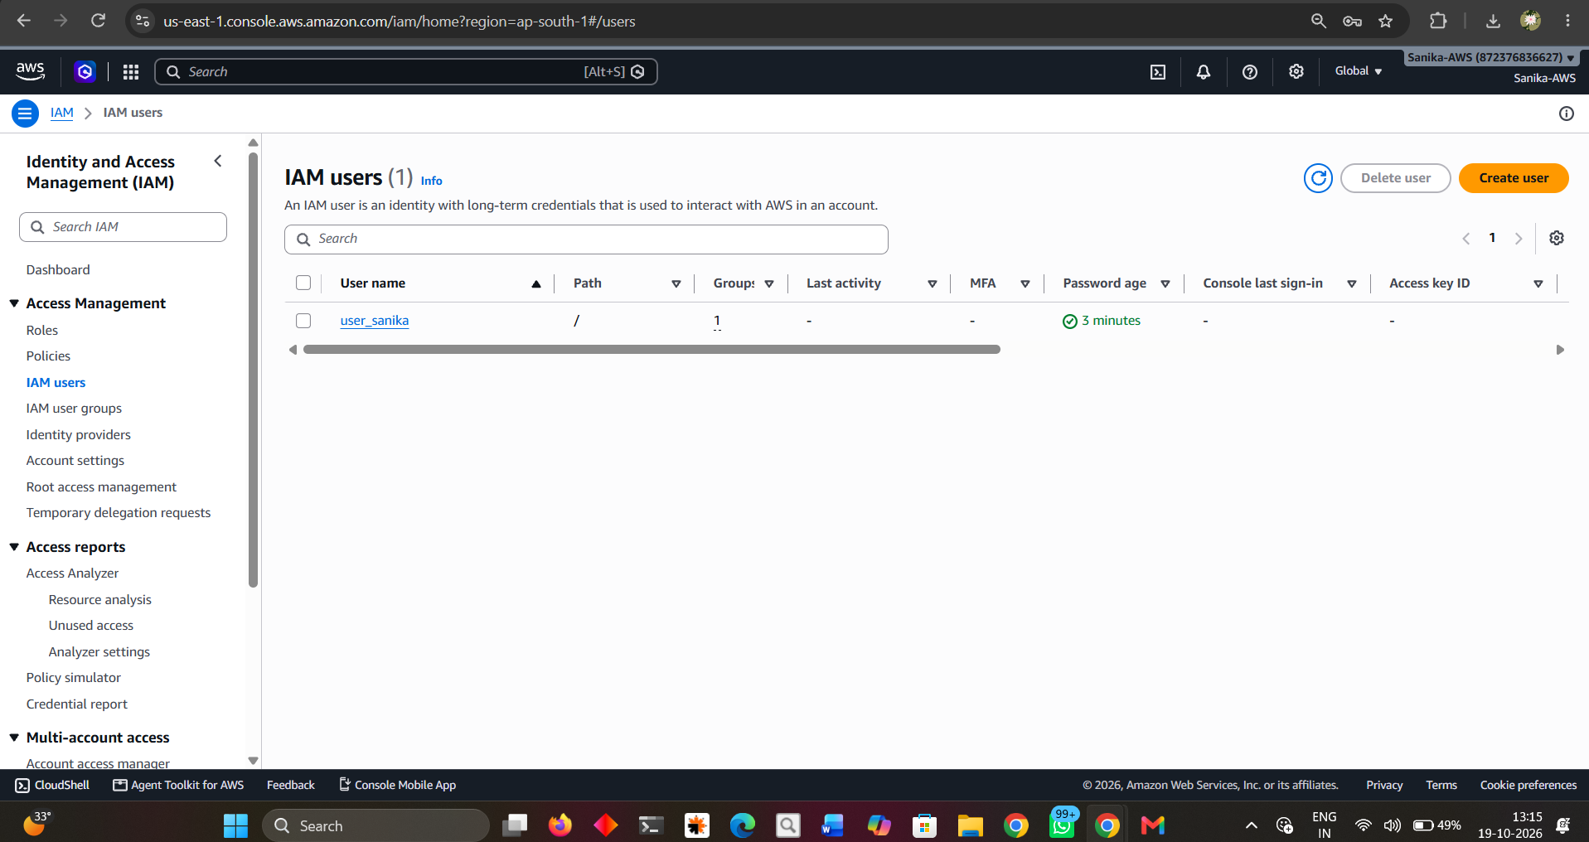
Figure 6. IAM user list showing user_sanika.

Step 7: Configure AWS CLI
Open Windows PowerShell and run aws configure. Enter the access key ID and secret access key privately when prompted, then enter the configured region (the screenshot shows ap-south-1) and output format json. Never commit credentials to GitHub or paste them into a report.
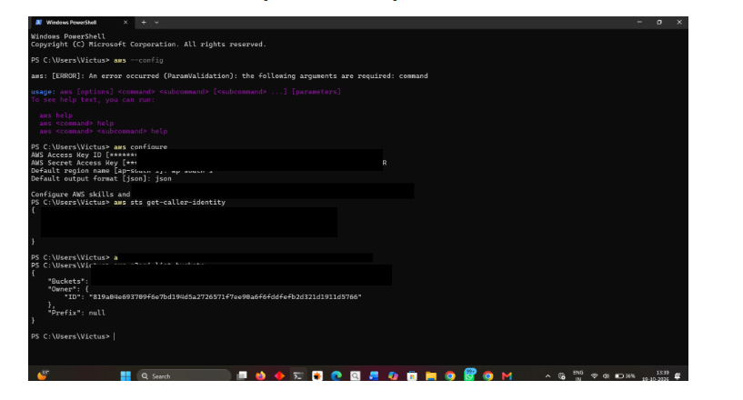
Figure 7. AWS CLI configuration and verification commands; credential and account-specific values have been redacted.

Step 8: Confirm group membership
Return to IAM user groups and confirm that Sanika-S3-Group is listed and has one user assigned. The S3 bucket-listing result is shown in the redacted PowerShell screenshot in Step 7.
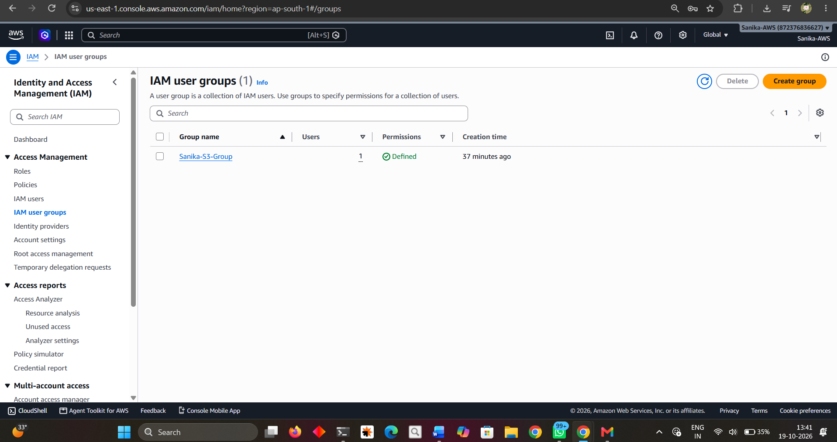
Figure 8. IAM user groups page showing Sanika-S3-Group with one user.

4. Observation
- The IAM group Sanika-S3-Group was created successfully.
- The IAM user user_sanika was created and appears in the IAM Users list.
- A permissions policy and the group are shown in the review summary.
- AWS CLI was configured with region ap-south-1 and JSON output format, as shown in the screenshot.
- The CLI identity check ran, and the S3 bucket listing returned an empty bucket list in the supplied screenshot.

5. Result
The IAM group and user were created, and AWS CLI commands were used to verify the configured identity and list S3 buckets. The captured bucket listing was empty, so no S3 buckets were shown during this run.

6. Security Notes Before Uploading to GitHub
- The PowerShell screenshot has been edited to cover the access key/secret key area and account-specific identity values.
- Never upload AWS access keys, secret access keys, passwords, session tokens, or unredacted credential files.
- If any real AWS secret key was exposed in a screenshot, terminal history, or repository, deactivate/delete that key in IAM and create a replacement before continuing.
- Do not commit the local AWS credentials file (typically located in the .aws folder) to GitHub.
- Use least-privilege permissions and remove temporary users, policies, or keys when they are no longer needed.

7. Conclusion
In this practical, an AWS IAM group and user were created and AWS CLI was configured on Windows. The identity and S3 listing commands were executed for verification. The screenshots have been arranged in the report, and sensitive values in the CLI screenshot have been masked for safer sharing.

