SKILLPILOTE PRACTICAL REPORT
Day 11: Connecting Amazon EC2 to Amazon RDS (MySQL)
Status: EC2 setup completed. RDS creation and database connection were not completed during this session.
Region: Asia Pacific (Mumbai) — ap-south-1

1. Aim
To launch an Amazon EC2 Linux instance and prepare secure network connectivity for a MySQL database hosted on Amazon RDS.

2. Objectives
- Launch and verify an EC2 instance.
- Configure restricted SSH and optional HTTP inbound rules.
- Review RDS MySQL instance, storage, and connectivity options.
- Plan private EC2-to-RDS access through security groups.
- Complete a database connection and sample-record test after verifying pricing.

3. Services and tools
AWS Management Console, Amazon EC2, Amazon RDS for MySQL, VPC security groups, and a web browser.

4. Procedure performed

Step 1 — Open EC2 in Mumbai
Opened the EC2 console in ap-south-1. The previous EC2 instance had been deleted, so a replacement instance was launched.

Step 2 — Configure EC2
Selected Amazon Linux 2023, t3.micro, and an 8 GiB root volume. The instance name was SkillPilote-Day11-EC2.

Step 3 — Configure inbound rules
SSH TCP port 22 was restricted to the user's public IP (/32). HTTP TCP port 80 was also present for a public web-server demonstration if required.

Step 4 — Verify EC2
The console showed the instance Running with 3/3 status checks passed.

Step 5 — Start RDS configuration
Selected Full configuration, MySQL Community, MySQL 8.4.11 as shown in the console, and a single-instance deployment.

Step 6 — Reduce the instance class
The initial RDS class was db.m7g.large. It was changed to db.t3.micro to reduce expected instance cost.

Step 7 — Review storage and connectivity
Reviewed gp3 storage with 20 GiB allocated. The plan was to use the default VPC, Public access No, and a dedicated security group named SkillPilote-Day11-RDS-SG.

Step 8 — Review monitoring
Reviewed Enhanced Monitoring and log export settings; optional monitoring was identified for disabling in this basic practical.

Step 9 — Stop before creation
The console continued to show an estimated cost of about USD 20.87/month. RDS creation was not submitted while cost eligibility was still being checked.

5. Actual results
- EC2 instance launched successfully in ap-south-1.
- Instance name: SkillPilote-Day11-EC2.
- Instance type: t3.micro; root volume: 8 GiB.
- EC2 state reached Running and 3/3 status checks passed.
- RDS MySQL configuration was reviewed but the database was not created.
- EC2-to-RDS connection and sample record insertion have not been performed.

6. Remaining work
- Check AWS Free Tier eligibility and credits; verify actual RDS price.
- If cost is acceptable, create the RDS MySQL database with private access.
- Allow inbound TCP 3306 on the RDS security group from the EC2 security group only.
- Connect to EC2 and use a MySQL client to connect to the RDS endpoint.
- Create a demo database/table, insert one sample record, and verify it with SELECT.
- Capture genuine screenshots of the successful connection and query.
- Delete RDS when no longer needed; avoid a final snapshot if it is not required.
- Check for remaining billable resources after the practical.

7. Security and cost notes
- Keep RDS Public access set to No.
- Do not open MySQL port 3306 to 0.0.0.0/0; allow the EC2 security group only.
- Keep SSH restricted to your own IP address.
- Never upload passwords, AWS access keys, or private .pem keys to GitHub.
- The RDS estimate shown was approximately USD 20.87/month; actual charges can differ and may include storage, backup, I/O, and data transfer.
- Free-tier offers and credits vary by account and may not cover every configuration.
- Deleting resources stops future applicable charges after deletion completes, but does not refund charges already incurred; retained snapshots can continue to cost money.

8. Conclusion
The EC2 portion of the practical was completed successfully. A t3.micro Amazon Linux 2023 instance was launched in Mumbai and reached Running state with 3/3 status checks passed. RDS MySQL configuration was reviewed, but database creation was intentionally postponed because the console estimated approximately USD 20.87 per month. Therefore, the actual EC2-to-RDS connection and sample-record test remain pending.

9. Screenshot evidence
These are actual console screenshots shared during the session. They document the EC2 setup and RDS configuration review; they do not claim that an RDS database or connection was successfully created.

Evidence 1: EC2 launch screen
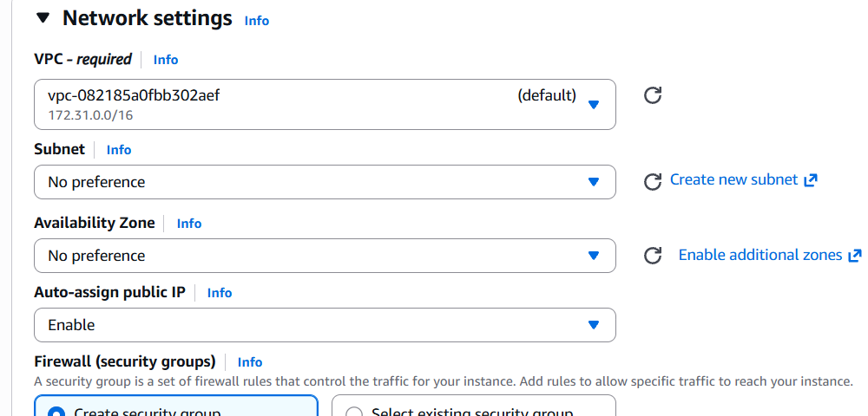

Evidence 2: EC2 network settings
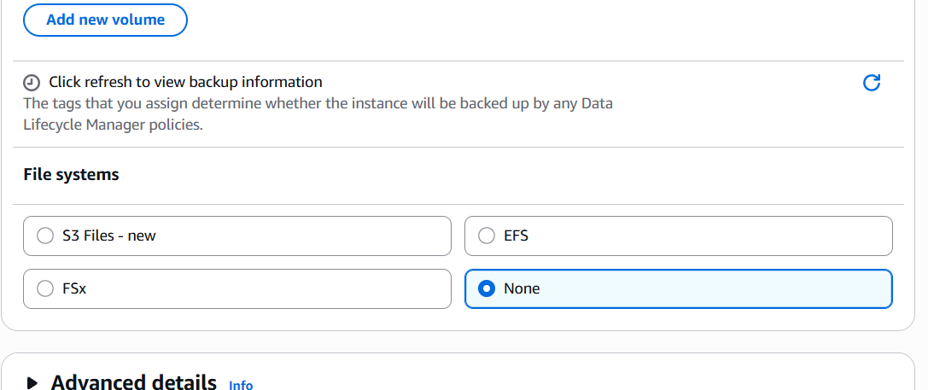

Evidence 3: EC2 launch configuration
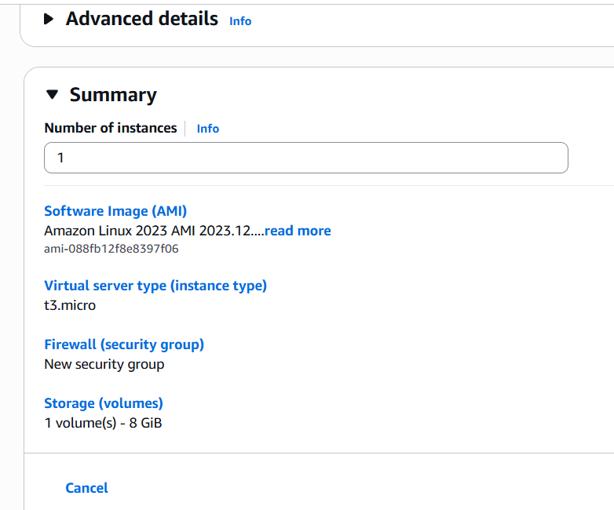

Evidence 4: Inbound rules
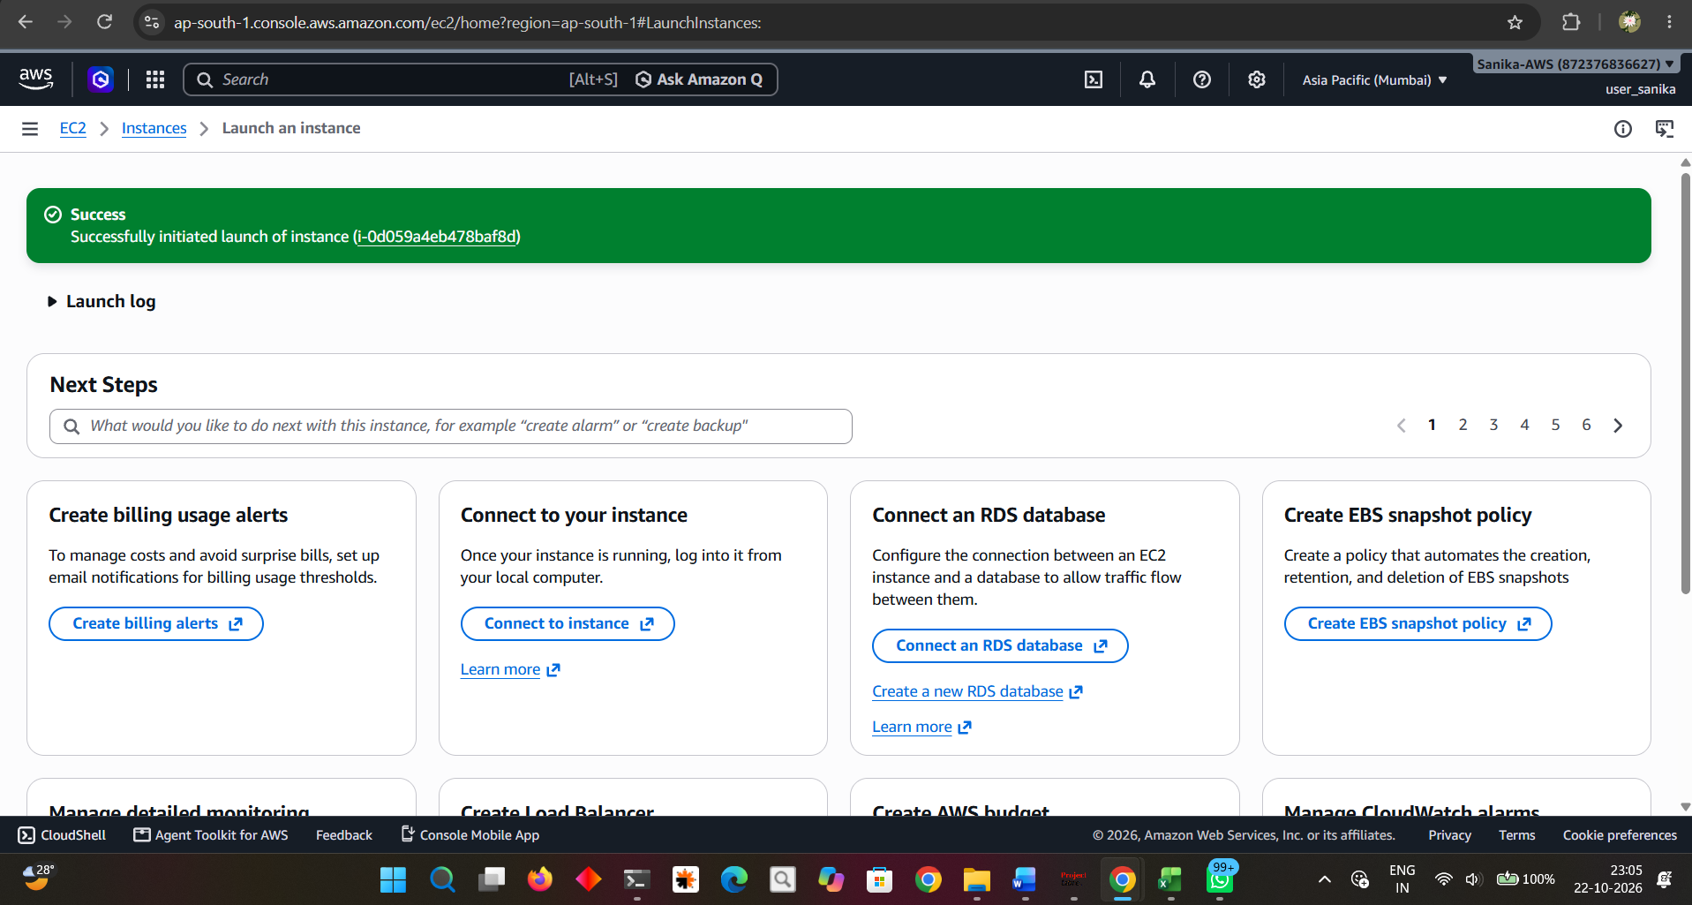

Evidence 5: Security-group source rules
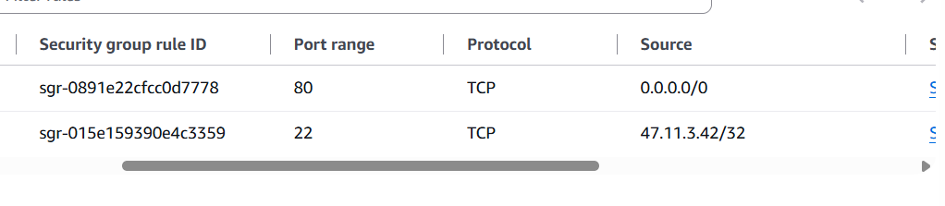

Evidence 6: EC2 instance details
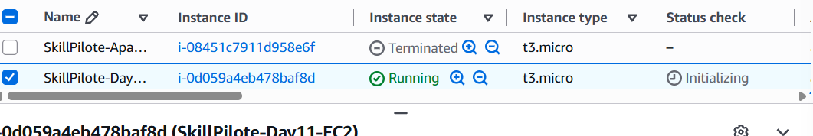

Evidence 7: EC2 status checks
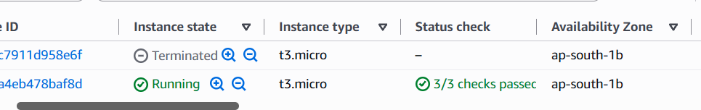

Evidence 8: RDS creation workflow
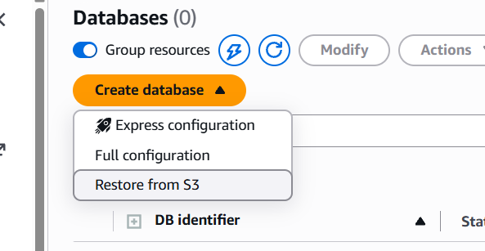

Evidence 9: RDS MySQL engine settings
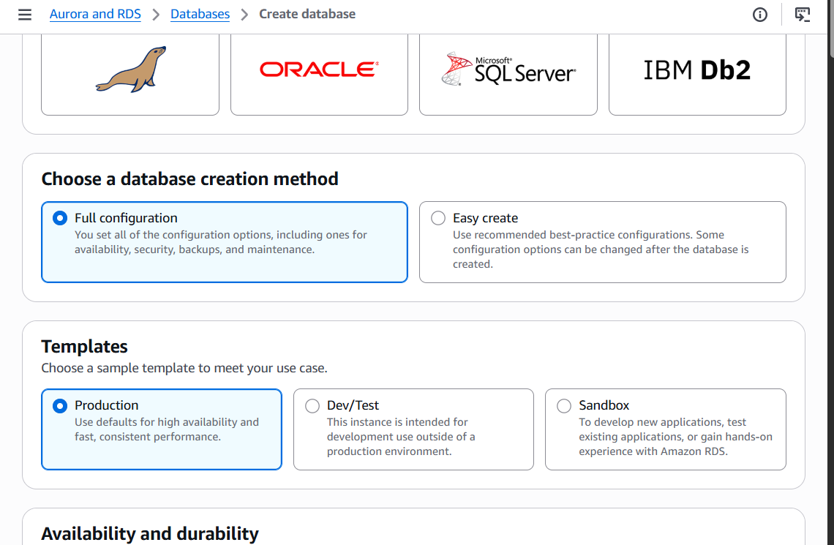

Evidence 10: RDS instance class settings
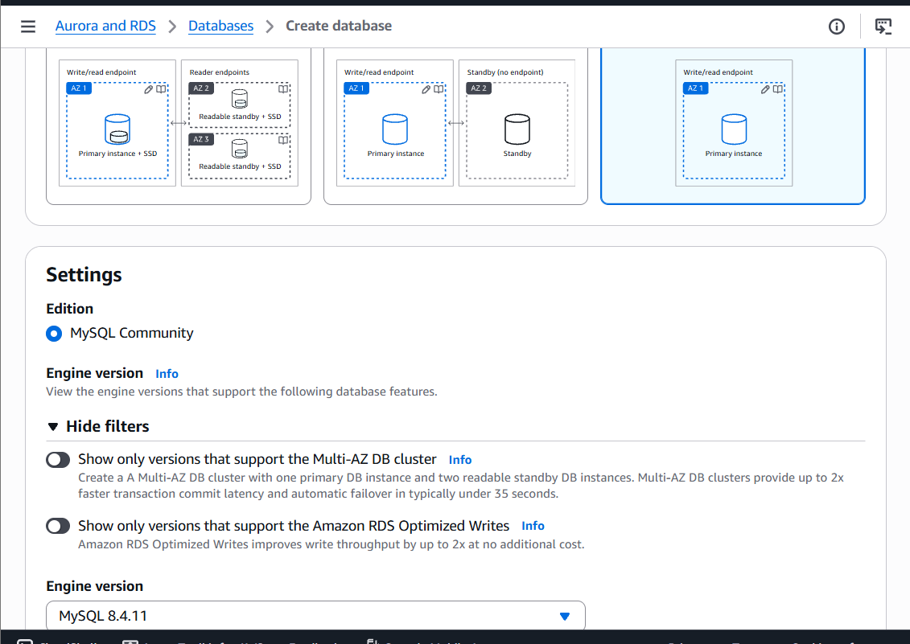

Evidence 11: RDS storage configuration
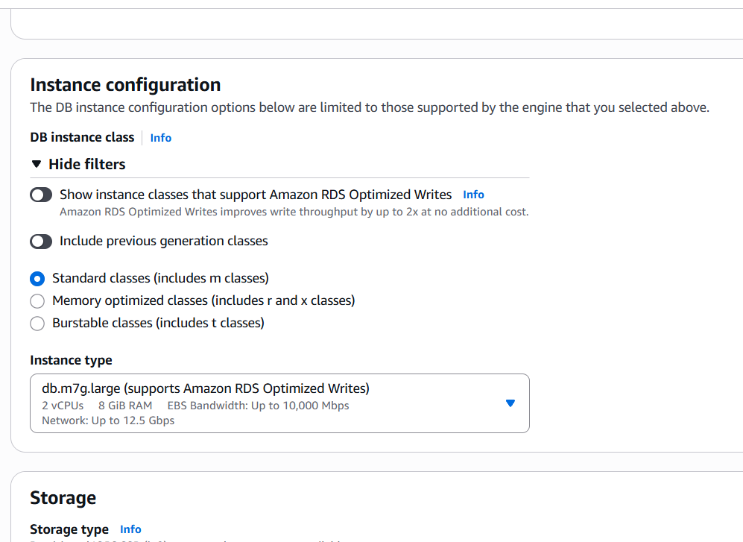

Evidence 12: RDS connectivity settings
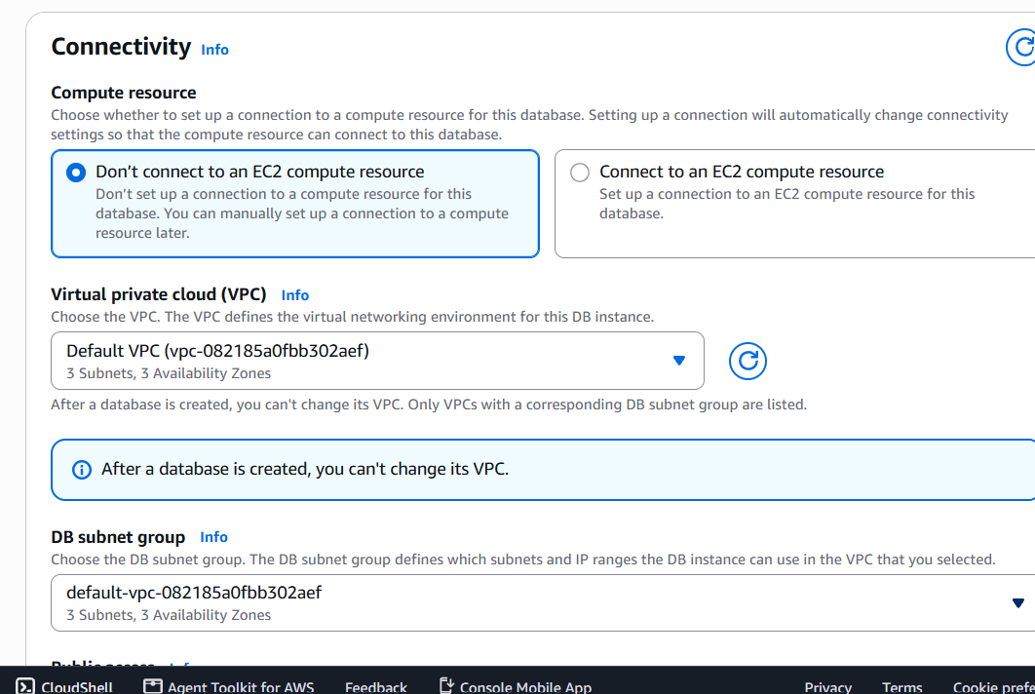

Evidence 13: RDS security-group name
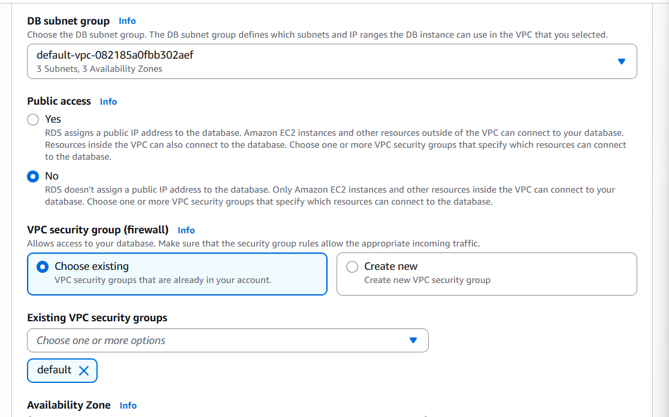

Evidence 14: RDS optional settings
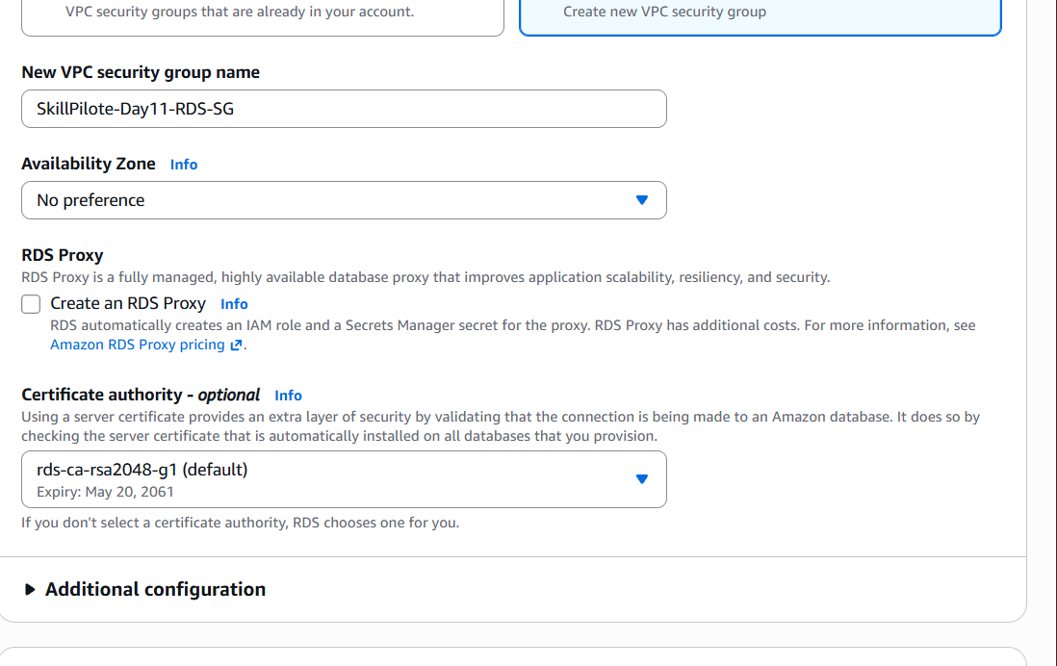

Evidence 15: RDS monitoring options
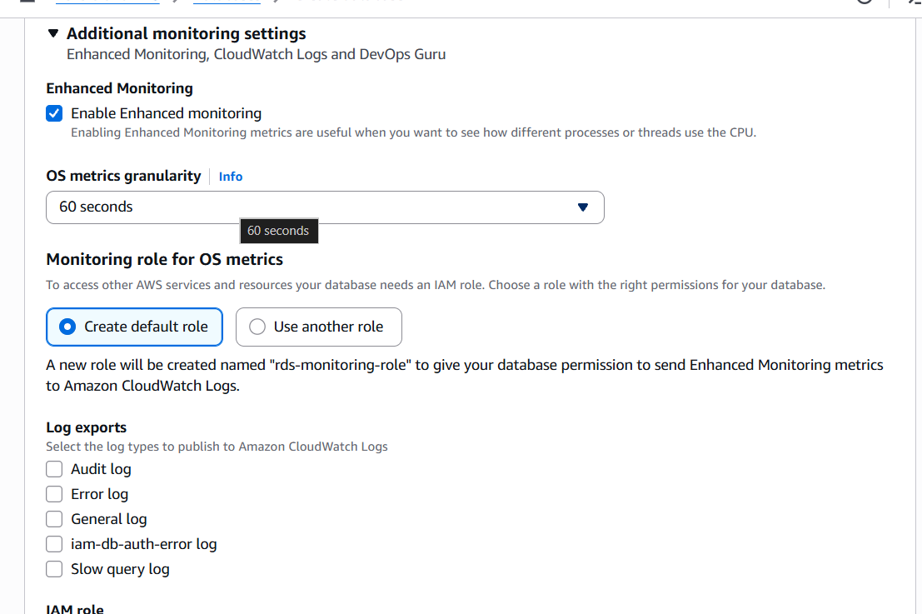

Evidence 16: RDS cost estimate
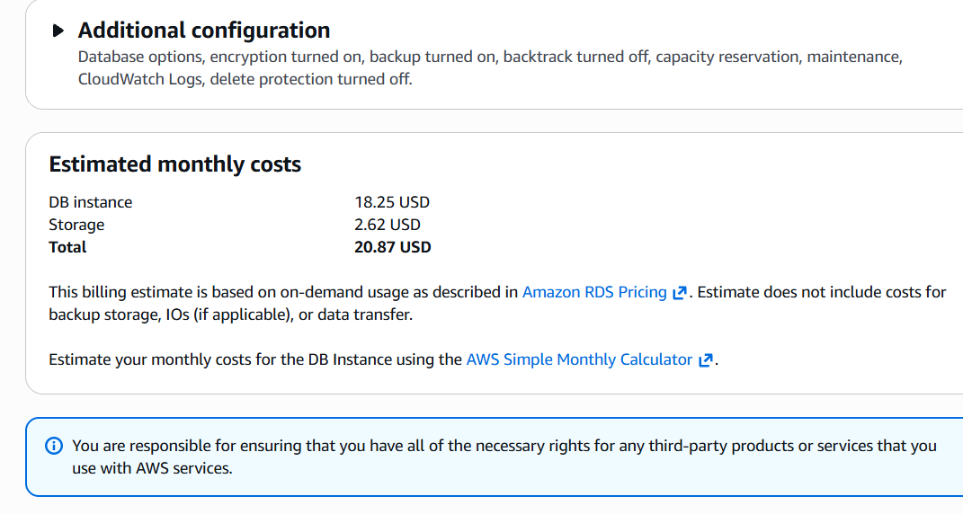

Evidence 17: Selected db.t3.micro class
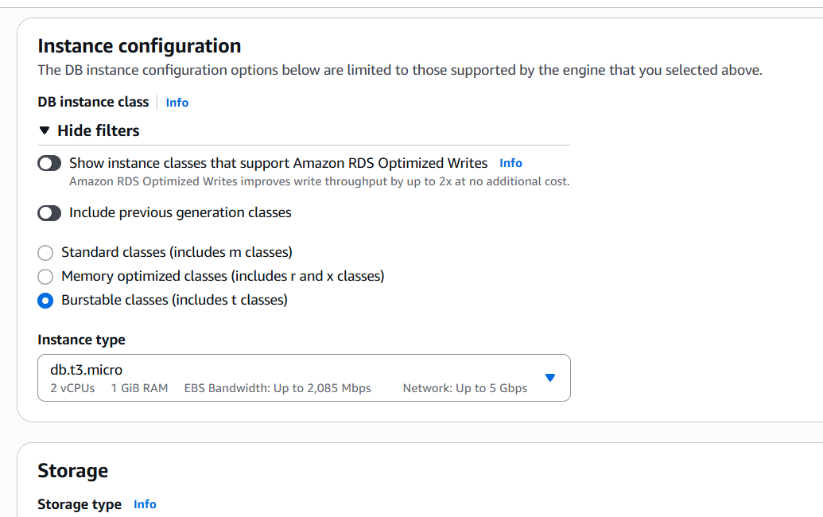

Evidence 18: RDS storage and price review
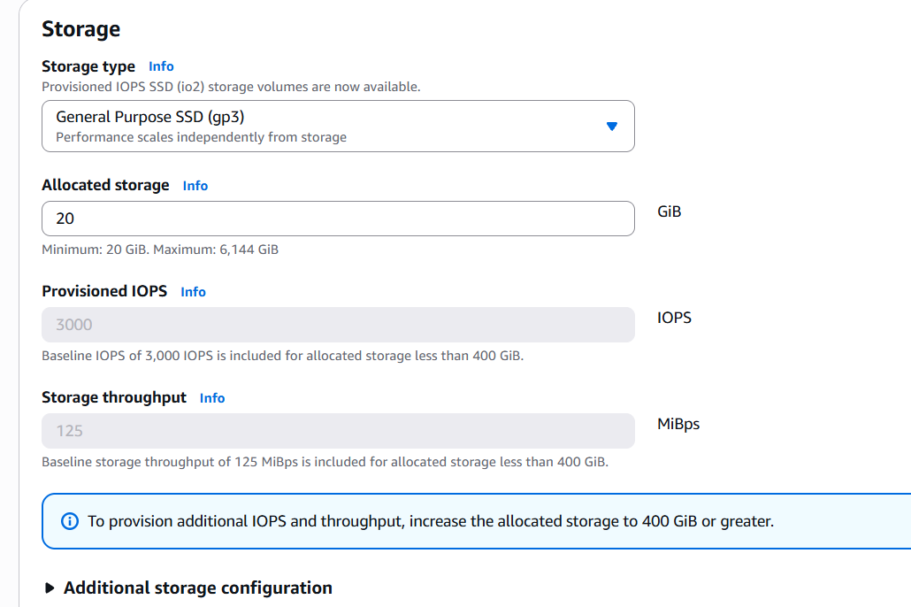

Evidence 19: Final cost estimate
