PRACTICAL REPORT
Hosting a Simple HTML Page on Apache Using AWS EC2
Platform: Amazon Web Services (AWS)
Region: Asia Pacific (Mumbai — ap-south-1)
Repository: https://github.com/Sanika474/skillpilote-daily-tasks

1. Aim
To host a simple HTML webpage on an Apache web server running on an Amazon EC2 instance and make it publicly accessible over HTTP.

2. Requirements
- AWS account with the necessary EC2 permissions
- Amazon Linux 2023 EC2 instance
- SSH key pair (.pem file) stored securely on the local computer
- Windows Command Prompt or PowerShell with SSH and SCP
- HTML file (index.html), Git, and GitHub repository

3. Procedure
- Create the HTML file: Create index.html with basic webpage content and store it in Task-Apache-EC2.
- Launch EC2: Launch an Amazon Linux 2023 instance in Mumbai (ap-south-1). Select a key pair and record the public IPv4 address.
- Configure security group: Allow SSH (TCP 22) from your own IP and HTTP (TCP 80) from 0.0.0.0/0 so the webpage can be publicly accessed.
- Connect to the instance: Use SSH from Windows with the private key. If Windows reports that the key permissions are too open, restrict access to your Windows user.
- Install Apache: On the EC2 Linux terminal, run `sudo dnf install -y httpd` and `sudo systemctl enable --now httpd`. Verify the service shows `active (running)`.
- Transfer the HTML file: Use SCP from Windows to copy index.html to `/tmp/index.html` on the instance.
- Publish the page: Copy the file to `/var/www/html/index.html` and set read permissions with `sudo chmod 644 /var/www/html/index.html`.
- Verify public access: Open `http://<PUBLIC-IP>` in a browser and confirm the custom HTML page appears.

4. Execution Screenshots
The screenshots below are taken from the user's supplied EC2.docx file and the specified Git status screenshot. Each image is labeled according to the visible step it supports. Screenshots are included as supplied; no additional execution screenshots have been invented.

EC2 launch confirmation
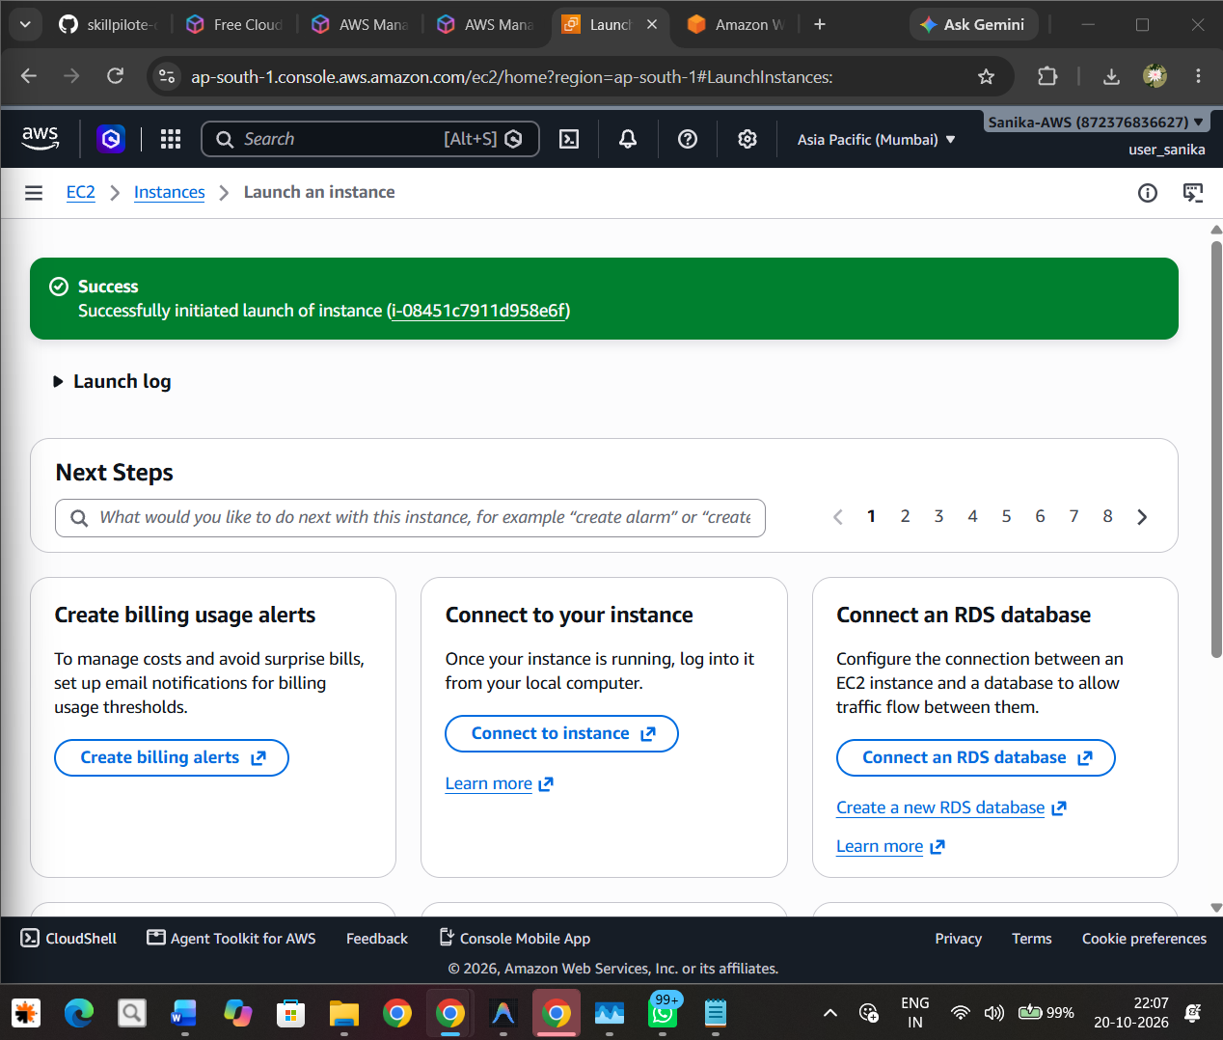
Screenshot 1. AWS console confirmation that the EC2 instance launch was successful.

EC2 instance status and public IP
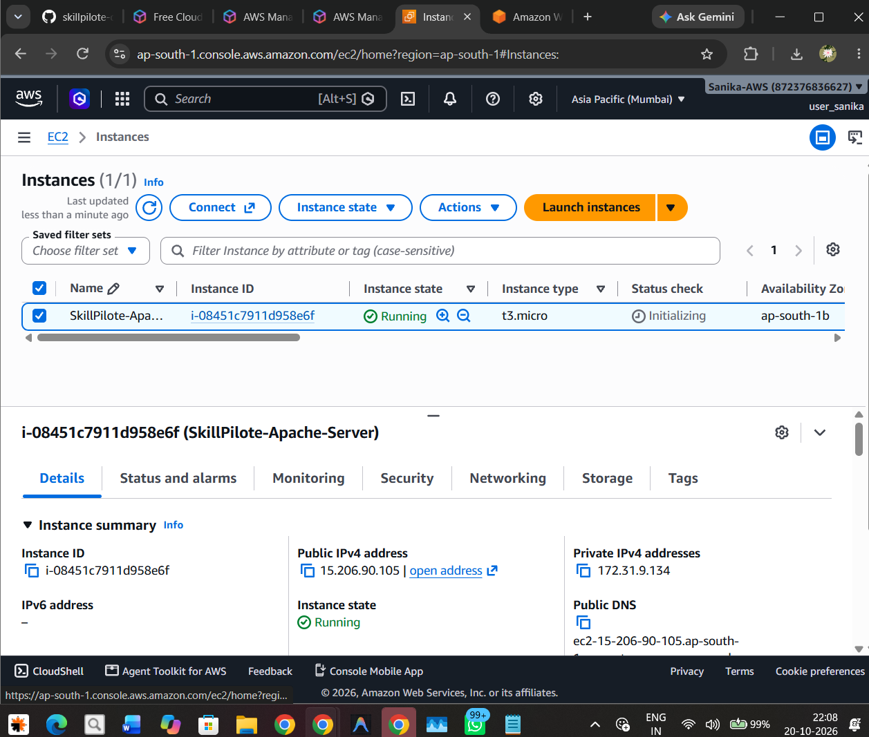
Screenshot 2. EC2 Instances page showing the SkillPilote-Apache-Server instance in Running state and its public IPv4 address.

Instance connection options
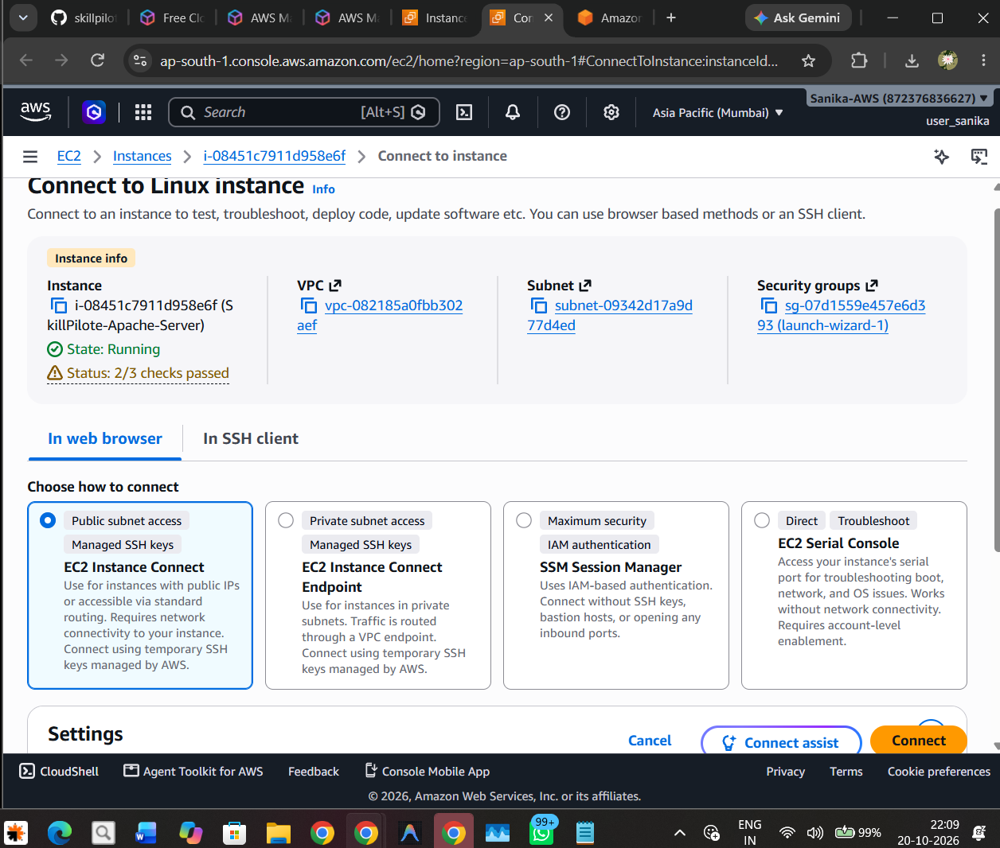
Screenshot 3. EC2 connection page showing the Linux instance status checks and available connection methods.

Apache installation and service setup
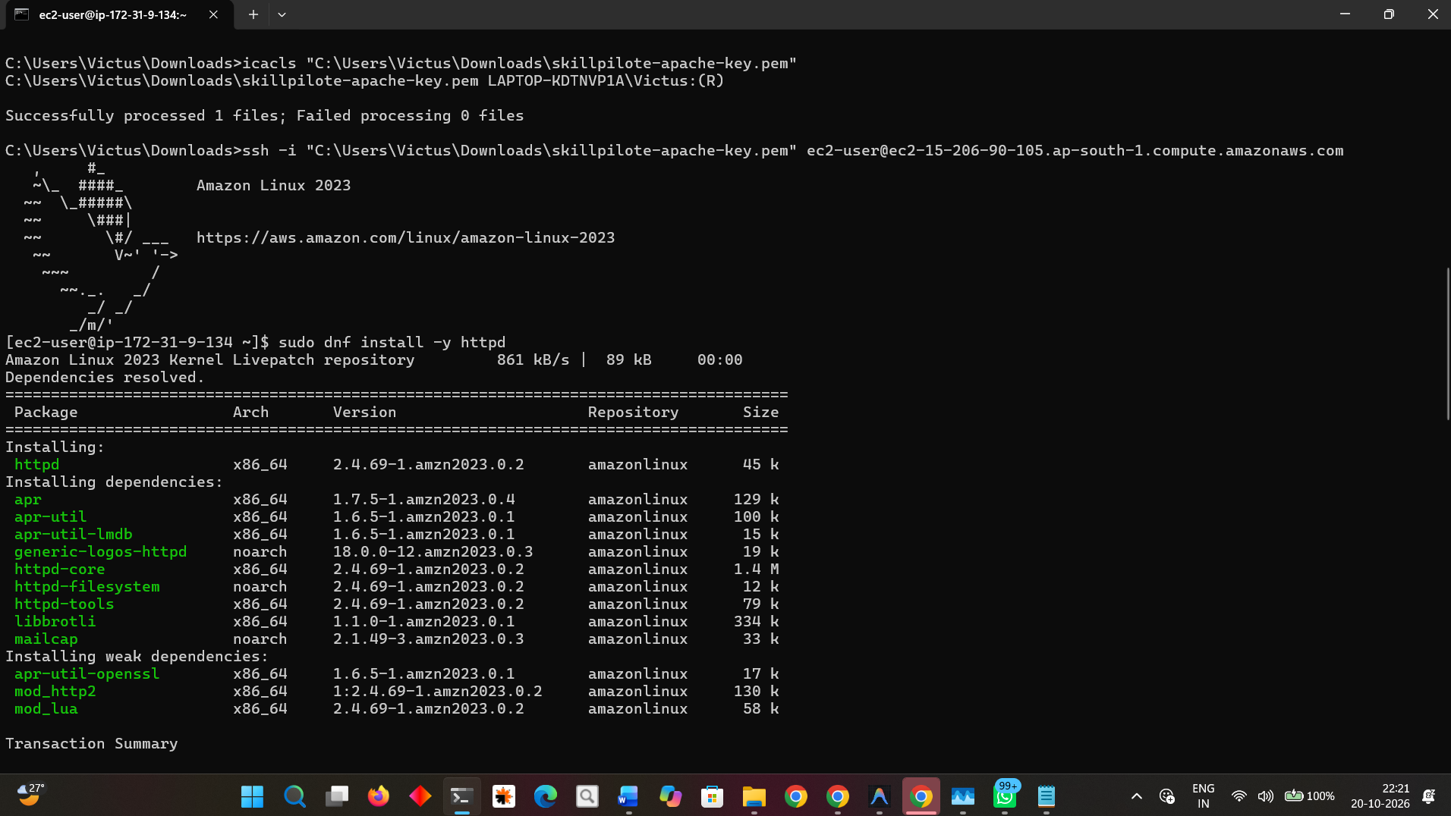
Screenshot 4. Windows terminal and Amazon Linux 2023 session showing Apache installation commands and package installation output.

Execution screenshot 5
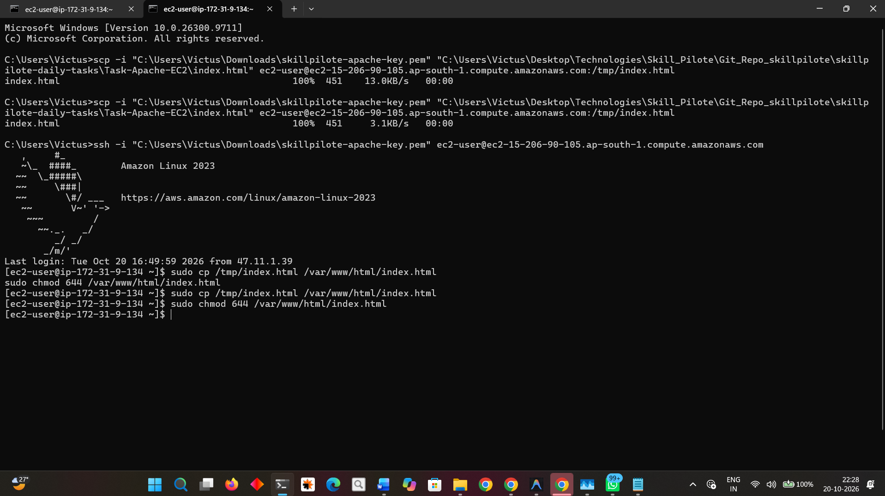
Screenshot 5. SCP transfer and SSH session showing index.html copied to the EC2 server and moved to /var/www/html/index.html.

Execution screenshot 6
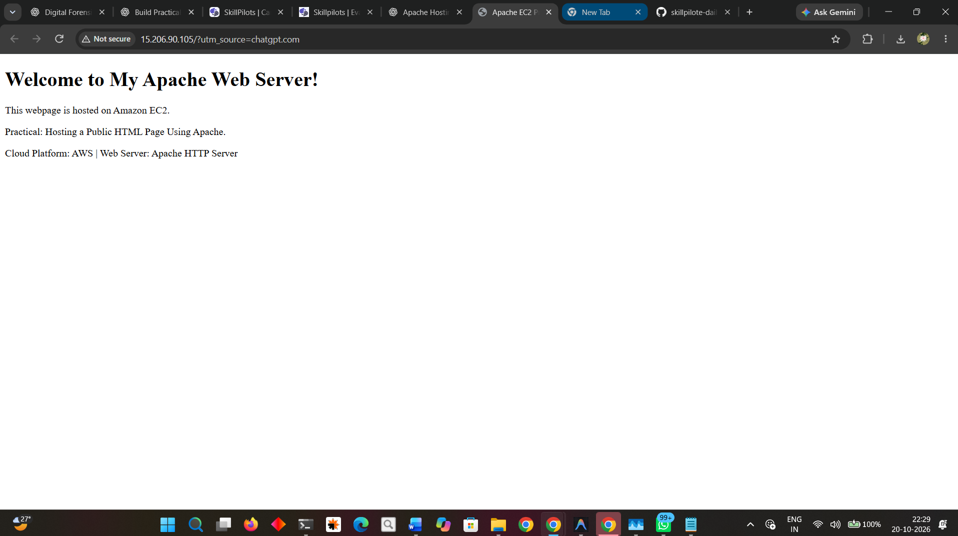
Screenshot 6. Browser view showing the custom page headed “Welcome to My Apache Web Server!”.

Git repository status
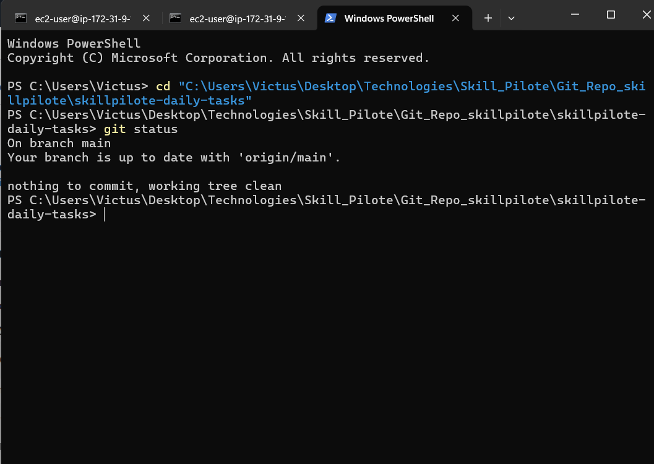
Screenshot 7. Git status showing branch main up to date with origin/main and a clean working tree.

5. Result
The supplied execution screenshots document the EC2 launch, instance details, connection options, Apache installation, SCP file transfer, and browser display of the custom HTML page. The separate Git screenshot shows the local repository was clean and synchronized with origin/main at the time of capture.

6. Conclusion
This practical demonstrates how to deploy a simple HTML page on an Apache HTTP server hosted by Amazon EC2. The main steps are launching the instance, allowing HTTP traffic through the security group, connecting securely with SSH, installing Apache, copying the HTML file using SCP, and checking the page in a browser.

7. Security Notes
- Never commit the .pem private key, AWS access keys, passwords, or other credentials to GitHub.
- Keep SSH access restricted to your own public IP rather than opening port 22 to everyone.
- Check AWS billing and stop or terminate resources when no longer needed.

