PRACTICAL REPORT

AWS CloudFormation
S3 Bucket Deployment
SkillPilote • Day 10 • 21 October 2026

1. Aim
To deploy a JSON template using the AWS CloudFormation console and verify that an Amazon S3 bucket is created successfully.

2. Services and requirements
- AWS Management Console with an IAM user authorised to use CloudFormation and the required S3 actions.
- AWS CloudFormation for stack deployment and resource tracking.
- Amazon S3 for verifying the created bucket.
- JSON template file: s3-bucket-template.json.
- AWS Region: Asia Pacific (Mumbai), ap-south-1.

3. Stack details
Stack name | skillpilote-day10-s3-stack
Resource logical ID | SkillPiloteS3Bucket
Resource type | AWS::S3::Bucket
Final stack status | CREATE_COMPLETE
Final resource status | CREATE_COMPLETE
Region | Asia Pacific (Mumbai) — ap-south-1

4. Procedure
- Open AWS CloudFormation and select Create stack → With new resources (standard).
- Select Upload a template file and upload s3-bucket-template.json.
- Enter the stack name skillpilote-day10-s3-stack.
- Keep optional settings at their defaults and leave the optional CloudFormation service role unset for this template.
- Review the configuration and submit the stack.
- Wait until the stack status changes to CREATE_COMPLETE.
- Inspect the Resources and Outputs tabs, then open Amazon S3 in the same region to verify the bucket.

5. Evidence screenshots

Screenshot 1 — CloudFormation stacks dashboard
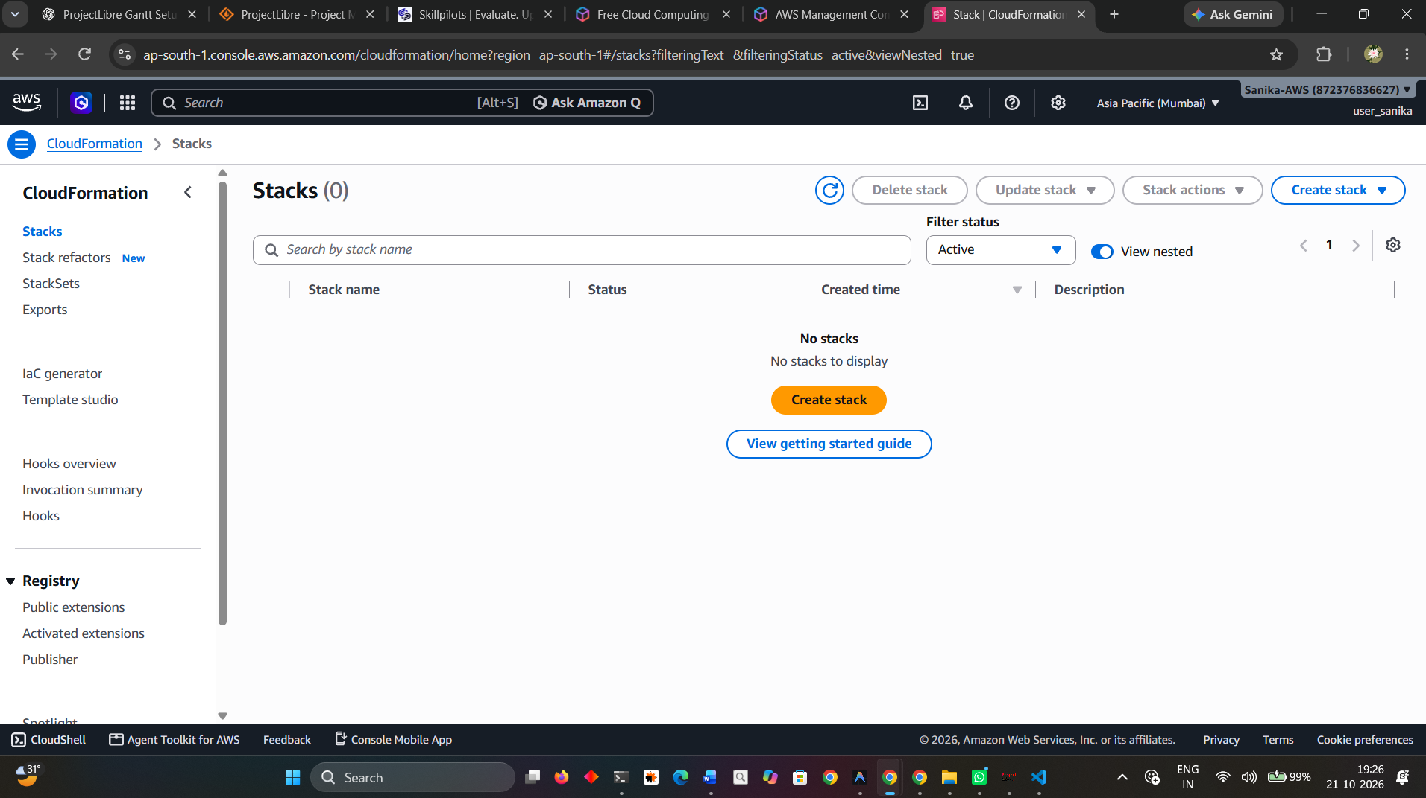
Initial CloudFormation dashboard before the new stack was created.

Screenshot 2 — Specify template
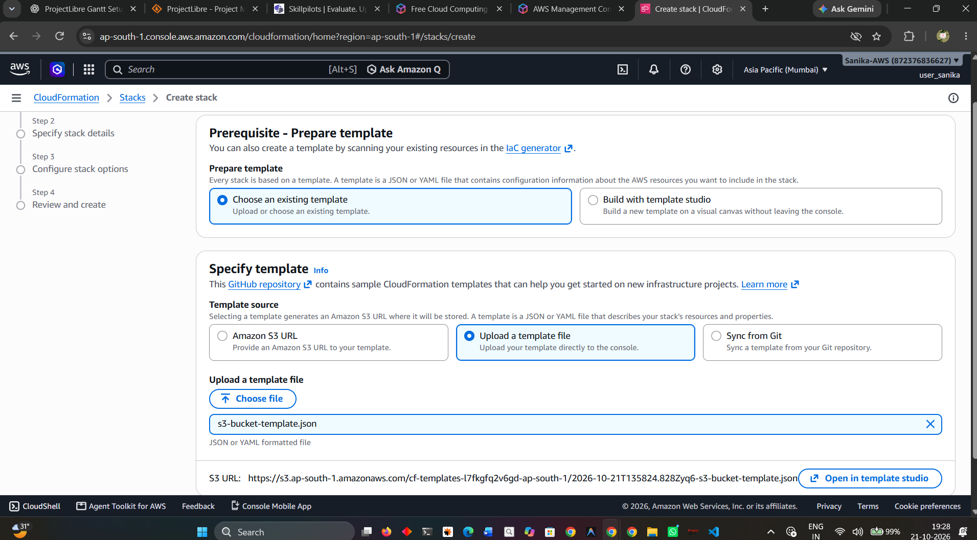
The Create stack workflow with the template source/upload option selected.

Screenshot 3 — Specify stack details
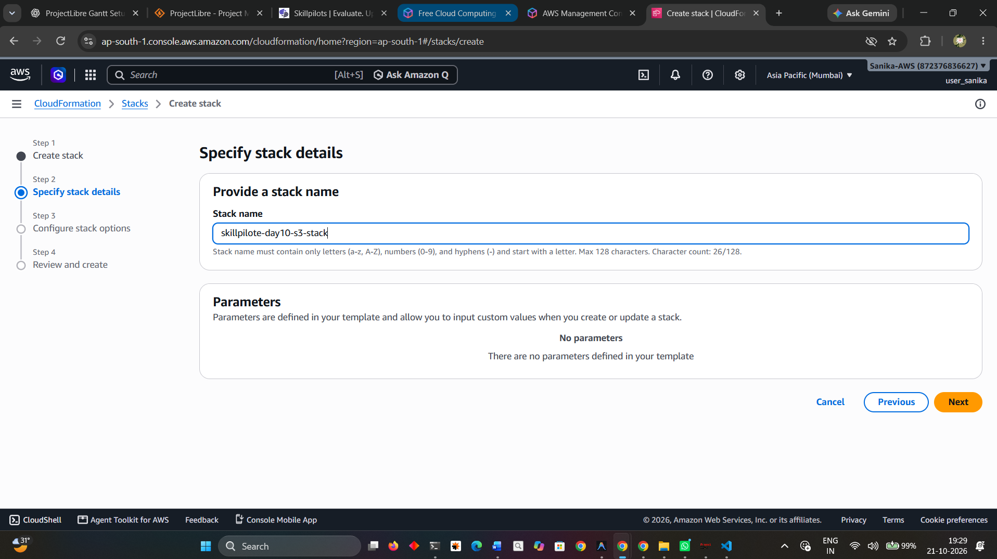
The stack name is entered and the template has no parameters.

Screenshot 4 — Review and create
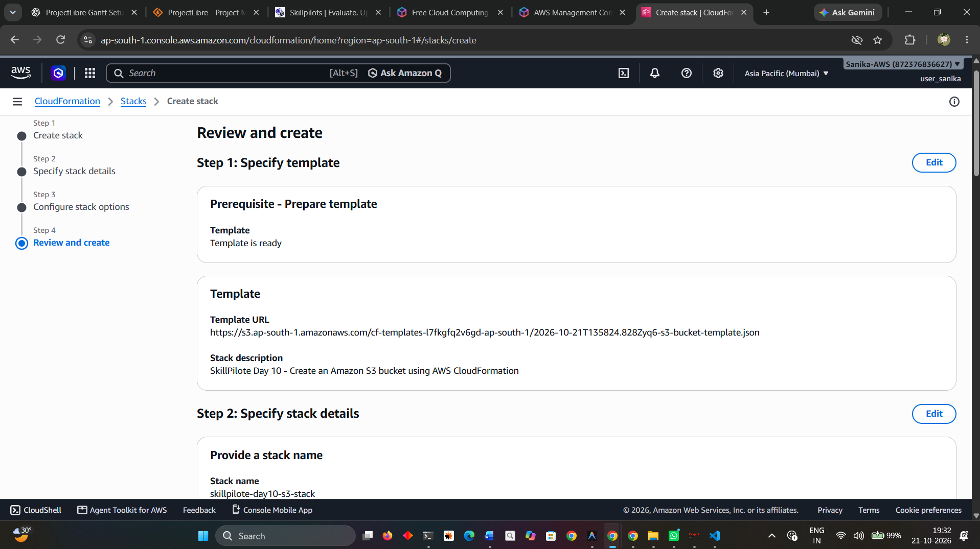
Review page showing the template description and stack details before submission.

Screenshot 5 — Stack events
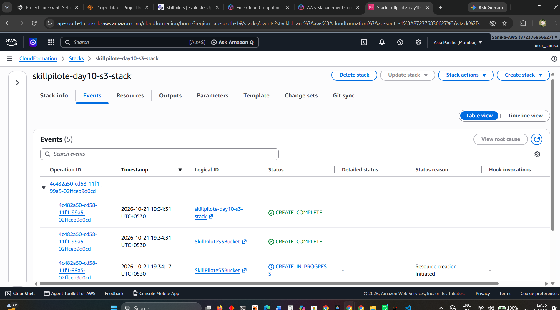
The Events tab used to follow CloudFormation resource creation and event statuses.

Screenshot 6 — Stack overview
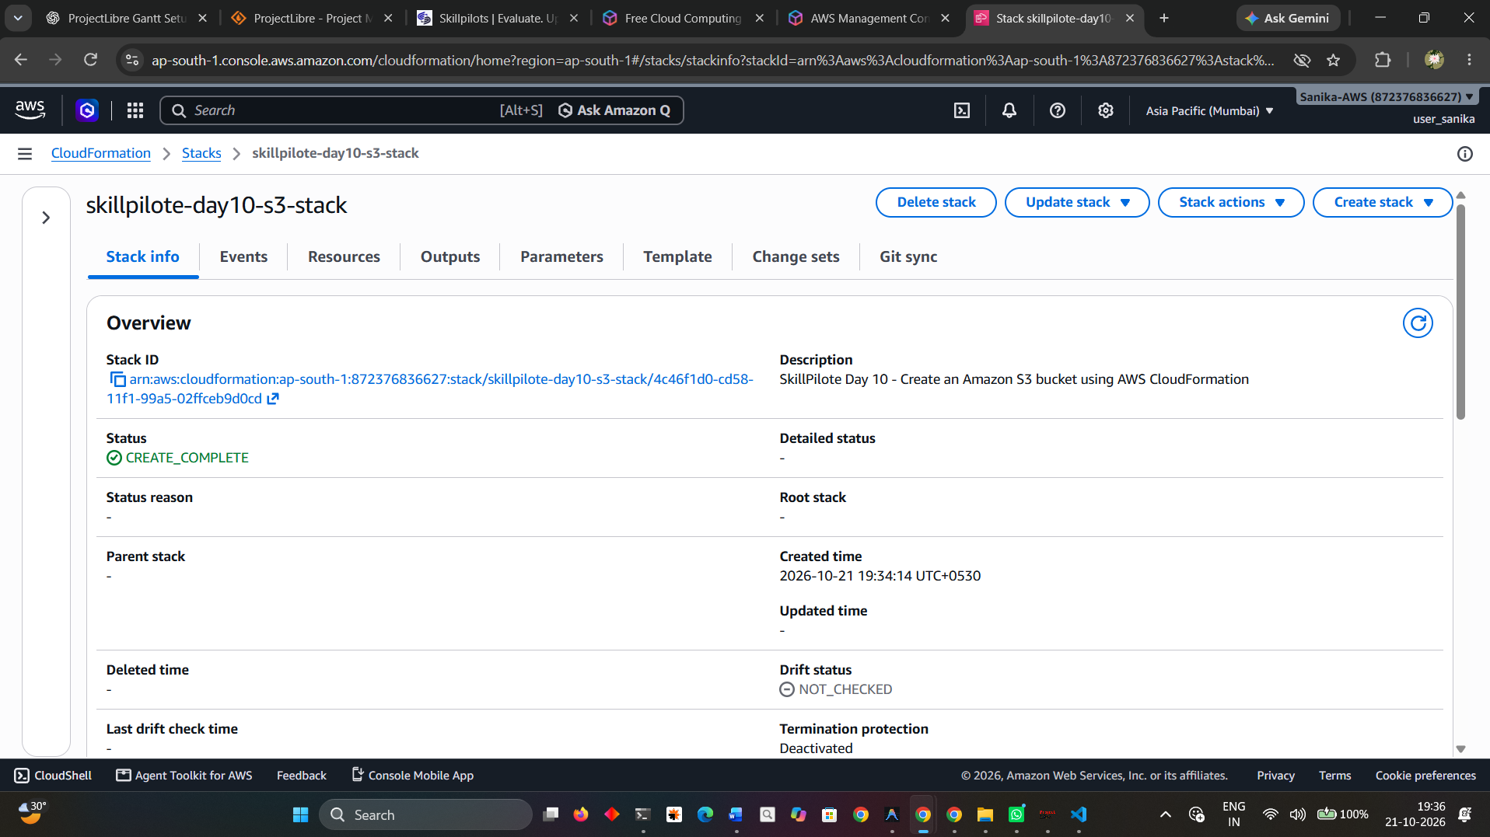
The Stack info page confirms the final stack status is CREATE_COMPLETE.

Screenshot 7 — CloudFormation outputs
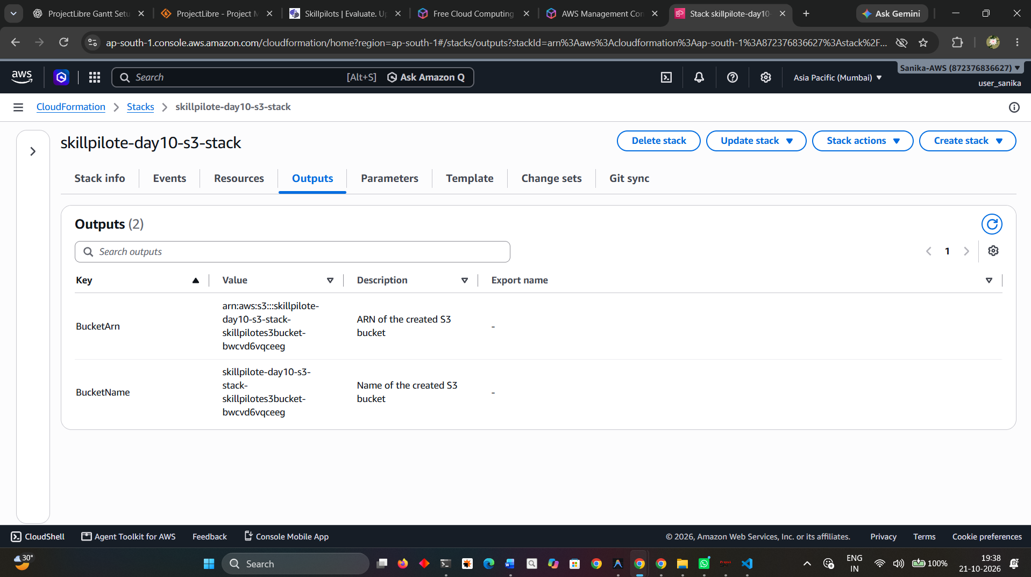
The Outputs tab displays the generated bucket name and bucket ARN.

Screenshot 8 — Amazon S3 bucket list
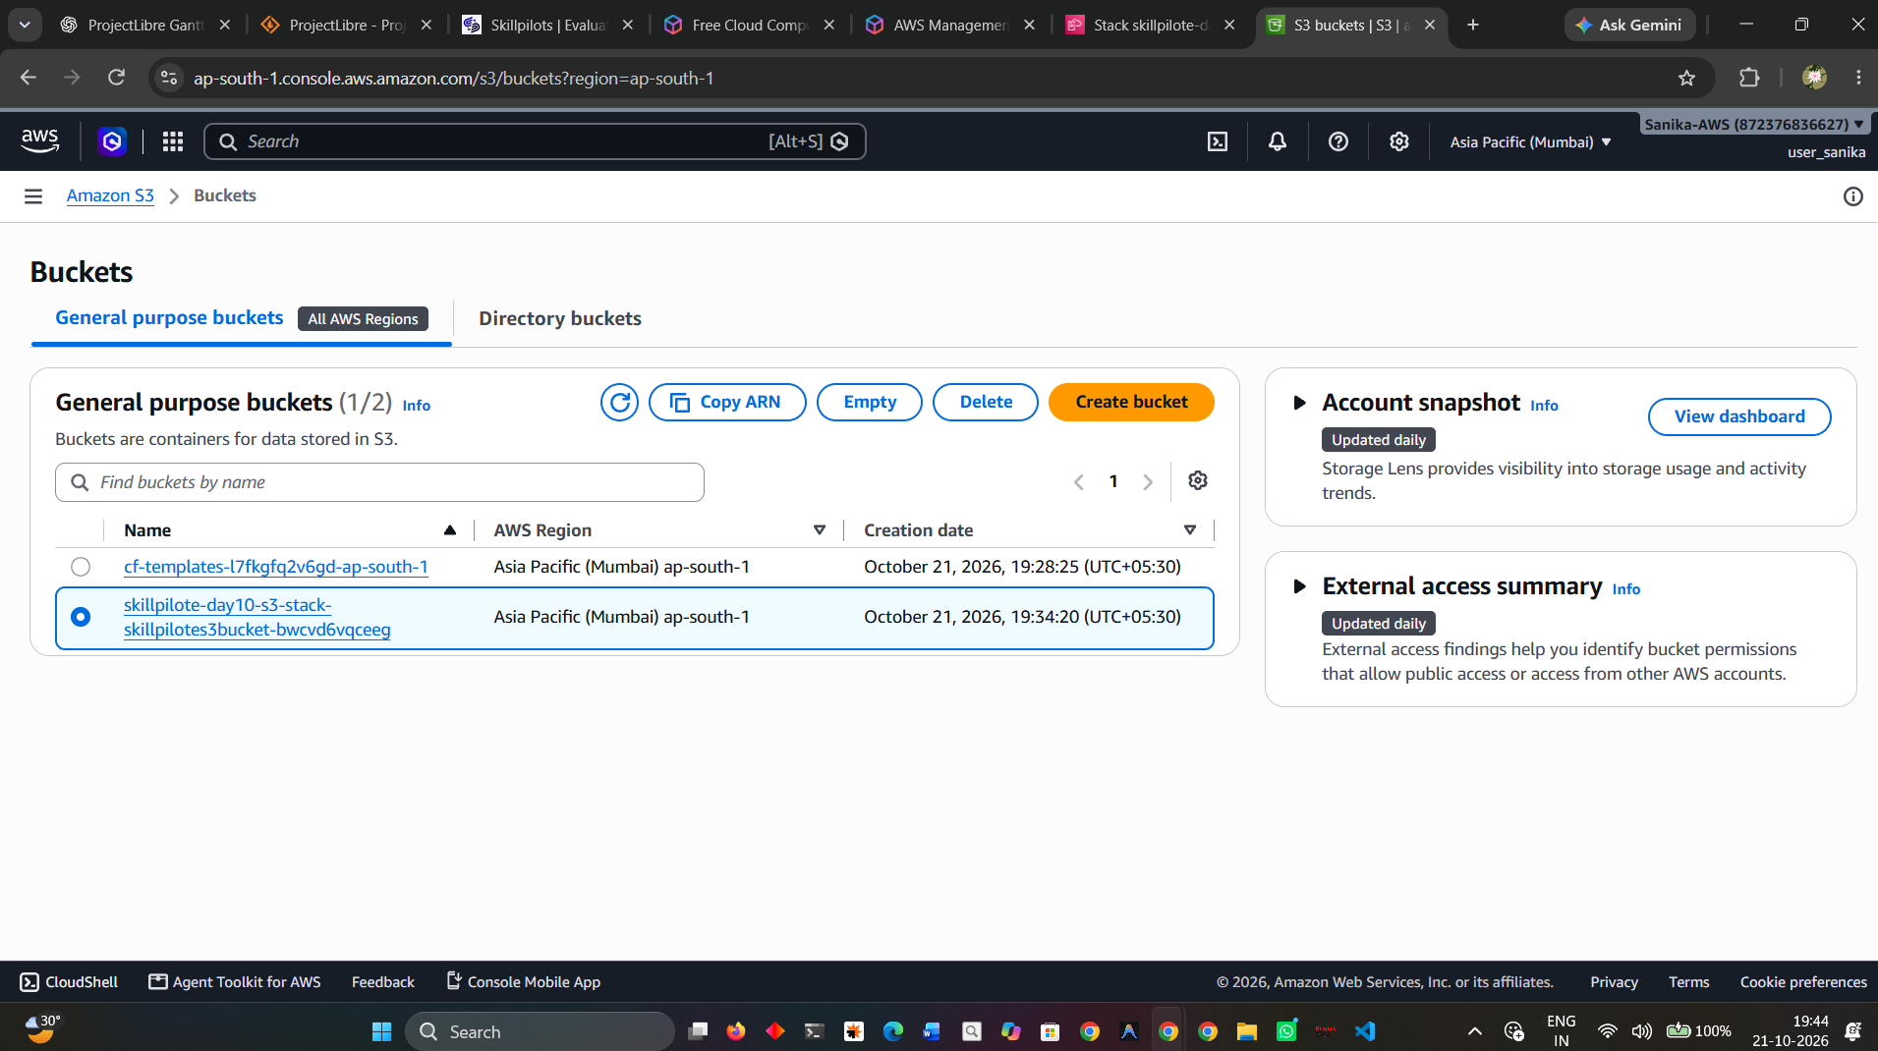
The S3 console in the Mumbai region displays the bucket created by this stack.

6. Result
The practical was successful. The evidence shows that the CloudFormation stack skillpilote-day10-s3-stack reached CREATE_COMPLETE, its S3 bucket resource reached CREATE_COMPLETE, the stack outputs were displayed, and the bucket was visible in the Amazon S3 console in the Mumbai region.

7. Security and cleanup
- The template blocks public access for the created bucket.
- Do not commit AWS credentials, access keys, passwords, MFA codes, or sensitive account details to GitHub.
- AWS resources can incur charges depending on usage. After SkillPilote evaluation, if the stack is no longer required, empty the bucket and delete the stack through CloudFormation.

