SKILLPILOTE — DAY 21
Final Practical: GitHub Portfolio, Documentation, AWS Architecture & GitHub Pages
Repository: https://github.com/Sanika474/skillpilote-daily-tasks

1. Aim
To consolidate the completed SkillPilote AWS practicals into a public GitHub repository, maintain a comprehensive root README with day-wise documentation, create and embed an overall AWS architecture diagram, and publish the repository README as a simple portfolio website using GitHub Pages.

2. Objectives
- Review the existing GitHub repository and its practical folders.
- Preserve source code, infrastructure templates, scripts, reports and genuine screenshots.
- Create a root README that acts as the portfolio landing page and links to individual practicals.
- Prepare a logical AWS architecture diagram that represents the services covered across the daily labs.
- Commit and push final documentation and diagram assets to the main branch.
- Enable GitHub Pages and verify the published site.

3. Tools and Technologies
- Git and GitHub
- Windows PowerShell
- AWS Management Console and AWS CLI
- draw.io / diagrams.net
- Markdown and Mermaid
- GitHub Pages

4. Existing Repository Review
Repository URL: https://github.com/Sanika474/skillpilote-daily-tasks
Default branch: main | Visibility: Public | AWS region used for most practicals: ap-south-1 (Mumbai).
The repository already contains practical documentation and evidence for Day 10 and Days 12–20, along with several Day 11 EC2-to-RDS implementation/report folders and an Apache EC2 task. The root README currently describes Day 13 CodeCommit rather than acting as a complete portfolio index; Day 21 should replace it with a repository-level overview while retaining the Day 13 documentation in its own folder.

5. Implementation Procedure

Step 1 — Inspect the repository
- Open the repository on GitHub and confirm it is public.
- Open the Code tab and review the main branch folder structure.
- Check each practical README, scripts, templates and screenshot/evidence directory.
- Identify missing or duplicate content; do not delete genuine evidence or rename folders without checking references.
- Clone or open the existing repository locally and confirm the origin remote points to the same GitHub URL.

Step 2 — Prepare the portfolio README
- Create a root-level README.md that introduces the 21-day AWS learning portfolio.
- Add project objectives, tools, AWS services, repository structure and day-wise practical links.
- For each day, summarise the actual aim, services used, main implementation and verification result based on its practical README.
- Include a security and cost-awareness section.
- Use relative links to files and folders so links work from GitHub and GitHub Pages.

Step 3 — Create the AWS architecture diagram
- Open https://app.diagrams.net/ and create a new diagram.
- Arrange the AWS services into logical groups: web/networking, serverless, data/storage, identity, monitoring and governance.
- Represent the flows practiced, such as Browser → API Gateway → Lambda → DynamoDB; EC2 → RDS; EC2 → EFS; ALB → target group → EC2 instances.
- Keep the diagram conceptual: the daily practicals were separate exercises, not one production system.
- Export the diagram as PNG and save it in the repository, for example architecture/SkillPilote_AWS_Architecture.png.
- Embed it in the root README using a relative Markdown image path.

Step 4 — Commit and push the final files
- Run git status and inspect the changed files.
- Stage the root README, Day 21 practical documentation and architecture image.
- Commit with a descriptive message such as Day 21: publish SkillPilote AWS portfolio.
- Push the main branch to origin.
- Refresh GitHub and confirm the README, diagram and Day 21 folder are visible.

Step 5 — Enable GitHub Pages
- Open repository Settings → Pages.
- Under Build and deployment, select Deploy from a branch.
- Select branch main and folder /(root), then Save.
- Wait for GitHub Pages deployment to complete.
- Open the published URL and test headings, relative links and the architecture image.

6. Day-wise Portfolio Index (Repository Review)
Day | Practical / verified repository content
Day 1–9 | No matching Day 1–9 README folders were identified in the repository tree reviewed. Add the correct original practical titles and source folders if those exercises are part of the assignment.
Day 10 | AWS CloudFormation — S3 Bucket: deploy an S3 bucket using a CloudFormation JSON template; includes report and evidence.
Day 11 | EC2 to Amazon RDS for MySQL: multiple implementation/report folders exist, including CloudFormation, SQL, scripts and evidence. Retain the authoritative completed report and clearly distinguish drafts/partial submissions.
Day 12 | AWS Lambda with API Gateway: Node.js Lambda exposed through an HTTP API; includes handler, test event, deployment package and evidence.
Day 13 | AWS CodeCommit: create repository, initialise Git, commit README and push to CodeCommit; PowerShell automation and screenshot evidence.
Day 14 | Amazon ECS Fargate — Nginx: CloudFormation deployment, ECS service/task, networking and HTTP verification; includes deployment/cleanup scripts.
Day 15 | EC2 CloudWatch Logs: CloudWatch Agent collects an EC2 log file into the /skillpilote/day15 log group; evidence included.
Day 16 | AWS Resource Tagging and Budget Alarm: Python/Boto3 resource tagging preview/apply workflow and budget alert configuration; verify final budget status and script/evidence completeness.
Day 17 | Amazon Cognito with S3-hosted Login Page: Cognito User Pool, browser app client, Amplify authentication and S3 static website hosting.
Day 18 | Amazon EFS with EC2 and AWS Backup: NFS v4.1 mount, test file and AWS Backup vault/plan/recovery point; evidence included.
Day 19 | Application Load Balancer: internet-facing ALB distributes HTTP traffic across two EC2 web servers using a target group and health checks.
Day 20 | AWS Lambda, DynamoDB and API Gateway: POST /visitors endpoint persists visitor data in DynamoDB; IAM and CloudWatch used for permissions and logs.
Day 21 | GitHub Portfolio: repository review, master README, architecture diagram, Git push and GitHub Pages publication.

7. Architecture Diagram
The attached diagram is a portfolio-level logical overview of services exercised in the daily labs. It does not imply that all resources were deployed together or remain active.
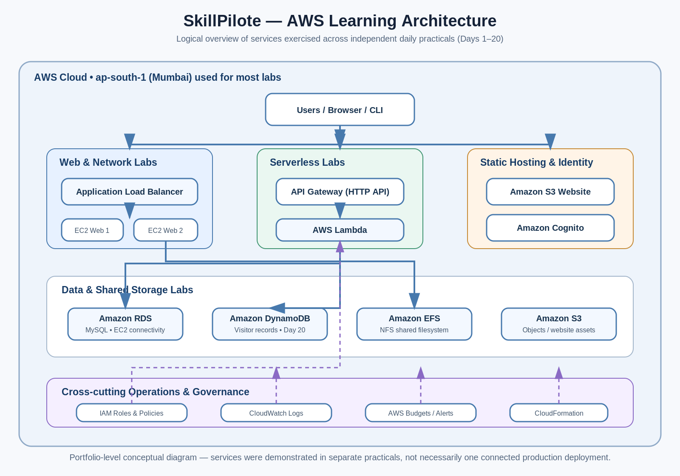

8. Verification Checklist
- Repository visibility is Public.
- Root README describes the full learning portfolio and links to practical folders.
- Day-wise descriptions match the real practical README files.
- Architecture PNG is committed and renders in the root README.
- No credentials, private keys, tokens or passwords are committed.
- GitHub Pages source is main /(root) and the deployment reports success.
- Published pages and all relative image/file links are tested.

9. Security and Cost Considerations
- Never commit AWS access keys, secret keys, session tokens, .pem files, passwords or .env files.
- Use least-privilege IAM policies and restrict security-group ingress to required sources/ports.
- Review public S3 website access and Cognito client configuration; classroom demo settings are not automatically production-safe.
- Remove billable lab resources after capturing evidence; also review snapshots, volumes, load balancers, NAT gateways, EFS, RDS, ECS and log retention.
- A budget alert notifies; it does not automatically stop or delete resources.

10. Result
The Day 21 practical consolidates the SkillPilote learning work into a public GitHub portfolio and prepares the repository for GitHub Pages publication. Final completion is confirmed only after the README and architecture image are pushed, Pages deployment succeeds, and the published website is manually tested.

11. Repository Links
- GitHub repository: https://github.com/Sanika474/skillpilote-daily-tasks
- Expected GitHub Pages URL: https://sanika474.github.io/skillpilote-daily-tasks/
- Diagram source/output: SkillPilote_AWS_Architecture.svg / SkillPilote_AWS_Architecture.png
Prepared for SkillPilote — Day 21 Final Practical Submission.

