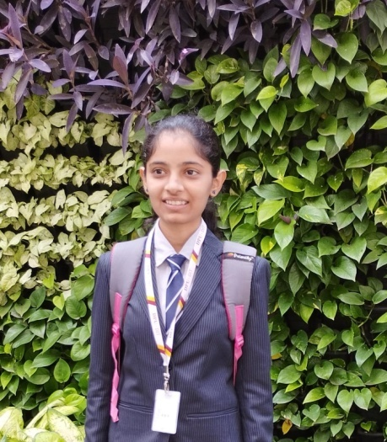**Dhongade Sanika Dhananjay**

E-mail: sanikadhongde@gmail.com



| ❖ | **CAREER OBJECTIVE:** |
| --- | --- |

I have been developing applications for over a year now and also have good command on Coding , I have Managed a team for developing Web Projects, Mentored new members towards developing and working in a team as well as a freelancer .

I have an idea how to work with a team remotely, and the way to approach a problem, I also understand how much modular and clean code is necessary when working in a team.

I have pursued numerous certifications to enhance my knowledge and validate my expertise. I am open to learning any new tools and technologies along the way.

| ❖ | **ACADEMIC BACKGROUND:** |
| --- | --- |

| **Degree** | **College/ School** | **University/ Board** | **Year of**  **Passing** | **CGPA/Percentage** |
| --- | --- | --- | --- | --- |
| Second Year Engineering | Dr. D.Y.  Patil Institute of Technology ,Pimpri | Savitribai  Phule Pune University | 2023 | 8.84CGPA |
| First Year  Engineering | Dr. D.Y.  Patil Institute of Technology ,Pimpri | Savitribai  Phule Pune University | 2022 | 9.61CGPA |
| H.S.C | A.S.C.C.College | State Board | 2021 | 92% |
| S.S.C. | Gurukul English Medium School | State Board | 2019 | 80% |

| ❖ | **TECHNICAL SKILLS:** |
| --- | --- |

* Programming Languages : Python, C++,Javascript,Java.

| ❖ | **AREA OF INTEREST:** |
| --- | --- |

* Object Oriented Programming
* Web Development
* Machine Learning
* Artificial Intelligence
* Data Structure and Algorithms

| ❖ | **ACHIEVEMENTS AND CERTIFICATIONS:** |
| --- | --- |

* Great Learning Course in “HTML”.
* Guvi Course in "Python".
* Dewtown bootcamp in " Python".
* SIH hackathon 2022.
* Udemy Course in "CSS''.
* Microsoft Learn AI Skills Challenge.

| ❖ | **PERSONAL INFORMATION:** |
| --- | --- |

* Name : Dhongade Sanika Dhananjay
* Father’s Name : Dhananjay Subhashchandra Dhongade
* Date of Birth : 09 April 2002
* Gender : Female
* Languages Known: English, Hindi, Marathi
* Local Address : Sant Tukaram Nagar , Pimpri ,Pune.
* Permanent Address : Malharwadi Road Bhujadi Estate ,Rahuri ,Ahmednagar .
* Nationality : Indian

I hereby state that the above given information is true to the best of my knowledge & belief.

Place:

Date: Dhongade Sanika D.