1)

CASE 1: IF A NEW USER WANTS TO DONATE :

**TO**

**WELCOME**





L O G I N

Already have an account?

C R E A T E A N A C C O U N T

K I T C H A I N



2) CREATE AN ACCOUNT:





USERNAME*

C O N T I N U E

REWRITE PASSWORD

PASSWORD

ENTER PASSWORD:

1. ONE CAPITAL LETTER
2. ONE SMALL LETTER
3. ONE NUMBER
4. ONE SPECIAL CHARACTER

EMAIL*

PHONE NUMBER*

LOCATION* (GOOGLE MAPS)

3) DONOR OR VOLUNTEER?





WHAT WOULD YOU LIKE TO REGISTER AS ?



VOLUNTEER

DONOR

DONOR (i) : YOU CAN DONATE ANY EXCESS FOOD YOU HAVE.

VOLUNTEER(i) : YOU CAN PICK UP FOOD FROM THE NEAREST PICK UP SPOT

THIS SETTING CAN BE CHANGED ANYTIME

YOU MAY SELECT BOTH



4) MAIN PAGE:



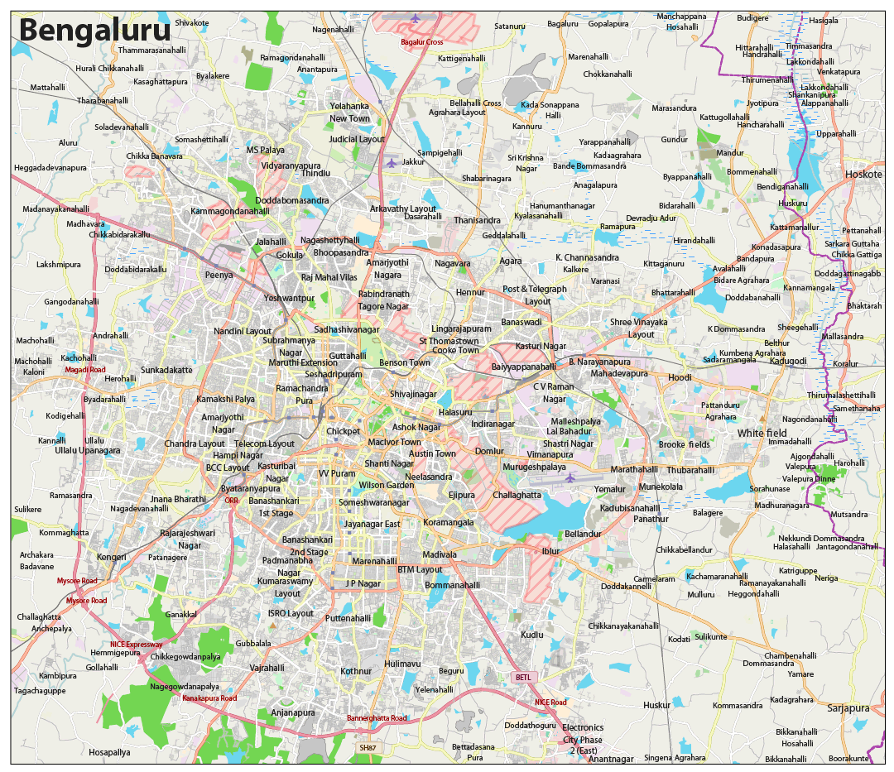



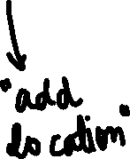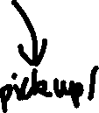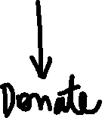

5) DONATING FOOD:

1. Please enter the food you would like to donate:

Enter here





//opens google maps

Add location

4) Please enter the location:

Drop down menu

3) Is the food perishable or non-perishable?

Drop down menu with numbers (1-20)

2) Enter the number of people it can feed :

C O N T I N U E



6) VERIFICATION:





WOO HOO! YOU JUST DONATED FOOD!

7) Back to main page ( Step3 )

CASE 2: IF AN EXISTING USER WANTS TO DONATE :

**TO**

**WELCOME**







L O G I N

Already have an account?

C R E A T E A N A C C O U N T

K I T C H A I N







L O G I N

PASSWORD

EMAIL ADDRESS





4) MAIN PAGE:









5) DONATING FOOD:

1. Please enter the food you would like to donate:

Enter here





//opens google maps

Add location

4) Please enter the location:

Drop down menu

3) Is the food perishable or non-perishable?

Drop down menu with numbers (1-20)

2) Enter the number of people it can feed :

C O N T I N U E

6) VERIFICATION:







WOO HOO! YOU JUST DONATED FOOD!

7) Back to main page ( Step3 )

CASE 3: IF AN NEW USER WANTS TO PICKUP/DROP :

**TO**

**WELCOME**





L O G I N

Already have an account?

C R E A T E A N A C C O U N T

K I T C H A I N



2) CREATE AN ACCOUNT:





USERNAME*

C O N T I N U E

REWRITE PASSWORD

PASSWORD

ENTER PASSWORD:

1. ONE CAPITAL LETTER
2. ONE SMALL LETTER
3. ONE NUMBER
4. ONE SPECIAL CHARACTER

EMAIL*

PHONE NUMBER*

LOCATION* (GOOGLE MAPS)



3) DONOR OR VOLUNTEER?



WHAT WOULD YOU LIKE TO REGISTER AS ?



VOLUNTEER

DONOR

DONOR (i) : YOU CAN DONATE ANY EXCESS FOOD YOU HAVE.

VOLUNTEER(i) : YOU CAN PICK UP FOOD FROM THE NEAREST PICK UP SPOT

THIS SETTING CAN BE CHANGED ANYTIME

YOU MAY SELECT BOTH



4) MAIN PAGE:









PICK UP/DROP (after clicking on pickup/drop)



To:

From:



ROUTE:





E N D T A S K

S T A R T T A S K





Verification For Pick up/ Drop :





WOO HOO! YOU JUST DELIVERED FOOD!

7) Back to main page ( Step3 )

CASE 4: IF AN EXISTING USER WANTS TO PICKUP/DROP :

**TO**

**WELCOME**





L O G I N

Already have an account?

C R E A T E A N A C C O U N T

K I T C H A I N





LOGIN:



L O G I N

PASSWORD

EMAIL ADDRESS











PICK UP/DROP (after clicking on pickup/drop)



To:

From:



ROUTE:





E N D T A S K

S T A R T T A S K



Verification For Pick up/ Drop :







WOO HOO! YOU JUST DELIVERED FOOD!

7) Back to main page ( Step3 )