EDS ACTIVITY-1

Name: Sanika Jaind

Roll no.: CS7-48

PRN: 202401110032

Dataset: FIFA DATASETS

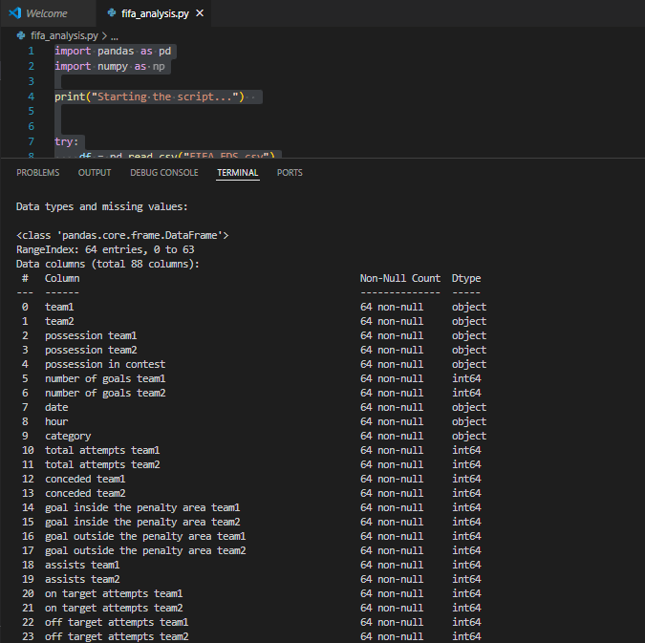

#1. total no of matches played

print("1. Total matches:", df.shape[0])

OUTPUT : 

#2. which team appeared most of the time

print("2. Most frequent team1:", df['team1'].value_counts().idxmax())

OUTPUT: 

#3. Which match had the highest number of total goals?

df['total_goals'] = df['number of goals team1'] + df['number of goals team2']

print(df.loc[df['total_goals'].idxmax(), ['team1', 'team2', 'total_goals']])

OUTPUT: 

#4. average possession for team1

df['possession team1'] = df['possession team1'].str.replace('%', '').astype(float)

print("4. Avg possession team1:", df['possession team1'].mean())

OUTPUT: 

#5. which match had the most yellow card

print("5. Match with most yellow card")

df['total_yellow_cards'] = df['yellow cards team1'] + df['yellow cards team2']

print(df.loc[df['total_yellow_cards'].idxmax(), ['team1', 'team2', 'total_yellow_cards']])

OUTPUT: 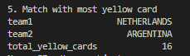

#6. total red cards in the tournament

print("6. Total red cards:", df['red cards team1'].sum() + df['red cards team2'].sum())

OUTPUT: 

#7. Goal difference in each match

print("7. Goal difference in each match")

df['goal_difference'] = abs(df['number of goals team1'] - df['number of goals team2'])

print(df[['team1', 'team2', 'goal_difference']].head())

OUTPUT: 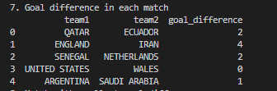

#8. match with smallest goal difference

print("8. Match with smallest goal difference: ")

print(df[df['goal_difference'] == df['goal_difference'].min()][['team1', 'team2', 'goal_difference']])

OUTPUT: 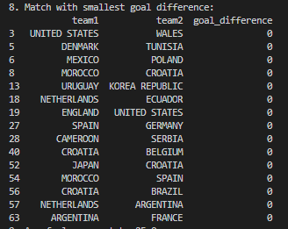

#9. average number of fouls per match

df['fouls_total'] = df['fouls against team1'] + df['fouls against team2']

print("9. Avg fouls per match:", df['fouls_total'].mean())

OUTPUT: 

#10. find number  of matches with more than 5 goals total

print("10. Matches with >5 total goals:", df[df['total_goals'] > 5].shape[0])

OUTPUT: 

#11. total number of own goals

print("11. Total own goals:", df['own goals team1'].sum() + df['own goals team2'].sum())

OUTPUT: 

#12. team with most penalties scored

print("12. Team with most penalties scored:")

pen1 = df.groupby('team1')['penalties scored team1'].sum()

pen2 = df.groupby('team2')['penalties scored team2'].sum()

pen_total = pen1.add(pen2, fill_value=0)

print(pen_total.idxmax())

OUTPUT: 

#13. team with a highest number of fouls

print("13. Team with the highest number of fouls committed:")

fouls_by_team1 = df.groupby('team2')['fouls against team1'].sum()

fouls_by_team2 = df.groupby('team1')['fouls against team2'].sum()

total_fouls_committed = fouls_by_team1.add(fouls_by_team2, fill_value=0)

print(total_fouls_committed.idxmax())

OUTPUT: 

#14. team that applied most defensive pressure

print("14. Team that applied the most defensive pressure:")

d1 = df.groupby('team1')['defensive pressures applied team1'].sum()

d2 = df.groupby('team2')['defensive pressures applied team2'].sum()

total_def_pressures = d1.add(d2, fill_value=0)

print(total_def_pressures.idxmax())

OUTPUT: 

#15. average  shots on target per team per match

print("15. Average shots on target per team per match:")

df['avg_on_target'] = (df['on target attempts team1'] + df['on target attempts team2']) / 2

print(df['avg_on_target'].mean())

OUTPUT: 

#16. team that never scored a penalty

print("16. Teams that never scored a penalty:")

all_teams = pd.unique(df[['team1', 'team2']].values.ravel())

pen_team1 = df.groupby('team1')['penalties scored team1'].sum()

pen_team2 = df.groupby('team2')['penalties scored team2'].sum()

pen_total = pen_team1.add(pen_team2, fill_value=0)

no_penalty_teams = pen_total[pen_total == 0].index.tolist()

print(no_penalty_teams)

OUTPUT: 

#17. team with the lowest yellow and red card

yellow_cards_team1 = df.groupby('team1')['yellow cards team1'].sum()

yellow_cards_team2 = df.groupby('team2')['yellow cards team2'].sum()

red_cards_team1 = df.groupby('team1')['red cards team1'].sum()

red_cards_team2 = df.groupby('team2')['red cards team2'].sum()

total_yellow_cards = yellow_cards_team1.add(yellow_cards_team2, fill_value=0)

total_red_cards = red_cards_team1.add(red_cards_team2, fill_value=0)

fair_play_score = total_yellow_cards.add(total_red_cards, fill_value=0)

fair_play_team = fair_play_score.idxmin()

print(f"17. Team with the lowest yellow and red cards (Fair Play Match): {fair_play_team}")

OUTPUT: 

#18. match with the most total attempts

df['total_attempts'] = df['total attempts team1'] + df['total attempts team2']

max_attempts_match = df.loc[df['total_attempts'].idxmax()]

print(f"18. Match with the most total attempts: {max_attempts_match['team1']} vs {max_attempts_match['team2']} - {max_attempts_match['total_attempts']} attempts")

OUTPUT: 

#19. team with the most successful passes

total_passes_completed_team1 = df['passes completed team1'].sum()

total_passes_completed_team2 = df['passes completed team2'].sum()

if total_passes_completed_team1 > total_passes_completed_team2:

    print(f"19. Team with the most successful passes: Team1 with {total_passes_completed_team1} successful passes")

else:

    print(f"19. Team with the most successful passes: Team2 with {total_passes_completed_team2} successful passes")

OUTPUT: 

#20. match with the highest number of free kicks

df['total_free_kicks'] = df['free kicks team1'] + df['free kicks team2']

max_free_kicks_match = df.loc[df['total_free_kicks'].idxmax()]

print(f"20. Match with the highest number of free kicks: {max_free_kicks_match['team1']} vs {max_free_kicks_match['team2']} on {max_free_kicks_match['date']} with {max_free_kicks_match['total_free_kicks']} free kicks.")

OUTPUT: 