**REPORT**

**1. Regional Sales Contribution**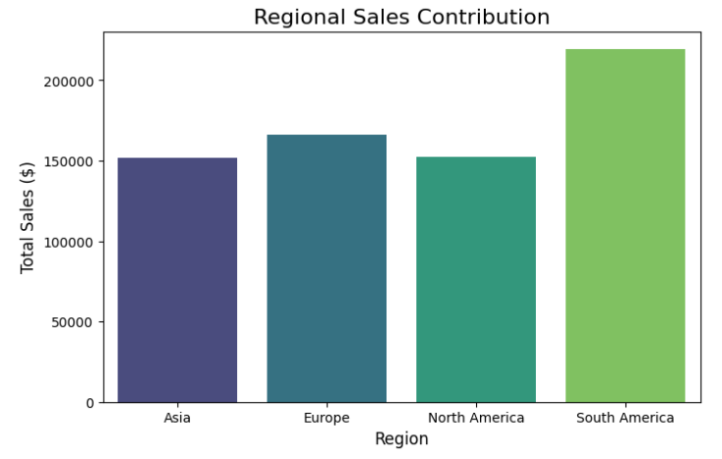

* This regional sales highlight South America as the highest revenue-generating region with total sales exceeding $ 2000000 .
* This accounts for a significant share of overall revenue, indicating strong customer engagement and product demands in South America.
* So it's feasible to prioritize South America for a targeted market and inventory optimization.

**2. Top-Selling Products**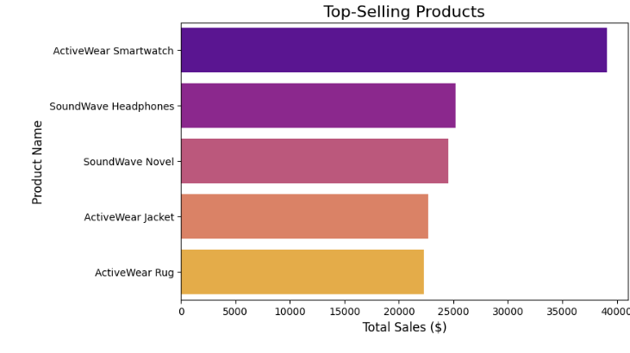

* The “ActiveWear Smartwatch” emerges as the best-selling product which contributes to nearly $40000 in revenue.
* Other popular products include the “SoundWave Headphones” for almost $25000 and “SoundWave Novel” for nearly $24500.
* The dominance of these products emphasizes the need for sustained promotion and inventory management of top-performing items.
* These items belong to a high-demand category like electronic wearables. Additionally, introducing complementary products like accessories for smartwatches and headphones could further boost sales.

**3. Category-Wise Sales Performance**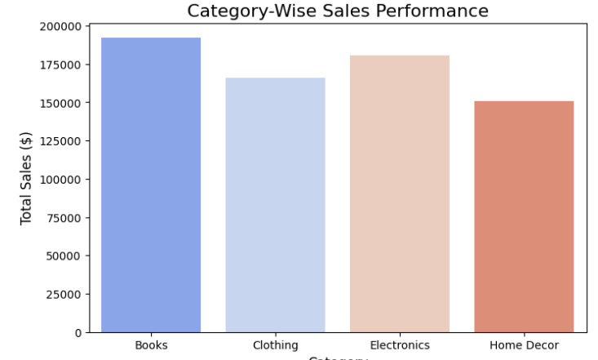

* The category “Books” contributes the highest revenue of $190000, followed by “Electronics” marking $180000 and “Clothing” for $160000.
* This data underscores the importance of maintaining a diverse range of products in the portfolio while focusing on the high-performing categories.
* The popularity of electronics indicates an opportunity to promote high-margin tech gadgets.
* Expanding product offerings within the “Books” category, such as an exclusive collection or a limited edition may attract more customers.

**4. Customer Retention and Engagement**

* Out of 200 customers 187 customers have multiple transactions, reflecting a strong repeating customer base.
* This indicates high satisfaction levels and loyalty among the client and the service/product provider.
* To further enhance customer retention, businesses could implement loyalty programs, personalized recommendations, or exclusive discounts for returning customers.
* Additionally, understanding the purchasing patterns of these repeat customers could guide targeted campaigns to drive even higher engagement.

**5. Monthly Sales Trends**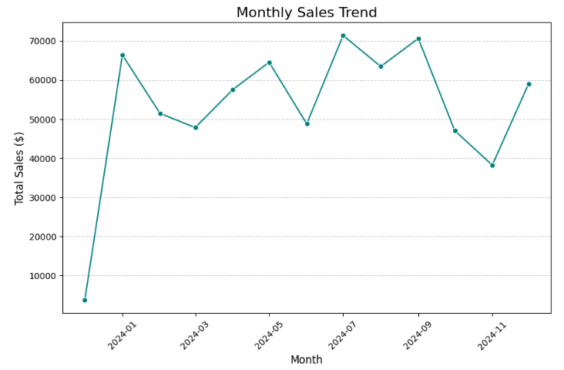

* The sales tend to reveal notable peaks in January 2024 and July 2024, indicating seasonal demand patterns.
* These months may correspond to holiday seasons or promotional campaigns. By analyzing these trends, businesses can plan targeted marketing efforts, such as holiday discounts or summer promotions, to maximize revenue during high-demand periods.
* Moreover, maintaining adequate inventory levels during these peak months will ensure seamless operations and customer satisfaction.