Case Study 9 – Project Management System

- Database Schema -
Created database -
create database projectmanagementsystem;
use projectmanagementsystem;

Created table project -
create table project (
project_id int primary key auto_increment,
project_name varchar(100) not null,
project_description varchar(200) not null,
start_date date not null,
status enum('started', 'dev', 'build', 'test', 'deployed') not null
);

Created table employee -
create table employee (
employee_id int primary key auto_increment,
employee_name varchar(100),
employee_designation varchar(100),
employee_gender varchar(10),
employee_salary double,
project_id int,
hire_date date,
foreign key (project_id) references project(project_id)
);

Created table task -
create table task (
task_id int primary key auto_increment,
task_name varchar(100),
project_id int,
employee_id int,
status varchar(20),
allocation_date date,
deadline date,
foreign key (project_id) references project(project_id),
foreign key (employee_id) references employee(employee_id) );
Created extra table expense to show expense report -
create table expense (
expense_id int primary key auto_increment,
employee_id int,
amount double,
expense_date date,
foreign key (employee_id) references employee(employee_id) );

- Java Schema -

Created 6 Packages -
- entity
- dao
- exception
- util
- main
- unitTest (To test the Project) (JUnit)

Created Classes in the respective Packages -
entity package -
1. Project.java
2. Employee.java
3. Task.java
4. ExpenseReport.java (Extra class to show the expense report)

dao package -
1. IProjectRepository.java (Interface)
2. ProjectRepositoryImpl.java
exception package -
- EmployeeNotFoundException.java
- ProjectNotFoundException.java
- TaskNotFoundException.java

util package -
1. DBConnUtil.java
2. DBPropertyUtil.java
main package -
1. ProjectApp.java (main class)
unitTest package -
1. ProjectAppTest.java (JUnit)

3. entity package -
Project.java
package entity; import java.time.LocalDate;
public class Project {
private int project_id;
private String project_name;
private String project_description;
private LocalDate startDate;
private String status;
//default constructor
public Project() {
}
//parameterized constructor
public Project(int project_id, String project_name, String project_description, LocalDate startDate, String status)
{
this.project_id = project_id;
this.project_name = project_name;
this.project_description = project_description;
this.startDate = startDate;
this.status = status;
}
//getters and setter methods
public int getProjectId() {
return project_id;
}
public void setProjectId(int project_id) {
this.project_id = project_id;
}
public String getProjectName() {
return project_name;
}
public void setProjectName(String project_name) {
this.project_name = project_name;
}
public String getDescription() {
return project_description;
}
public void setDescription(String project_description) {
this.project_description = project_description;
}
public LocalDate getStartDate(){
return startDate;
}
public void setStartDate(LocalDate startDate){
this.startDate = startDate;
}
public String getStatus() {
return status;
}
public void setStatus(String status) {
if(status.equalsIgnoreCase("started") || status.equalsIgnoreCase("dev") || status.equalsIgnoreCase("build") ||
status.equalsIgnoreCase("test") || status.equalsIgnoreCase("deployed")) {
this.status = status;
}
else {
throw new IllegalArgumentException("Invalid status value! Must be: started, dev, build, test, deployed");
}
}
}

Employee.java
package entity;
public class Employee {
private int employee_id;
private String employee_name;
private String employee_designation;
private String employee_gender;
private double employee_salary;
private int project_id;
// Default constructor
public Employee() {
}
// Parameterized constructor
public Employee(int employee_id, String employee_name, String employee_designation, String employee_gender, double employee_salary, int project_id) {
this.employee_id = employee_id;
this.employee_name = employee_name;
this.employee_designation = employee_designation;
this.employee_gender = employee_gender;
this.employee_salary = employee_salary;
this.project_id = project_id;
}
// Getter and setter methods
public int getEmployeeId() {
return employee_id;
}
public void setEmployeeId(int employee_id) {
this.employee_id = employee_id;
}
public String getEmployeeName() {
return employee_name;
}
public void setEmployeeName(String employee_name) {
this.employee_name = employee_name;
}
public String getEmployeeDesignation() {
return employee_designation;
}
public void setEmployeeDesignation(String employee_designation) {
this.employee_designation = employee_designation;
}
public String getEmployeeGender() {
return employee_gender;
}
public void setEmployeeGender(String employee_gender) {
this.employee_gender = employee_gender;
}
public double getEmployeeSalary() {
return employee_salary;
}
public void setEmployeeSalary(double employee_salary) {
this.employee_salary = employee_salary;
}
public int getProjectId() {
return project_id;
}
public void setProjectId(int project_id) {
this.project_id = project_id;
}
}

Task.java
package entity;
import java.time.LocalDate;
public class Task {
private int task_id;
private String task_name;
private int project_id;
private int employee_id;
private String status;
private LocalDate allocationDate;
private LocalDate deadline;
public Task() {}
public Task(int task_id, String task_name, int project_id, int employee_id, String status, LocalDate allocationDate, LocalDate deadline) {
this.task_id = task_id;
this.task_name = task_name;
this.project_id = project_id;
this.employee_id = employee_id;
this.status = status;
this.allocationDate = allocationDate;
this.deadline = deadline;
}
public int getTaskId() { return task_id; }
public void setTaskId(int taskId) { this.task_id = taskId; }
public String getTaskName() { return task_name; }
public void setTaskName(String taskName) { this.task_name = taskName; }
public int getProjectId() { return project_id; }
public void setProjectId(int projectId) { this.project_id = projectId; }
public int getEmployeeId() { return employee_id; }
public void setEmployeeId(int employeeId) { this.employee_id = employeeId; }
public String getStatus() { return status; }
public void setStatus(String status) {
if (status.equalsIgnoreCase("assigned") || status.equalsIgnoreCase("started") || status.equalsIgnoreCase("completed")) {
this.status = status;
} else {
throw new IllegalArgumentException("Invalid status. Must be: assigned/started/completed");
}
}
public LocalDate getAllocationDate() { return allocationDate; }
public void setAllocationDate(LocalDate allocationDate) { this.allocationDate = allocationDate; }
public LocalDate getDeadline() { return deadline; }
public void setDeadline(LocalDate deadline) { this.deadline = deadline; }
@Override
public String toString() {
return task_id + " - " + task_name + " - " + status + " | Start: " + allocationDate + ", Deadline: " + deadline;
}
}

ExpenseReport.java
package entity;

import java.time.LocalDate;

public class ExpenseReport {
private int employeeId;
private double amount;
private LocalDate date;
public ExpenseReport() {
}

public ExpenseReport(int employeeId, double amount, LocalDate date) {
this.employeeId = employeeId;
this.amount = amount;
this.date = date;
}

public int getEmployeeId() {
return employeeId;
}

public void setEmployeeId(int employeeId) {
this.employeeId = employeeId;
}

public double getAmount() {
return amount;
}

public void setAmount(double amount) {
this.amount = amount;
}

public LocalDate getDate() {
return date;
}

public void setDate(LocalDate date) {
this.date = date;
}

@Override
public String toString() {
return "Employee ID: " + employeeId + ", Amount: " + amount + ", Date: " + date;
}
}

- dao package -

IProjectRepository.java (Interface)
package dao;
import entity.Employee;
import entity.ExpenseReport;
import entity.Project;
import entity.Task;
import java.time.LocalDate;
import java.util.List;
import exception.EmployeeNotFoundException;
import exception.ProjectNotFoundException;
import exception.TaskNotFoundException;

public interface IProjectRepository {
boolean createEmployee(Employee emp);
boolean createProject(Project pj);
boolean createTask(Task tk);
boolean assignProjectToEmployee(int project_id, int employee_id);
boolean assignTaskInProjectToEmployee(int task_id, int project_id, int employee_id);
public boolean deleteEmployee(int employee_id) throws EmployeeNotFoundException;
public boolean deleteProject(int project_id) throws ProjectNotFoundException;
public boolean deleteTask(int task_id) throws TaskNotFoundException;
boolean updateProject(Project pj) throws ProjectNotFoundException;
List<Task> getAllTasks(int employee_id, int project_id);
List<Project> getAllProjects();
List<Employee> getAllEmployees();
List<ExpenseReport> generateExpenseReport(LocalDate startDate, LocalDate endDate);
}

ProjectRepositoryImpl.java
package dao;
import entity.Employee;
import entity.ExpenseReport;
import entity.Task;
import entity.Project;
import exception.EmployeeNotFoundException;
import exception.ProjectNotFoundException;
import exception.TaskNotFoundException;
import util.DBConnUtil;
import java.sql.*;
import java.time.LocalDate;
import java.util.ArrayList;
import java.util.List;

public class ProjectRepositoryImpl implements IProjectRepository {
private Connection conn;
public ProjectRepositoryImpl() {
this.conn = DBConnUtil.getDbConnection();
System.out.println("DB connection in constructor: " + this.conn);
}
@Override
public boolean createEmployee(Employee emp) {
String sql = "INSERT INTO employee(employee_name, employee_designation, employee_gender, employee_salary, project_id) VALUES (?,?,?,?,?)";
try (PreparedStatement stmt = conn.prepareStatement(sql)) {
stmt.setString(1, emp.getEmployeeName());
stmt.setString(2, emp.getEmployeeDesignation());
stmt.setString(3, emp.getEmployeeGender());
stmt.setDouble(4, emp.getEmployeeSalary());
stmt.setInt(5, emp.getProjectId());
return stmt.executeUpdate() > 0;
} catch (SQLException e) {
e.printStackTrace();
}
return false;
}
@Override
public boolean createProject(Project pj) {
String sql = "INSERT INTO project(project_name, project_description, start_date, status) VALUES (?, ?, ?, ?)";
try (PreparedStatement stmt = conn.prepareStatement(sql)) {
stmt.setString(1, pj.getProjectName());
stmt.setString(2, pj.getDescription());
stmt.setDate(3, java.sql.Date.valueOf(pj.getStartDate()));
stmt.setString(4, pj.getStatus());
return stmt.executeUpdate() > 0;
} catch (SQLException e) {
e.printStackTrace();
}
return false;
}
@Override
public boolean createTask(Task tk) {
String sql = "INSERT INTO task(task_name, project_id, employee_id, status, allocation_date, deadline) VALUES (?, ?, ?, ?, ?, ?)";
try (PreparedStatement stmt = conn.prepareStatement(sql)) {
stmt.setString(1, tk.getTaskName());
stmt.setInt(2, tk.getProjectId());
stmt.setInt(3, tk.getEmployeeId());
stmt.setString(4, tk.getStatus());
stmt.setDate(5, Date.valueOf(tk.getAllocationDate()));
stmt.setDate(6, Date.valueOf(tk.getDeadline()));
return stmt.executeUpdate() > 0;
} catch (SQLException e) {
e.printStackTrace();
}
return false;
}
@Override
public boolean assignProjectToEmployee(int project_id, int employee_id) {
String sql = "UPDATE employee SET project_id = ? WHERE employee_id = ?";
try (PreparedStatement stmt = conn.prepareStatement(sql)) {
stmt.setInt(1, project_id);
stmt.setInt(2, employee_id);
return stmt.executeUpdate() > 0;
} catch (SQLException e) {
e.printStackTrace();
}
return false;
}
@Override
public boolean assignTaskInProjectToEmployee(int task_id, int project_id, int employee_id) {
String sql = "UPDATE task SET project_id = ?, employee_id = ? WHERE task_id = ?";
try (PreparedStatement stmt = conn.prepareStatement(sql)) {
stmt.setInt(1, project_id);
stmt.setInt(2, employee_id);
stmt.setInt(3, task_id);
return stmt.executeUpdate() > 0;
} catch (SQLException e) {
e.printStackTrace();
}
return false;
}
@Override
public boolean deleteEmployee(int employee_id) throws EmployeeNotFoundException {
String checkSql = "SELECT employee_id FROM employee WHERE employee_id = ?";
String deleteExpensesSql = "DELETE FROM expense WHERE employee_id = ?";
String deleteTasksSql = "DELETE FROM task WHERE employee_id = ?";
String deleteEmployeeSql = "DELETE FROM employee WHERE employee_id = ?";
try (Connection con = DBConnUtil.getDbConnection()) {
// Check if employee exists
try (PreparedStatement checkStmt = con.prepareStatement(checkSql)) {
checkStmt.setInt(1, employee_id);
ResultSet rs = checkStmt.executeQuery();
if (!rs.next()) {
throw new EmployeeNotFoundException("Employee with ID " + employee_id + " not found.");
}
}
try (PreparedStatement deleteExpensesStmt = con.prepareStatement(deleteExpensesSql)) {
deleteExpensesStmt.setInt(1, employee_id);
deleteExpensesStmt.executeUpdate();
}
// Delete associated tasks
try (PreparedStatement deleteTasksStmt = con.prepareStatement(deleteTasksSql)) {
deleteTasksStmt.setInt(1, employee_id);
deleteTasksStmt.executeUpdate();
}
// Delete the employee
try (PreparedStatement deleteEmployeeStmt = con.prepareStatement(deleteEmployeeSql)) {
deleteEmployeeStmt.setInt(1, employee_id);
return deleteEmployeeStmt.executeUpdate() > 0;
}
} catch (SQLException e) {
e.printStackTrace();
}
return false;
}
@Override
public boolean deleteProject(int project_id) throws ProjectNotFoundException {
String checkSql = "SELECT project_name FROM project WHERE project_id = ?";
String deleteSql = "DELETE FROM project WHERE project_id = ?";
try (PreparedStatement checkStmt = conn.prepareStatement(checkSql)) {
checkStmt.setInt(1, project_id);
ResultSet rs = checkStmt.executeQuery();
if (!rs.next()) {
throw new ProjectNotFoundException("Project with id " + project_id + " not found");
}
} catch (SQLException e) {
e.printStackTrace();
}
try (PreparedStatement deleteStmt = conn.prepareStatement(deleteSql)) {
deleteStmt.setInt(1, project_id);
return deleteStmt.executeUpdate() > 0;
} catch (SQLException e) {
e.printStackTrace();
}
return false;
}
@Override
public boolean deleteTask(int task_id) throws TaskNotFoundException{
String checkSql = "SELECT task_name FROM task WHERE task_id = ?";
String deleteSql = "DELETE FROM task WHERE task_id = ?";
try (PreparedStatement checkStmt = conn.prepareStatement(checkSql)) {
checkStmt.setInt(1, task_id);
ResultSet rs = checkStmt.executeQuery();
if (!rs.next()) {
throw new TaskNotFoundException("Task with id " + task_id + " not found");
}
} catch (SQLException e) {
e.printStackTrace();
}
try (PreparedStatement deleteStmt = conn.prepareStatement(deleteSql)) {
deleteStmt.setInt(1, task_id);
return deleteStmt.executeUpdate() > 0;
} catch (SQLException e) {
e.printStackTrace();
}
return false;
}
@Override
public List<Task> getAllTasks(int employee_id, int project_id) {
List<Task> tasks = new ArrayList<>();
String sql = "SELECT * FROM task WHERE employee_id = ? AND project_id = ?";
try (Connection conn = DBConnUtil.getDbConnection();
PreparedStatement stmt = conn.prepareStatement(sql)) {
stmt.setInt(1, employee_id);
stmt.setInt(2, project_id);
try (ResultSet rs = stmt.executeQuery()) {
while (rs.next()) {
tasks.add(new Task(
rs.getInt("task_id"),
rs.getString("task_name"),
rs.getInt("project_id"),
rs.getInt("employee_id"),
rs.getString("status"),
rs.getDate("allocation_date").toLocalDate(),
rs.getDate("deadline").toLocalDate()
));
}
}
} catch (SQLException e) {
e.printStackTrace();
}
return tasks;
}
public List<Project> getAllProjects() {
List<Project> projectList = new ArrayList<>();
String query = "SELECT * FROM Project";
try (Connection con = DBConnUtil.getDbConnection();
Statement stmt = con.createStatement();
ResultSet rs = stmt.executeQuery(query)) {
while (rs.next()) {
Project p = new Project(
rs.getInt("project_id"),
rs.getString("project_name"),
rs.getString("project_description"),
rs.getDate("start_date").toLocalDate(),
rs.getString("status")
);
projectList.add(p);
}
} catch (SQLException e) {
e.printStackTrace();
}
return projectList;
}
@Override
public List<Employee> getAllEmployees() {
List<Employee> employeeList = new ArrayList<>();
String query = "SELECT * FROM employee";
try (Connection con = DBConnUtil.getDbConnection();
Statement stmt = con.createStatement();
ResultSet rs = stmt.executeQuery(query)) {
while (rs.next()) {
Employee emp = new Employee(
rs.getInt("employeeId"),
rs.getString("employeeName"),
rs.getString("role"),
rs.getString("gender"),
rs.getDouble("salary"),
rs.getInt("projectId")
);
employeeList.add(emp);
}
} catch (SQLException e) {
e.printStackTrace();
}
return employeeList;
}
public Project getProjectByNameAndDate(String name, LocalDate date) {
String query = "SELECT * FROM project WHERE project_name = ? AND start_date = ? ORDER BY project_id DESC LIMIT 1";
try (Connection conn = DBConnUtil.getDbConnection();
PreparedStatement ps = conn.prepareStatement(query)) {
ps.setString(1, name);
ps.setDate(2, Date.valueOf(date));
ResultSet rs = ps.executeQuery();
if (rs.next()) {
Project p = new Project();
p.setProjectId(rs.getInt("project_id"));
p.setProjectName(rs.getString("project_name"));
p.setDescription(rs.getString("project_description"));
p.setStartDate(rs.getDate("start_date").toLocalDate());
p.setStatus(rs.getString("status"));
return p;
}
} catch (SQLException e) {
e.printStackTrace();
}
return null;
}
public Employee getEmployeeByNameAndProject(String name, int projectId) {
String query = "SELECT * FROM employee WHERE employee_name = ? AND project_id = ? ORDER BY employee_id DESC LIMIT 1";
try (Connection conn = DBConnUtil.getDbConnection();
PreparedStatement ps = conn.prepareStatement(query)) {
ps.setString(1, name);
ps.setInt(2, projectId);
ResultSet rs = ps.executeQuery();
if (rs.next()) {
return new Employee(
rs.getInt("employee_id"),
rs.getString("employee_name"),
rs.getString("employee_designation"),
rs.getString("employee_gender"),
rs.getFloat("employee_salary"),
rs.getInt("project_id")
);
}
} catch (SQLException e) {
e.printStackTrace();
}
return null;
}
@Override
public boolean updateProject(Project pj) throws ProjectNotFoundException {
String checkSql = "SELECT * FROM project WHERE project_id = ?";
String updateSql = "UPDATE project SET project_name = ?, project_description = ?, start_date = ?, status = ? WHERE project_id = ?";
try (PreparedStatement checkStmt = conn.prepareStatement(checkSql)) {
checkStmt.setInt(1, pj.getProjectId());
ResultSet rs = checkStmt.executeQuery();
if (!rs.next()) {
throw new ProjectNotFoundException("Project with ID " + pj.getProjectId() + " not found.");
}
} catch (SQLException e) {
e.printStackTrace();
}
try (PreparedStatement updateStmt = conn.prepareStatement(updateSql)) {
updateStmt.setString(1, pj.getProjectName());
updateStmt.setString(2, pj.getDescription());
updateStmt.setDate(3, Date.valueOf(pj.getStartDate()));
updateStmt.setString(4, pj.getStatus());
updateStmt.setInt(5, pj.getProjectId());
return updateStmt.executeUpdate() > 0;
} catch (SQLException e) {
e.printStackTrace();
}
return false;
}
@Override
public List<ExpenseReport> generateExpenseReport(LocalDate start, LocalDate end) {
List<ExpenseReport> reports = new ArrayList<>();
String sql = "SELECT employee_id, amount, expense_date FROM expense WHERE expense_date BETWEEN ? AND ?";
try (Connection conn = DBConnUtil.getDbConnection();
PreparedStatement ps = conn.prepareStatement(sql)) {
ps.setDate(1, java.sql.Date.valueOf(start));
ps.setDate(2, java.sql.Date.valueOf(end));
try (ResultSet rs = ps.executeQuery()) {
while (rs.next()) {
reports.add(new ExpenseReport(
rs.getInt("employee_id"),
rs.getDouble("amount"),
rs.getDate("expense_date").toLocalDate()
));
}
}
} catch (SQLException e) {
e.printStackTrace();
}
return reports;
}
}

5. exception package -

EmployeeNotFoundException.java
package exception;

public class EmployeeNotFoundException extends Exception {
public EmployeeNotFoundException(String message) {
super(message);
}
}

ProjectNotFoundException.java
package exception;

public class ProjectNotFoundException extends Exception {
public ProjectNotFoundException(String message) {
super(message);
}
}

TaskNotFoundException.java
package exception;

public class TaskNotFoundException extends Exception {
public TaskNotFoundException(String message) {
super(message);
}
}

6. util package -
db.properties File (Not in util package, it is in Project folder)
user=root
password=Sanika@12345
protocol=jdbc:mysql:
system=localhost
database=projectmanagementsystem
port=3306

DBConnUtil.java
package util;

import java.io.IOException;
import java.sql.Connection;
import java.sql.DriverManager;
import java.sql.SQLException;

public class DBConnUtil {

private static final String fileName = "db.properties";

public static Connection getDbConnection() {
Connection con = null;

try {
Class.forName("com.mysql.cj.jdbc.Driver");
String connString = DBPropertyUtil.getConnectionString(fileName);
System.out.println("Connection String: " + connString);

con = DriverManager.getConnection(connString);
System.out.println("DB Connection Established");

} catch (ClassNotFoundException e) {
System.out.println("JDBC Driver not found");
e.printStackTrace();

} catch (IOException e) {
System.out.println("Failed to read DB properties file");
e.printStackTrace();

} catch (SQLException e) {
System.out.println("Error while connecting to the database");
e.printStackTrace();
}

return con;
}
}

DBPropertyUtil.java
package util;

import java.io.FileInputStream;
import java.io.IOException;
import java.util.Properties;

public class DBPropertyUtil {
public static String getConnectionString(String fileName) throws IOException {
String connStr = null;
Properties props = new Properties();
FileInputStream fis = new FileInputStream(fileName);
props.load(fis);

String user = props.getProperty("user");
String password = props.getProperty("password");
String protocol = props.getProperty("protocol");
String system = props.getProperty("system");
String database = props.getProperty("database");
String port = props.getProperty("port");

connStr = protocol + "//" + system + ":" + port + "/" + database +
"?user=" + user + "&password=" + password;

return connStr;
}
}

7. main package -
ProjectApp.java
package main;
import dao.ProjectRepositoryImpl; import entity.Employee; import entity.ExpenseReport; import entity.Project; import entity.Task; import exception.EmployeeNotFoundException; import exception.ProjectNotFoundException; import exception.TaskNotFoundException;
import java.time.LocalDate; import java.util.List; import java.util.Scanner;
public class ProjectApp {
public static void main(String[] args) {
Scanner scanner = new Scanner(System.in);
ProjectRepositoryImpl repo = new ProjectRepositoryImpl();
while (true) {
System.out.println("\n *****PROJECT MANAGEMENT SYSTEM*****");
System.out.println("1. Add Employee");
System.out.println("2. Add Project");
System.out.println("3. Add Task");
System.out.println("4. Assign Project to Employee");
System.out.println("5. Assign Task within a Project to an Employee");
System.out.println("6. Delete Employee");
System.out.println("7. Delete Task");
System.out.println("8. List all projects assigned with tasks to an employee");
System.out.println("9. Update a Project");
System.out.println("10. View All Projects");
System.out.println("11. Generate Expense Report");
System.out.println("12. Exit");
System.out.print("Enter your choice: ");
int choice = scanner.nextInt();
try {
switch (choice) {
case 1 -> addEmployee(scanner, repo);
case 2 -> addProject(scanner, repo);
case 3 -> addTask(scanner, repo);
case 4 -> assignProjectToEmployee(scanner, repo);
case 5 -> assignTaskToEmployee(scanner, repo);
case 6 -> deleteEmployee(scanner, repo);
case 7 -> deleteTask(scanner, repo);
case 8 -> listEmployeeProjects(scanner, repo);
case 9 -> updateProject(scanner, repo);
case 10 -> viewAllProjects(repo);
case 11 -> generateExpenseReport(scanner, repo);
case 12 -> {
System.out.println("Exiting...");
scanner.close();
return;
}
default -> System.out.println("Invalid choice! Try again...");
}
} catch (EmployeeNotFoundException | TaskNotFoundException | ProjectNotFoundException e) {
System.out.println("Error: " + e.getMessage());
}
}
}
private static void addEmployee(Scanner scanner, ProjectRepositoryImpl repo) {
System.out.print("Enter Employee Name: ");
scanner.nextLine();
String name = scanner.nextLine();
System.out.print("Enter Designation: ");
String designation = scanner.nextLine();
System.out.print("Enter Gender: ");
String gender = scanner.nextLine();
System.out.print("Enter Salary: ");
double salary = scanner.nextDouble();
System.out.print("Enter ID of Project Assigned: ");
int projectId = scanner.nextInt();
Employee emp = new Employee(0, name, designation, gender, salary, projectId);
System.out.println(repo.createEmployee(emp) ? "Employee added successfully!" : "Failed to add employee.");
}
private static void addProject(Scanner scanner, ProjectRepositoryImpl repo) {
System.out.print("Enter Project Name: ");
scanner.nextLine();
String projectName = scanner.nextLine();
System.out.print("Enter Project Description: ");
String description = scanner.nextLine();
System.out.print("Enter Start Date (YYYY-MM-DD): ");
LocalDate startDate = LocalDate.parse(scanner.nextLine());
System.out.print("Enter Status (started/dev/build/test/deployed): ");
String status = scanner.nextLine();
Project project = new Project(0, projectName, description, startDate, status);
System.out.println(repo.createProject(project) ? "Project added successfully!" : "Failed to add project.");
}
private static void addTask(Scanner scanner, ProjectRepositoryImpl repo) {
System.out.print("Enter Task Name: ");
scanner.nextLine();
String taskName = scanner.nextLine();
System.out.print("Enter Project ID: ");
int projectId = scanner.nextInt();
System.out.print("Enter Employee ID: ");
int employeeId = scanner.nextInt();
scanner.nextLine(); // flush
System.out.print("Enter Task Status (Assigned/Started/Completed): ");
String status = scanner.nextLine();
System.out.print("Enter Allocation Date (YYYY-MM-DD): ");
LocalDate allocationDate = LocalDate.parse(scanner.nextLine());
System.out.print("Enter Deadline Date (YYYY-MM-DD): ");
LocalDate deadline = LocalDate.parse(scanner.nextLine());
Task task = new Task(0, taskName, projectId, employeeId, status, allocationDate, deadline);
System.out.println(repo.createTask(task) ? "Task added successfully!" : "Failed to add task.");
}
private static void assignProjectToEmployee(Scanner scanner, ProjectRepositoryImpl repo) {
System.out.print("Enter Project ID: ");
int projectId = scanner.nextInt();
System.out.print("Enter Employee ID: ");
int employeeId = scanner.nextInt();
System.out.println(repo.assignProjectToEmployee(projectId, employeeId)
? "Project assigned to employee successfully!"
: "Failed to assign project.");
}
private static void assignTaskToEmployee(Scanner scanner, ProjectRepositoryImpl repo) {
System.out.print("Enter Task ID: ");
int taskId = scanner.nextInt();
System.out.print("Enter Project ID: ");
int projectId = scanner.nextInt();
System.out.print("Enter Employee ID: ");
int employeeId = scanner.nextInt();
System.out.println(repo.assignTaskInProjectToEmployee(taskId, projectId, employeeId)
? "Task assigned successfully!" : "Failed to assign task.");
}
private static void deleteEmployee(Scanner scanner, ProjectRepositoryImpl repo) throws EmployeeNotFoundException {
System.out.print("Enter Employee ID to delete: ");
int empId = scanner.nextInt();
System.out.println(repo.deleteEmployee(empId) ? "Employee deleted successfully." : "Failed to delete employee.");
}
private static void deleteTask(Scanner scanner, ProjectRepositoryImpl repo) throws TaskNotFoundException {
System.out.print("Enter Task ID to delete: ");
int taskId = scanner.nextInt();
System.out.println(repo.deleteTask(taskId) ? "Task deleted successfully." : "Failed to delete task.");
}
private static void listEmployeeProjects(Scanner scanner, ProjectRepositoryImpl repo) {
System.out.print("Enter Employee ID: ");
int empId = scanner.nextInt();
System.out.print("Enter Project ID: ");
int projectId = scanner.nextInt();
System.out.println("Tasks Assigned to Employee in the Project:");
repo.getAllTasks(empId, projectId).forEach(System.out::println);
}
private static void updateProject(Scanner scanner, ProjectRepositoryImpl repo) throws ProjectNotFoundException {
System.out.print("Enter Project ID to update: ");
int projectId = scanner.nextInt();
scanner.nextLine(); // consume newline
System.out.print("Enter New Project Name: ");
String name = scanner.nextLine();
System.out.print("Enter New Description: ");
String desc = scanner.nextLine();
System.out.print("Enter New Start Date (YYYY-MM-DD): ");
LocalDate start = LocalDate.parse(scanner.nextLine());
System.out.print("Enter New Status: ");
String status = scanner.nextLine();
Project p = new Project(projectId, name, desc, start, status);
System.out.println(repo.updateProject(p) ? "Project updated." : "Failed to update project.");
}
private static void viewAllProjects(ProjectRepositoryImpl repo) {
List<Project> projects = repo.getAllProjects();
System.out.println("All Projects:");
projects.forEach(p -> System.out.println(p.getProjectId() + " - " + p.getProjectName()));
}
private static void generateExpenseReport(Scanner scanner, ProjectRepositoryImpl repo) {
System.out.print("Enter Start Date (YYYY-MM-DD): ");
scanner.nextLine();
LocalDate startDate = LocalDate.parse(scanner.nextLine());
System.out.print("Enter End Date (YYYY-MM-DD): ");
LocalDate endDate = LocalDate.parse(scanner.nextLine());
List<ExpenseReport> total = repo.generateExpenseReport(startDate, endDate);
System.out.println("Total Expenses from " + startDate + " to " + endDate + ": " + total);
}
}

8. unitTest package (JUnit) -
ProjectAppTest.java
package unitTest;

import dao.ProjectRepositoryImpl;
import entity.Employee;
import entity.Project;
import entity.Task;
import exception.EmployeeNotFoundException;
import exception.ProjectNotFoundException;
import exception.TaskNotFoundException;

import org.junit.jupiter.api.*;

import java.time.LocalDate;
import java.util.List;

import static org.junit.jupiter.api.Assertions.*;

@TestMethodOrder(MethodOrderer.OrderAnnotation.class)
public class ProjectAppTest {

private static ProjectRepositoryImpl repo;

@BeforeAll
static void initRepo() {
repo = new ProjectRepositoryImpl();
}

private int createProjectAndReturnId() {
Project project = new Project();
project.setProjectName("Test Project");
project.setDescription("For testing");
project.setStartDate(LocalDate.now());
project.setStatus("started");

boolean success = repo.createProject(project);
assertTrue(success, "Project creation should succeed");

Project inserted = repo.getProjectByNameAndDate("Test Project", LocalDate.now());
assertNotNull(inserted, "Inserted project should be retrievable");
return inserted.getProjectId();
}

private int createEmployeeAndReturnId(int projectId) {
Employee emp = new Employee(0, "Sanika", "Developer", "Female", 500000, projectId);
boolean created = repo.createEmployee(emp);
assertTrue(created, "Employee creation should succeed");

Employee inserted = repo.getEmployeeByNameAndProject("Sanika", projectId);
assertNotNull(inserted, "Inserted employee should be retrievable");
return inserted.getEmployeeId();
}

@Test
@Order(1)
public void testCreateEmployeeSuccess() {
int projectId = createProjectAndReturnId();
Employee emp = new Employee(0, "Sanika", "Tester", "Female", 400000, projectId);
boolean result = repo.createEmployee(emp);
assertTrue(result, "Employee created successfully");
}

@Test
@Order(2)
public void testCreateTaskSuccess() {
int projectId = createProjectAndReturnId();
int employeeId = createEmployeeAndReturnId(projectId);

Task task = new Task(0, "Unit Test Task", projectId, employeeId, "assigned", LocalDate.now(), LocalDate.now().plusDays(7));
boolean result = repo.createTask(task);
assertTrue(result, "Task created successfully");
}

@Test
@Order(3)
public void testSearchTasksForEmployeeInProject() {
int projectId = createProjectAndReturnId();
int employeeId = createEmployeeAndReturnId(projectId);

Task task = new Task(0, "Search Task", projectId, employeeId, "started", LocalDate.now(), LocalDate.now().plusDays(5));
boolean created = repo.createTask(task);
assertTrue(created, "Task should be created for searching");

List<Task> tasks = repo.getAllTasks(employeeId, projectId);
assertNotNull(tasks, "Task list should not be null");
assertFalse(tasks.isEmpty(), "Task list should not be empty");
}

@Test
@Order(4)
public void testEmployeeNotFoundExceptionThrown() {
int invalidEmpId = 9999;
assertThrows(EmployeeNotFoundException.class, () -> {
repo.deleteEmployee(invalidEmpId);
});
}

@Test
@Order(5)
public void testProjectNotFoundExceptionThrown() {
int invalidProjectId = -1;
assertThrows(ProjectNotFoundException.class, () -> {
repo.deleteProject(invalidProjectId);
});
}

@Test
@Order(6)
public void testTaskNotFoundExceptionThrown() {
int invalidTaskId = 9999;
assertThrows(TaskNotFoundException.class, () -> {
repo.deleteTask(invalidTaskId);
});
}
}

9. Output -
JUnit Test -
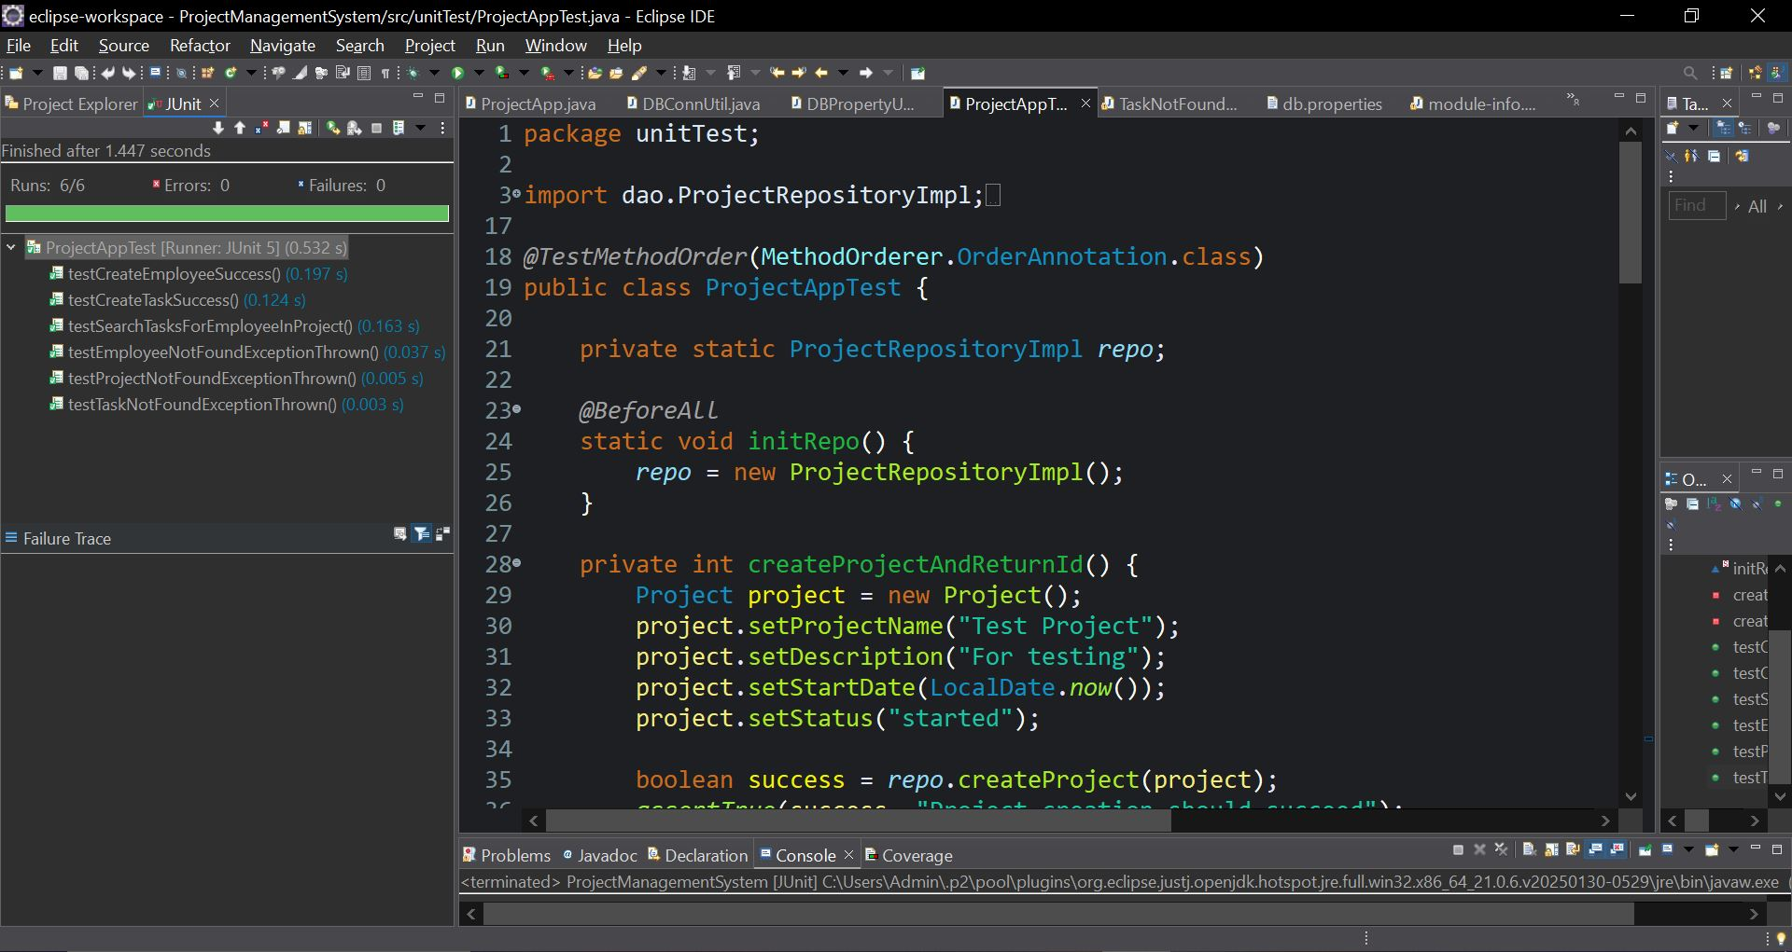
Add Employee
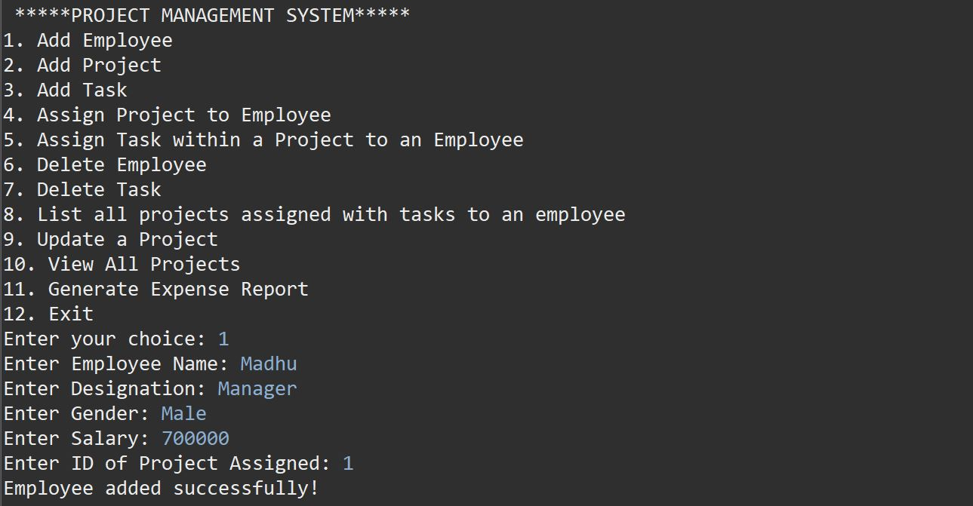

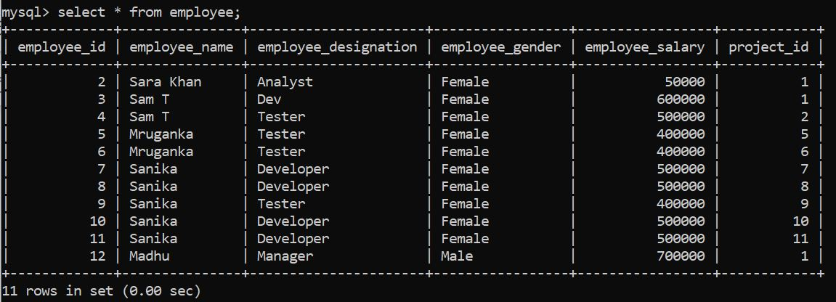

Add Project
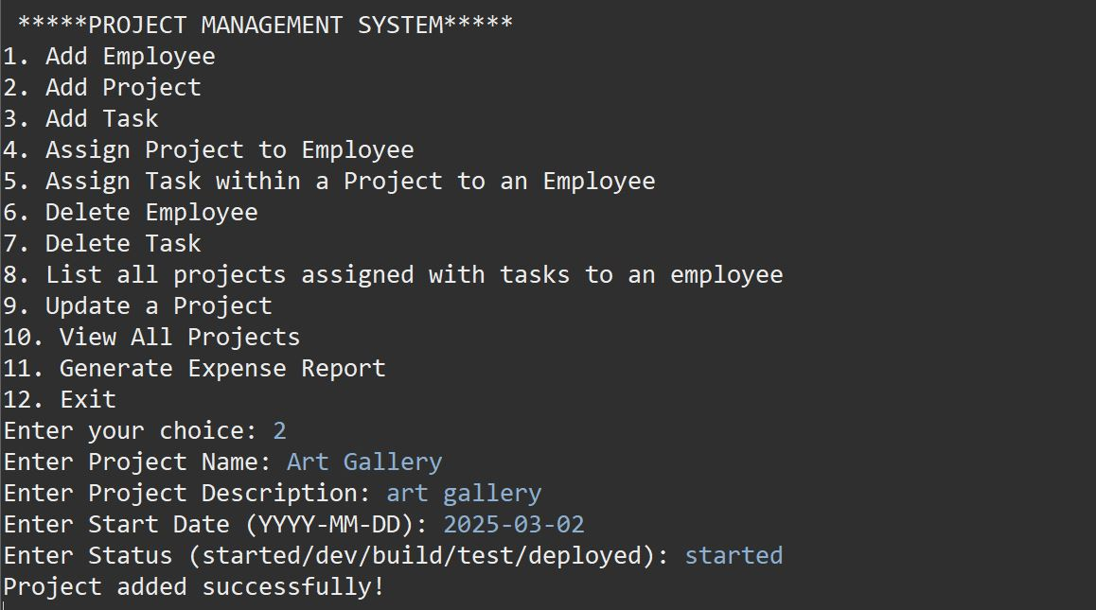

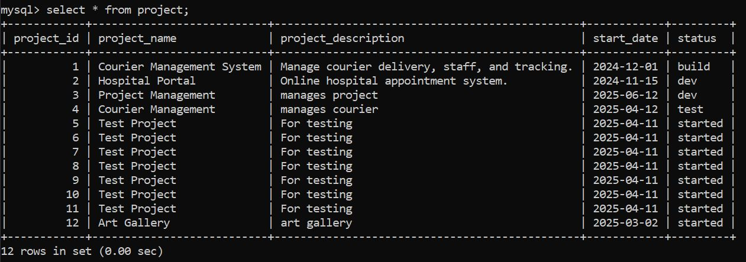

Add Task
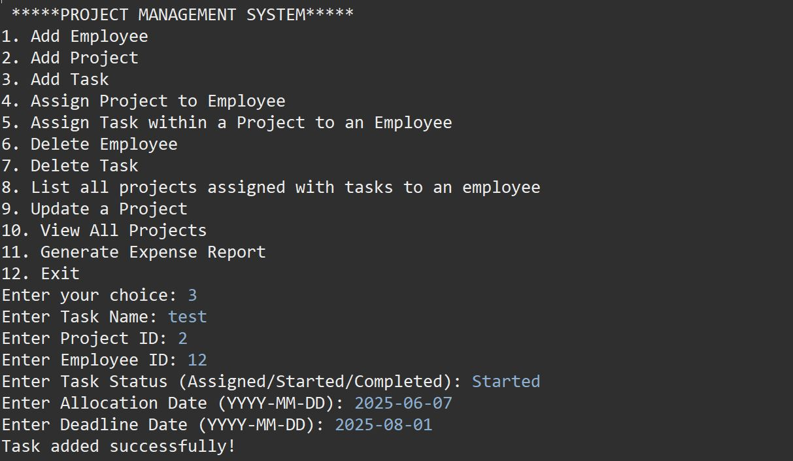

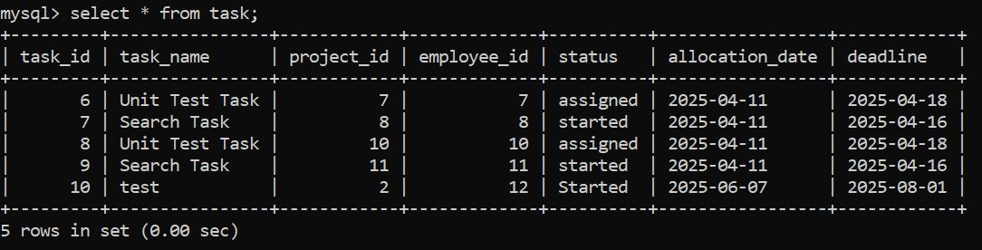

Assign Project to Employee
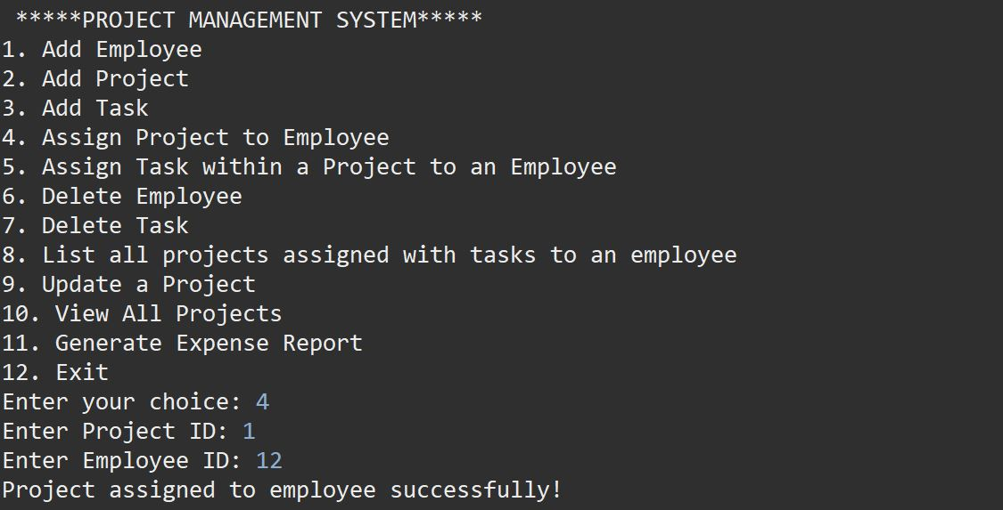

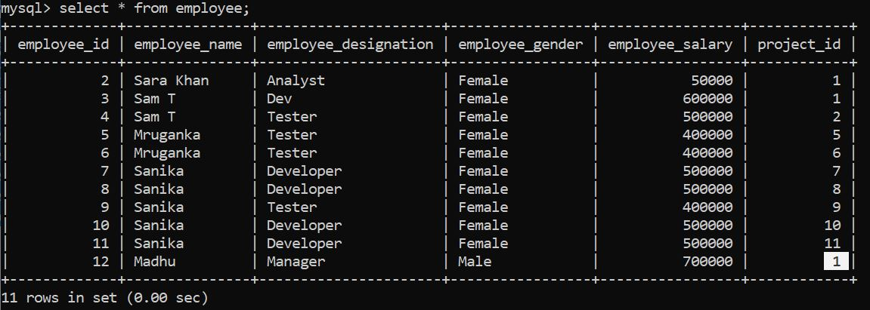

Assign Task within a project to employee
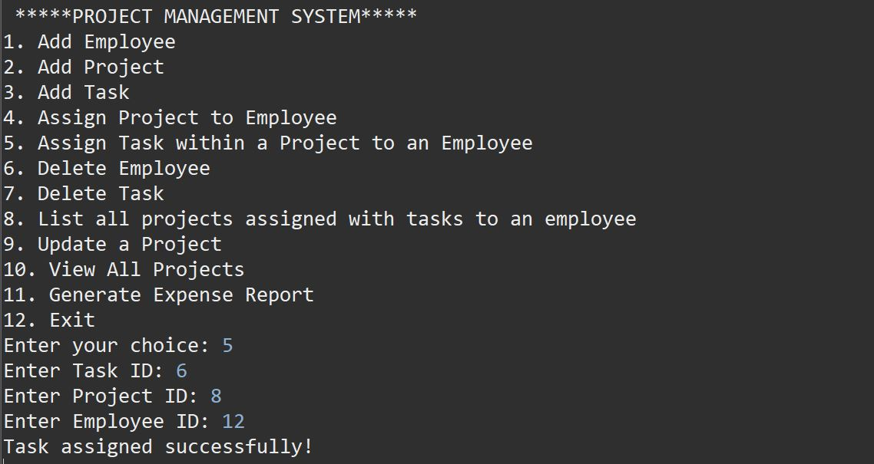

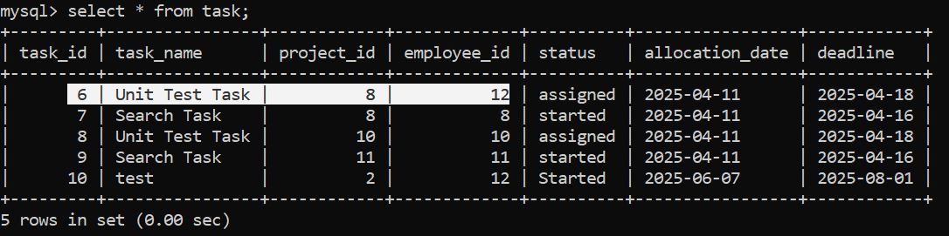

Delete Employee
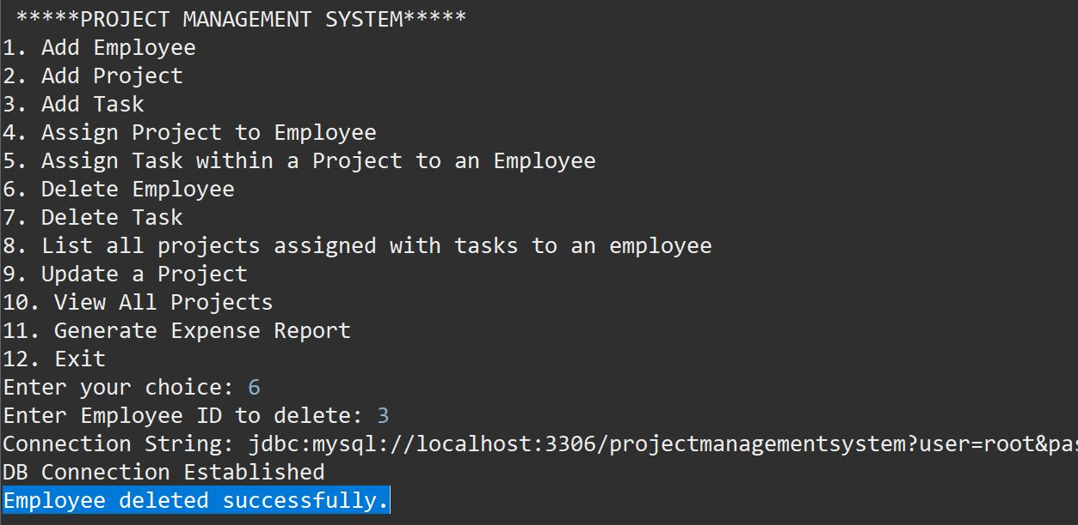

Delete Task
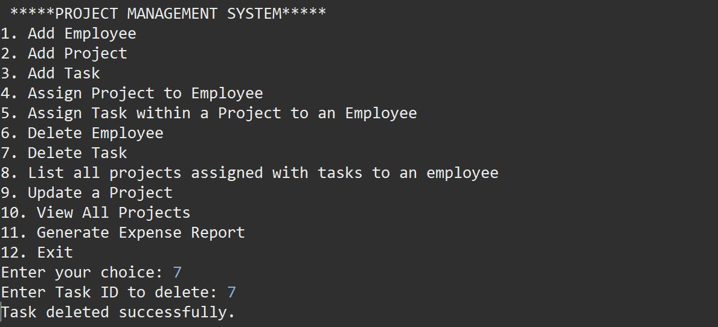

List all projects assigned with tasks to an employee
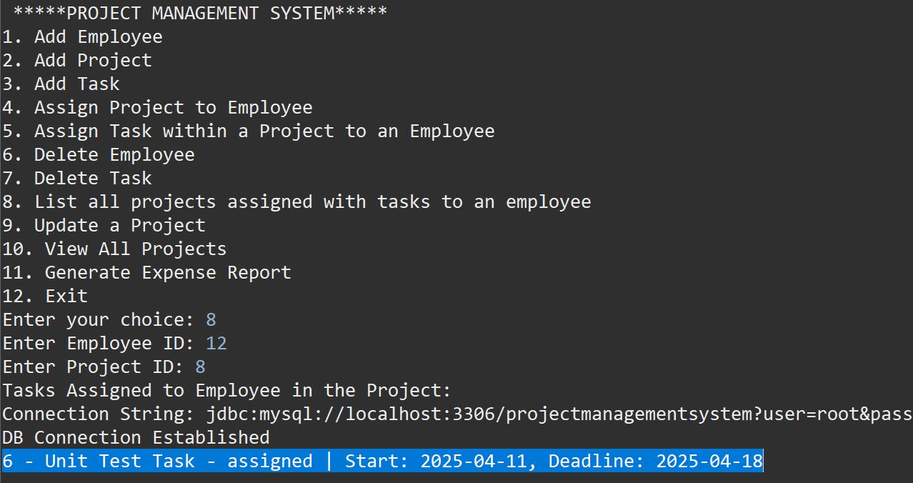

Update a Project
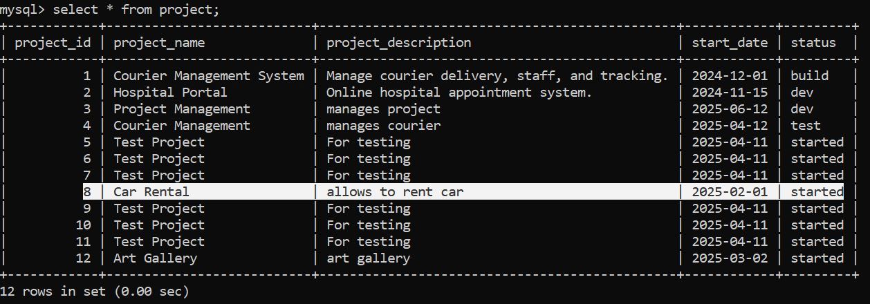

View All Projects
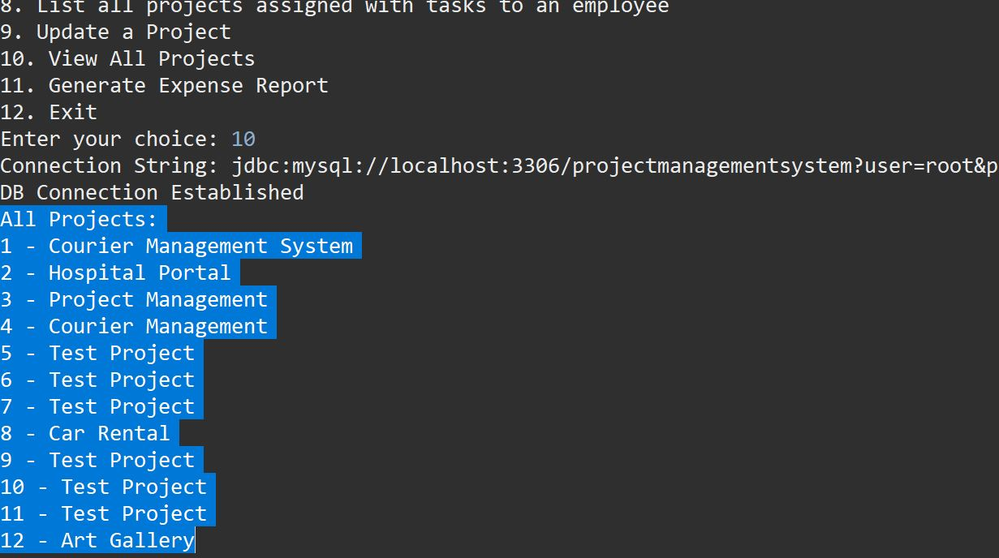

Generate Expense Report
