VISVESVARAYA TECHNOLOGICAL UNIVERSITY

**JNANA SANGAMA,BELAGAVI – 590018**

**KARNATAKA**



**Assignment Report**

**On**

**“AMBULANCE SOUND BASED TRAFFIC SIGNAL CONTROL SYSTEM ”**

**SUBMITTED IN PARTIAL FULFILLMENT OF THE REQUIREMENTS**

**FOR THE DATA STRUCTURES AND APPLICATIONS (BCS304) COURSE OF III SEMESTER**

Submitted by

|  |  |  |
| --- | --- | --- |
| **SANIKA . S** |  |  |
| **[1CG22AD046]** |  |  |

**Guide: HOD:**

**Mrs. Mala K .M. Tech. Dr. GavisidappaPhD.,**

Asst. Prof., Dept. of ISE Head, Dept. of AD

CIT, Gubbi. CIT, Gubbi.

**DEPARTMENT OF ARTIFICIAL INTELLIGENCE AND DATA SCINECE**

**Channabasaveshwara Institute of Technology**

(Affiliated to VTU, Belgaum & Approved by AICTE, New Delhi)

(**ISO 9001:2015 Certified Institution)**

NH 206 (B.H. Road), Gubbi, Tumkur – 572 216. Karnataka.

**2023-24**

**Rubric – B.E. Mini-Project [BCS304]**

|  |  |  |  |  |  |  |
| --- | --- | --- | --- | --- | --- | --- |
| **Course**  **outcome** | **Rubric/Level** | **Excellent**  **(91-100%)** | **Good**  **(81-90%)** | **Average**  **(61-80%)** | **Moderate**  **(40-60%)** | **Score** |
| **CO1** | **Identification of project**  **proposal**  **(05 Marks)** |  |  |  |  |  |
| **CO2** | **Design and**  **Implementation**  **(10 Marks)** |  |  |  |  |  |
| **CO3** | **Presentation skill**  **(05 Marks)** |  |  |  |  |  |
| **CO4** | **Report**  **(05 Marks)** |  |  |  |  |  |
| **Total** | | | | | |  |

**Course outcome:**

**CO 1: Identification of project proposal which is relevant to subject of engineering.**

**CO 2: Design and implement proposed project methodology.**

**CO 3: Effective communication skill to assimilate their project work.**

**CO 4: Understanding overall project progress and performance.**

**Student Signature Faculty signature**

**INDEX**

**Abstract :**

Traffic over crowding is one of the major problem in over populated cities . The main aim of the project is to provid e solution for the ambulances which is heading towords the taffic signal for emergency when there is heavy traffic . This is implemented by detecting the sound frequency of the ambulances using sound sensors and monitoring the ambulances so that it can over come the tarffic and reach the destination . The project can also be used to the high priority vehicals like fier disaster prevention vehicals and police jeed heading towords the traffic signals during emergencies .

**Introduction :**

Due to rapid growth in the urbanization , the population is also growing rapidly and so the traffic . We are planning to implement the ambulance sound detectors in the exsisting traffic signal so that the ambulace can overcome the traffic and reach the destination during the emergencies . This innovation approach amis to improve the co-ordination between the emergency vehicals and the traffic signals , thereby prioritizing their passage throught intersection .

**Problem Statement :**

Due to traffic overflow in traffic signals the abulance has to wait for some time . This increases the risk in saving someone’s lives . so by taking this into the consideration , we have to find the solution for this problem .

**Implementation :**

We have implementated the code to dectect the sound of the amulance based On its frequency i.e., 1500hz and change the traffic signal light according to it .

#include<stdio.h>

#include<stdlib.h>

#include<time.h>

#include<unistd.h>

enum TrafficLightState {

RED,

GREEN,

YELLOW

};

struct TrafficLight {

enum TrafficLightState state;

};

// Function to switch traffic light to the next state

void switchTrafficLight(struct TrafficLight *light) {

switch (light->state) {

case RED:

light->state = GREEN;

break;

case GREEN:

light->state = YELLOW;

break;

case YELLOW:

light->state = RED;

break;

default:

break;

}

}

// Function to simulate traffic signal control

void simulateTrafficSignalControl(struct TrafficLight *light) {

// Simulate time passing (in seconds)

sleep(5);

// Switch to the next traffic light state

switchTrafficLight(light);

// Display the current state

switch (light->state) {

case RED:

printf("Traffic Light:GREEN\n");

break;

case GREEN:

printf("Traffic Light:GREEN\n");

break;

case YELLOW:

printf("Traffic Light: YELLOW\n");

break;

default:

break;

}

}

int main() {

// Initialize traffic light and sound detection system

struct TrafficLight intersectionLight;

intersectionLight.state = RED;

// Simulate traffic signal control and sound detection for a few cycles

for (int i = 0; i < 5; ++i) {

int freq;

printf("Enter frequency: ");

scanf("%d", &freq);

// If sound is detected, trigger traffic light change

if (freq == 1500) {

printf("Emergency vehicle detected! Triggering traffic light change.\n");

switchTrafficLight(&intersectionLight);

simulateTrafficSignalControl(&intersectionLight);

printf("RED light turned GREEN");

} else {

printf("Traffic signal remains same\n");

// Otherwise, continue normal traffic signal control

simulateTrafficSignalControl(&intersectionLight);

}

}

return 0;

}

**Results/Screen Shote :**

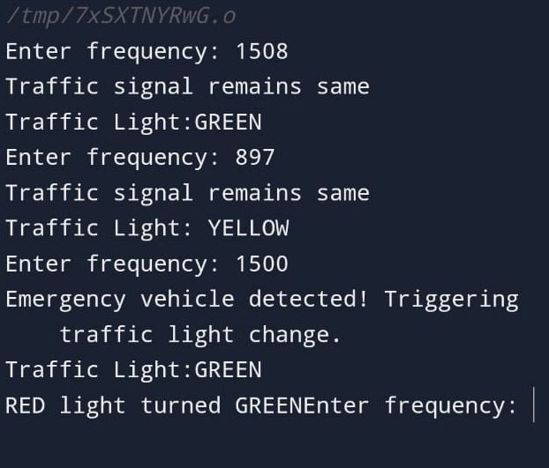

**Conclusion :** In this work , we are providing the solution for the existing problem of an ambulance stuck in the traffic by employing a sensor to detect the ambulance sound frequency and change the traffic signal light .This solution can completely eleminate the problem of ambulance waiting time in overcrowded traffic .

**References :** [1] Bilal Ghazal, Khaled EIKhatib, Khaled Chahine,

Mohamad Kherfan, Smart Traffic Light Control Syatem, Third

International Conference on Electrical, Electronics, Computer

engineering and their Applications.

[2] Linganagouda R, Pyinti Raju, Anusuya Patil, Automatic Intelligent Traffic Control System, International Journal of Advanced Research in Electrical, Electronics and Instrumentation Engineering, vol. 5, issue 7,july. Ahmed S. Salama, Bahaa K. Saleh & Mohamad M. Eassa “Intelligent Cross Road Traffic Management System (ICRTMS)”, 2nd International Conference on Computer Technology and Development, pp27- 31.

[3] Vandana Jayaraj, Hemath. C. Emergency Vehicle Signalling Using VANETS, 17th International Conference on High Performance Computing and Communications, 7th International Symposium on Cyberspace Safety and Security, and 12th International Conference on Embedded Software and Systems .